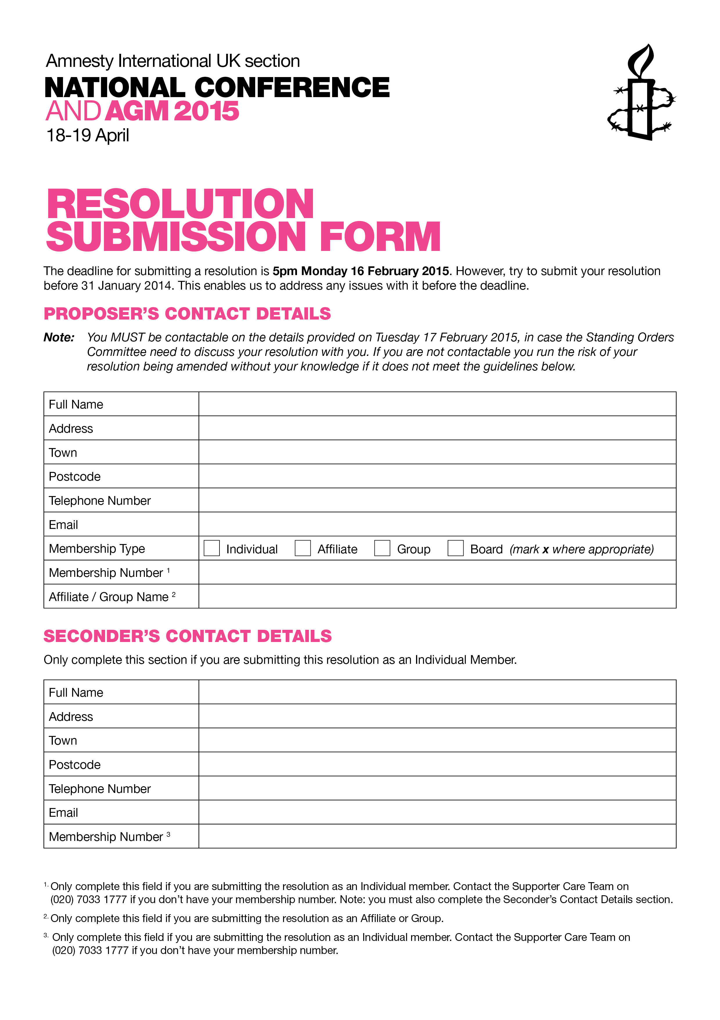

0
DD/MM/YYYY
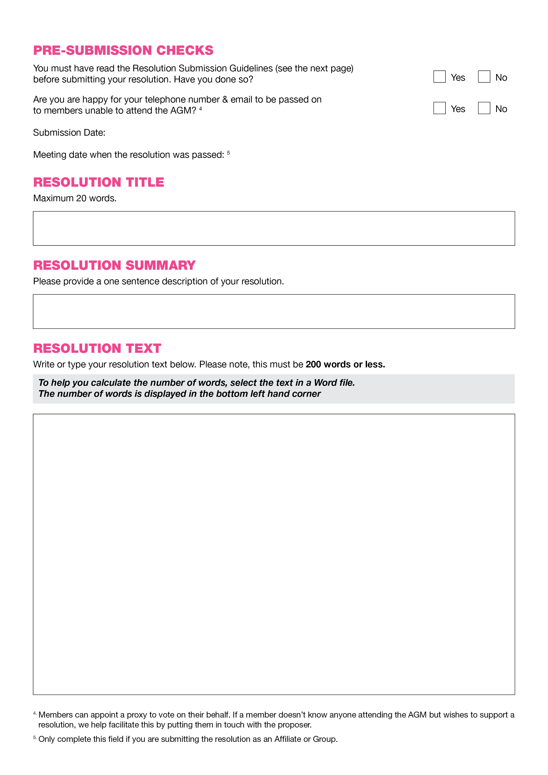

RESOLUTION SUBMISSION GUIDELINES

We want members to have an opportunity to raise issues at the AGM and get the most from the debate. To help us, please ensure you have worded your resolution correctly. To help, here are some guidelines.

A resolution MUST:

- start with an action statement (eg ‘This AGM instructs / decides / calls on…’).
- ask the Amnesty International UK Section to take action on either an issue relevant to the:
  - wider international movement (eg developing policy on Female Genital Mutilation).
  - UK Section (eg creating an AGM decision reporting mechanism).
- be brief and to the point.
- if a timescale forms part of the resolution, it must be specific (e.g. ‘by the 2015 AGM’).
- have been cleared with the Country Coordinator if calling for a country-related campaign.
A resolution MUST NOT:
- instruct the AIUK Board (or the UK Section) to undertake action outside its power and remit. If in doubt, consult the Standing Orders Committee before submitting your motion.

- contain phrases like ‘This AGM notes / acknowledges / agrees / reaffirms…’. Such content is better placed in the Background Notes.
- contain wording from previous AIUK or ICM resolutions. It is better to reference them by name
(eg ‘The 2013 ICM decision 2: Restricted Giving’).
- ask the AIUK Board to implement something that was defeated at a previous AGM.
- state opinion as fact.
A background note:

- adds context and understanding to the resolution. For example, it can include references to:
  - previous Amnesty International decisions.
  - facts and figures.
- should not contain wording from previous AIUK or ICM resolutions. It is better to reference them by name (eg ‘The 2013 ICM decision 2: Restricted Giving’).
- must not include an argument in support of the resolution. The Standing Orders Committee has the power to delete material that in its opinion is in breach of this rule.
- is not compulsory.

FREQUENTLY ASKED QUESTIONS

Do the Proposer and Seconder have to attend the AGM?
It is in your interests to attend the AGM if proposing a resolution, but you do not have to. Provided the Standing Orders Committee has been notified in advance, you can nominate another member to propose the resolution on your behalf. Remember that your motion can be amended at the AGM. Ensure you nominate someone on the same wavelength as you. Seconders do not need to attend the AGM.

Do I need to consult with anyone before submitting my resolution?
The only requirement to consult is if the resolution focuses on a country. In this instance you must contact the AIUK Country Coordinator. This ensures your suggested policy is not detrimental to that country’s campaigning.

That said, it can often be useful to consult with the Standing Orders Committee. This can avoid any last minute problems which could result in the resolution not being submitted for debate. If you need any clarification or information, contact the SOC on soc@amnesty.org.uk.

What happens after I have submitted a resolution?
The Standing Orders Committee will confirm receipt of your email within five days. If there is more than one resolution on the same topic, the Standing Orders Committee has the power to “composite” them into a single resolution. If your resolution is affected, the Standing Orders Committee will work with you to agree the wording. Once accepted, your resolution is placed on the AGM’s agenda and is debated in a plenary session.

What majority is required for a motion to pass?
All resolutions (except constitutional amendments and special resolutions) require a simple majority. Constitutional amendments and special resolutions require a three-quarters majority.

Are there exceptions to the AGM resolution deadline?
The only exception is for emergency resolutions. These are resolutions that relate to something that has arisen after the deadline for resolutions has passed. As such they could not have been raised in time. The deadline to submit an emergency resolution is the start of the first AGM session.

What happens to my resolution at the AGM?
Debating, amending and voting on resolutions are the means by which the AGM makes good policy decisions. This process generates informed discussion among the membership; a crucial aspect of AIUK’s democracy. Resolutions (except constitutional amendments / special resolutions which can not be changed) may be changed by amendments submitted by other members at the AGM. Each amendment is debated, and if passed becomes part of your resolution.

What happens to my resolution after the AGM?
If your resolution is passed, the AIUK Board has a duty to ensure it is acted upon. An AIUK Board Member is appointed to ensure it is, and to communicate with the resolution’s proposer. A report is issued prior to the next AGM detailing the progress of its implementation.

Is all Amnesty International UK Section policy agreed by AGM resolutions?
No. Resolutions are not the only means for you to raise concerns or stimulate debate. In fact in some instances, they may not be the most appropriate. Other opportunities for discussion exist throughout the AGM (eg workshops and meetings). Additionally, members of AIUK’s staff and governance bodies (ie the Board and its Sub-Committees) attend the AGM and are clearly visible. They are available for you to informally discuss anything you wish to raise with them.

Contact the Activism Team (activism@amnesty.org.uk) to get details of the relevant Country Coordinator.
Contact the Activism Team (activism@amnesty.org.uk) to get details of the Standing Orders Committee.

