Write for Rights 2014
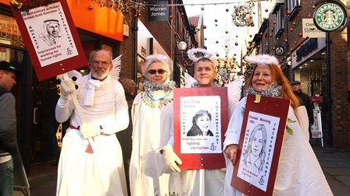
Our annual Write for Rights campaign is over for another year, and this year it’s been bigger than ever! Here at Amnesty UK we would like to take this opportunity to thank you for all your hard work and support over November and December. Thousands of you wrote messages of support for individuals, signed petitions, and sent letters calling for their release. Indeed over 85, 000 actions were taken in the UK throughout the campaign! We are constantly impressed by your campaigning.
Your actions were part of something global
Over 3 million actions have been taken in over 100 countries!
Hundreds of thousands of activists around the world have written letters to government authorities on behalf of those individuals featured in our cases, putting pressure on authorities to take action. These amazing levels of activism are a reminder of the size and diversity of our global movement. In Morocco activists dressed up as giant pencils, there were candlelit vigils in Algeria, a live interview with Edward Snowden and Amnesty supporters in France, a 24 hour pyjama party for Write for Rights in Chile, and many more letter writing events across the world. Even in countries with no Amnesty section, activists organised amazing letter writing events to join in with the campaign.
Here in the UK
We have had a fantastic response to the campaign this year. To date we have counted over 85,000 actions taken across the UK in support of the campaign, but we know that there are many more of you that send cards and letters for this campaign. The time and effort that supporters and activist groups have given to this campaign has been incredible. From letter writing nights at the local pub, to stalls in town centres, Amnesty activist groups across the country embraced the campaign and held letter writing events in their communities.
For example, In Saffron Walden activists held a series of events where members of the public sent over 700 solidarity messages! Activists in York dressed up as ‘human rights angels’ in their town centre and got the public to write their own messages. Youth groups got involved too making over 2500 feathers, banners, cards and letters for individuals. It is innovative events like this that has helped the campaign reach out to new audiences and get more people involved.
On 10th December staff and Country Coordinators held an event in Parliament to mark Human Rights Day and to ask parliamentarians to support the Write for Rights campaign. 40 MPs and Peers took action for individuals at risk, writing letters to governments and solidarity messages for individuals.

Wish you were here
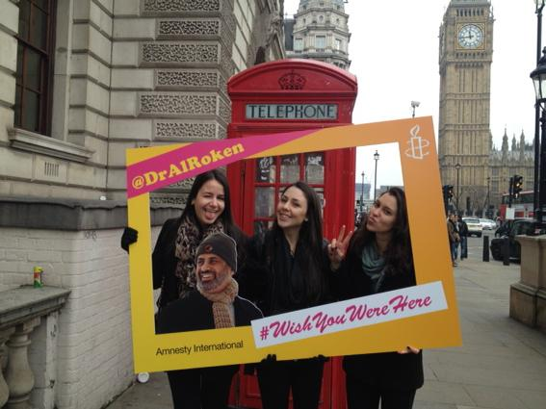
A keen traveller, we took human rights lawyer Mohammed al-Roken on a virtual tour of the UK with our ‘Wish You Were Here’ campaign. Staff in London and Edinburgh kicked off the social media action by taking pictures with a giant photo frame and then Amnesty activists across the country took part with homemade signs and placards. Through the magic of social media our action made it as far as Japan and New Zealand! Our message of support was heard loud and clear, with human rights activists in the United Arab Emirates sharing them widely.
Good news
It didn’t take long before good news started coming through about this year’s cases.
Liu Ping, China: In late December Liu Ping’s daughter was able to visit her mother in prison, having previously been refused permission. Liao Minyue said: "I'm very moved by all the action for my mother; I want to send my thanks to everyone who has been campaigning on her case".
John Jeanette, Norway: The Norwegian Government committed to ending the practice of demanding sterilisation as a requirement for changing legal gender and pledged to look at broader issues around the trans rights. John Jeanette had this to say about the level of solidarity she received from Amnesty supporters: “Getting this massive, wonderful and warm support from people worldwide really makes a great difference to my daily life.”
Chelsea Manning, USA: Chelsea was granted access to hormone treatment, a first for the US Military. She sent us this message to all of you “I greatly appreciate all of the strong words of support and warm words of comfort that I receive every day. I am so glad that Amnesty International and its many members have been reaching out to help me.”
Raif Badawi, Saudi Arabia: Ensaf Haidar, Raif Badawi’s wife, told us how much your support means to her and her husband: “At times when Raif called me I conveyed to him the activities of Amnesty International's campaign. I even remember that suddenly he started to cry out of joy, and he said to me: ‘Ensaf how can I thank all those people who supported me; I want to thank them one by one.’”
Continuing our work on Individuals at Risk
The Write for Rights campaign runs from November to the end of December, but Amnesty’s work with individuals at risk is a year round activity. We hope you’ll continue to support our other campaigning throughout the upcoming year. Your help makes all the difference.
For more information, please visit our webpage: http://www.amnesty.org.uk/issues/Action-for-individuals
Thank you
Karen and Jonathan, Individuals at Risk Programme

