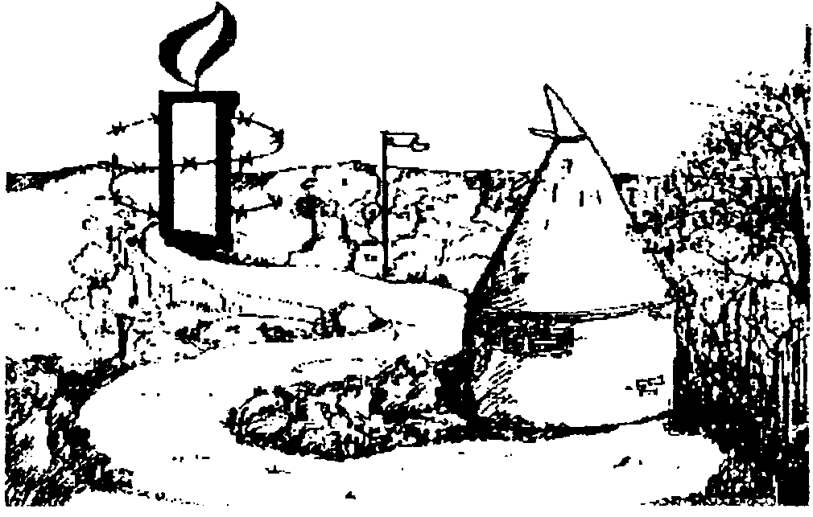

AMNESTY INTERNATIONAL SEVENOAKS SPONSORED WALK HELP LIST 16 September 2012

This year we have prioritised the areas in which we most need YOUR help!

NAME……………………………………………………………………… Tel. No…………………………………………………….......

High Priority

- Walking – more than anything we need Amnesty supporters to turn out and walk (walks are, either 3, 6 or 11 miles with lunch at the farm).

- Leading the long walk (maps etc provided)

- Helping at the farm, including driving 3 mile walkers or exhausted walkers back to the car park.

- Making soup

- Providing FOOD (lunch has become a major attraction; bread, soup, salad and cheese are provided); donations of the following will be gratefully received:

- cake(s)
- quiche(s)
- pasta/rice/couscous salad

Medium Priority

- Counting walkers leaving the car park 9.00-11.00am and 11.00am-1.00pm

- Signing in walkers at Buckhurst car park, (please state preferred time)

Please return or e-mail preferences to Neville White, 2 Chapmans Lane, Orpington, Kent BR5 3JA: Tel: 01689 896368 E Neville.white@waitrose.com

