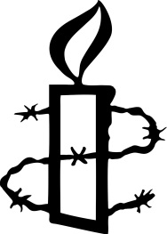AMNESTY
INTERNATIONAL
COLWYN BAY GROUP
and
THE ZIMBABWE ASSOCATION
SATURDAY 29 JUNE 2013
12.30-4.30pm
Hear some uplifting music from the Zim Assoc Choir and take the opportunity to cast your vote for elections free from violence in Zimbabwe this year.
St John’s Church, Mostyn Street, Llandudno
Refreshments from Fair Trade Coalition
further details Maggie 01492 514870 or
http://www2.amnesty.org.uk/groups/colwyn-bay

