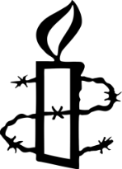 Amnesty International UK Mid-Warwickshire Group

SPOTLIGHT ON TORTURE - BRITISH STYLE

Andrew Williams, Professor of Law and Co-Director of the Centre for Human Rights in Practice at the University of Warwick

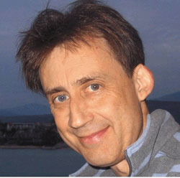

will talk to us about

‘BRITAIN AND TORTURE’

Thursday 6th November

7.30pm for 8.00pm
at

Saint Patricks Irish Club
Riverside,
Adelaide Road
Leamington Spa
CV31 3PW

We are very pleased that Andrew Williams has accepted our invitation to talk to us at our November meeting. Those of us who have heard Andrew talk on this subject before know him to be an accomplished speaker who is passionate about his subject.

The official line is clear - the UK does not ‘participate in, solicit, encourage or condone’ torture. Andrew will argue the evidence against this is irrefutable, ‘a sinister and unpalatable chain of complicity going from the military right to the top of government enables the on-going abuse of terror suspects by Britain’.

Throughout his talk Andrew will refer to his recent book ‘A Very British Killing - the Death of Baha Mousa’, that won the 2013 Orwell Prize for political writing.

At a time when Amnesty are pursuing a ‘Stop Torture’ as a major campaign , it behoves us to take a look at what is going on in our own ’back yard’.

Following the talk there will be time for questions and discussion.

********

