Next Meeting
Thame Amnesty’s Big Debate
Wednesday 23rd May, 7.30 p.m.
Sports Centre
Lord Williams Lower School

An opportunity to contribute to Amnesty’s Big Debate in relation to possible future national campaigning. We welcome all contributions and would want to hear from the wider membership so please join our discussions on this occasion

Everyone welcome – so please come along
Contact Bob for further details -
christinefieldsend@hotmail.com

April Meeting - AGM
This month’s meeting was the AGM and in addition to welcoming three new members, there were the usual elections, with all current officers being re-elected. The accounts and annual report were adopted and information on these is available from Bob, for those who were unable to attend.
Sue Rowe also provided feedback on the AIUK Annual Conference and AGM, which was held at the end of April in Manchester. The focus was the ‘Bulletproof’ Arms Trade treaty and you can still sign the petition to David Cameron on the Amnesty web-site. There were also speakers from Syria, Bahrain, Azerbyjan and WOZA in Zimbabwe. In addition the current death penalty campaign is focussing on Reggie Clements in USA. All the petitions and resolutions passed at the AIUK AGM are on the Amnesty web-site and in the new magazine. www.amnesty.org.uk/content.asp?CategoryID=10159
The actions that we undertook this month were; letters on behalf of Filep Karma demanding that his medical treatment is paid for by the Indonesian authorities; letters to the Pakistan authorities on behalf of Masood Janjua and Faisal Faraz (our regular special campaign) and letters to the Japanese authorities following the execution of a death row prisoner, the first for many years following the appointment of a new Minister for Justice.
Other discussions related to our participation in the local Flower Festival and our non-participation in the local carnival which has not been a very successful event for us in the past.
Also our continuing thanks to Sue for work on our local Thame Amnesty web-site. Have a look at our new resources and let us have your feedback:-

New webpage: http://www2.amnesty.org.uk/groups/thame

Yahoo group:
http://groups.yahoo.com/group/thame-amnesty/

Facebook page:
http://www.facebook.com/ThameAmnesty
You can contact Sue directly on suer1953@yahoo.co.uk

Dates For Your Diary

18th – 20th May – Flower Festival,
St Mary’s Church, Thame

Volunteers needed to help with our display

June Meeting – 27th June

Michael Esvelt the Amnesty trainer from Oxford City will run the seminar on the ‘Control Arms’ campaign – an opportunity to find out more about this topical issues and Amnesty’s role

Saturday July 14th – Street Collection

The Thame Amnesty street collection will be held Saturday July 14th – collectors and volunteers needed – contact Owen on
davies2399@yahoo.co.uk or

(01844 214466)

Events

‘Burma’s Ok – Oh No It Isn’t

Welwyn, Hatfield & East Herts Amnesty Group are holding an open evening on May 15th at 8.00 p.m. at Free Church Hall, Church Road, Welwyn Garden City AL8 6PS.
There will be four speakers looking at on-going human rights in Burma. Speakers include
Ko Aung – Generation 88
Tun Khin – Rohingya People
Kai Htang & Nancy Seng Lu – Kachin People
Free Entry & All Welcome – for further details call
Reg Pyne 01707 320510

Actions - (Source AI Website)

Syria

A year has passed since mass protests began in Syria. The majority of people across the country continue to demand change peacefully. But the government response has turned some protests into a bloodbath - well over 8,000 people are reported to have been killed and many more injured. It is believed that tens of thousands of people have been arrested during the

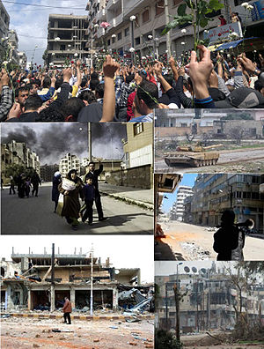

last twelve months. Many were detained arbitrarily and tortured or otherwise ill-treated. The international community has failed to effectively address this human rights crisis.

Despite the Syrian government’s acceptance on 27 March 2012 of the ‘six-point plan’ by Kofi Annan (Joint Special Envoy for the United Nations and the Arab League on Syria) and agreed ceasefire in the morning of 12 April, violence continues. Amnesty have received reports of the use of heavy weaponry by the Syrian authorities. As well as arrests and continuing detention of individuals in conditions amounting to enforced disappearance, we have received the names of over 553 individuals killed since 27 March 2012.
We continue to receive what appear to be credible reports of abuses committed by armed opposition groups since the start of the ceasefire.

The international community and Russia in particular must use its influence over the Syrian authorities to ensure that the Syrian government’s obligations under the plan are fulfilled in good faith. Whilst Russia supported a UN Security Council Resolution on 14 April calling for the full implementation of the plan, it continues to supply the Syrian government with arms.
To monitor implementation of the plan, a larger UN observer mission with the expertise and resources to monitor all parts of the plan should be established and despatched as soon as is feasible. This mission should include independent international human rights monitors.

http://action.amnesty.org.uk/ea-action/action?ea.client.id=1194&ea.campaign.id=13500&utm_source=aiuk&utm_medium=Homepage&utm_campaign=MENA&utm_content=Syria_nib#action

China

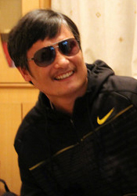

.
At the end of April legal activist Chen Guangcheng fled his home in Shandong province to escape 19 months of illegal house arrest. He is believed to have sought diplomatic protection at the US Embassy in Beijing but is now reportedly in a Beijing hospital where he has been reunited with his wife and children.

While we are extremely relieved to hear that Chen is no longer under house arrest, we continue to call on China to ensure the safety of Chen and his family - as well as others involved with his escape. We are deeply concerned by reports that individuals who have assisted with his escape have been detained in recent days.

http://action.amnesty.org.uk/ea-action/action?ea.client.id=1194&ea.campaign.id=8256&utm_source=Email&utm_medium=mass_email&utm_campaign=IAR&utm_content=Chen_link1

Nigeria

Emmanuel Kuru used to have his own fishing business in Bodo Creek in the Niger Delta, Nigeria. His wife, Cecilia Teela, collected shellfish – the money she made paid for the children to go to school and a new roof for their house.
But in 2008, a pipeline owned by Shell failed. Oil poured into the creek, destroying Emmanuel’s boat and nets, and killing most of the shellfish. The community had driven away poverty, Emmanuel says, but now they are unable to fish it has returned. The oil spills have still not been cleaned up. Shell's activities in the Niger Delta are robbing people of their livelihoods, making them sick and ruining their lives.


Since the company now known as Royal Dutch Shell first discovered oil in the Niger Delta in 1956, the region’s oil reserves have generated billions of dollars for Shell and other multinationals.
But for people living in the region, the oil deposits have been a curse. Thanks to the oil industry, many rivers, mangrove swamps and farming lands are poisoned and the air people breathe is polluted.
It’s time for Shell to own up to what they’ve done to the Niger Delta. We want them to put up an initial $1 billion (£630 million) to kick start the clean-up. That may seem a lot of money, until you consider the company recently posted an annual profit of $28.6 billion (£18 billion) – or more than $3.2 million (£2 million) profit per hour.
http://action.amnesty.org.uk/ea-action/action?ea.client.id=1194&ea.campaign.id=14557&utm_source=Email&utm_medium=mass_email&utm_campaign=CA&utm_content=shell_link2

Bahrain

Unless the Bahrain authorities act quickly, prisoner of conscience Abdulhadi al-Khawaja is likely to die in their custody. Al-Khawaja is one of 14 opposition activists arrested and imprisoned after trial by military court following their involvement in anti-government protests last year. We consider all 14 to be prisoners of conscience.
On 30 April Bahrain's Court of Cassation granted Al-Khawaja and the 13 other prisoners of conscience the right to a retrial before a civil court, but their sentences have not been quashed and they will remain in custody while their case is reviewed.
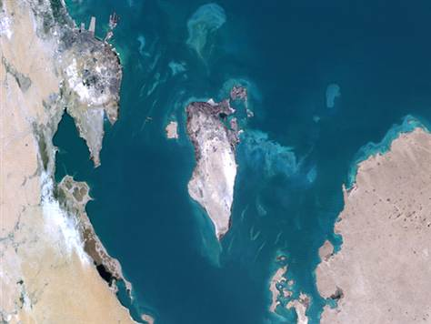
None of these men should have been charged in the first place and we continue to call for their immediate and unconditional release. Al-Khawaja has been on hunger strike since 8 February 2012 to highlight the injustice of these politically-motivated imprisonments. He has told his family that from 23 – 29 April he was force fed by the authorities. He has been denied access to his lawyer for weeks.

http://action.amnesty.org.uk/ea-action/action?ea.client.id=1194&ea.campaign.id=13860&utm_source=Email&utm_medium=monthly_email&utm_campaign=MENA&utm_content=bahrain

Chair – Bob Fieldsend, Vice-Chair – Anita Clayton, Treasurer – Owen Davies, Press & Publicity – Jeannette Watson & Newsletter/Secretary – Julia Worms

