Next Meeting
Summer Social
Wednesday 25th July, 7.30 – 9.30 p.m.
Owen’s House – 4 Cedar Crescent, Thame

Come and join us for our summer social event and catch up with everyone – we will be in the garden weather permitting...

Everyone welcome – but please bring along a contribution to the finger food and something to drink
Contact Owen for further details -
davies2399@yahoo.co.uk or 01844 214466

May Meeting
Various actions were undertaken. The first on behalf of Ragihar Manohran, who died six years ago in Sri Lanka, - his parents who have been campaigning to get his death investigated – Amnesty are creating a six year petition to present to the embassy in London.
Letters were sent to the Prime Minister, Director of Police and Mayor of Carrefour in protest against the forced eviction of families in the Carrefour region of Haiti with a request for due legal process, the provision of alternative accommodation and to stop harassment.
A petition is also being collated in protest against the death penalty in Pakistan – although there have been no executions for some time, that of Behram Khan is scheduled for 30th June 2012 – to take action email the president via publicmail@president.gov.pk.
We then participated in our own Amnesty Big Debate by watching and discussing a speech by Nick Dearden (Director of the Jubilee Debt Campaign) on poverty as a human rights issue. Lively discussions ensued and it proved to be an interesting evening. For further details of the Jubilee Debt Campaign access www.jubileedebtcampaign.org.uk.
A copy of the Amnesty Big Debate DVD is available to borrow from Julia on juliaworms@hotmail.com – it includes talks on poverty, human rights, climate change and religious fundamentalism and provides an opportunity to join the nationwide discussions.


Our Thanks were also extended to Sandy for all her efforts at the Thame Flower Festival – we had a very unusual and eye-catching display, which was commented on by many – as you can see below.
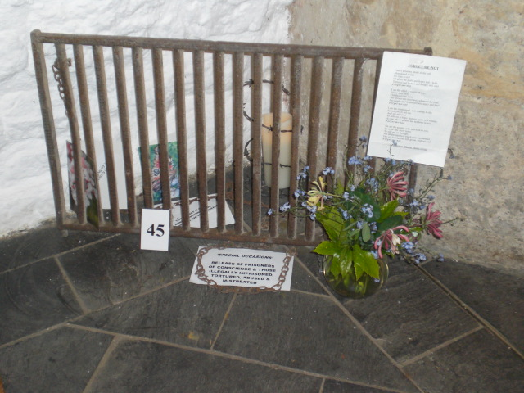
June Meeting
Actions were undertaken on behalf of Ali Hassan an 11 year boy who has been arrested and charged in Bahrain for ‘illegal gathering’, for an investigation into the deaths of Bertin Vazquez Ruiz & Guadalupe Andes Vazquez Ruiz, members of CPUVO in Mexico which protests against mining operations and on behalf of Masood Janjua and Faisal Faraz (our regular special campaign in Pakistan). For further details contact Bob on christinefieldsend@hotmail.com
The rota for our local Thame Amnesty street collection on July 14th was distributed. We do however still need some collectors so please contact Owen as soon as possible if you can help davies2399@yahoo.co.uk or 01844 214466
John Davies also gave us a brief overview of his work for Iran Aid and the Third Option – campaigning on behalf of Iranians refugees held in camps in Iraq. A large rally was held in Paris recently to highlight the plight of these individuals. We are hopeful that John will be able to attend our summer social where he will have more time provide more information and details about these campaigns.

Arms Trade Treaty
The majority of this month’s meeting consisted of a training session on ‘Control Arms’ by Michael Esvelt the Amnesty trainer from Oxford City. The campaign is designed to influence the debate in relation to the new arms trade treaty which is currently under discussion -with final meetings due in July 2012. Currently this trade is unregulated globally and Amnesty are campaigning for a robust treaty that includes all conventional weapons and equipment, all transfers and transactions, protects human rights, protects victims and which contains strong enforcement mechanisms, with the hope that the treaty will now be enacted and signed up to by all nations.
More than one person dies every minute from armed violence
Two bullets are produced each year for every person on the planet – some 14 billion
Two out of three people killed by armed violence die in countries at peace.
Our displays and street collection petitions will focus on this campaign on July 14th. If you have any contributions to make to the display materials please contact Julia at juliaworms@hotmail.com.
We would like to thank Michael for taking the time to visit our group and for a really interesting session.
Also our continuing thanks to Sue for work on our local Thame Amnesty web-site. Have a look at our new resources and let us have your feedback:-

New webpage: http://www2.amnesty.org.uk/groups/thame

Yahoo group:
http://groups.yahoo.com/group/thame-amnesty/

Facebook page:
http://www.facebook.com/ThameAmnesty
You can contact Sue directly on suer1953@yahoo.co.uk

Future Events

Amnesty Street Collection
July 14th

Volunteers Still Required – Please Contact Owen if you can spare an hour - davies2399@yahoo.co.uk
or 01844 214466

Apologies for our missing newsletter last month – there will not be a meeting in August but we will send actions and news via the newsletter

Chair – Bob Fieldsend, Vice-Chair – Anita Clayton, Treasurer – Owen Davies, Press & Publicity – Jeannette Watson & Newsletter/Secretary – Julia Worms

