Next Meeting
Wednesday 24th April
7.30 – 9.00
Sports Centre
Lord Williams Lower School

Talk ‘Focus on Northern Nigeria’ with John and Abi Hunt discussing the diversity of Christian-Muslim relations, increasing marginalisation and discrimination, freedom and lack of freedom to believe, and the influence of extremist groups.
We will also be undertaking future actions in relation to Amnesty’s priorities.

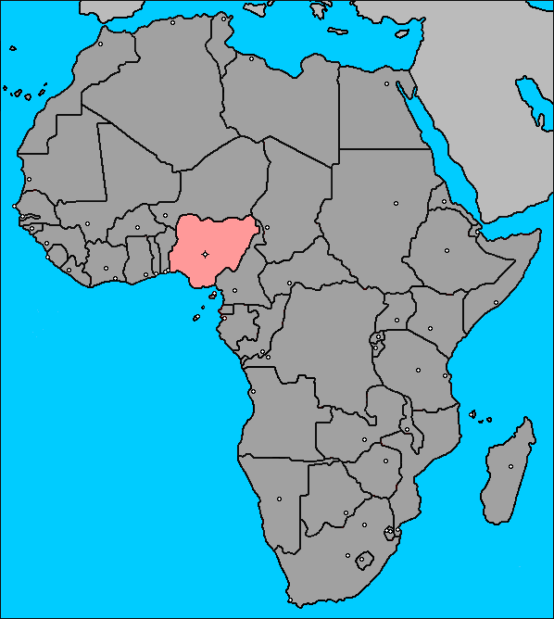

Contact Bob for further details -
christinefieldsend@hotmail.com

March Meeting
At the March meeting we discussed the outcomes of some recent actions. In response to actions in relation to Israel we had a letter from the Israeli Embassy and the two detainees concerned who had been on hunger strike are now due for release in May. Local members also had responses from our local MP in relation to the Arms Trade Treaty and a decision is imminent as the treaty is due for consideration for signature at the end of March. (Subsequently 154 countries have voted to be a party to this treaty). There has also been a statement in relation to Women’s Rights in Afghanistan, which Bob has emailed, but if you would like further information please let him know.
We also considered the recent newsletter received from the AIUK board. There have been various organisational changes within AIUK especially in relation to the London international secretariat, including the creation of office hubs abroad e.g. Africa & Hong Kong. These updates will now be issued monthly, if you would like to be notified of the content please contact Bob at christinefieldsend@hotmail.com
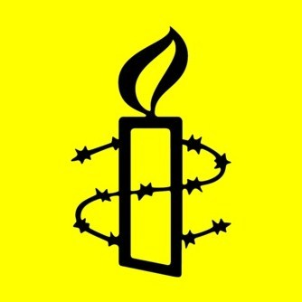
We also discussed the nature of the Urgent Action Network as there has been an update on its effectiveness over the past 40 years. This network is capable of responding very quickly and there are currently 13,950 people in the UK’s urgent action group and 165,000 members globally. In 2012 there were 671 urgent actions with the most common issues being freedom of expression, prisoners of conscience, fear of safety, risk of torture and ill treatment and the death penalty. In 2012, 105 urgent actions related to issues in Syria.

Monthly actions were undertaken in relation to Hakamada Iwao in Japan with letters sent to the Minister of Justice. A petition was signed in support of Women’s Rights in Afghanistan in support of their purple fingerprint campaign and a letter sent to our local MP. If you would like further details of this campaign or would like to sign the petition please contact Julia on juliaworms@hotmail.com
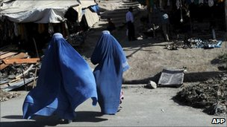
Future Events



AIUK National AGM

University of Warwick, Coventry

13 - 14 April 2013
Join Amnesty in Coventry for two days of international speakers, thought-provoking panel discussions, and workshops where you can share skills, knowledge and experiences. The keynote speaker is Fawzia Koofi. Details from:-
http://www.amnesty.org.uk/content.asp?CategoryID=10159#programme

Thame Amnesty AGM
Lord Williams Lower School
Wednesday May 22nd
Hugh Sandeman -
Amnesty Country Coordinator for Algeria / Libya will be speaking on Human Rights in North Africa.
Join us also for elections, review of our progress and planning our way forward.

Annual Street Collection
Saturday 29th June
This is an important event for us both in terms of fund raising, but also in relation to campaigns and petitions. If you can spare an hour or two to rattle a tin or help with the campaign table – please let Owen know as soon as possible on 01844 214466 or davies2399@yahoo.co.uk

Membership

Please note that its annual subscriptions time - £5 is payable either directly to Owen (4 Cedar Crescent, Thame OX9 2AU) or at the next meeting. Contact davies2399@yahoo.co.uk for further information.

Chair – Bob Fieldsend, Vice-Chair – Anita Clayton, Treasurer – Owen Davies, Press & Publicity – Jeannette Watson & Newsletter/Secretary – Julia Worms

