Amnesty International
Reading Group Newsletter
February 2015

PROTECT THE HUMAN

We are ordinary people from across the world standing up for humanity and human rights. Our purpose is to protect individuals wherever justice, fairness, freedom and truth are denied.

PREVIOUS EVENTS and MEETINGS
- December, January and February monthly meetings
In December, the group took part in Amnesty’s annual Write for Rights campaign, sending cards around the world.
In January, we raised £296 at our street collection in Caversham – thanks to all those who rattled a tin for Amnesty!
In January we had a guest speaker, Lindsey Sharpe. Lindsey worked for EAPPI - the Ecumenical Accompaniment Programme of the World Council of Churches from April until July 2014. She was based in East Jerusalem, working with an international team as a human rights observer in the Old City of Jerusalem, notably the Al Aqsa Compound, in villages around Jerusalem and at the Qalandiya checkpoint. Lindsey gave us a fascinating talk about her work – many thanks for spending the time with us. https://www.eappi.org/en
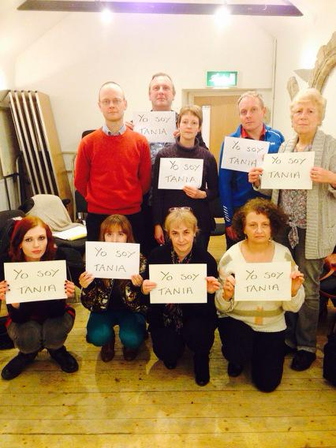
In February, we had our annual planning meeting (see group plan for 2015 attached), where we decided to take on two new regions of the world. Watch this space for more info over the next few months.
We also took action for Cuban artist Tania Bruguera, who has been prevented from staging a performance on freedom of speech in Havana.

FORTHCOMING EVENTS
- BARN DANCE – Saturday 7th March

Sat 7 March 2015, 7pm – 10pm: Barn Dance at the Warehouse, Cumberland Road, Reading RG1 3LB– live music provided by The Scamping Rogues.
Tickets £12 per adult, £5 per child (primary school age or under).
Fish and chips supper included, veggie option available.
Bring your own drinks.
This is our third Barn Dance and they’ve all be great fun!
For tickets please contact amnesty.reading@gmail.com

- National Conference and AGM – 18th-19th April
Members of Amnesty are invited to attend the annual conference and AGM which takes place at Warwick University this year 18th/19th April. The event will be packed with thought-provoking discussion and debate, as well as an exhibition, action centre and international guests. It's a great place to meet others who share your commitment to justice and human rights.
There are a variety of packages to book which makes it quite affordable. Places must be booked by Monday 2nd March.
http://www.amnesty.org.uk/events/amnestys-national-conference-and-annual-general-meeting-2015?page=1

- WOMAD 24TH- 26TH July, Charlton Park, Wiltshire
Each year, our group has a big presence at WOMAD, an interactive stall promoting one of Amnesty’s main campaigns. Put the date in your diary and contact Sue Bingham if you’re able to help out on the rota this year. Future meetings and newsletters will keep us updated with the plans.
s.bingham748@btinternet.com

NEXT MEETINGS
- March 12th – Benny Wenda joins the group to give us an update of West Papau and news about our Prisoner of Conscience, Filep Karma
- April 9th – discussion on motions to be debated at the AGM. This meeting informs those attending on behalf of the group, so we can use the group’s 10 votes wisely.
NEWS and ACTIONS – please scroll down to find the actions
Cuba update Feb 2015
Following the historic US-Cuban talks to normalize relations, Amnesty International has published a new blog, Cuba-USA: a new hope for human rights, in the Huffington Post series blog 90 Miles: Rethinking of U.S.-Cuba Relations. It is an excellent summary and analysis of the situation and I urge you to read and share it as widely as possible.
http://www.huffingtonpost.com/robin-guittard/cubausa-a-new-hope-for-hu_b_6581312.html
Amnesty is reiterating its call for a new human rights focused agenda between the two countries, including the lifting of the US embargo, civil and political reforms in Cuba to allow the peaceful exercise of freedom of expression, association and assembly, the abolition of the death penalty, the ratification of key international human rights treaties, and the visit to Cuba of independent human rights bodies experts such as Amnesty International.
For our February action (scroll down), please find below an amended version of the last Urgent Action, reflecting the new situation. This is a very exciting time, with news and opinions coming from all sides. It's also a crucial time for us to bring human rights into the spotlight and keep them there while all the historic negotiations are taking place.

EGYPT
Below is an Urgent Action to try to get charges dropped against two of the three Al Jazeera journalists who still face charges for just doing their jobs and reporting about protests against Egypt’s new military rulers.
Here is the story:
· December 2013: three Al Jazeera journalists are arrested for covering protests by Muslim Brotherhood supporters against the military government that deposed President Morsi in mid-2013 – and charged with broadcasting false news, working without permits, and aiding or belonging to the Muslim Brotherhood
· In June 2014, after a trial in which the prosecution failed to produce any evidence to substantiate the charges, the three were sentenced to up to 7 years in jail
· Following an appeal, one of the three – Australian Peter Greste – was released and allowed to fly homeon 2 February
· The other two journalists – Mohamed Fahmy and Baher Mohamed – were released on bail on 12 February but charges are still pending against them
· Their case comes up for a further hearing on Monday 23 February
What we can do:
Please send one or more of the attached letters, as they are or with your changes, THIS WEEK.
The letters ask for charges to be dropped, and for their release to be immediate and unconditional (instead of their release just being as now on bail).
One of the letters (to the Egyptian president) is by fax – if you have a fax, the fax number is working today Sunday (if you don’t have a fax, don’t worry about this one!). One is by email to the Foreign Ministry in Egypt. And the third is for enclosing your signed letters and sending to the Egyptian Embassy in London – but you can email this too.
Hopefully this is the last push before Mohamed Fahmy and Baher Mohamed regain their freedom.
Many thanks for your help on this,

Republic of the Union of Myanmar (Burma)
Please take action for Htin Lin Oo, who is a writer and former information officer of the National League for Democracy. He faces up to 3 years in prison for ‘insulting religion’ and ‘wounding religious feelings’. In 2014, he gave a speech at a literary event in Chaung-U Township in Sagaing Region criticising the use of Buddhism to promote discrimination and prejudice.
Don’t forget to keep up to date with our group’s news, frequently updated with photos and updates:

- Website = http://www2.amnesty.org.uk/groups/reading
- Facebook page –search for Reading Amnesty International – Town Group = http://www.facebook.com/groups/187525074719402
- twitter = @amnestyreading
- Our Prisoner of Conscience, Filep Karma, has a website where you can keep up-to-date with latest developments - www.freefilepkarma.org
- And a facebook page - https://www.facebook.com/groups/253959534694499/

MEETINGS:
- Second Thursday of each month at 8pm
- All are welcome
- upstairs at RISC, 35-39 London Street, Reading, RG1 4PS

ALSO: We raise funds for Amnesty International, and can provide speakers about Amnesty and human rights issues for local organisations: contact our secretary Anne McFarlane, ammcf@o2.co.uk.
Amnesty Reading Newsletter editor Helen Ball- email: helenball03@yahoo.co.uk

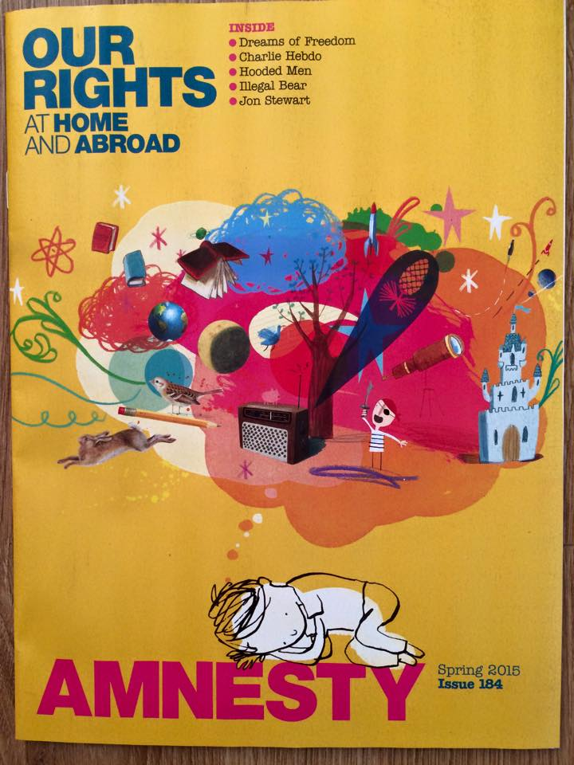

Amnesty International’s Spring magazine is sent to all members – great for updates on past/present/future campaigns and events at national and international level.

From:
To: Head of State and Government
Raúl Castro Ruz
Presidente de la República de Cuba
La Habana, Cuba
Fax: +41 22 758 9431 (Cuba office in
Geneva); +1 212 779 1697 (via Cuban
Mission to UN)
Email: cuba@un.int (c/o Cuban Mission
to UN) Date:

Your Excellency

Bianco Vargas Martín, Django Vargas Martín and Alexeis Vargas Martín

I am writing to say that I very much welcome the release of the 5 prisoners of conscience in Cuba, following the historic announcement on 17th December 2014 of steps to normalize relations between Cuba and the USA.

However I would urge the Cuban authorities to immediately and unconditionally lift the restriction on the freedom of the three brothers, Bianco Vargas Martín, Django Vargas Martín and Alexeis Vargas Martín.

Finally I wish to call on the Cuban government to complete those releases with the necessary civil and political reforms in order to lift all restrictions on the peaceful exercise of freedoms of expression, association and assembly, the abolition of the death penalty, the ratification of key international human rights treaties, and the visit to Cuba of independent human rights bodies experts such as Amnesty International."

Thank you for your attention to this urgent matter.

Yours truly,
copies to:
Interior Minister
General Abelardo Colomé Ibarra
Ministro del Interior y Prisiones
Ministerio del Interior
Plaza de la Revolución
La Habana, Cuba
Fax: +1 212 779 1697 (via Cuban
Mission to UN)
Email: correominint@mn.mn.co.cu

Her Excellency Mrs Esther Gloria Armenteros Cárdenas
Embassy of the Republic of Cuba
167 High Holborn,
London WC1 6PA
Fax: 020 7836 2602 email: secembajador@uk.embacuba.cu

From:
To:
Attorney General
Dr. Darío Delgado Cura
Fiscal General de la República
Fiscalía General de la República
Amistad 552, e/Monte y Estrella
Centro Habana
La Habana, Cuba Date:

Dear Attorney General,

Bianco Vargas Martín, Django Vargas Martín and Alexeis Vargas Martín

I am writing to say that I very much welcome the release of the 5 prisoners of conscience in Cuba, following the historic announcement on 17th December 2014 of steps to normalize relations between Cuba and the USA.

However I would urge the Cuban authorities to immediately and unconditionally lift the restriction on the freedom of the three brothers, Bianco Vargas Martín, Django Vargas Martín and Alexeis Vargas Martín.

Finally I wish to call on the Cuban government to complete those releases with the necessary civil and political reforms in order to lift all restrictions on the peaceful exercise of freedoms of expression, association and assembly, the abolition of the death penalty, the ratification of key international human rights treaties, and the visit to Cuba of independent human rights bodies experts such as Amnesty International."

Thank you for your attention to this urgent matter.

Yours truly,
copies to:
Interior Minister
General Abelardo Colomé Ibarra
Ministro del Interior y Prisiones
Ministerio del Interior
Plaza de la Revolución
La Habana, Cuba
Fax: +1 212 779 1697 (via Cuban
Mission to UN)
Email: correominint@mn.mn.co.cu

Her Excellency Mrs Esther Gloria Armenteros Cárdenas
Embassy of the Republic of Cuba
167 High Holborn,
London WC1 6PA
Fax: 020 7836 2602 email: secembajador@uk.embacuba.cu

President of the Arab Republic of Egypt
Abdel Fattah al-Sisi
Office of the President
Al Ittihadia Palace
Cairo, Arab Republic of Egypt
Fax: 00202 2 391 1441

February 2015

Your Excellency

Appeal for the release of Al Jazeera journalists Mohamed Fahmy and Baher Mohamed

I am writing to urge the Egyptian authorities to drop the charges against Mohamed Fahmy and Baher Mohamed, and to ensure their immediate and unconditional release. Mohamed Fahmy and Baher Mohamed face charges based solely on their rights to the freedom of expression and free association, and their duties as journalists to report events that they witness.

Thank you for your attention to this urgent matter.

Yours sincerely,

Deputy Assistant Minister of Foreign Affairs for Human Rights
Mahy Hassan Abdel Latif
Multilateral Affairs and International Security Affairs
Ministry of Foreign Affairs
Corniche al-Nil
Cairo
Arab Republic of Egypt
Email: Contact.Us@mfa.gov.eg

February 2015

Dear Minister

Appeal for the release of Al Jazeera journalists Mohamed Fahmy and Baher Mohamed

I am writing to urge the Egyptian authorities to drop the charges against Mohamed Fahmy and Baher Mohamed, and to ensure their immediate and unconditional release. Mohamed Fahmy and Baher Mohamed face charges based solely on their rights to the freedom of expression and free association, and their duties as journalists to report events that they witness.

Thank you for your attention to this urgent matter.

Yours sincerely,

His Excellency Mr Nasser Kamel
Embassy of the Arab Republic of Egypt
26 South Street
London W1K 1DW,

Email: egamboff.london@mfa.gov.eg
egyemblondon@mfa.gov.eg

February 2015

Your Excellency

Appeal for the release of Al Jazeera media workers Mohamed Fahmy and Baher Mohamed

Following the decision of the Court of Cassation on 1 January, I am enclosing a copy of letters I have sent to your government, appealing for the immediate dropping of charges against Mohamed Fahmy and Baher Mohamed. These charges based on the peaceful exercise of their rights to freedom of expression and association, and on their work as journalists to report events as they witness them.

Thank you for your attention to this matter.

Yours sincerely,

U Thein Sein
President
President’s Office
Nay Pyi Taw
Republic of the Union of Myanmar

February 2015

Your Excellency
Htin Lin Oo
Htin Lin Oo is a writer and former information officer of the National League for Democracy. On 23 October 2014 he gave a speech at a literary event in Chaung-U Township in Sagaing Region criticising the use of Buddhism to promote discrimination and prejudice. A short version of the speech appeared on social media.
Following a complaint being raised against him by officials, Chaung-U Township Court has charged him with ‘insulting religion’ under Section 295(a) of the Penal Code, and ‘wounding religious feelings’ under Section 298. If convicted he faces imprisonment of up to two years and up to one year respectively under the two charges.
He is currently detained in Monywa prison in Sagaing Region.
Can I urge you to please:
- Immediately and unconditionally release Htin Lin Oo and drop the charges against him, as he is a prisoner of conscience;
- Pending his release, ensure he is not tortured or ill-treated in detention; not transferred to a remote prison; has regular access to family members and lawyers of his choosing; and is provided with any medical treatment he might require;
- Repeal or else review and amend all laws which restrict the right to freedom of expression to bring them into line with international human rights law and standards;
- Take concrete action to address the growing use of advocacy to incite discrimination, hostility and violence against non-Buddhists.

Yours sincerely

