**Campaigns: Individuals at Risk (Death Penalty) September 2016**

**I Welcome**

**Stand against Hate**



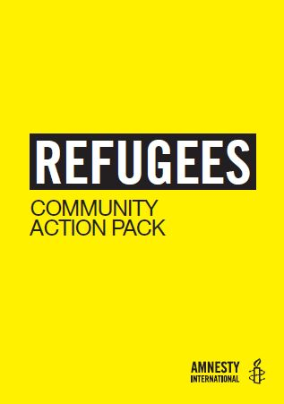



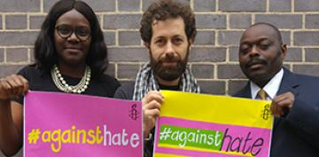

Contents Page

Campaign Action 1: Take action for Matsumoto Kenji 2

Campaign Action 2: New Refugees campaign (I Welcome) 5

Campaign Action 3: Stand against Hate 8

Return post form 9

Frame template (for Refugees action) 10

**Campaign Action 1: Solidarity with Matsumoto Kenji**

Matsumoto Kenji was sentenced to death in September 1993 for two separate robberies and murders. Matsumoto has an intellectual disability affecting his ability to learn, communicate and look after himself. During Matsumoto’s sentencing the court recognised that Matsumoto was dependent on his brother and that he could not stand up to him. His brother was also suspected of being involved in the crimes, however he died before he could be sentenced.

Matsumoto has been on death row for 23 years. In Japan, people on death row are kept in solitary confinement (in a cell by themselves). They are not allowed to speak to other inmates and only have occasional visits from family or lawyers. When they are in their cell they are forbidden from moving and must remain seated. Over the years Matsumoto’s mental health has become very bad. He is confused and is not able to communicate. Last year he stopped drawing, something he used to love doing. He is still being held in solitary confinement.

**Drawings by Matsumoto**

On this and the next page you can see some of Matsumoto’s drawings.

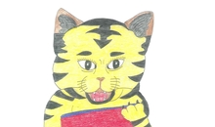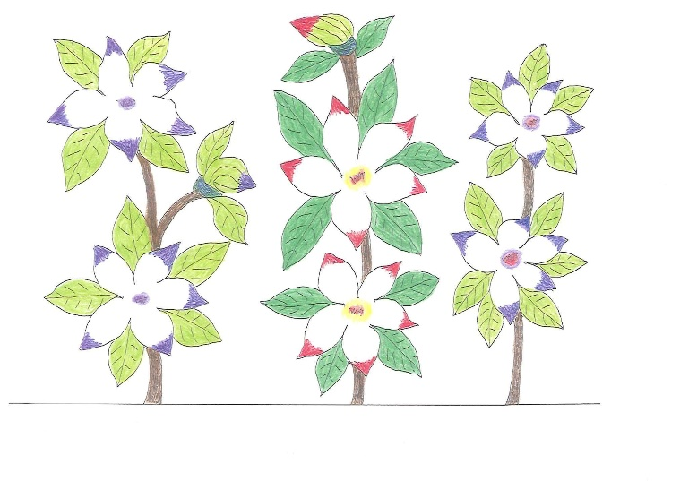

**Take Action: Creative solidarity action**

We would like to send cards to the prison where Matsumoto is being held. We can’t guarantee that he will be given the cards we send him, but we hope that by showing the prison guards that we care about him it will make them treat Matsumoto better.

Matsumoto used to like drawing pictures of animals and plants. Draw a picture of an animal or plant on the front of a card for Matsumoto. Inside your card write a message to let Matsumoto know you care about him and hope he is able to start drawing again.

**Please do not:**

* Send a religious card or message
* Mention Amnesty International
* Include your home address (school address is fine).

Send your letters and cards to us and we will forward them on (don’t forget to tell us which youth group you are from).

Anne Montague

Community Organiser (Youth)

Amnesty International

17-25 New Inn Yard

London EC2A 3EA

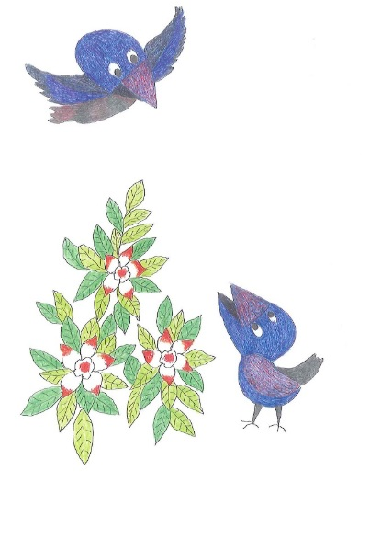

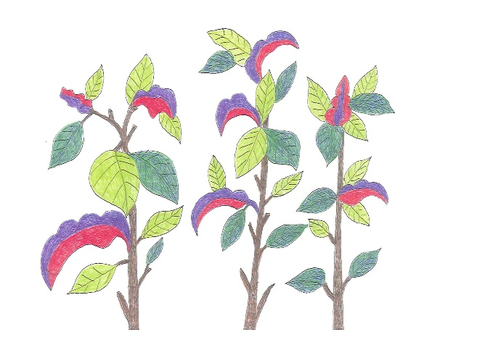

**Take Action: Write to the Japanese authorities**

Please also write letters to Mistsuhide Iwaki, the Minister of Justice in Japan.

* Tell the minister that you have learnt about Matsumoto Kenji’s case.
* Urge him to not execute Matsumoto or anyone else on death row in Japan.
* Ask him to improve the treatment of Matsumoto and ensure he has access to the health care he needs.

Send your letters to the same address as your cards (see above).

**Deadline:** Please send us your letters and cards before the end of the autumn term.





**Campaign Action 2: New Refugee Campaign – I WELCOME**

The new global refugee campaign, **‘I Welcome’**, will launch in October. The aim of the campaign is that refugees are protected, welcomed and enjoy their human rights, including through strengthened global responsibility-sharing and international cooperation.

In the UK the campaign will have a number of strands, both at a national and local level. We want to influence the government to open up more safe and legal routes, so that refugees can seek sanctuary in the UK, but we also want to try to create a more welcoming environment for refugees already in the UK. There will be a huge role to play for supporters to engage with your local communities and partner with others in this campaign.

**Why help refugees?**

People fleeing from war or persecution should be allowed to seek safety outside their own country. After World War 2 the United Nations recognised this principle as a basic human right. But it has been a part of British traditions for much longer. Protestants from France in the 1680s, Jews from the Russian Empire in the 1890s, Belgians fleeing the First World War – these and many others found refuge in Britain, rebuilt their lives and contributed to our society.

**A global crisis**

* 65 million people have been forcibly displaced
* 24.5 million have sought refuge in another country
* About half of the world’s refugees are under 18. (Source: UNHCR)

**Why do people flee their countries?**

The key causes include armed conflict in countries such as Syria, Iraq and Afghanistan; wholesale abuse of human rights, as in Eritrea; and persecution of minorities, such as the Rohingya in Burma. The largest refugee movements are from relatively few

countries. Three examples:

* **SYRIA**: 4.9 million refugees – homes bombarded and towns under siege in five years of war, perceived opponents of the government imprisoned and often tortured
* **AFGHANISTAN**: 2.7 million refugees – armed conflict intensifying: the first three months of 2015 were the most violent on record
* **SOMALIA:** 1.1 million refugees – armed conflict continues with all sides targeting civilians

**Who is responsible for helping refugees?**

The United Nations High Commissioner for Refugees (UNHCR), is responsible for coordinating the international community’s response. But it relies on governments to provide resources and resettlement places. Governments are also responsible for fair processing of

asylum applications.

**How has the international community responded to the current crisis?**

The response so far has been completely inadequate:

* The world’s poorer countries are doing much more than their fair share: 86 per cent of refugees are hosted by low income and middle-income nations.
* Some of the world’s wealthier countries, notably in Europe, have put up legal and physical obstacles to keep refugees out. By making it impossible to cross borders safely and legally, they encourage refugees to risk their lives making dangerous countries.
* More than one million refugees urgently need resettlement to keep them safe or to enable them to rebuild their lives. But governments are offering just over 100,000 resettlement places a year.
* Governments are failing to fund the UNHCR adequately, leaving it unable to provide for the people in its care.

**What has the UK done?**

Since 2011 the UK government has given a significant amount of overseas aid to help countries near Syria to host Syrian refugees. It also sent a warship to join the European search and rescue mission in the Central Mediterranean, helping to save thousands of lives. However, it has been slow and reluctant

to accept refugees for resettlement. The latest commitment is to resettle only 20,000 Syrian refugees and up to 3,000 children and their families. For what is supposed to be the world’s fifth largest economy, that is too little, too late.

**What needs to be done?**

Amnesty International UK is calling on the international community to agree to:

* Fair distribution of responsibility for hosting and helping refugees, including resettlement for those who need it
* Safe and legal routes for refugees to reach safety.
* Adequate funding for UN humanitarian appeals.

**Take action: Stand with refugees**

We would like youth groups to ask as many people as possible to openly express their support for refugees. You can do this in two ways:

**Option 1: Get people to sign our pledge poster**

We’ve enclosed our Refugees Community Action pack in this mailing (or if you are reading this online there are details of how to order one below). The pack contains a pledge poster for people to sign. Don’t forget to write the name of your youth group clearly at the top of the poster.

**Option 2: Take photos of people using our frame template**

At the end of this mailing you’ll find a template for how to make an ‘**I stand with refugees’** frame. We suggest that the ideal size for the hole in the middle of the frame is 32x28cm but you can make them as big or small as you like. Take photos of people inside the frame. Please make sure they know that their photo is being sent to us and may be used in our publications or website!

You can of course do both of these options.

Send your photos and/or pledge posters to:

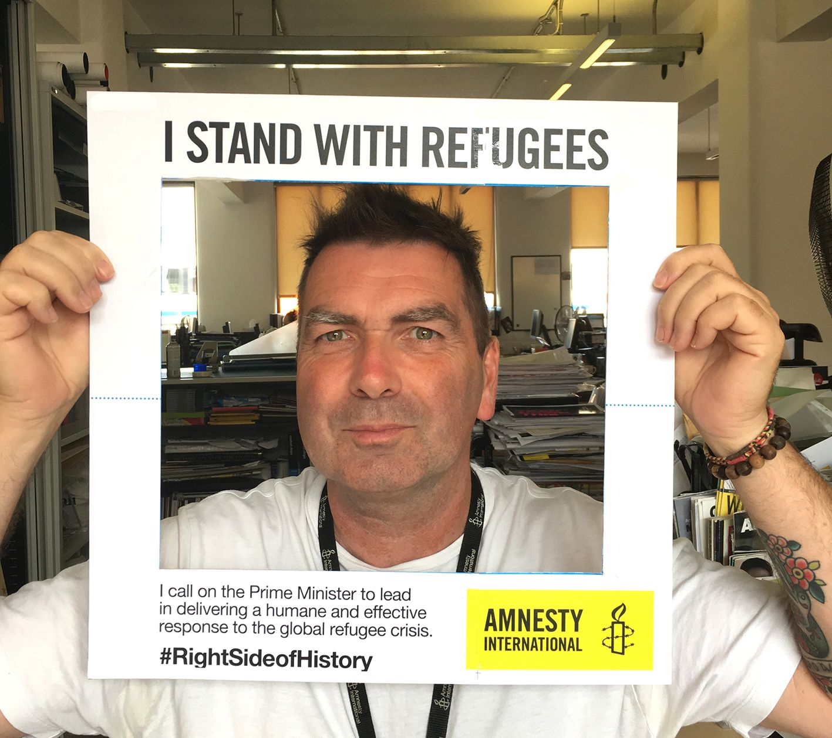

Anne Montague

Community Organiser (Youth)

Amnesty International

17-25 New Inn Yard

London EC2A 3EA

You can also email them to [anne.montague@amnesty.org.uk](mailto:anne.montague@amnesty.org.uk).

**Resources**

Refugee Community Action Pack REF16/001

Stickers REF16/002

Refugees Welcome Placards REF16/003

Refugee Pledge poster REF16/004

Resources can be ordered from our mailing house by contacting them on 01788 545 553 and quoting the relevant product codes.

**Campaign 3: Stand against hate**



We have recently been seeing a rise in hate crimes on our streets and in our communities. Reports of hate crimes soared by 400% after the UK voted to leave the European Union on 23 June and the Metropolitan Police have recorded an average of [three hate crimes an hour since the Brexit result](http://www.independent.co.uk/news/uk/politics/huge-rise-in-anti-immigrant-hate-crimes-caused-by-eu-referendum-police-chiefs-warn-a7130631.html). And these are just reported incidents - it is impossible to know just how many people have experienced a hate crime. This isn’t about leave or remain – no matter how people voted, we know this isn’t what the UK is about. We are a proudly multicultural, diverse and tolerant society and we are powerful when we all come together. In response we launched a campaign addressing the issue of hate crimes and are currently asking people to write to their local councils calling on them to condemn hate crimes. We are also undertaking research which will shape the next stage of this work.

**Take Action: Ask your council to stand up against hate crime**

Tell your council to stand up against hate crime and make it clear that such behaviour will not be tolerated in your community. There is an online action [**here**](http://webmail.amnesty.org.uk/_act/link.php?mId=J9188634863817084154428906473019&tId=218914421) (www.amnesty.org.uk/actions) as well as a [**petition**](https://www.amnesty.org.uk/resources/petition-calling-your-local-council-stand-against-hate#.V8l2cFsrJMy) you can print (www.amnesty.org.uk/resources/petition-calling-your-local-council-stand-against-hate). Get as much support as possible and hand it in to the leader of your council. We also have an [**A3 poster**](http://webmail.amnesty.org.uk/_act/link.php?mId=J9188634863817084154428906473019&tId=218914424) you can print (https://www.amnesty.org.uk/resources/against-hate-a3-posters-print-home. Please do not collect the data entered into this petition for any purpose other than to hand it to your local council. If you wish to ask people to join your group, please have a separate sign-up sheet.

**Resources**

Stand together against hate stickers AH001  
Stand together against hate placards AH002  
Stand together against hate badges (yellow/pink) AH003  
Stand together against hate badges (yellow/green) AH004  
  
Materials can be ordered from our mailing house by contacting them on 01788 545553 and quoting relevant product codes.

**Return form**

✂

**Please include this information with any items you send back to us:**

Name of person submitting these items: ......................................................................

Are you a:  Teacher

❑ Student

❑ Other …………………………………………………………………..

Name of youth group: ....................................................................................................

Postcode: ......................................................................................................................

Number of items included in this envelope: ..................................................................

