Amnesty International
Reading Group Newsletter
January 2013

PROTECT THE HUMAN

We are ordinary people from across the world standing up for humanity and human rights. Our purpose is to protect individuals wherever justice, fairness, freedom and truth are denied.

Recent events and news
- our group secretary ann in her Kilimanjaro climb - Our group secretary, Ann McFarlane, climbed Kilimanjaro for her honeymoon and raised money for Amnesty!!
You can still donate http://www.justgiving.com/Anne-McFarlane

- AI:UK’s Director Kate Allen came to Reading for the International Festival in October. Kate talked about the human rights situation in Middle East and North Africa, as well as taking general questions about Amnesty’s work.

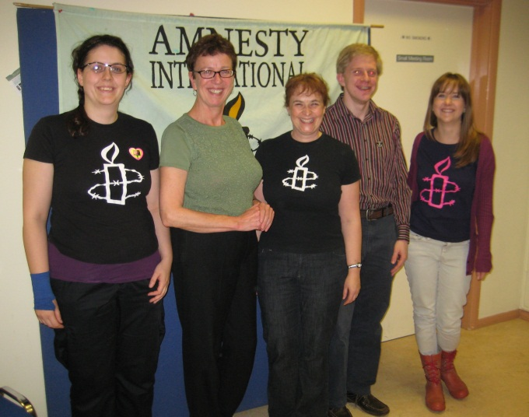

- Protest for our Prisoner of Conscience, Filep Karma– Sean O’Leary organised a protest on Wednesday 31st October in London during visit from President of Indonesia visits London. Check out the facebook page, Free Filep Karma Campaign, for photos and updates on the campaign.
- November’s group meeting’s speaker, Steve Hynd gave a fascinating talk about the time he spent in Palestine and Israel. Check out Steve’s blog on http://stevehynd.com/talks/ Steve is keen to visit groups to give his talk so do contact him if you’re interested.
- Music, Mulled Wine and Mince Pies – Our annual classical music concert at Chantry House, Henley. We raised over £500. Thanks to everyone who organised and helped with the event, particularly Peter.
- December’s group meeting gave everyone a chance to discuss Amnesty’s up-coming Extra-ordinary General Meeting. This important event will determine if significant changes will be made to AI:UK this year. http://www.amnesty.org.uk/content.asp?CategoryID=12402
- Our treasurer, Peter Howe, has just sent AI:UK a cheque for £1250. Great fundraising by the Reading group this Autumn!!

Forthcoming events
- Street Collection, Caversham, Saturday 5th January 2013 – contact Peter on amnesty.reading@googlemail.com if you can take a turn on the rota.
- Next group meeting – Thursday 10th January at 8pm at RISC
- AI:UK – Extra-ordinary General Meeting – 12th January, 12.00- 5.00 - Methodist Central Hall, Storey's Gate, Westminster, London SW1H 9NH. Members only, register online.
- Regional Conference - Saturday 26th January in Aylesbury. 10am-5pm in the Multi-cultural centre. Speaker for the day will include a Syrian Architect; Hugh Sandeman to talk re-North Africa; Oliver Sprague to update folk on the Arms Trade Campaign; Kate Allen and Sarah O'Grady to speak on where AIUK is going after the EGM and 'Delivering the Role'.
- Barn Dance - Saturday 2nd March. Following our brilliant Barn Dance last year, we are delighted that the Scamping Rogues will be leading us in dance again next year. More details about tickets to follow.

ACtions
Please click the link or scroll to the end of this document or follow the links for actions you can take to support issues that the Reading Group follows closely.
- AI:UK’s annual Write for Rights Campaign - You still have time to send a card or a message to support those suffering human rights abuses. http://www.amnesty.org.uk/content.asp?CategoryID=10673
- Cuba - Elizardo Sánchez & Guillermo Fariñas – scroll down please!! Please send these letters until 11th January, thanks
Don’t forget to keep up to date with our group’s news, frequently updated with photos and updates:
- Website = http://www2.amnesty.org.uk/groups/reading
- NEW facebook page –search for Reading Amnesty International – Town Group = http://www.facebook.com/groups/187525074719402
- twitter = @amnestyreading
MEETINGS: second Thursday of each month at 8pm. All are welcome. All at RISC, 35-39 London Street, Reading, RG1 4PS
ALSO: We raise funds for Amnesty International, and can provide speakers about Amnesty and human rights issues for local organisations: contact our secretary Anne McFarlane, ammcf@o2.co.uk.
Amnesty Reading Newsletter editor Helen Ball- email: helenball03@yahoo.co.uk
TO: FROM:
Raúl Castro Ruz
Head of State and Government
Presidente de la República de Cuba
La Habana
Cuba
Fax: +41 22 758 9431 (Cuba office in Geneva);
+1 212 779 1697 (via Cuban Mission to UN)
Email: cuba@un.int (c/o Cuban Mission to UN)
Date:

Your Excellency,

Elizardo Sánchez & Guillermo Fariñas

I am very concerned to hear, firstly, that state security officials threatened Elizardo Sánchez, president of the Cuban Commission of Human Rights and National Reconciliation (Comisión Cubana de Derechos Humanos y Reconciliación Nacional – CCDHRN), in front of his home on the afternoon of 27 November 2012.

Secondly, that independent journalist, Guillermo Fariñas, was stopped on the street later that day in the Havana neighbourhood of Vedado by two men in civilian clothes, one of whom hit him on the right forearm with a piece of wood.

I am therefore calling on the Cuban authorities to investigate immediately these threats against Elizardo Sánchez and the assault on Guillermo Fariñas, and to cease immediately the harassment of the two men and all other citizens who peacefully exercise their rights to freedom of expression and association.

Thank you for your attention, and I look forward to hearing from you on these urgent matters.

Yours truly,

Copies to:
General Abelardo Colomé Ibarra
Interior Minister
Ministro del Interior y Prisiones
Ministerio del Interior,
Plaza de la Revolución,
La Habana, Cuba
Fax: +1 212 779 1697 (via Cuban Mission to UN)
Email: correominint@mn.mn.co.cu

Her Excellency Esther Armenteros Cárdenas
Cuban Ambassador
Embassy of the Republic of Cuba
167 High Holborn,
London WC1 6PA
Fax: 020 7836 2602 embacuba@cubaldn.com
FROM:

TO:

Dr. Darío Delgado Cura
Attorney General
Fiscal General de la República
Fiscalía General de la República,
Amistad 552, e/Monte y Estrella, Centro Habana
La Habana,
Cuba
Date:

Dear Attorney General,

Elizardo Sánchez & Guillermo Fariñas

I am very concerned to hear, firstly, that state security officials threatened Elizardo Sánchez, president of the Cuban Commission of Human Rights and National Reconciliation (Comisión Cubana de Derechos Humanos y Reconciliación Nacional – CCDHRN), in front of his home on the afternoon of 27 November 2012.

Secondly, that independent journalist, Guillermo Fariñas, was stopped on the street later that day in the Havana neighbourhood of Vedado by two men in civilian clothes, one of whom hit him on the right forearm with a piece of wood.

I am therefore calling on the Cuban authorities to investigate immediately these threats against Elizardo Sánchez and the assault on Guillermo Fariñas, and to cease immediately the harassment of the two men and all other citizens who peacefully exercise their rights to freedom of expression and association.

Thank you for your attention, and I look forward to hearing from you on these urgent matters.

Yours truly,

Copies to:
General Abelardo Colomé Ibarra
Interior Minister
Ministro del Interior y Prisiones
Ministerio del Interior,
Plaza de la Revolución,
La Habana, Cuba
Fax: +1 212 779 1697 (via Cuban Mission to UN)
Email: correominint@mn.mn.co.cu

Her Excellency Esther Armenteros Cárdenas
Cuban Ambassador
Embassy of the Republic of Cuba
167 High Holborn,
London WC1 6PA
Fax: 020 7836 2602 embacuba@cubaldn.com

