Amnesty International
Reading Group Newsletter
May 2015

PROTECT THE HUMAN
We are ordinary people from across the world standing up for humanity and human rights. Our purpose is to protect individuals wherever justice, fairness, freedom and truth are denied.

BREAKING NEWS!!!!!!!!!
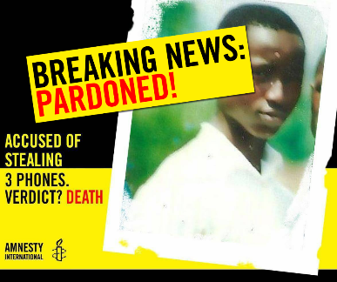
As I sit here, finalising this newsletter, the most joyous news has just been whizzing over Twitter and Facebook. Moses Akatugba, from Nigeria, has just been pardoned. Amnesty had a massive online petition campaign to save his life over the past week. 35,000 people signed the petition and today, he is saved.
Online actions really do work! Please do whatever you can – every letter, text, email counts!!!!!!

http://www.amnesty.org.uk/nigeria-moses-akatugba?utm_source=TWITTER&utm_medium=Social&utm_content=20150528184700&utm_campaign=Torture#.VWdkKc_BzGd

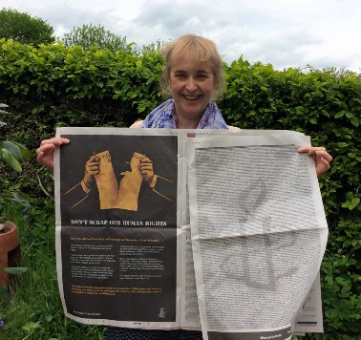

Human Rights Act
The Crowd-funded ad in this week’s The Times and The Telegraph was very eye-catching. Thanks to Reading group members for supporting this initiative. Keep up the pressure on the Government to save the Human Rights Act. Please follow this link and keep an eye on our facebook page and twitter to see what the current actions are.
http://savetheact.uk/#signup-form

PREVIOUS EVENTS and MEETINGS
- March – Benny Wenda joined the group to give us an update of West Papau and news about our Prisoner of Conscience, Filep Karma. Benny has been travelling internationally to draw attention to the plight of West Papuans who regularly have their human rights abused.
- April – A discussion on motions taken to the AGM. This meeting informed those attending on behalf of the group, so we could use the group’s 10 votes wisely.
- May – As the group has 2 new campaign’s, Syria and South Asia, the new co-ordinators, Hilary and Charlotte for South Asia and Elahe and Dina for Syria, gave the group a broad outline of the key issues for each country. Please read the minutes of the May meeting for full details. Minutes are available on our website http://www.amnesty.org.uk/groups/reading
BARN DANCE – March 7th 2015

We had great fun at our 3rd Barn Dance in March.
Liz, Peter and Hilary did a fantastic job of making this another brilliant evening for everyone.

The Scamping Rogues gave their time freely to support our barn dance for the 3rd time! Many thanks to them!!!!

- National Conference and AGM – April 18th-19th April
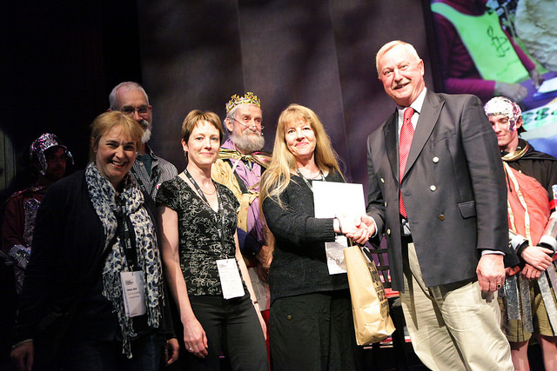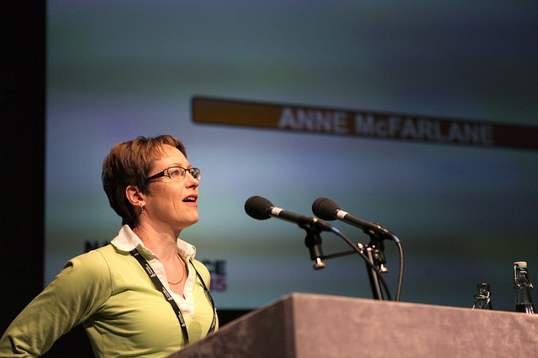
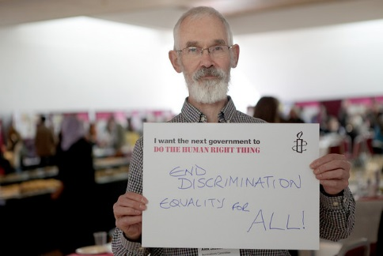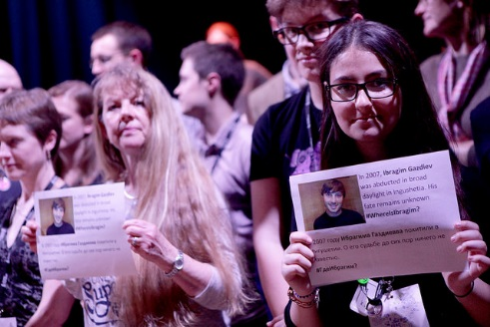

4 members of the Reading group attended this year’s inspiring National Conference and AGM.
Photos show
- Top left – the group receiving an award from the Marsh Foundation - £750 to support our work!!
- Top right – our secretary, Anne McFarlane, giving a speech to support her nomination to be elected to the Standing Orders Committee – she was elected.
- Bottom left – Alex Siddall voicing his thoughts for human rights
- Bottom middle – media officer, Helen Ball, getting advice for organising the group’s social media
- Bottom right – Sue Bingham supporting a group action

FORTHCOMING EVENTS
- East Reading Festival – Sunday 14th June in the afternoon. Please let Peter know if you are able to help on the stall. Amnesty.reading@googlemail.com
- WOMAD 24TH- 26TH July, Charlton Park, Wiltshire
Each year, our group has a big presence at WOMAD, an interactive stall promoting one of Amnesty’s main campaigns. Put the date in your diary and contact Sue Bingham if you’re able to help out on the rota this year. Future meetings and newsletters will keep us updated with the plans. s.bingham748@btinternet.com
- Reading Pride – Saturday 5th September – King’s Meadow in the afternoon. Please let Helen know if you’re able to help on the stall helenball03@yahoo.co.uk

NEXT MEETINGS
- June 11th – our AGM and letter writing
- July 9th – talk about the poor educational provision for Roma children

NEWS and ACTIONS – please scroll down to find the letters to send.
Cuba update May 2015: coming in from the cold but still a long way to go
- The normalisation of relations between the US and Cuba continues with talks on setting up embassies. Licences for ferries to run from Florida soon have been granted, but this has not stopped an increasing number of Cubans from attempting to cross the 90 miles in make-shift boats, often risking death.
- The French President, François Hollande, recently made a historic visit to Cuba - the first time a western leader has been officially invited since the revolution in 1959. In June the EU will begin talks with Cuba on human rights and a possible new agreement by 2016, to replace the "common position" in place since 1996.
- World Press Freedom Day is observed annually on May 3 to inform the international community that freedom of the press and freedom of expression are fundamental human rights. May is therefore a good time to flag up The Reporters Without Borders World Press Freedom Index which ranks the performance of 180 countries according to a range of criteria that include media pluralism and independence, respect for the safety and freedom of journalists, and the legislative, institutional and infrastructural environment in which the media operate.
Cuba is ranked at 160 out of 180 countries, in the "Very serious situation" category, although one place higher than 2014. The UK stands at 34 & the US at 49.
Details here: http://index.rsf.org/#!/index-details
- Cuba does not fare much better in the Freedom House 2015 report on World Freedom, with a status of "Not Free", and ratings of 6.5 for overall Freedom, 6 for Civil Liberties and 7 for Political Rights, where 1 is the best and 7 is the worst.
Details here:
https://freedomhouse.org/report/freedom-world/2015/cuba#.VUT9-9HwvIU
Sue Bingham
Amnesty International UK
Country Coordinator, Cuba & English Speaking Caribbean
North America & Caribbean Team Leader
sue.bingham@amnesty.org.uk
@sue4cuba

Morocco Urgent Action – please scroll down
- An Urgent Action on Morocco sent out by Amnesty on wrongfully imprisoned Moroccan journalist Hicham Mansouri

Thailand Online petition
- Somyot Prueksakasemsuk, a pro-democracy and labour rights activist in Thailand, was detained four years ago on April 30, 2011, just days after he initiated a peaceful campaign to collect 10,000 signatures to seek a parliamentary review of Thailand’s lèse-majesté law (Article 112 of the Thai Criminal Code), which has been used to undermine freedom of expression.
http://www.ipetitions.com/petition/tell-thailand-free-thai-activist-somyot
When I clicked on the link, it came up with an error – if you remove %20 from the end of the address at that stage, it works!

Indonesian Executions – please scroll down
- Letter to express dismay at the execution by firing squad on 29 April of Andrew Chan, Myuran Sukumaran, Raheem Agbaje Salami, Zainal Abidin, Martin Anderson, Rodrigo Gularte, Sylvester Obiekwe Nwolise and Okwudii Oyatanze. All eight were sentenced to death for drug-related offences. Also to express concern over the possible execution of Filipino national Mary Jane Veloso and French national Serge Atlaoui. Both of them for drug trafficking offences, which do not meet the threshold of the “most serious crimes” under which the death penalty may be imposed under international law.

Don’t forget to keep up to date with our group’s news, frequently updated with photos and updates:

- Website = http://www2.amnesty.org.uk/groups/reading
- Facebook page –search for Reading Amnesty International – Town Group = http://www.facebook.com/groups/187525074719402
- twitter = @amnestyreading
- Our Prisoner of Conscience, Filep Karma, has a website where you can keep up-to-date with latest developments - www.freefilepkarma.org
- And a facebook page - https://www.facebook.com/groups/253959534694499/

MEETINGS:
- Second Thursday of each month at 8pm
- All are welcome
- upstairs at RISC, 35-39 London Street, Reading, RG1 4PS

ALSO: We raise funds for Amnesty International, and can provide speakers about Amnesty and human rights issues for local organisations: contact our secretary Anne McFarlane, ammcf@btinternet.co.uk.
Amnesty Reading Newsletter editor Helen Ball- email: helenball03@yahoo.co.uk

Minister of Justice and Liberties
El Mustapha Ramid
Ministry of Justice and Liberties
Place El Manounia
Rabat, Morocco
Fax: +212 5 37 26 31 03

Your Excellency,
Hicham Mansouri
I call on you seeking the immediate and unconditional release of wrongfully imprisoned journalist Hicham Mansouri and his co-defendant. Mansouri has been imprisoned by the Moroccan authorities under unfounded charges, including adultery, which we believe were brought about by his encouragement of investigative journalism within Morocco. We would like to remind you that under Article 17 of the International Covenant on Civil and Political Rights, of which Morocco is a state party, the right to privacy is supposed to be upheld.
In addition to this, not only were the arresting officers using excessive force while arresting Mansouri they also denied him his legal right to an attorney, a right guaranteed under Article 68 of the Moroccan Code of Criminal Procedure. Prior to his arrest, Mansouri also reported several instances of harassment which had been filed with the police and with which no further action was taken. It is in light of this that we also request you ensure journalist and press freedom advocates are guaranteed protection from assault, harassment, and prosecution in reprisal for their work peacefully defending the right to freedom of expression. All things considered, please kindly push for the dismissal of the charges against Mansouri and his co-defendant and for their swift release.

Yours,

H.E. Joko Widodo
President of the Republic of Indonesia
Istana Merdeka
Jakarta Pusat 10110
Indonesia

Email: dumas@setneg.go.id May 2015
Dear President
Concern at resumption of executions
I write to express my dismay at the execution by firing squad on 29 April of Andrew Chan, Myuran Sukumaran, Raheem Agbaje Salami, Zainal Abidin, Martin Anderson, Rodrigo Gularte, Sylvester Obiekwe Nwolise and Okwudii Oyatanze. All eight were sentenced to death for drug-related offences.
I am also concerned at the possibility that Filipino national Mary Jane Veloso and French national Serge Atlaoui may be at risk of execution, both of them for drug trafficking offences, which do not meet the threshold of the “most serious crimes” under which the death penalty may be imposed under international law.
There is no convincing evidence that the death penalty deters crime more effectively than other punishments. Moreover, the decision to resume executions in Indonesia has set your country against the global trend towards abolition and its own recent progress in this area.
I therefore call on you to put an immediate stop to plans to carry out any executions and to commute the death sentences imposed on Mary Jane Veloso and Serge Alaoui.
I further urge you to establish a moratorium on capital punishment with a view to its eventual abolition.
Yours most respectfully

Cc
H.E. Mr Teuku Mohammad Hamzah Thayeb.
Embassy of the Republic of Indonesia,
38 Grosvenor Square, London W1K 2HW

