Amnesty International
Reading Group Newsletter
August 2015

PROTECT THE HUMAN
We are ordinary people from across the world standing up for humanity and human rights. Our purpose is to protect individuals wherever justice, fairness, freedom and truth are denied.

WOMAD 2015
Taking action to End the Segregation of Roma Children in The Czech Republic
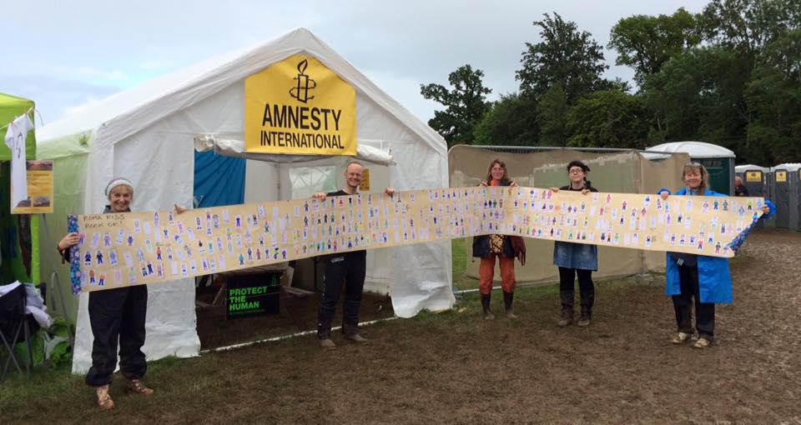
Romani children in the Czech Republic are not getting the same education as other children. They’re bullied just for being different, kept separate from other pupils and even placed in schools for children with learning disabilities. It means they can’t fulfil their potential and build a better future – for themselves, their families and communities, and Czech society.
The European Commission has criticised the government for failing to tackle this discrimination.
Our group asked WOMAD festival goers to fill in an action cards and a draw a “mini me” to add to a giant visual petition to hand into The Czech Republic embassy. The visual petition had about 330 little folk on it by the end of the weekend.
Do come and join us on Wednesday 26th August to hand the petition in to the Ambassador of the Czech Republic at the Embassy of Czech Republic. The time will be 12noon-1pm. The address is 26-30 Kensington Palace Gardens, London W8 4QY
You can take action by signing the petition online or scrolling below to see the letter to the Prime Minister of The Czech Republic.
https://www.amnesty.org/en/get-involved/take-action/action-roma-czech-discrimination/

We also added more names to our petition calling for the release of our Prisoner of Conscience, West Papuan Filep Karma.

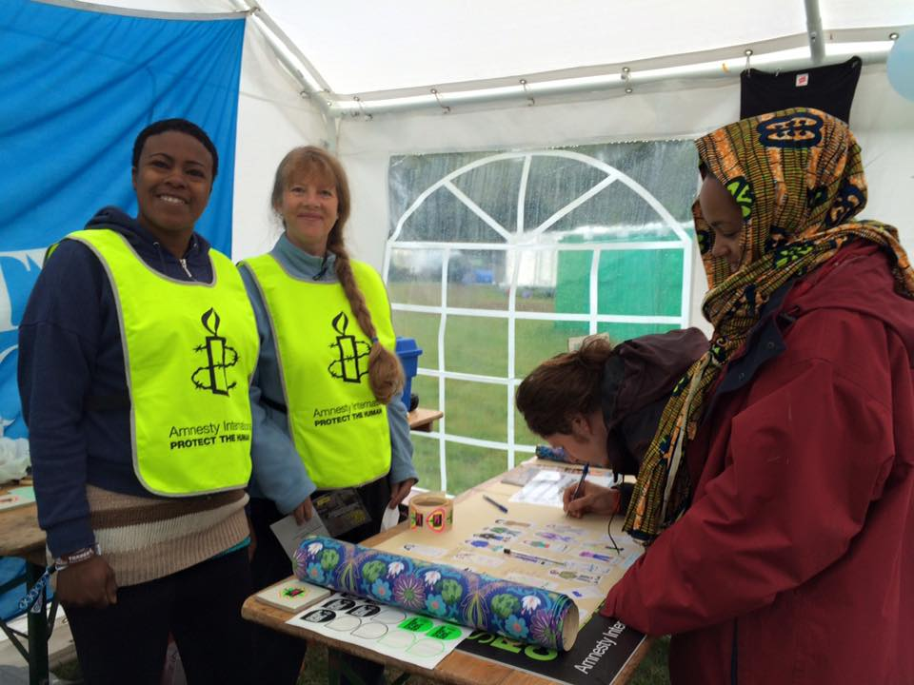
Festival goers adding their “mini me” and message to our giant visual petition.

Channel 4 News’s Jon Snow supports our campaign.
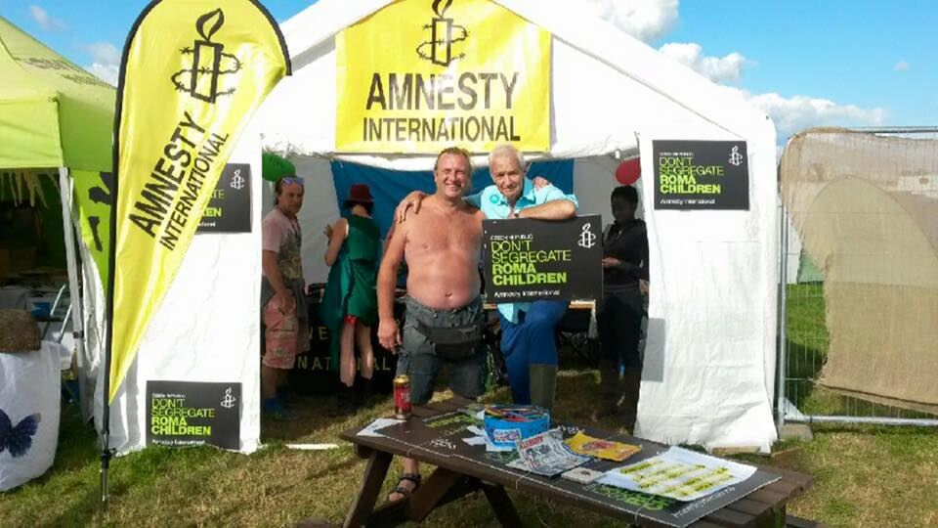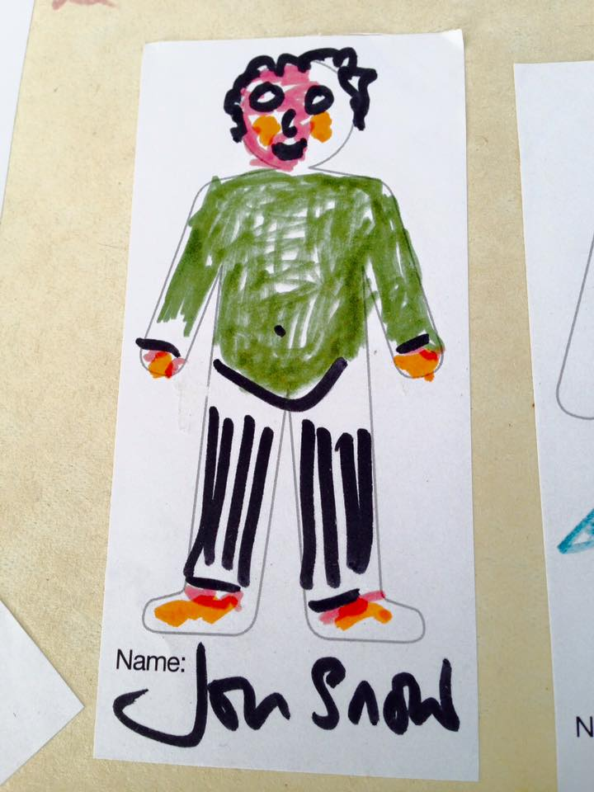

PREVIOUS MEETING
- July – Amnesty’s East Europe co-ordinator, Ulrike Schmidt, came to our meeting to help with our prep for our WOMAD action. She gave a fantastic talk about the history and current situation of the Roma people in East Europe, particularly The Czech Republic.

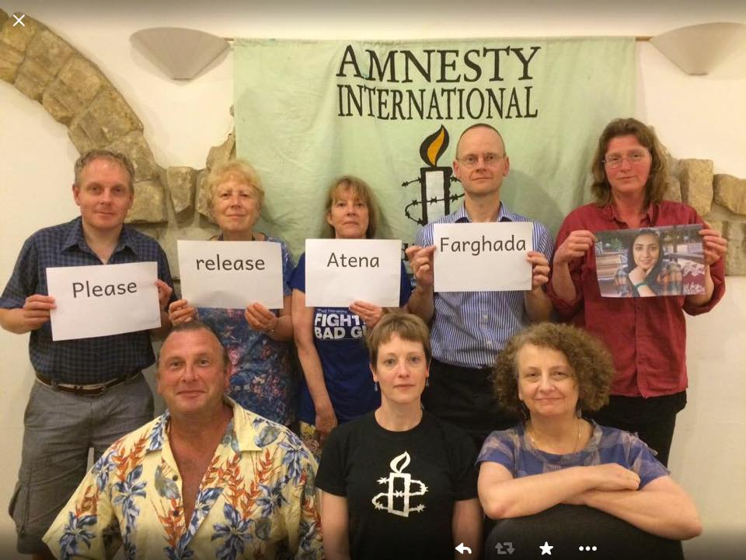
We also took action for Atena Farghada from Iran. She’s in prison for her art and peaceful activism, after she was found guilty of charges including “insulting members of parliament through paintings”. In June, Iran sentenced Atena to more than 12 years in prison, after a trial that lasted just half an hour – the only “evidence” against her extracted under interrogation.
https://www.amnesty.org.uk/actions/free-atena-farghadani-iran-prison-drawing-cartoons-artist

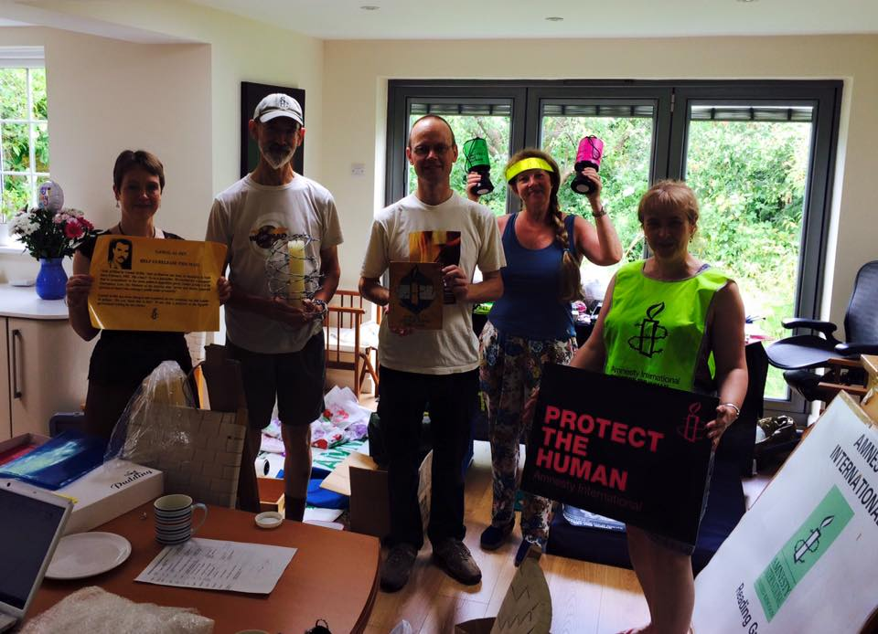
Our group had a great sort out session! We brought along all our various banners, placards, leaflets, made a list of what’s where and how many we had – a very pleasing morning’s work!!

FORTHCOMING EVENTS
- Hand in of the WOMAD Petition – Wednesday 26th August at the Czech Republic – see details above
- Reading Pride – Saturday 5th September – King’s Meadow in the afternoon. Please let Helen know if you’re able to help on the stall helenball03@yahoo.co.uk
- Reading International Festival – we’re still deciding what to focus on – keep Thursday 15th October free in your diaries.

NEXT MEETING – always 2nd Thursday of the month
- August 13th

NEWS and ACTIONS – please scroll down to find the letters to send.
- Thailand - Students Charged for Peaceful Protest
- Sudan – priests arrested for religious beliefs
- Indonesia – commute a death sentence
- The Czech Republic – end segregation of Roma children’s education
- Zimbabwe – licensing community radio stations
Don’t forget to keep up to date with our group’s news, frequently updated with photos and updates:
- Website = http://www2.amnesty.org.uk/groups/reading
- Facebook page –search for Reading Amnesty International – Town Group = http://www.facebook.com/groups/187525074719402
- twitter = @amnestyreading
- Our Prisoner of Conscience, Filep Karma, has a website where you can keep up-to-date with latest developments - www.freefilepkarma.org
- And a facebook page - https://www.facebook.com/groups/253959534694499/

MEETINGS:
- Second Thursday of each month at 8pm
- All are welcome
- upstairs at RISC, 35-39 London Street, Reading, RG1 4PS

ALSO: We raise funds for Amnesty International, and can provide speakers about Amnesty and human rights issues for local organisations: contact our secretary Anne McFarlane, ammcf@btinternet.com
Amnesty Reading Newsletter editor Helen Ball- email: helenball03@yahoo.co.uk

Somyot Pumpanmuang
Royal Thai Police Commissioner-General
Royal Thai Police
1 Building, Floor 7 Rama 1 Road
Pathumwan
Bangkok 10330
Thailand
prforeign@gmail.com
August 2015
Dear General
Students Charged for Peaceful Protest
I am writing concerning the case of sixteen students who have been charged with taking part in peaceful protests. Fourteen of them remain in prison following their arrest on 26 June, and have also been charged with sedition. They had previously taken part in protests in Bangkok and Khon Kaen on the anniversary of the 2014 military coup, and were arrested at subsequent protest after official calls to report to police.
I consider them to be prisoners of conscience.
Can I urge you to:
- Immediately and unconditionally release the fourteen and drop all charges against all sixteen student charged in relation to their exercise of the human right to act peacefully
- Pending the release of the fourteen ensure they are not tortured or otherwise ill-treated and ensure they have access to lawyers of their choice, visits from family members and adequate medical care
- Repeal or else amend all laws and edicts which arbitrarily restrict the right to peaceful assembly in accordance with Thailand’s obligations under international human rights law.

Yours sincerely

Awad Al Hassan Alnour
Minister of Justice
Ministry of Justice
PO Box 302
Al Nil Avenue
Khartoum
Sudan
Email: moj@moj.gov.sd

August 2015
Your Excellency
Reverend Yat Michael and Reverend Peter Yen
I write once again to express my grave concern at the arrests in Khartoum of Reverend Yat Michael and Reverend Peter Yen on 21 December 2014 and 11 January 2015 respectively.
I believe both men to be prisoners of conscience, detained solely because of the peaceful expression of their religious convictions. Therefore I call for their immediate and unconditional release and for all charges against them to be dropped.
Meanwhile, as long as they are kept in detention, I urge you to ensure that they are not subjected to torture or other ill-treatment.
I further urge you to abolish the punishments of flogging and the death penalty in law and practice.

Yours respectfully

Cc
His Excellency Mr Mohammed Abdalla Ali El Tom, Embassy of the Republic of Sudan, 3 Cleveland Row, St James’s, London SW1A 1DD Email: info@sudan-embassy.co.uk

H.E. Joko Widodo
President of the Republic of Indonesia
Istana Merdeka
Jakarta Pusat 10110
Indonesia
Email: dumas@setneg.go.id
Twitter: @jokowi
August 2015

Dear President
Mary Jane Veloso
I write to urge you not to resume plans once the holy month of Ramadan has ended to execute Filipino national Mary Jane Veloso, whose execution was originally scheduled for April but who was granted a last-minute stay to enable her to testify at the trial of a woman accused of tricking her into becoming a drug-courier.
There is no convincing evidence that the death penalty deters crime more effectively than other punishments. Moreover, the decision to resume executions in Indonesia has set your country against the global trend towards abolition and its own recent progress in this area.
I therefore call on you to commute the death sentence imposed on Mary Jane Veloso and any other and to establish a moratorium on capital punishment with a view to its eventual abolition.
Yours most respectfully

cc
H.E. Mr Teuku Mohammad Hamzah Thayeb. Embassy of the Republic of Indonesia,
38 Grosvenor Square, London W1K 2HW kbri@btconnect.com

Retno Marsudi, Mionister of Foreign Affairs, Jl. Pejambon No 6, Jakarta Pusat 20110, Indonesia kami@kemlu.go.id

Bohuslav Sobotka
Prime Minister of Czech Republic
Urad vlady CR
Nabrezi Edvarda Benese 4
11801 Prague
Czech Republic

Dear Prime Minister

End the ethnic discrimination of Romani children in schools
Every child should be able to go to school without experiencing discrimination, including being bullied just for who they are. But thousands of Romani children in your schools suffer prejudice every day. The European Commission has criticised your government for failing to tackle this problem and you can’t ignore this any longer. You should:
1. Acknowledge the ongoing ethnic discrimination of Romani children in your country’s schools.
2. Make a strong and unequivocal political commitment that elimination of discrimination against Roma in education is a priority and will be tackled urgently.
3. Adopt a plan with comprehensive measures to end ethnic discrimination and segregation of Romani children in Czech schools.
Right now, Romani children are not getting the education that is their right. Integration, not segregation, is the answer. Please act now.
Yours sincerely

The Chairperson of the Broadcasting Authority of Zimbabwe
Dr. Tafataona Mahoso
1 Pennefather, Media Center
Rainbow Towers Grounds
P.O.Box CY496
Causeway
Harare
Dear Dr. Tafataona Mahoso
We are members of Amnesty International and are concerned about the restriction of access to information and freedom of expression in Zimbabwe. The establishment of a broad range of broadcast media providers would go some way towards addressing these concerns. We write to urge you therefore to quickly issue licenses for community radio stations in Zimbabwe. We are concerned that BAZ has not licensed a single community radio station since 2001 when the Broadcasting Services Act was enacted.
Community Radio gives voice to isolated, poor, voiceless and marginalised communities, and allow people to express themselves freely without any social, political or economic hindrance. Community Radio is a tool for development and gives communities a chance to raise awareness of their community needs.
We urge the Broadcasting Authority of Zimbabwe to
- Adopt an open-ended mechanism of licensing of community broadcasting services by accepting applications any time of the year.
- Lower the fees for licenses to ease the financial burden for applicants for community broadcasting services.
- Adopt a user-friendly application process for community broadcasting services that takes into account the technical limitations of community-based organizations that are interested in establishing radio stations.
- Operate in a non-partisan, fair and transparent manner including by opening the adjudication process to the public particularly to allay fears that licenses are being issued to ruling party members and sympathizers as part of government’s strategy to control access to information
Thank you for your attention in this matter
Yours Sincerely

