Syria Through a Lens
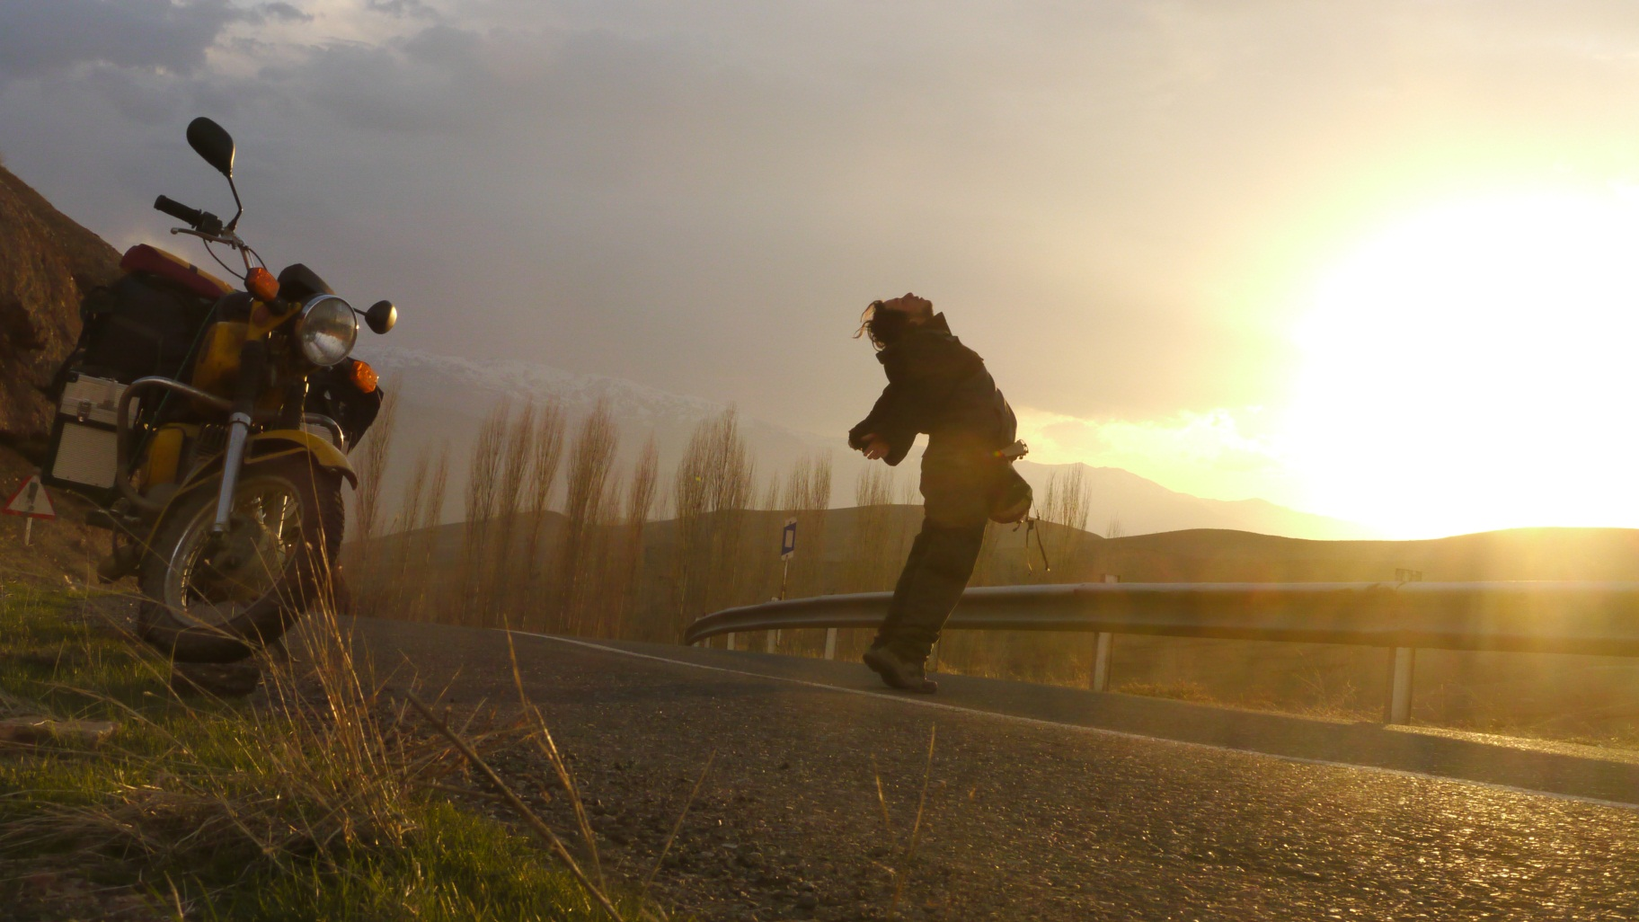
The life and works of filmmaker Bassel Shehadeh

Bassel Shehadeh was a Syrian film producer and well-respected activist, killed in May 2012 during a government assault on a neighbourhood in Homs.
Shehadeh played an integral role in organising and documenting the peaceful protests that have swept Syria since the Arab Spring. “Syria Through A Lens” is a collection of works by and about Bassel, which capture the beauty of Syria and the inspirational courage of the Syrian people in the face of adversity.
The screening will be followed by a discussion panel that will highlight some aspects about the Syrian revolution.

