Film Workshop
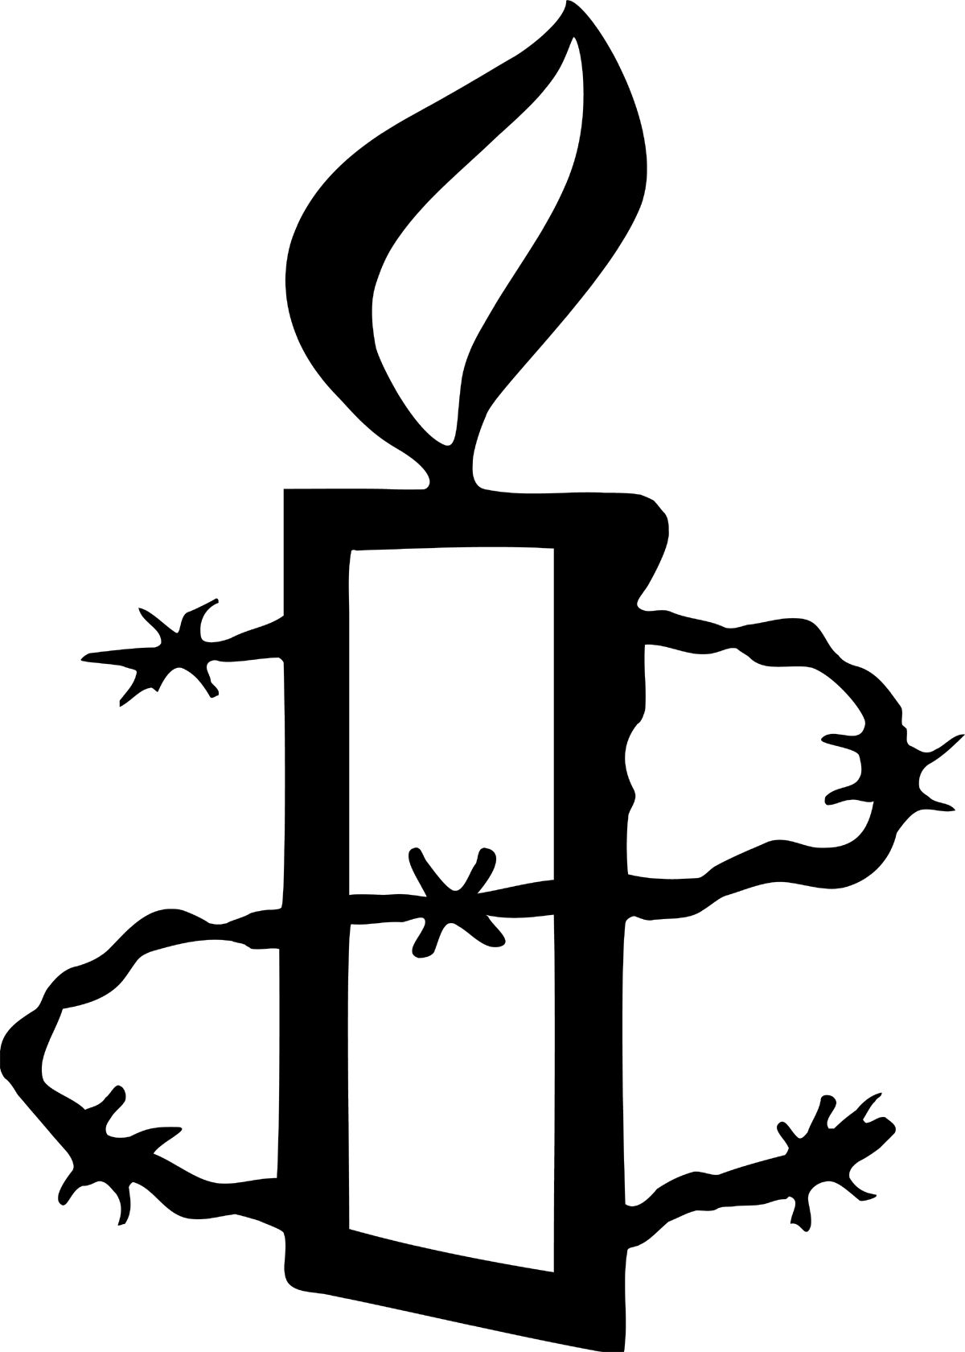

Persepolis
Top Tip: If you don’t have access to PowerPoint, then print off the location map ready to show or hand out to the audience
Use in conjunction with the PowerPoint presentation.

Before the film (PP Slide 2)
- Introduce yourself
- Introduce Amnesty International
- Talk about human rights – You could introduce human rights, and the Universal Declaration of Human Rights, depending on the group’s level of knowledge (PP slides 11 and 12 - optional)

Background (PP slide 3)
Use the map to show where Iran is. Introduce the film by sharing some of the background information below with the group, as appropriate. Additional, detailed notes on the background to the film can be found at the end of the workshop notes.
- The film is an animation based on two graphic novels by Iranian artist Marjane Satrapi, based on her personal experiences growing up in Iran and Vienna
- She grows up through some turbulent years in Iran’s history:
  - Late 1970s - The film begins in the final years of the Shah’s rule, a dictator (someone with complete power over a country). He was supported by the dreaded secret police SAWAK
  - 1979 – The Shah’s rule was overthrown. The Islamic Republic was quickly established under the leadership of Ayatollah Khomeini
  - Women’s rights were severely affected. If anyone complained about the new government, the Revolutionary Guards quickly stopped them
  - 1980 - Iraq attacked Iran and the war lasted till 1988. Intense bombing of cities increased suffering of Iranian people. The government made life even harder for the people in Iran as it kept complete control over their lives.
- Marjane used animation rather than actors to give the film a universality – everyone can enjoy an animation, even if they don’t know much about Iran
- Title comes from the ancient capital of the Persian empire, showing Iran has an identity and history separate from western stereotypes. See notes on back page.
- Women in Iran today – see back pages

Questions to think about during the film (PP slides 4, 5, 6)
Choose one, two, three or all four of the questions. Ask the audience to think about them whilst they watch the film. These are the questions that you’ll discuss afterwards.

- How are the lives of Marjane and other women affected by the Islamic revolution?

- What human rights are the Iranian people, in general, denied under the Shah and after the Islamic revolution? (Refer to optional slide 12 for an explanation of human rights and some examples)

- In the film how do Iranian citizens get around the rules imposed on them?

- What problems does Marjane encounter in the West (Vienna)?

One further question and suggested answers can be found on the back page.

After the film

Warm-up activity (PP slide 7)
Top Tip: It can be difficult to manage a discussion amongst a large group of people. Why not use a signal to show the audience when to be quiet? You could:
- Raise your arm
- Or make a noise with a musical instrument
Remember to explain this to the audience before the first discussion!
Ask the audience to talk to their neighbours
and come up with
- a question
- a fact
- a feeling
that the film has suggested to them. Spend a few minutes sharing these initial responses.

Discussion questions and possible responses:

QUESTION 1
(PP slide 4)
How are the lives of Marjane and other women affected by the Islamic revolution?
- Wearing veil made compulsory regardless of religious beliefs
- Segregation of sexes in education
- Life drawing of woman in robes

QUESTION 2 (PP slide 5)
What human rights are the Iranian people in general denied under the Shah and after the Islamic revolution?
Under the Shah
- Loss of freedom of expression, freedom of thought, freedom of movement (Anoush can’t return from Russia)
- Arbitrary arrest (people are arrested but not charged with any crime) and execution
- Lack of political self-determination (uncle in Azerbaijan)

After the Islamic revolution
- Arbitrary arrest (people are arrested but not charged with any crime) and execution (300,000 political prisoners, executions after Iraq invades)
- Restrictions on freedom of expression (eg publishing company shut down, Botticelli censored, certain types of music not considered acceptable)
- No freedon of movement (Tahir can’t go abroad for operation)
- Interference in private life (raids on homes, not allowed to hold parties, arrested for handholding)
- Political persecution – people are targeted because of their political beliefs (Commuists put to death)
- Torture of prisoners (Ninofar raped before execution)

QUESTION 3 (PP slide 6)
In the film how do Iranian citizens get around the rules imposed on them?
- Lying (‘wicked stepmother’)
- Using black market (music, nail polish etc)
- Bribery (over wine and marjane’s arrest for handholding)
- Forgery of documents (for Tahir)
- Challenging (Marjane over veils)

QUESTION 4 (PP slide 7)
What problems does Marjane encounter in the West (Vienna)?
- Language
- Isolation
- Ignorance of Islam and Iran
- Superficiality (about political struggle)
- Christmas
- Loss of identity (conceals nationality)
- Homelessness and indifference of society
- After return, mental illness and attempted suicide

About Amnesty International (PP Slides 8 and 9)
Give more information about Amnesty International. You could also talk about your personal involvement with Amnesty, or ask the audience to talk about their involvement.

Take action (PP Slide 10)
Amnesty members take action to change things for the better. Use slide 10 to encourage students to take action on one of Amnesty’s campaigns.

Thank you
Thank your audience for their time. Take questions. Take action.

Further background notes and questions
Please note: Although Amnesty International is running a workshop alongside the NSFW screening of Persepolis, this does not mean that Amnesty supports the views put forward in the film. Please make this clear during the course of your workshop activities.

Context
Persepolis is based on the two graphic novels by Marjane Satrapi recounting her own experiences growing up in Iran and Vienna. This personal account is set against the backdrop of the changing political situation in Iran. At the start of the film, the adult Marjane is looking back on her life as a young child in the late 1970s, in the final years of the Shah’s rule in Iran.

The Shah had ruled since 1941 with support from the US and Britain. He had tried to modernize Iranian society through economic reforms, by making education free and compulsory and by giving women more rights such as the vote. However, any opposition to him was ruthlessly dealt with (as is shown in the film) by the dreaded secret police, SAVAK. By the time he was overthrown in 1979 there were around 3000 political prisoners.

The Shah was also unpopular because his regime was seen as corrupt and extravagant and too close to the West. He was opposed both by members of the liberal intelligentsia such as Marjane’s parents and also the Islamic clerics whose influence he had undermined. Opposition forced him to leave the country in 1979 and very quickly his rule was replaced by the Islamic Republic under the leadership of Ayatollah Khomeini who had been living in exile.

Women’s rights were affected, especially in the areas of marriage, divorce, child custody and inheritance. Strict segregation of the sexes was imposed, as well as compulsory wearing of the veil in public places. The Revolutionary Guards replaced SAVAK as upholders of the regime and opposition was suppressed as in the case of Marjane’s uncle Anoush. The regime also attempted to curtail western influences.

In 1980 Iraq attacked Iran and the war that followed lasted until 1988. Thousands of Iranians were killed and there was intense bombing of 87 Iranian cities including Tehran, increasing the suffering of the Iranian people.

Style of film
Marjane Satrapi chose animation for the film as she wanted it to have a universality that using actors would not allow. ‘Dictatorships can happen everywhere, to everybody’ she says. She also wanted old-fashioned animation techniques, using pencil on paper, as she feels that computer-generated images are too perfect, but human beings are not perfect. She believes that the vibrations of the hand drawing bring the drawings to life.
Most of the film is in black and white with some muted colour tones for the present day scenes.

Title
Persepolis was the ancient capital of the Persian Empire laid waste by Alexander the Great in 330BC. The ruined site is still a source of national pride to Iranians. When she arrived in France she was dismayed at the lack of knowledge and understanding of the centuries old culture of Iran and wanted to emphasis this in contrast to the stereotypes we have of contemporary Iran.

Women in Iran today
Literacy has been a priority under the Islamic Republic and while girls are still less well educated than boys in rural areas, women are now the majority of university students. Women have also been able to play a part in civil society, in arts, culture and sciences and this has led to increasing confidence to challenge inequalities, as did the award of the Nobel Peace Prize to human rights lawyer Shirin Ebadi in 2003. However, the age of marriage is 13 although a father can apply for permission to marry his daughter to another man at a younger age than 13, and to a much older man. A woman’s evidence in court is worth half of a man’s. While a man has an undisputed right to divorce, a woman does not.

One further question

1. What impact of the Iran/Iraq war does the film show?
- Food shortages
- Enables the regime to become more repressive
- Propaganda – use of the key to heaven to enlist boy warriors
- Air raids, destruction and death
- Execution of political prisoners

Further reading
AI’s report Iran: Women's rights defenders defy repression which you can find at http://www.amnesty.org.uk/uploads/documents/doc_18417.pdf
Shirin Ebadi: Iran Awakening
Azar Nafisi: Reading Lolita in Tehran

