Amnesty International  Frome Group Newsletter  WE ARE ORDINARY PEOPLE FROM ACROSS THE WORLD STANDING UP FOR HUMANITY AND HUMAN RIGHTS  Website: www.amnesty.org.uk/groups/frome  Thank you for supporting our September group action  On Saturday 24th September we held a letter signing stall and book sale in Kingsway precinct, just outside M&S.  In total we signed 30 letters. 15 were sent to Mistsuhide Iwaki, Japan’s Minister of Justice calling on him not to execute Matsumoto Kenji and to introduce a moratorium on executions in Japan. 15 letters were sent to Ayatollah Sayed ‘Ali Khamenei , the supreme leader of Iran regarding Nazanin Zaghari Ratcliffe, a British-Iranian charity worker who has been sentenced to 5 years in prison for “national security” reasons, urging him to use his authority to release her immediately or to charge her with an internationally recognisable offence.  We raised £43.16 from the sale of books and donations, which will be used to cover postage costs. Thank you to everyone who came along to support our September group action. |  | October 2016  Issue 7  Issue 2  IN THIS ISSUE: *Our September letter signing event *Refugee play *Write for rights
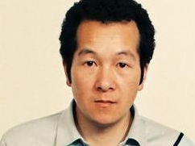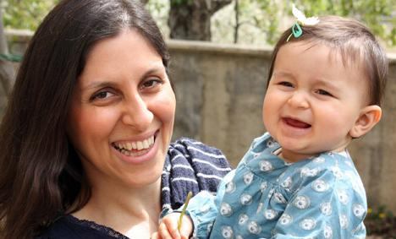
Matsumoto Kenji Nazanin Zaghari Ratcliffe
pictured with her 2 year old daughter
who was handed over to grandparents and
her passport seized when Nazanin was arrested.

If you missed the event but would like to take action please click on the following links or copy and paste them into your browser for further information.
Write to the Minister of Justice or the Minister of Health, Labour and Welfare in Japan https://www.amnesty.org.uk/sites/default/files/september_2016_monthly_group_action_-_matsumoto_kenji.docx.pdf
Sign the petition urging Boris Johnson to speak out for UK citizens imprisoned in Iran: https://www.amnesty.org.uk/actions/nazanin-zaghari-ratcliffe-kamal-foroughi-boris-johnson-uk-citizens-imprisoned-iran

Our next meeting – change of date!
Our next meeting will be held on Thursday 27th October (the 4th Thursday of the month) instead of 20th October at the Bridge café on Selwood Road in Frome.
If you haven’t been along to a monthly meeting before this is where all of the behind the scenes action happens!
So if you’d like to get more involved in helping to plan and organise events and monthly group actions then please come along. It would be great to meet you and hear your ideas….
See you on 27th October!

Refugee play
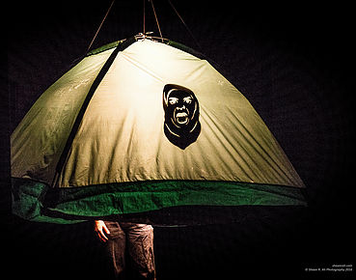
HOT OFF THE PRESS! Save the date!
This hasn’t yet been confirmed by the Merlin Theatre, so pencil this in and we will confirm the details later!
On Wednesday 2nd November at The Studio, The Merlin Theatre Ellen Muriel will be putting on her powerful one woman show “You, Me and the Distance between us”. Tickets are £10.
Ellen spent 6 months volunteering in refugee camps across Europe.
For a trailer please click on this link, or copy and paste it into your browser.
http://youmeandthedistance.wixsite.com/theatre

Write for rights campaign
We will be participating in the Write for Rights campaign. This is the one time of the year when we write greetings cards to the prisoners rather than to the governments.
12 cases of people whose human rights are being abused are featured in a booklet produced by Amnesty and there are more cases online https://www.amnesty.org/en/get-involved/write-for-rights/
We will be holding letter and greetings card signing events on Saturday 12th November and on Saturday 10th December in the Cheese and Grain foyer. Exact times to be confirmed.

Your ideas for the newsletter…
If you have any feedback about the group newsletter or would like anything included in the next issue then please feel free to contact me – Nadine Crook njwardman@yahoo.co.uk
Our next meeting is: Thursday 27th October at the Bridge Café, Selwood Road, Frome, BA11 3BS at 8pm.

