Amnesty International  Frome Group Newsletter  WE ARE ORDINARY PEOPLE FROM ACROSS THE WORLD STANDING UP FOR HUMANITY AND HUMAN RIGHTS  Website: www.amnesty.org.uk/groups/frome  Facebook: www.facebook.com/fromeamnesty  Write for rights campaign  On Saturday 12th November and Saturday 10th December 9am-1pm we will be writing messages of solidarity and friendship on greetings cards as part of Amnesty’s Write for Rights campaign.  Our stall will be in the foyer of the Cheese and Grain.  Every December, Amnesty supporters from across the globe write millions of letters and cards. It is one of the world’s biggest human rights events. Since its inception, Amnesty’s Write for Rights has been phenomenally successful. People who were unfairly imprisoned have been freed; human rights defenders who have been threatened and harassed by authorities have been able to live freely without intimidation, and forced evictions have been halted. Sending a message of support to those whose rights are being abused and also to the authorities on that person’s behalf is so powerful. Imagine drowning in thousands of letters of encouragement and solidarity – in fact, imagine the officials who will see and deliver thousands of cards to the victims and their families. The effect on both of them is priceless. |  | November 2016  Issue 8  Issue 2
It shows the authorities that the individual is not alone and that all over the world thousands of people are standing up with them, and for them.
Here are just two examples of people who released as a direct result of last year’s write for rights campaign… In April 2016, student leader Phyoe Phyoe Aung (pictured left) was released from prison in Myanmar after more than 394,000 Amnesty supporters took action for her and on his 69th birthday, 19 February 2016, Louisiana prisoner Albert Woodfox walked free – 44 years after he was first put into solitary confinement in the USA. More than 200,000 people took action.
Saturday 10th December is also Human Rights day so what better way to spend it than to join the global letter writing marathon!
For more information see: https://www.amnesty.org/en/get-involved/write-for-rights/
A day of TED talks
On Thursday 17th November starting at 9:30am there will be a day of TED talks at The Forum in Bath. The theme for the day is “You can make a difference” and the event is hosted by TEDxYouth@Bath.
For more information and to buy tickets please go to www.bathforum.co.uk
It promises to be an inspirational, jam-packed day with over 20 brilliant speakers on various topics. Including:
• BBC correspondent Frank Gardner, who was shot six times in 2004 in Saudi Arabia and paralysed from the waist down, and who was back reporting the next year
• Sarah Corbett from the Craftivist Collective, demonstrating that activism does not need to be violent and angry, but can be peaceful, gentle, and still effective
• Aimee Ansari from Translators Without Borders flying over from refugee camps in Greece to give a talk … just to mention a few!

Bath Amnesty presents: Close the camps
A talk on North Korea from an ex-army captain who defected from the country and now lives safely in Britain. Joo il Kim grew up “brainwashed into thinking that North Korea was the best country in the world". He now campaigns to improve human rights in North Korea and runs a newspaper called Free NK.
Kim will be talking via an interpreter and alongside Benedict Rogers, a specialist in human rights in Asia. Get your tickets now for this fascinating talk!
WHERE? Manvers Street Baptist Church
WHEN? Monday, December 5. Starts at 7.30pm
TICKETS: £5 (email wendyhug@gmail.com to reserve a seat)

Refugee play
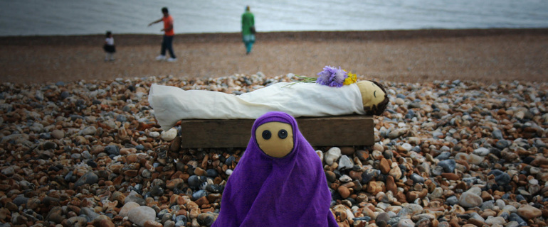

Thank you to everyone who attended Ellen Muriel’s play “You, me and the distance between us”. The play was well attended.
It was thought provoking performance by Ellen who had seen the best and the worst of life as a volunteer in a refugee camp in northern Greece.
8 letters were sent to Amber Rudd, the Home Secretary, urging her to take a lead in Europe and to welcome our fair share of refugees.

Amnesty has released a new global report for the ‘I Welcome’ refugees campaign. The report ‘Tackling the Global Refugee Crisis: From Shirking to Sharing Responsibility’ provides a comprehensive assessment of the global refugee crisis and documents the precarious situation faced by many of the world’s 21 million refugees. It also shows that of the 193 countries in the world the majority of the wealthiest have shown a near absence of leadership and responsibility while a global refugee crisis continues to escalate. This has left just 10 countries – each bordering conflict zones and accounting for less than 2.5% of world GDP – to take in 56% of the global refugee population. The UK hosts less than one per cent of the world’s refugees.
To find out more: https://www.amnesty.org.uk/world-leaders-are-spectacularly-failing-refugees
To read the report: https://www.amnesty.org/en/documents/pol40/4905/2016/en/

Our next meeting
Our next meeting will be held on Thursday 17th November at the Bridge café on Selwood Road in Frome.
If you haven’t been along to a monthly meeting before this is where all of the behind the scenes action happens!
So if you’d like to get more involved in helping to plan and organise events and monthly group actions then please come along. It would be great to meet you and hear your ideas….

Your ideas for the newsletter…
If you have any feedback about the group newsletter or would like anything included in the next issue then please feel free to contact me – Nadine Crook

Our next meeting is: Thursday 17th November at the Bridge Café, Selwood Road, Frome, BA11 3BS at 8pm

