North Africa Region Newsletter
Welcome to the March edition of the newsletter. Unrest in the region continues. Freedom of expression is under attack in Tunisia and repression of protests, the reintroduction of a State of Emergency and violence against women give great cause for concern in Egypt. On a more positive note and despite government restrictions you can read about how Amnesty membership in the area is growing. We also include a letter in support of justice for the family of an Egyptian shot dead by police and notice of actions being planned for the Tawargha community in Libya.
Good luck with your campaigning and best wishes from the North Africa CC team.

Local Amnesty Sections Grow in North Africa
Greater freedoms that followed the uprisings against old dictators in North Africa have given local Amnesty sections more space to grow.
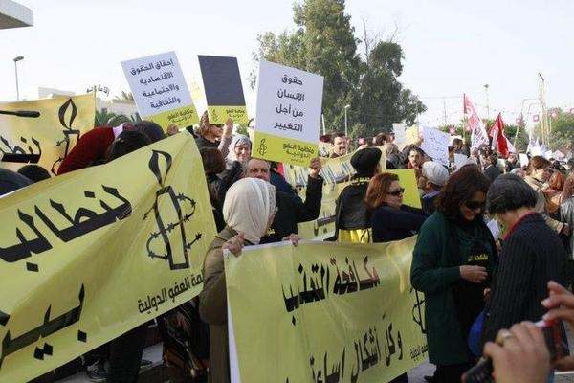
AI Tunisia, which reported 800 members in 2010, before the Arab Spring, expects to have 15,000 members by the end of this year. AI Morocco is targeting 4,000 members in 2013.
AI Tunisia demonstration on opening day of Constituent Assembly Tunis, October 2011

When Tunisia’s new constituent assembly first met in October 2011, AI Tunisia was outside the building on opening day, with a demonstration to remind assembly members to make human rights a priority in the new constitution. The Amnesty report on the first year of the Arab Spring was launched simultaneously by the International Secretariat in London and by AI Tunisia in Tunis. AI Morocco is campaigning against the death sentence in Morocco and other countries.
Amnesty is now exploring setting up in Egypt, although Egypt’s law on non-governmental associations, which prevents links between international and Egyptian NGOs, is a big obstacle. Amnesty has told President Morsi’s officials that it wants a presence in Egypt. But new proposals from members of the Morsi government in February would, if implemented, result in a severe setback to the growth of civil society organisations, and make it impossible for any NGO with foreign links to operate in Egypt.
Algeria already has a small Amnesty section, with about 150 members, campaigning on issues outside Algeria. There are strict curbs on NGOs in Algeria too, that were tightened by a new law last year. Amnesty’s International Secretariat is now going to take a look at campaigning to support Algerian civil society associations to make this law less restrictive.

EGYPT
The situation in Egypt has deteriorated severely over the last 3 months. The draft Constitution was rushed through in December after many liberal, Christian and female members of the Constituent Assembly withdrew when their objections to its illiberal features were overridden. Sharia (Islamic) law was to be the basis not international law; only the three Abrahamic religions were permitted to practise thereby ignoring many other sects; gender discrimination was not specifically banned. Amnesty is supporting the Opposition parties in their demands for amendments (after new Parliamentary elections are held).
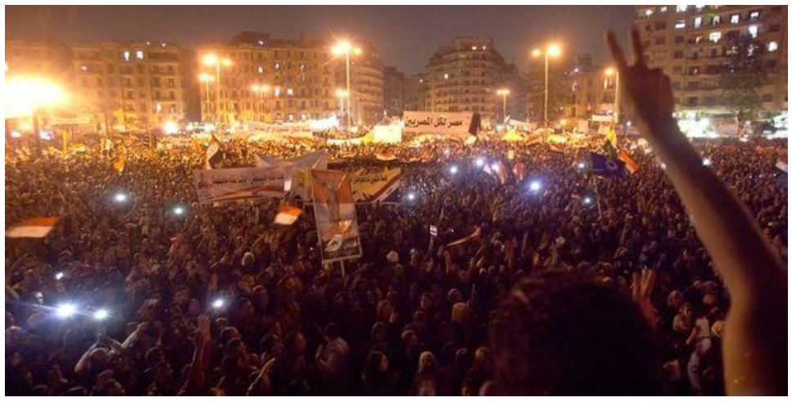
Relations between President Morsi, supported by the Muslim Brotherhood and the other political Parties, is polarized with the Opposition divided and weak making the prospect of effective reform in favour of human rights appear remote.
Repression of protests over failure to implement reform has become more brutal. Factions gathered outside the Presidential Palace in December 2012 and the security forces stood by when the pro Morsi supporters attacked their opponents. The army was summoned to defend the palace and has since stayed on the streets to maintain law and order.
Protests to mark the second anniversary of the “25 January Revolution” have been overshadowed by violence, as well as new incidents of attacks on women protesters in Tahrir Square. In some cases the security forces have suppressed protests using unnecessary lethal force.
Much of the violence has been focused in the cities of Suez and Port Said. At least nine people died in Suez on the evening of 25 January, after thousands marched on the Security Directorate. Riot police reportedly panicked, firing randomly at protesters after one of their number was badly injured. On 26 January, clashes erupted in Port Said after a court hearing the case of a deadly football riot referred the files of twenty one defendants to the Grand Mufti for him to endorse their death sentences.
The resulting violence around Port Said’s General Prison, where the defendants were kept, left scores dead. The violence continued the next day, with further attacks on funerals. In total, thirty eight people have died.
In response to the unrest, on 27 January President Morsi announced a month-long State of Emergency in Suez, Port Said and Ismailia, and also said he was prepared to take further measures if necessary. On 3 February he approved a new law giving the army new powers of arrest and detention – though those arrested by the army will reportedly be referred to civilian courts.
Frustrations continue to grow at the slow pace of reform and ongoing abuses committed by police and other security forces acting with impunity. Amnesty has documented these in its report published in January 2013 “Rampant Impunity- still no justice for Protestors killed in the 25 Jan Revolution”.
http://www.amnesty.org/en/library/info/MDE12/004/2013
For a short pamphlet with an online card about the demand for justice for the 840 victims go to: http://www.amnesty.org/en/library/info/MDE12/006/2013/en
The violent attacks against women in the vicinity of Tahrir Square have been documented and a press release and report were issued in early February (please see the report “Egypt: Gender-based violence against women around Tahrir Square": http://www.amnesty.org/en/library/info/MDE12/009/2013/en).
The Egypt research team is planning a new action calling on Egypt’s leaders to condemn and combat sexual violence. This will be accompanied by a campaign digest on women human rights activists, as well as a checklist on women and policing, to be launched around Egypt Women’s Day (16 March).
Another thread of campaigning will focus on the use of excessive and unnecessary force by the security forces and the need for accountability
ACTION
Mohamed Latif’s family are still trying to get justice and an admission of truth from the authorities. All the officers involved in incidents resulting in his death in 2011 (and that of several other young men) were acquitted. Families are now required to submit new evidence if the cases are to be reopened. As one of the mothers remarked, “Where are we going to get new evidence? We presented everything we had. Am I supposed to paint the witness a different colour and present him as a different witness?” Amnesty is continuing to fight with the family for justice.
A letter to the Minister of Justice can be found at the end of the newsletter. For addresses of more targets contact ann.marcus@amnesty.org.uk
If any group would like to adopt this case as an IAR please contact amy.summers@amnesty.org.uk
News of Campaigns
Azza Suleiman, who was beaten up by soldiers when going to help a woman being assaulted by them and herself ended up in hospital with a fractured skull, was one of the cases in the Write for Rights campaign and has been adopted as an IAR by some groups. There were so many messages that the Post Office asked her to come with bags to collect them! She wrote to Amnesty thanking them for all their support
“I only have faith in people, whether in Egypt or abroad, to achieve change… We have suffered a lot in the past two years and faced a lot: teargas, shotgun pellets, beatings, sleeping in the cold outside.
Government will not improve or do anything unless there is pressure from people...The amount of messages I received (from AI members and activists) gives me a lot of hope despite all the challenges. I feel like all the English wrote to me! "
Sadly her own situation has not changed and she is still waiting for news of an investigation into her attack by the Public Prosecutor. Both the army and the security forces continue to benefit from near-total impunity for human rights violations. Amnesty is continuing to campaign on her behalf and if other groups would like to work on her case please get in touch with ann@marcuses.co.uk
The Rule of Law Campaign was launched in October. More than 56,000 signatures addressed to President Morsi were collected from different Sections and were delivered in February by our Egypt researcher Diana Eltahawy. The petition asked the authorities to end the use of excessive force in suppressing protest and to ensure accountability for members of the army and security forces. Petitions were handed over to President Morsi’s Secretary and his Human Rights representative who mentioned that they had also received other individual messages. Many thanks to those who supported this online campaign.
LIBYA
Local Accountability
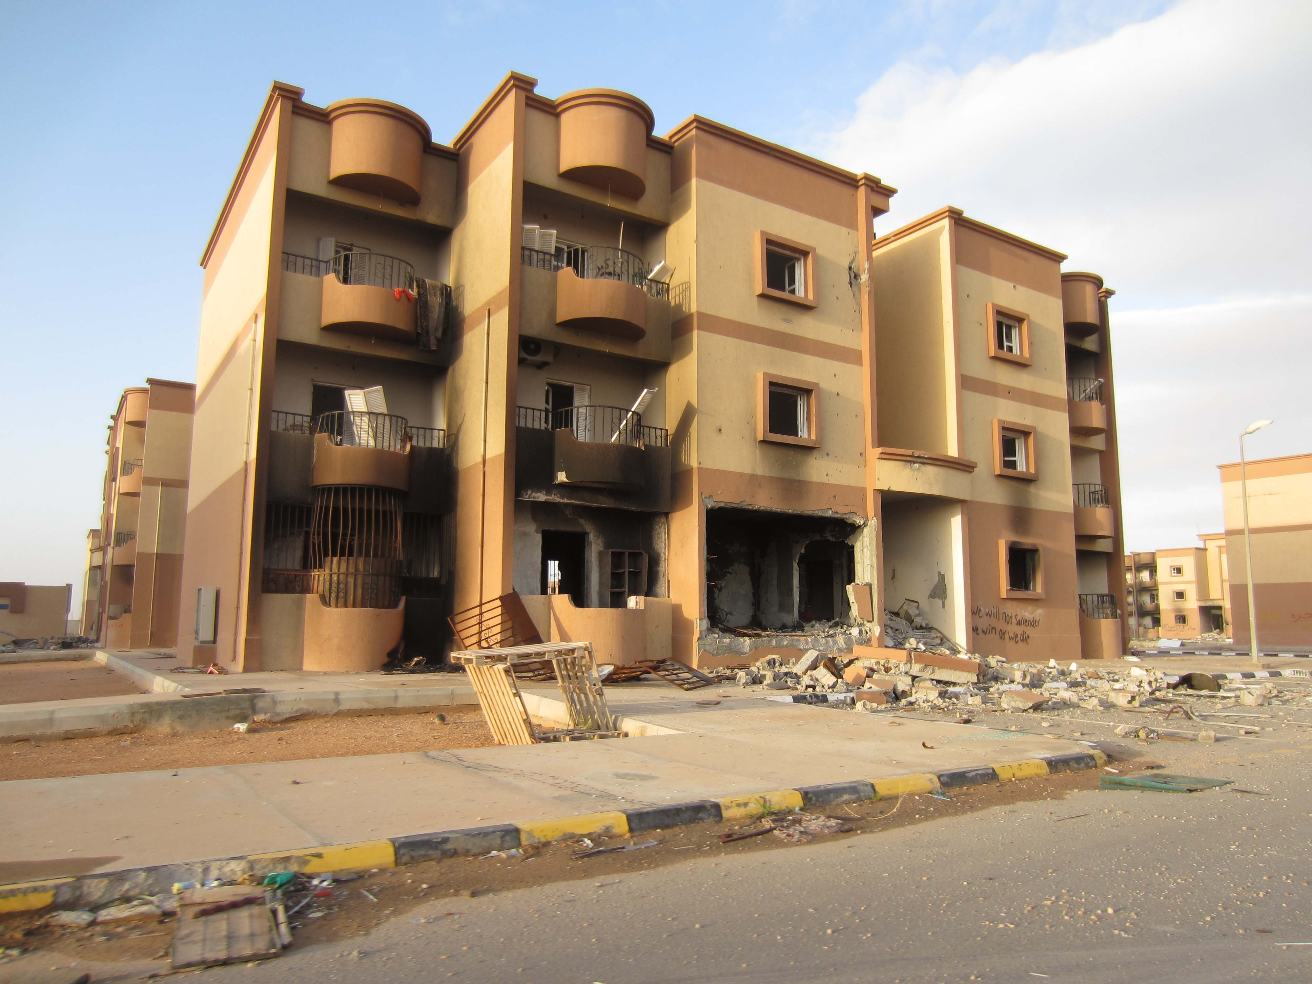
Local groups campaigning in support of the safe return home of the Displaced People of Tawargha have come up with the idea of asking their local mayor or council to write to the local council of Misratah in Libya, where a number of Tawarghans are held in detention.
The Displaced People of Tawargha were expelled from their homes in the summer of 2011, when militias from nearby Misratah attacked the town. The Tawarghans, who are ethnically distinct from the Arab inhabitants of Libya, are in refugee camps in different parts of Libya and are unable to return home. The Misratah militias continue to hold Tawargha men in detention, and Amnesty has documented cases of torture and killing of these detainees.
The Libyan government has not yet established effective control over regional militias. For this reason, it may be that the local council of Misratah has, for the moment, more influence over the fate of Tawarghans than the central government. Amnesty met with the leader of the city council of Misratah in 2012, and handed over petitions containing almost 2,700 signatures, asking for the safe return home of the people of Tawargha.
This is a rare Amnesty case where action from one local council, in the UK, to the local council of Misratah, could have a direct impact on individuals at risk –the 30,000 people displaced from Tawargha.
We are talking to Amnesty’s International Secretariat about when and how letters from local councils in the UK can get delivered to the local council in Misratah. It is important to confirm this, before asking local councillors to write letters. As soon as this is confirmed, we will send details, and a suggested format for the letter. This has been discussed in a preliminary way by the Scarborough, Lyme Regis and Kingston upon Thames local groups. Other local groups following the Tawargha case include East Devon, Hornsey & Woodgreen, Horsham, and Wandsworth.
TUNISIA
Freedom of Expression still being eroded In Tunisia.

Recent months have seen further attacks on freedom of expression in Tunisia.

In Siliana, a city in south western Tunisia, it was reported that as many as 300 protestors and bystanders were injured by the Tunisian police's use of excessive force during demonstrations from 27th -29th November 2012. Protestors had been calling for the departure of the Governor of Siliana, economic development of the town and the release of 13 detainees arrested during protests in April 2011 and still held in pre-trial detentions. The UN High Commissioner for Human Rights said in a public statement that "our staff visited victims who had been taken to hospitals in the capital Tunis, and have documented cases of shotgun wounds to the head, back and face, as well as eye injuries which could in some cases lead to blindness. Some demonstrators are also suffering from broken bones".

The National Union of Tunisian Journalists stated that several journalists had been injured by stones, rubber bullets or shotgun pellets, and others were prevented from filming the events. On the 29th November Prime Minister Hamadi Jebali called for civil society to create an independent commission of inquiry into the violence.

Also in November 2012 Oussama Bouajila and Chahine Berrich from the anti-poverty street group, Zwewla ("the poor"), were charged with "spreading false information with the aim of disrupting public order", "defying the State of Emergency" and "writing on public buildings without permission" after they were caught writing slogans in support of the poor on a university wall in the city of Gabes. Both men could face up to five years in prison if convicted.

TV producer, Sami Fehri, has remained arbitrarily in detention despite a court decision of 28th November 2012, ordering his release. Sami Fehri told the press that he was being detained for political reasons in relation to a show broadcast on Attounoussia TV called "the Political Logic" which was critical of the government, and which Sami Fehri decided to stop broadcasting days before he was detained. The satirical show featured puppets representing Tunisian politicians.

In January a military appeal court upheld the conviction on defamation charges of former Presidential Advisor, Ayoub Massoudi, and extended his original suspended sentence from four months to one year's imprisonment. He was also stripped of certain civil rights including serving in the army, being employed in the civil service or being able to receive honours or distinctions from the state. The charges stemmed from Massoudi's public criticism of the extradition of former Libyan Prime Minister, Al-Baghdadi al-Mahmoudi, from Tunisia to Libya in June 2012. "This even harsher punishment is sending a clear message that the authorities intend to clamp down hard on those critical of the authorities," said Hassiba Hadj Sahraoui, Deputy Middle East and North Africa Programme Director at Amnesty International.
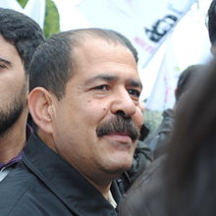
On 6th February 2013 Tunisian opposition politician, Chokri Belaid, a leading figure of the leftist opposition in Tunisia, was shot in the neck and head as he was leaving his home. He was the Secretary General of the Democratic Patriots Party, and a vocal critic of the government. He denounced political violence and called for democratic values to be upheld in Tunisia. It is the first time that such a killing has taken place in Tunisia. So far no one has claimed responsibility.
Chokri Belaid

Update Regarding Case of Manal Boualagi

On 28 January the military court in Sfax issued its verdict in the case of Manal Boualagi and four others who had been killed in Regueb during the uprising. One of the defendants, Mourad Jouini, a commandant in the security forces, who had been detained during the trial was sentenced to ten years in prison on the counts of murder and attempted murder. The other defendant, Bassem Akremi, a lieutenant in the security forces considered a fugitive by the court, was sentenced in absentia to 20 years in prison.
Chadia, Manal Boualagi's mother, expressed to AI her disappointment at the sentence. She said that she and the other families felt that ten years was too little for someone whom they believed was responsible for the deaths of five people. They are also upset that Bassem Akremi remains at large although he got a longer prison sentence. One of the lawyers for the families has said that they plan to appeal the court verdict, but this is not confirmed yet.
We would like to thank everyone for their hard work and Chadia expressed her gratitude for the continued support throughout the trial. As soon as we get a fuller picture from the lawyers we will share another update with more details on the court decision and what the families plan to do. The goals and appeals in the casefile may be accordingly updated.

GROUP NEWS

Cambridge University group show True Defiance Exhibition

In January the Cambridge University group arranged an exhibition and an event around the True Defiance exhibition at the popular cafe the Michaelhouse. Lucia Corsini reviews the exhibition and the event:

In celebration of the second anniversary of Tunisia’s Jasmine Revolution, Cambridge
University Amnesty group hosted the photography exhibition ‘True Defiance’. Featuring the work of five photographers it documents Tunisia’s revolutionary timeline from riots to elections. The sensitive and powerful images focus on three stages: faces of defiance; expressions of revolution; people power.
The first explores the identity of individuals involved in Tunisia’s protests and challenges the viewer with striking portraits of bloggers, protesters and activists. The second celebrates the power of the united people of Tunisia with symbols of the country’s religion and culture used as displays of liberation. The final section of the exhibition offers a review of the protesters’ work. Moving and intimate images of ‘First time voter’ underline the motivation for the Tunisians’ struggles. The 23rd October elections offered a fair and democratic future with promise to reinstall the Tunisians’ freedom and identity.
Woman Protesting
Nesrine Cheikh Ali
Rachid Belgacem Fitouri, 97 – First time voter
Augustin Le Gall

Over seven days, hundreds of locals and visitors came to the bustling cafe, The Michaelhouse, which featured the exhibition. Amnesty also hosted a late evening to celebrate the opening and to encourage students to visit and learn about action on Tunisia. The event received a warm reception from students and members of the public, with many people enthusiastic to learn more about Tunisia and its role in propagating change throughout North Africa. Benedicte Goderiaux, Amnesty International researcher for North Africa, spoke at the event to explain some of the humanitarian work taking place. Her emphasis on the ongoing need for support readdressed some of the concern’s that remain in the vacuum following a revolution. New struggles have emerged – there is a sentiment of feeling ‘cheated by change’ in that Tunisians’ ideals of jobs and equality had not been fully realised.
Some of these issues were highlighted in the Amnesty action cases on the evening, for example the case of Manal Boualagi. She was shot dead in a peaceful protest on 9th January 2011, while visiting her mother; since then her family’s efforts to seek justice have been hindered by serious delays to the investigation and as such no one has faced sentence for this crime.
The exhibition provided an interesting and powerful insight into Tunisia’s call for reform and posed more relevant and piercing questions of what could be done now to secure the country a future of equality and freedom of expression.

If your group would be interested in arranging a showing of the True Defiance exhibition in your locality please contact Beverley Foulkes-Jones.

INTRODUCING GROUP MEMBERS
Franki Gray, Dorking Group
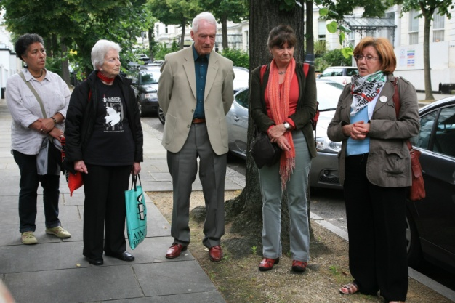
As a translator/interpreter and language teacher, Franki first became fully aware of the civil war in Algeria in 1993, when she was teaching English to some Algerian detainees at a local prison. During her studies for the Sorbonne, her special study had been on “De Gaulle and the 5th Republic” which basically meant French involvement in Algeria and the move to independence… and all the fallout from that.
( Franki is standing between Nassera – on the right- and Roger, listening to Nassera speaking.).

Information later used for Amnesty campaigns in Algeria was gathered by her in support of Algerians facing Immigration Tribunals, where she appeared as a witness/ supporter. Franki was living and working as a translator/interpreter in Paris in 1996/ 97, and as an individual supporter, she was ideally placed to collect information to help Roger Goldsmith in his work as UK Country Coordinator for Algeria. Some of this material was used for the Algeria newsletter and for action files for groups to campaign on, specifically in the cases of those who “disappeared” in the civil war in Algeria in the 1990s.

When Franki returned from France at the end of 1997, she joined Dorking as a group member, and continued with lots of letter writing and e-mails concerning enforced disappearances in Algeria. The policy of AIUK to suspend action on individual disappearance cases was a bitter disappointment to her, but she has continued action and research on an individual basis. She made personal contact with Nassera Dutour of the Collectif des Familles des Disparus en Algerie, has visited both their old and new offices in Paris and hopes to be able to organise more help for them in the gargantuan task of maintaining databases on more than 8,000 of the “disappeared”.

Franki has also taken part in actions ranging from demonstrations in Paris, to a writathons in Dorking High Street (complete with Bedouin tent, photos and stories of hundreds of the “disappeared”, mint tea, pastries and Rai music), to the latest demonstration on the 50th Anniversary of Independence, at the Algerian Embassy in London last June, when Nassera came over from Paris (see photo above).

She has also organised other fund and awareness-raising events, such as an “Amnesty Night” at a local cinema showing “Of Gods and Men”- a wonderful film about the monks of Tibherine, murdered in the Atlas mountains in Algeria, during the civil war She would be happy to show this to any group, accompanied by a talk.

Her main concern for Algeria now: the Algerian Government’s new law on civil society associations which imposed even tighter restrictions. Harassment of activists defending labour and student rights started again in January, and the brave families of the disappeared are still harassed and frustrated in their attempts to demonstrate and seek justice. Franki believes there is a great need to do more, within and with Europe, to campaign for freedom in Algeria.

GOODBYE TO JACKIE
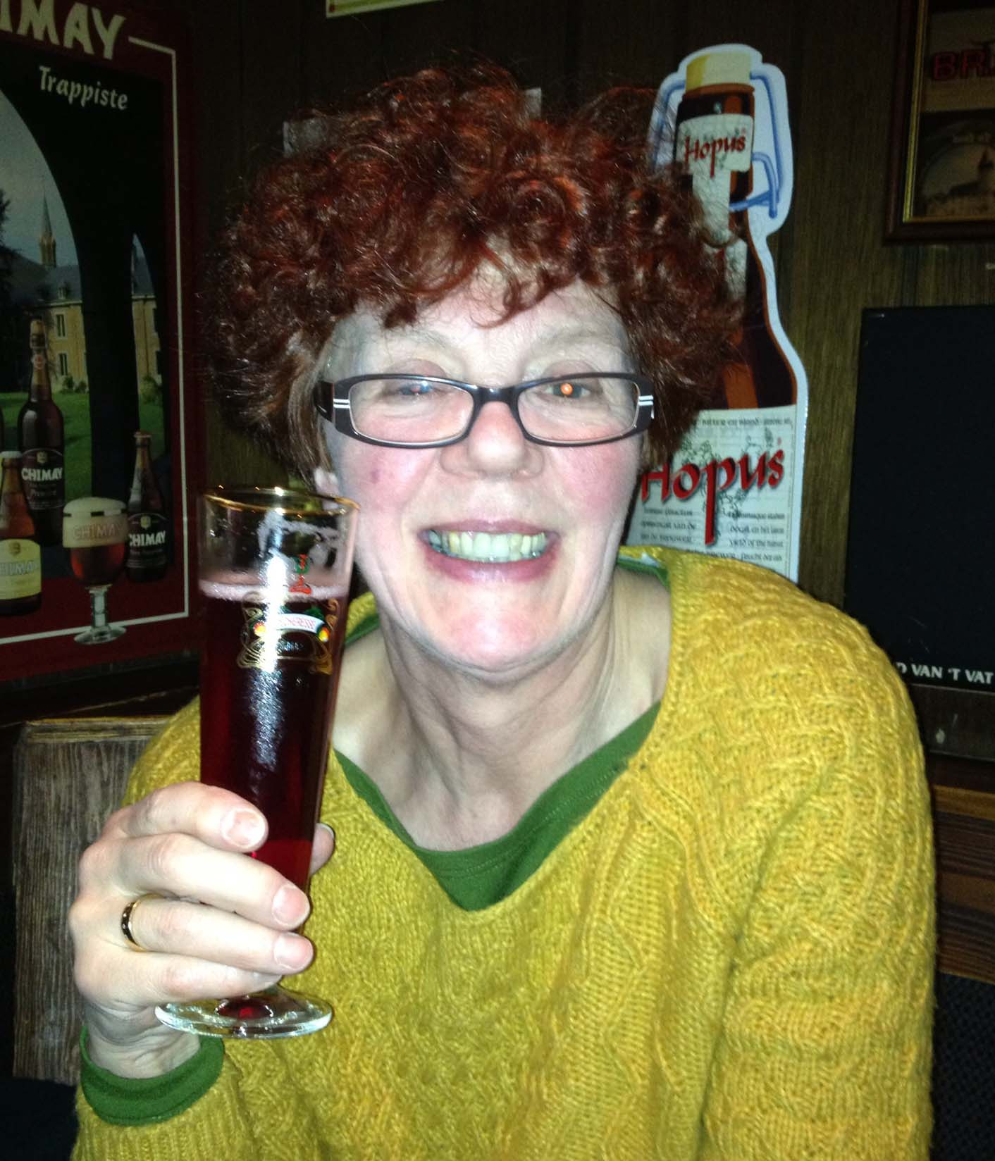
We are sure that you will be as sad as the North Africa Country Coordinators to learn that after six years of working on Libya we have had to bid farewell to Jackie Fry who has been suffering from bad back problems for some time. We thank Jackie for the fantastic work that she has done on Libya in past years. We shall particularly miss her artistic flair and IT skills. She will still be helping the team with one off tasks and she volunteers for Amnesty as a school speaker and is an active member of the Horsham group so she is still very much a part of the Amnesty family. Hugh Sandeman has taken over work on Libya but will continue to work on Algeria too.

New Country Coordinator required for the North Africa Team

We are looking for a new Country Coordinator to help with work on the region. We are particularly looking for someone who can develop our work in social media via Facebook and Twitter and by blogging on the forthcoming new Amnesty website.

Please spread the word. If anyone is interested please ask them to contact Beverley Foulkes-Jones in the first instance.

Contact the North Africa Regional Team

Tunisia
Beverley Foulkes-Jones
beverley.foulkes-jones@amnesty.org.uk

Algeria and Libya
Hugh Sandeman
hugh.sandeman@amnesty.org

Morocco
Situation vacant –
Beverley Foulkes-Jones acting in theinterim
beverley.foulkes-jones@amnesty.org.uk

Egypt
Ann Marcus
ann.marcus@amnesty.org.uk

Minister of Justice Councillor Ahmed Mahmoud Ahmed Mekky
Ministry of Justice
Lazoghly Square Ministry of Justice Building
CAIRO
Arab Republic of Egypt

Your Excellency
MOHAMED SAYED IBRAHIM ABDEL LATIF
I am writing to express my concern that the death of Mohamed Sayed Ibrahim Abdel Latif has not been impartially investigated. Mohamed Sayed Ibrahim Abdel Latif was shot dead on 29 Jan 2011 by the police in Imbaba, Giza Governate, while helping an injured man who had been peacefully protesting,.
The family of Mohamed Sayed Ibrahim Abdel Latif and their lawyers have been under pressure to drop the case, offered bribes to withdraw and witnesses to several killings were harassed and forced to sign false testimonies.
On 6 June 2012 the police officers of Imbaba were among 13 defendants who were acquitted of the murders on grounds of “self-defence”. Lawyers have subsequently questioned the role of the Public Prosecution office in investigating the evidence thoroughly and impartially.
In July 2012 President Morsi set up a Fact–finding Committee specifically devoted to investigating the deaths of protestors involved in the 25 January Revolution of 2011. After a new Public Prosecutor was appointed in November 2012 and following the Decree-Law on Protection of the Revolution by the President the family were told that they must submit NEW evidence. The court with “special jurisdiction” by which the case will be tried appears to put the burden of proof on the family with no commitment by the court to re-examine the evidence submitted at the time of Mohamed Sayed Ibrahim Abdel Latif’s death.
I would therefore be grateful if you could intervene to ensure that the Egyptian authorities scrutinise the evidence impartially, uphold the family’s right to truth and justice, and that those responsible for the death of Mohamed Sayed Ibrahim Abdel Latif (and others who were involved in a peaceful protest) are held to account. If the officers are found to be responsible for the death of Mohamed Sayed Ibrahim Abdel Latif I hope that the family will receive reparation.
Yours respectfully

