
Amnesty International
Southend Group
amnestysouthend.googlemail.com
www.amnesty.org.uk/southend

March 2014 NEWSLETTER
Next Meeting Thursday 10th April at 7:30pm
Avenue Baptist Church, Milton Road, Westcliff-on-Sea SS0 7JX
Liesbeth Ten Ham, E Anglia Regional Rep – Workshop on “Adequate Housing, a Right not a Privilege”

CAMPAIGNING
Write a letter to the Syrian Ambassador at the UN and e-mail the President of the Coalition of Opposition Forces in Syria asking them both to protect civilians caught up in the fighting. Go to:
https://www2.amnesty.org.uk/groups/southend/march-2013-newsletter for details and sample letters

Dr Tun Aung, Burma (Myanmar) – write a letter on behalf of this Prisoner of Conscience – details including a sample letter at http://www2.amnesty.org.uk/groups/southend/send-appeal-behalf-dr-tun-aung-burma

Womens’ Rights in Afghanistan – there are several actions in
the current AI UK Monthly Action. We took this photo of
Group members showing support for Afghan women human
rights defenders which will be used by AI to put pressure on
governments.. More details and sample letters at
https://www2.amnesty.org.uk/groups/southend/march-2013-newsletter
or to send an e-mail to David Cameron go to
https://www.amnesty.org.uk/actions/david-cameron-afghan-women-rights-afghanistan?from=issues

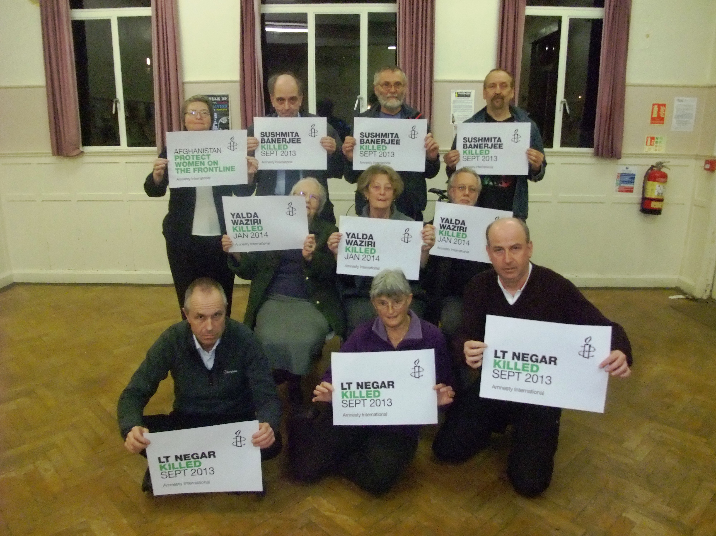

YET FURTHER REVISED PROGRAMME OF MEETINGS

This is our amended programme of meetings.
Meetings will start at 7:30pm and will normally be at Avenue Baptist Church.

WHEN | WHERE | WHAT
10th Apr | Avenue Baptist Church | Liesbeth ten Ham Housing Workshop
8th May | Avenue Baptist Church | Tony Fairman AI UK Burma Co-ordinator
12th Jun | Avenue Baptist Church | Human Rights Film
10th July | Avenue Baptist Church | Letter Writing/Campaigning

All meetings will include some letter writing. Further details of meetings will be included in this monthly newsletter and on the Group Website & Facebook page.

Meeting on 13th March 2014 at Avenue Baptist Church

This was the Group’s AGM – we spent the first part of the meeting on AGM matters then wrote letters on behalf of Dr Tun Aung, the Group’s Burmese Prisoner of Conscience, and to both sides in Syria asking them to protect all those caught up in the conflict – as there was a world-wide, candle-lit vigil that evening Lynnette lit a candle as we wrote the letters. We also took part in a photo action on behalf of women in Afghanistan. More details of these actions can be seen on the front page of this newsletter and on the Group’s website and Facebook page.

Present – Heidrun, Doug, Richard, Lynnette, Andrew, Martin, Audrey, Tricia, Mike & Muriel

Apologies: Maureen & Julian

Review of 2013-2014
We’d changed our approach during this last year, with less emphasis on fundraising and more on letter-writing/campaigning. The main reasons for the reduced amount of fundraising was the lack of support for events and the unsatisfactory events at AI and AI UK. We’d also tried meeting in different places but it was felt that this had not been successful and a “permanent” base was preferable. Mike will check with the Church to see if it’s OK to revert to meeting here every month (it is). We had written a lot more letters as a result of the changed approach and thanks to donations, and subject to the result of our imminent subs reminder, we are able to survive financially. Postage is our biggest expense.

Financial Report
At the beginning of the year our account stood at £776.80 and at the end of the year £745.56 but the Write for Rights postage, etc., expenses have reduced that to £585.44 to date. Apart from postage and incidental expenses we only need to find the annual AI UK Group membership fee. It was agreed to keep the annual subscription at the current level.

Election of Officers.
Richard agreed to continue as Chairman, Heidrun as Treasurer, Tricia as Publicity Secretary, Muriel as Membership Secretary and Mike as Secretary. Maureen did not want to carry on as Fundraiser and it was felt that there was no real need for us to have a specific post of fundraiser,. If anybody wanted to arrange an event e.g. a meal or Amnestea they could do so.

Next Year
We agreed to continue with the present format of meetings and try to get more speakers and another film – Mike to check what’s available from AI UK (still need to arrange a suitable film for 12th June). Heidrun will arrange distribution of Group posters to local libraries; Mike will try to book a display in October in the new library foyer which is now available at £10 per week. Audrey is still thinking about trying to set up a feeder group in Benfleet and may have an Amnestea to attract people – we could help with contacting individual AI members in the area.

AOB:
Martin is going to the Annual Conference and AGM in Edinburgh. He and friends of Lynette also went to the Regional Conference on Migration and Human Rights at Ely where the speakers were Richard Howitt MEP, a BBC presenter and someone from the CAB; a useful and interesting Conference.
We agreed to make a donation of £50 to the Church for letting us use the room.
Next meeting: 10th April 7:30pm at Avenue Baptist Church

Mike Pregnall
01702 204748

