Amnesty International

Southend Group


Meeting on 12th July 2012

PLEASE SUPPORT

Mike’s One Man Show!
Saturday 29th September

A Concert in
Hockley & Hawkwell Methodist Church Hall,
Main Road Hockley SS5 4QY

A vast range of entertainment!!

£10 inc. Hot Supper Under 12s £5
TICKETS AVAILABLE SOON

Proceeds to AI Southend
& Hockley & Hawkwell Meths.
Next Regional Meeting Cambridge
1st December Cambridge
No Group meeting in August
Next meeting Thursday 13th September

Amnesty Music Night 28th July 8:00pm 2 Christchurch Road, Crouch End N8 9QL. Bring a bottle and Food contribution. £10 (£5 concessions) donation at the door.
Hornsea & Wood Green AI

The new Group website is now up and running. It’s the same address as before so please visit www.amnesty.org.uk/southend (or type in Southend Amnesty on a Google search) and post your comments and feedback.
More material will be added soon. If you would like to add something contact Martin via amnestysouthend@googlemail.com

Monthly Action

The July Monthly Action from AI UK is a petition calling for the immediate and unconditional release of all prisoners of conscience in Myanmar including Aye Aung, Khin Kyi aka Zin Min Aung and Khun Kawrio. It also calls for the government to set up a review mechanism with assistance from the United Nation and with participation from civil society to identify all remaining political prisoners, who should be promptly charged with and tried for an internationally recognised crime or released. A petition form is attached that can be printed and signed in the old-fashioned way or you can sign it on-line at:
http://action.amnesty.org.uk/ea-action/action?ea.client.id=1194&ea.campaign.id=15309

We also wrote letters at the meeting on behalf of Pussy Riot (a women’s punk group detained in Russia for protest against the stifling of free expression and for
anti-Putin protests) and two Mexican Prisoners of Conscience, José Ramόn Aniceto Gόmez and Pascual Agustín Cruz who have spent 2 years in prison for a crime that they did not commit.

Details of these actions are attached
Please write to the Russian and Mexican authorities

Notes of Meeting held at Avenue Baptist Church 12th July 2012

Present – Maureen, Steve, Martin, Sonya, Helena, Mu and Mike. Steve took the Chair.

Apologies – Richard, Heidrun Audrey, Tricia & Doug

Notes of 24th June Meeting – no response from AI UK to criticism of Monthly Mailing; receipt received for £150 donation to AI in May; further £150 sent as agreed.

Campaigns – Djamel Fahassi – nothing new –Martin had posted details of his case on the new website (and subsequently discovered that the case had been closed). Arms Trade Treaty – after initially agreeing to a meeting James Duddridge’s Office wouldn’t give Doug an appointment because he wanted it for 'lobbying activity'; Doug will try to get to one of his open surgeries. Nothing recent despite the fact that the Treaty Conference takes place this month. LGBT – Richard sent a report detailing a ban in Uganda on 38 non-governmental organisations it accuses of undermining the national culture by promoting homosexuality and the break-up of a gay rights workshop organised at a hotel just outside the capital Kampala. AI has condemned this raid. In the UK a report by Stonewall suggests that many teachers still treat homophobic insults as mere ‘banter’ with severe consequences for young people. Almost one in four of those surveyed said they had tried to take their own life at some point (compared with 7% of all young people) and 56% said they had self-harmed. (Essex is apparently the most improved LEA for tackling homophobic bullying in schools). Corporate Responsibility – update about Shell AGM in May, where AI was represented – Shell is failing to meet its obligations to clean up pollution and compensate local communities despite acknowledging responsibility for events or being found guilty in the courts. AI will soon hand in a global petition to Shell about it’s activities in the Niger Delta
Forced Evictions, Women’s Rights and Death Penalty – nothing to report.

Treasurer – Current balance £277.60.

Fundraising – Next event - Mike’s One Man Show at Hockley Methodist Church on September 29th; the proceeds will be shared with the Church. Tickets available soon. Maureen will look at a possible Sunday morning Lazybones boot sale, collections at supermarkets and another meal (possibly at East again). There will be a meeting about the Art Lottery immediately after the Amnestea on 14th July.

Publicity – Mike will ask AI UK about a display for the Southend Library exhibition 8th -13th October; if no new one is available we will just have general publicity. Martin has designed the new Group website which, is now up and running. It’s the same address as before so please visit www.amnesty.org.uk/southend (or type in Southend Amnesty on a Google search) and post your comments and feedback. More material will be added as time allows. If you would like to add something, contact Martin via amnestysouthend@googlemail.com. Thank you to Martin for all his work on this – we are one of only 16 Groups in the UK that have converted to the new website format. Mike will apply for a stall at the SEC Freshers’ Fair on 20th September.

Secretary - There will be a meeting at AI UK Human Rights Resources Centre in London on 25th July at 7:00pm to discuss the Cost & Priorities Programme – e-mail sct@amnesty.org.uk or phone 02070331777 if you want to go. Further info at www.amnesty.org.uk/capp . There’s a free Skillshare event at AI UK on Saturday 6th October – contact training@amnesty.org.uk if you’re interested in learning how better to get across the Amnesty message. The Basildon Group has had to close – Mike to invite any ex-member there to come to our meetings. The next Regional Conference will be on the 1st December in Cambridge.

A.O.B. – There was some discussion about and criticism of the content of the Monthly Mailing and the Monthly Actions. Mike to inform AI UK of our concerns.

Next meeting – No meeting in August – next meeting Thursday 13thSeptember at Avenue Baptist Church, Milton Road, Westcliff-on-Sea SS0 7JX .

Mike Pregnall 01702 204748
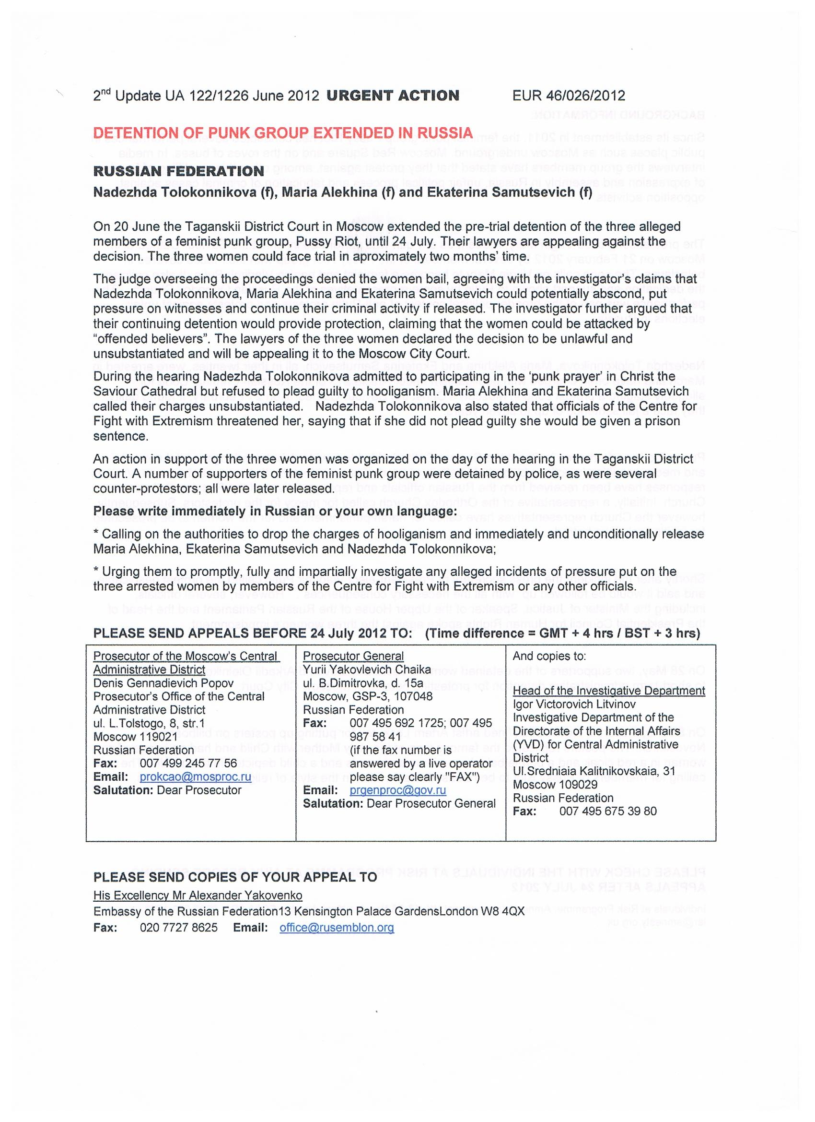
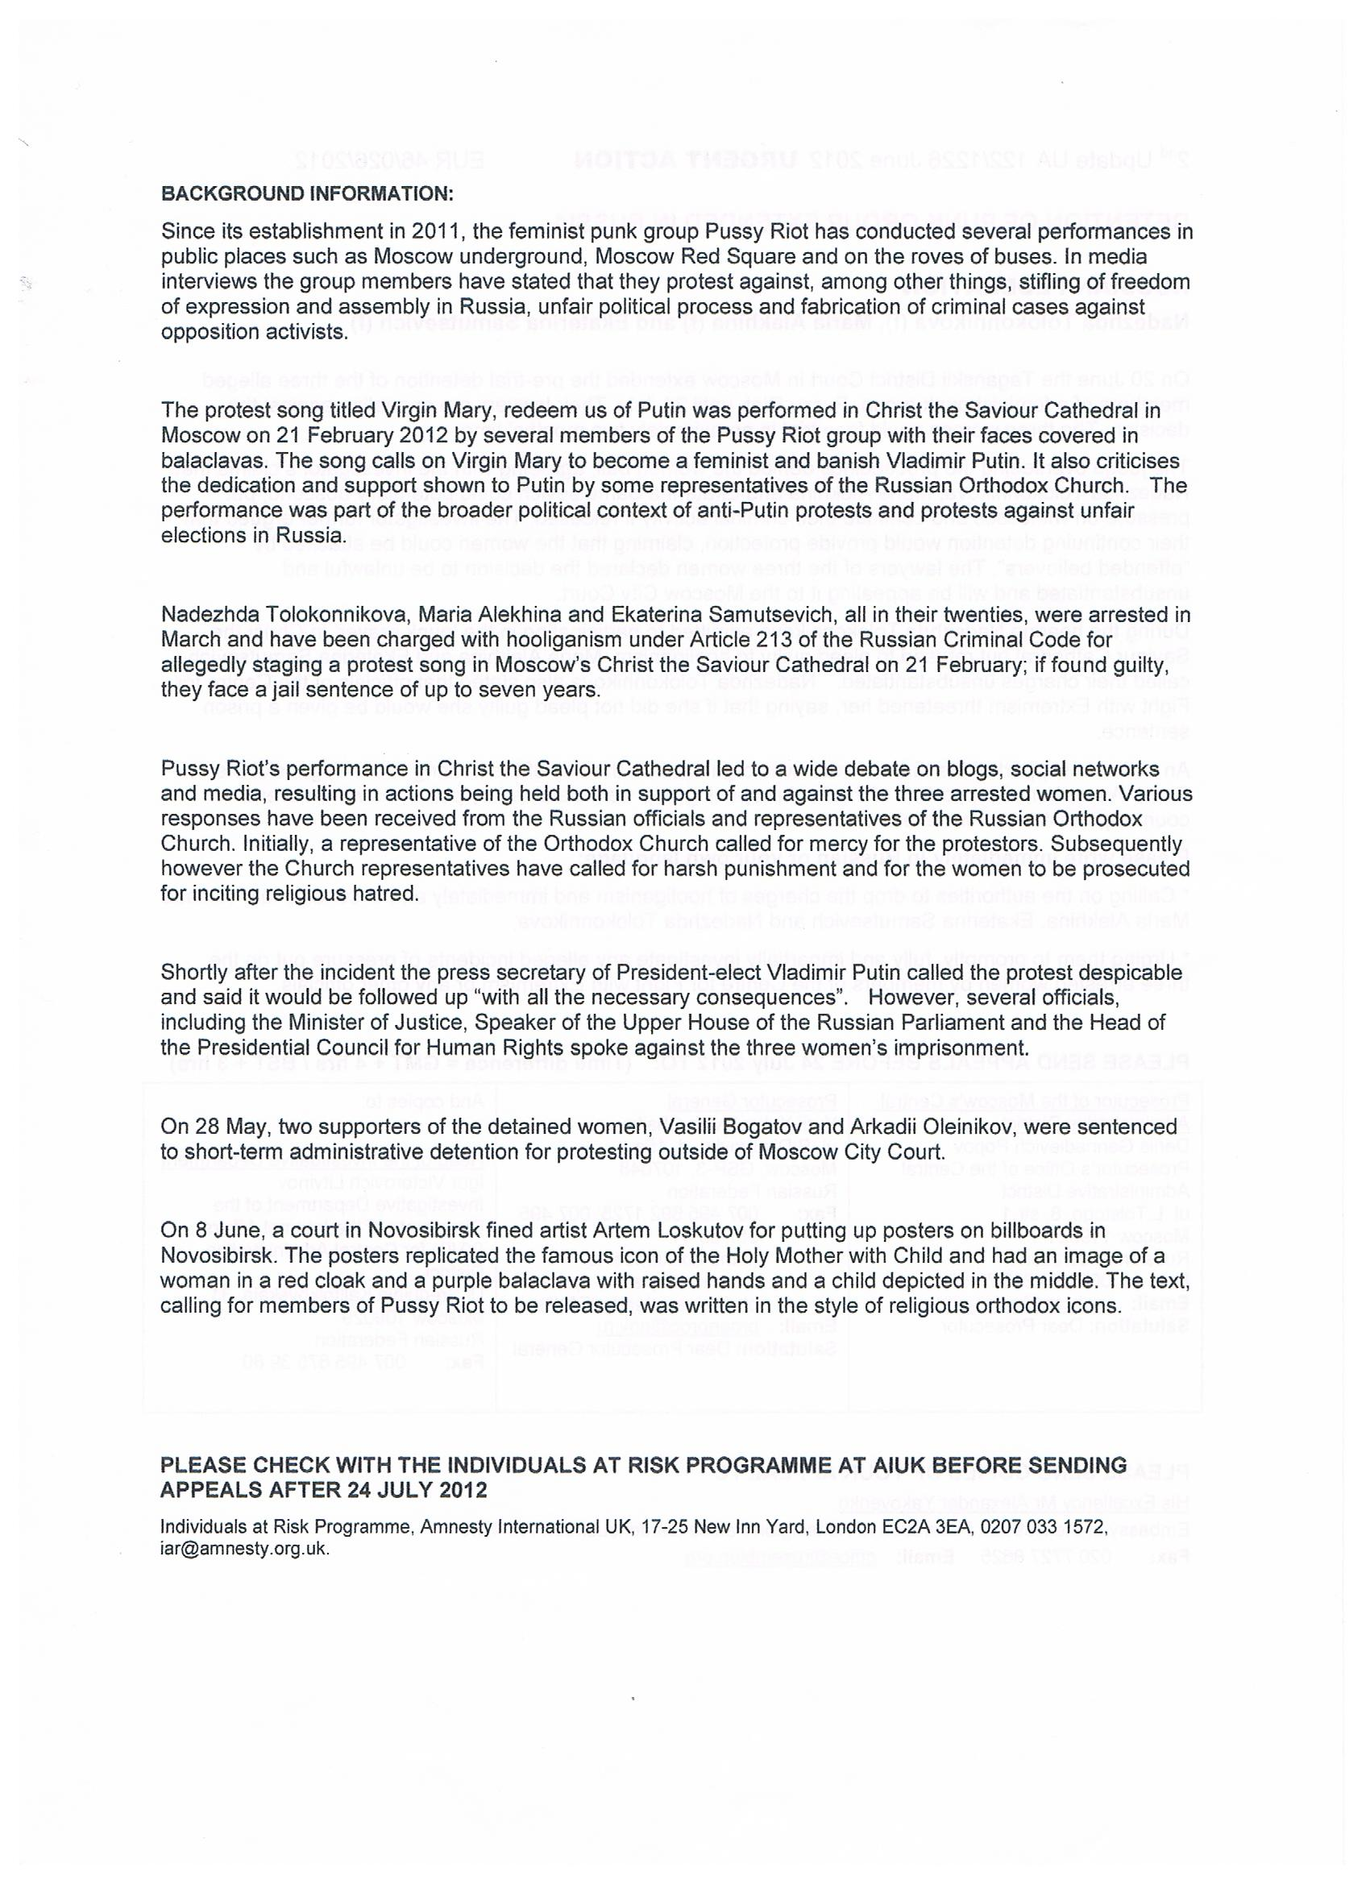

Freedom and justice for José Ramón and Pascual Agustín Cruz
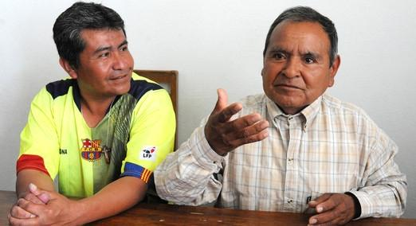
Pascual Agustín Cruz and José Ramón Aniceto Gómez in Huauchinango prison, Puebla, Mexico, 28 March 2012. © Ricardo Ramírez Arriola
“Sometimes I have felt exasperated, at 5:30 they lock us in again – I feel sad, I get desperate – sometimes I think, when will I get my freedom”
José Ramón Aniceto Gómez and Pascual Agustín Cruz are human rights defenders from the indigenous nahuátl community of Atla, in Mexico. They have already spent more than two years in prison for a crime they did not commit.
For many years a powerful local group controlled access to running water for their own economic benefit, charging connection fees which equate to more than four months wages for many community members. Whilst acting as elected leaders of their community, José Ramón and Pascual increased access to water in people’s homes. As a result of this work, they were detained, tried and sentenced to almost 7 years in prison by Puebla state courts for stealing a car - something they hadn’t done. The case against them was brought solely in reprisal for their legitimate work to extend their community’s access to water.
The investigation into the accusations made against José Ramón and Pascual were based on fabricated evidence and their trial was unfair. Jose Ramón and Pascual’s first language is nahua yet they weren’t provided with an interpreter or a defence lawyer with knowledge of their language or culture, severely undermining their right to a fair trial. The authorities also failed to carry out an impartial investigation to establish the facts, and the judge denied their right to the presumption of innocence and equality before the law.
Two years have passed and the men remain in jail. Take action now to demand that the Mexican President ensures that the government immediately and unconditionally releases José Ramón and Pascual.

Dear President Calderón,

Freedom and justice for José Ramón and Pascual Agustín Cruz

I am writing to you to express my deep concern regarding the unfair trial of José Ramón Aniceto Gómez y Pascual Agustín Cruz, two indigenous human rights defenders from the Nahuan community of Atla, in the municipality of Pahuatlán, Puebla State.

They have already spent more than two years in prison for a crime they did not commit as the result of their work to guarantee access to water in their community. In 2010, they were detained, tried and sentenced to almost seven years in prison by Puebla state courts.

The two men are prisoners of conscience and Amnesty International will campaign on their behalf until they are released. The human rights organisation has documented many of the irregularities which resulted in the unsafe conviction of José Ramón Aniceto Gómez y Pascual Agustín Cruz, including the denial of their right to an impartial hearing, equality before the law, the presumption of innocence, and the right to an effective defence.

I welcome the fact that the Supreme Court of Justice of the Nation has decided to review the case, as it is essential to correct the injustices that the two men have faced and to remedy the human rights violations committed against them.

Mr President, I call on your government to ensure José Ramón Aniceto Gómez y Pascual Agustín Cruz’s immediate and unconditional release, to guarantee a full and impartial investigation into their unfair detention and trial and to hold to account those responsible.

Yours sincerely,

President Felipe Calderón,
Casa Miguel Alemán,
PB,
Col. San Miguel Chapultepec,
11850,
Ciudad de México,
Distrito Federal
Mexico

