Film Workshop
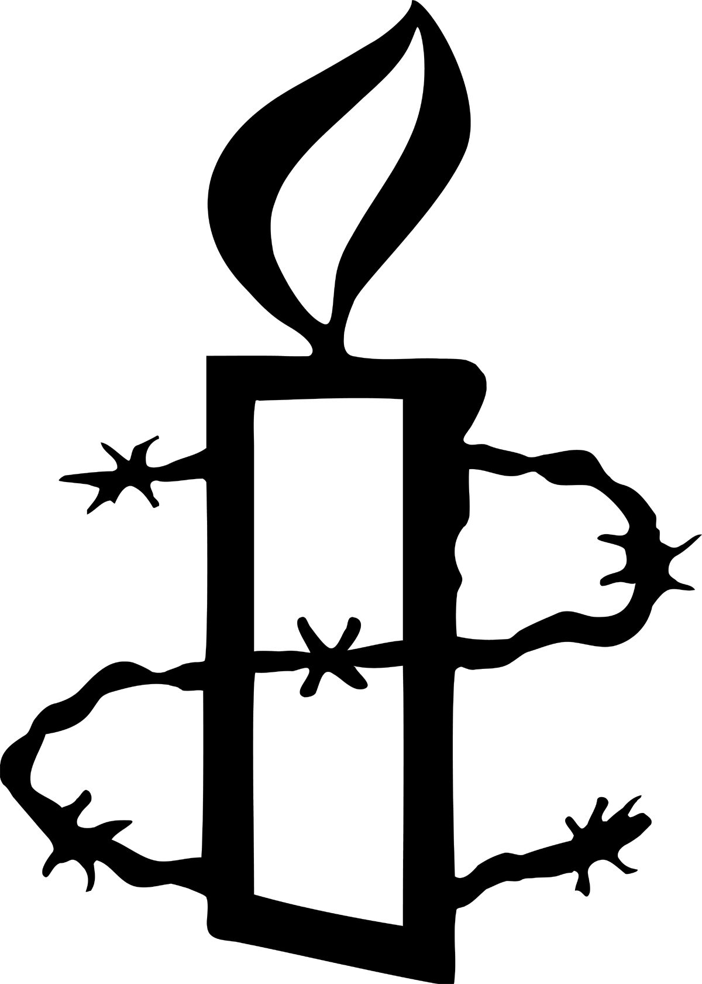

The Kite Runner
Use in conjunction with the PowerPoint presentation.

Before the film (PP Slide 2)
- Introduce yourself
- Introduce Amnesty International
- Talk about human rights – You could introduce human rights, and the Universal Declaration of Human Rights, depending on the group’s level of knowledge (PP slides 11 and 12 - optional)

Background (PP slide 3)
Use the map to show where Afghanistan is. Introduce the film by sharing some of the background information below with the group, as appropriate. Additional, detailed notes on the background to the film can be found at the end of the workshop notes.
- The film is based on the novel by Khaled Hosseini and is set in Afghanistan and California, USA
- Afghanistan is culturally and ethnically mixed: the largest group is Pashtun (42%), followed by Tajiks (27%), Hazara (9%), Uzbek (9%) and other smaller minorities
- The film starts just before the Soviet invasion of Afghanistan in 1979 and ends at the time when the Taliban had control over much of the country in 2000 (depending on your group you may want to explain who the Soviet forces were, and who the Taliban is)
- The Soviet occupation led to the killing of between 600,000 and 2 million Afghan civilians and 5 million Afghans fled, many to Pakistan and Iran
- Following the Soviet withdrawal in 1989, there was a power vacuum – there wasn’t a strong group ready to take over power, just lots of smaller, local warlords. Eventually a group called The Taliban took advantage of this situation and took control over most of the country. They imposed strict codes of behaviour based on their interpretation of Islamic law and in particular restricted the role and rights of women, including to education. Kite flying and recorded music were among the pastimes banned

Questions to think about during the film (PP slides 4, 5, 6)
Choose one, two or all three of the questions. Ask the audience to think about them whilst they watch the film. These are the questions that you’ll discuss afterwards.

- When Amir returns to Afghanistan, what human rights do we see have been taken away from the people living there? (Refer to optional slide 12 for an explanation of human rights and some examples)

- What inequalities do people face in the film?

- What do we learn of the lives of Afghan refugees in the US?

After the film

Warm-up activity (PP slide 7)
Top Tip: It can be difficult to manage a discussion amongst a large group of people. Why not use a signal to show the audience when to be quiet? You could:
- Raise your arm
- Or make a noise with a musical instrument
Remember to explain this to the audience before the first discussion!
Ask the audience to talk to their neighbours
and come up with
- a question
- a fact
- a feeling
that the film has suggested to them. Spend a few minutes sharing these initial responses.

Discussion questions and possible responses:

QUESTION 1
(PP slide 4)
When Amir returns to Afghanistan, what human rights do we see have been taken away from the people living there?
- Right to freedom of expression: Men growing beards made compulsory, women required to wear burka – some men/women may choose to do these things due to their religious beliefs, others may have them forced upon them against their wishes – this illustrates that a balance can be difficult between human rights and religious beliefs
- Right to rest and leisure: Music banned, entertainment strictly controlled (no women at the football match, watch the football match in silence), street life virtually non-existent
- Stoning to death for adultery – There is no specific article in the UDHR relating to the death penalty, although in Amnesty’s view the use of the death penalty is a direct abuse of Article 3, the right to life and is the most extreme example of torture and degrading treatment – Article 5.
- Freedom of movement: Checkpoints curtail freedom of movement

QUESTION 2 (PP slide 5)
What inequalities do people face in the film?
- Between the two boys: Hassan waits on Amir and lives in much poorer conditions; Amir has good education, Hassan has to teach himself to read
- Prejudice against the Hazara: Assef uses this as excuse to persecute and rape Hassan; In the US the General refers to Sohrab as ‘that Hazara boy’
- Between those in power and those with no power: Soviet soldier tries to rape woman in the truck when Amir and his father are fleeing; Children in orphanage treated as objects for the Taliban official.

QUESTION 3 (PP slide 6)
What do we learn of the lives of Afghan refugees in the US?
Examples of continuity:
- Kiteflying – still a major pastime
- Respect for rank eg ‘General’ (‘a Pashtun to the root’), despite new life in the US
- Support of community of other Afghans when father is ill
- Traditional codes of behaviour e.g. father asking for girl’s hand in marriage/general’s family driven out of Virginia because of Soraya’s running off with a boy
- Religious funeral for father
- Prejudice against the Hazara e.g. the General’s reaction to Sohrab
Examples of change:
- Father, a successful businessman, working in a gas station
- General running a market stall
- Amir almost apologises for attending ‘just a community college’
About Amnesty International (PP Slides 8 and 9)
Give more information about Amnesty International. You could also talk about your personal involvement with Amnesty, or ask the audience to talk about their involvement.

Take action (PP Slide 10)
Amnesty members take action to change things for the better. Amnesty members take action to change things for the better. Use slide 10 to encourage students to take action on one of Amnesty’s campaigns.

Thank you
Thank your audience for their time. Take questions. Take action.

Further background notes

Please note: Although Amnesty International is running a workshop alongside the NSFW screening of Kite Runner, this does not mean that Amnesty supports all the views put forward in the film. Please make this clear during the course of your workshop activities.

Context

Afghanistan is a mountainous country in central Asia with a population of approximately 32million. It is culturally and ethnically mixed: the largest group is Pashtun (42%), followed by Tajiks (27%), Hazara (9%), Uzbek (9%) and other smaller minorities. Because of its position it has often seen invasions by different foreign powers seeking to use it as a buffer zone or to boost their own power in the region. Since the late 1970s it has been in a state of civil war, often involving different ethnic loyalties and including foreign interventions such as the Soviet invasion of 1979 and the US-led invasion of 2001.

The film opens just before the Soviet invasion of December 1979 and ends in the period of Taliban control of much of the country in 2000. The Russians invaded to prop up a pro-Communist government. The Soviet occupation led to the killing of between 600,000 and 2 million Afghan civilians and 5 million Afghans fled, many to Pakistan and Iran. TheUS continued to fund the mujahedin who fought against the Russians. In 1989, the Russians withdrew as a result of increasing numbers of casualties and international pressure. This left the various factions fighting each other and the emergence of regional warlords: in 1994 over 10,000 people were killed in Kabul alone. In this vacuum, the Taliban (mainly Pashtun) with their fundamentalist religious ideas came to the fore and in 1996 seized Kabul. By the end of 2000, they had control over 95% of the country and imposed very strict rules of behaviour based on their interpretation of Islamic law. Women’s rights in particular were severely curtailed.

Afghanistan today
Following the attack on the World Trade Center in September 2001, the US led an invasion of Afghanistan because the Taliban refused to hand over Osama bin Laden. They overthrew the Taliban government and in 2004 a new constitution was ratified with Hamid Karzai as President. In 2005 there were elections to the new National Assembly. However, its authority is really only recognized in the area round Kabul. The problems that the government faces are renewed Taliban insurgency, desperate poverty with limited access to health care and education, ineffective infrastructure and the difficulties caused by the opium trade which accounts for 90% of the world’s supply and is between half and two thirds of the Afghan economy. Money from the trade helps to buy arms to oppose the government. The UK and the US both still have forces in parts of the country. Osama bin Laden was discovered in Pakistan in May 2011 and was shot and killed by US Navy SEALs and CIA operatives.

Sohrab and Rustum
There are several references to this story in the film. It comes from the Shahnameh, an 11th century epic based on ancient Persian history and legend. Rustum is a hero who fathers a son with a princess. The baby Sohrab grows up to be a great warrior and Rustum determines to fight him. He did not know he had fathered a son as the princess told him she had given birth to a daughter. At their third encounter Rustum killed Sohrab but discovered from the seal his mother had placed on his arm that he had killed his own son. Hassan in the film is the unacknowledged son and Sohrab is Amir’s unknown nephew until Rahim Khan reveals his relationship.

