Amnesty International  Frome Group Newsletter  WE ARE ORDINARY PEOPLE FROM ACROSS THE WORLD STANDING UP FOR HUMANITY AND HUMAN RIGHTS  Website: www.amnesty.org.uk/groups/frome  Facebook: www.facebook.com/fromeamnesty  2016, what a year… and bring on 2017!  I’ve heard many people saying how they are glad to see the back of 2016 and make no mistake Amnesty International definitely had its work cut out this year. But before we write 2016 off as a terrible year let’s look at the positives…  Did you know, this year you helped to free more than 650 people – that’s nearly two each day of the year – from unfair and often abusive imprisonment?  Please have a look at the 33 ways that Amnesty supporters have helped change lives this year in every region of the world by clicking on this link …  https://www.amnesty.org.uk/blogs/ether/33-reasons-be-positive-about-2016  So how has Frome group been contributing to Amnesty’s efforts… Well here it is – what we all got up to….A massive thank you to everyone who signed a letter, sold books, sold cakes, ran stalls, signed a petition or wrote a message of support to a prisoner of conscience. |  | January 2017  Issue 10  Issue 2  IN THIS ISSUE: * *Frome Amnesty - what we did in 2016! * January events - Archangel pub letter writing -January coffee morning fundraiser

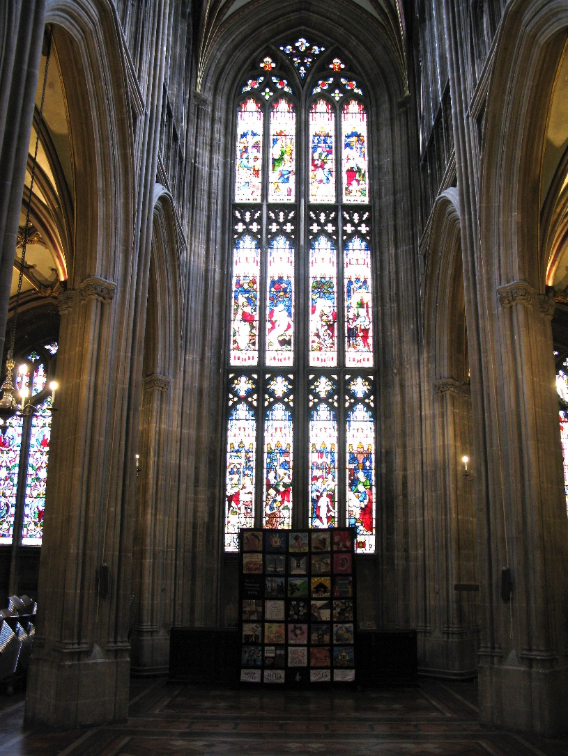
January – Amnesty South’s Tapestry
In January a group of us went to Salisbury Cathedral to see the finished tapestry. Three supporters of the Frome group made three 'squares' to represent three different Articles of the Declaration of Human Rights. The tapestry had pride of place at Salisbury Cathedral for six months, just metres from Magna Carta. It then travelled to Bristol in the Summer to make a guest appearance at the annual Golden Garden Party. It then took up a happy new residence in St. Mary Redcliffe one of Bristol’s oldest and most beautiful churches. This was just in time for 12 Nov, being the 800th anniversary of the second sealing of Magna Carta in Bristol. It is going to Gloucester cathedrale soon.
It was such as success at Salisbury Cathedral that there are plans afoot to have it back there for the summer, for the 800th anniversary of Henry III’s Charter of the Forest.

February – Coffee and Cake!
Ann kindly hosted a coffee morning and bring and buy sale and we sent 20 letters.

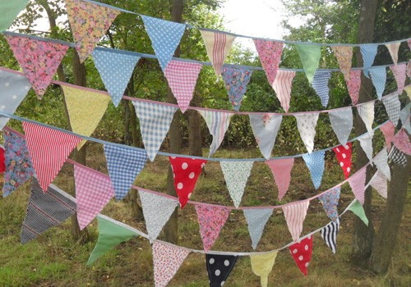
April – Books and Bunting!
We wrote messages on bunting triangles to girls who had fled from early, forced marriages and who are currently housed in shelters across Burkina Faso that are supported by Amnesty International. 33 letters were sent to the authorities in Burkina Faso.
We also sent 20 letters about a prisoner of conscience.
Despite the rain it proved to be a popular event. It was great to see that the books attracted lots of people to the stall, young and old, including many people who hadn’t heard of Amnesty International.

April was also Amnesty International’s national conference/ AGM and Frome group’s AGM. Kit Pharaoh stepped down as treasurer after 4 years and Claire Stott kindly agreed to take over this position. Judy Hosegood continued as the group coordinator and I (Nadine Crook) took over the role of group secretary/ newsletter editor temporarily from Cath Adkins.

May – Film night and the first of many pub letter writing sessions

May was a busy month! We submitted a question about the Human Rights Act to the hustings arranged in Frome before the General Election.
We gave out tailor-made leaflets on the door at the Athenaeum in Warminster after Warminster film society’s screening of “Difret”. The leaflet linked the film (which was based on a true story) into Amnesty’s campaign on early, forced marriage in Burkina Faso and gave details of how people could take action by signing an online petition or writing a letter. Approximately 80 people attended the film and about 50 leaflets were given out and many people were really keen to read the leaflet.

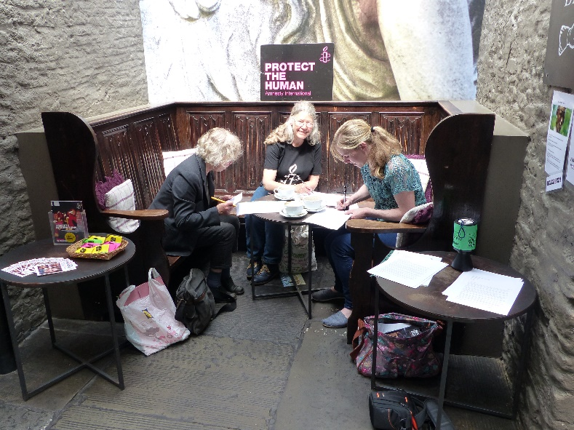
May also saw the first of our pub letter writing sessions at the Archangel pub on King Street.
Our first “pop-up letter signing shop’ was a lovely, social affair. 21 letters were sent.

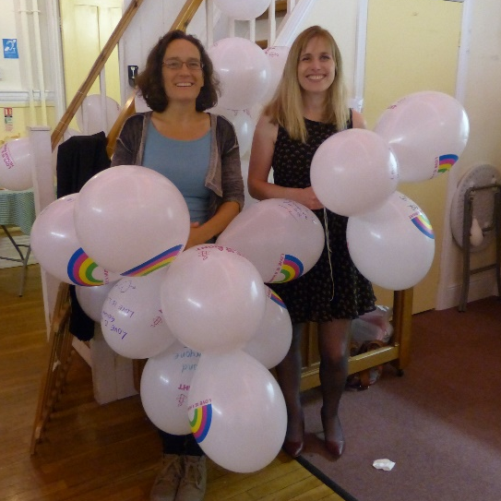
June – Frome AI supports Midsomer Norton’s Pride event
Midsomer Norton held its first ever Pride festival on 17/18th June and Frome AI group was there for the opening of the festival.
We showed our solidarity with the LGBTI community in Tunisia by writing messages of solidarity on balloons and signing letters to the Tunisian authorities at the screening of the film ‘Pride’ in Midsomer Norton’s town hall. We were overwhelmed by the show of support for our solidarity action. In total 20 people wrote messages on balloons and posed for their photo to be taken and 22 letters were signed, during the interval of the film. The photos were emailed to AIUK who have used them to create posters and postcards which will be shared with LGBTI organisations in Tunisia who will in turn share them with survivors of sexual and gender-based violence.
June also saw a flurry of letter writing activity! We held 2 more letter signing sessions at the Archangel. On 4th June we sent 16 letters and on 18th June we sent 18 letters.

July – Hidden gardens fundraiser and much more letter writing!
Saturday 9th July was a busy day! We held a tea and cake stall at Orchard street allotments as part of Frome festival’s Hidden gardens event. Our stall publicised Amnesty International and raised much needed funds to cover our postage costs!

On the same day we also held a pop-up letter signing stall at the Archangel pub and sent 43 letters!
Another letter signing stall was held at the Archangel on Saturday 23rd July and another 16 letters were sent!

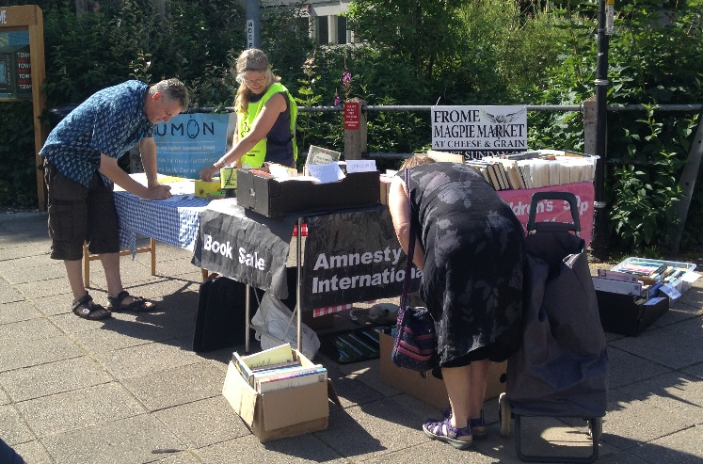
August – The ‘Refugee pledge’
On Saturday 6th August we held a book sale, letter signing stall and asked people to sign the Refugee Pledge.
The pledge called on the Prime Minister to lead in delivering a humane and effective response to the global refugee crisis. This action was part of a nationwide action undertaken by Amnesty groups across the country.
Our pledge placard then joined thousands of others at the Welcome Refugees march in London on 17th September (2 days before the UN special assembly on refugees).
We also sent 33 letters; 15 letters to United Arab Emirates and 18 to Brazil.
A few of us attended a talk by Jim and Tabitha Ross (husband and wife team) about their work with the SYRIA CAMPAIGN, hosted by West Wilts Amnesty group on 30th August.

The Syria campaign is an independent advocacy group campaigning for a peaceful and democratic future for Syria. The talk was both an informative and heart wrenching account of the current situation in Syria. Watch out for a film soon to be released on Netflix called ‘The White Helmets’. West Wiltshire group are planning to show this film. I’ll keep you posted! For more information and to sign up to the email list for the Syria campaign, please go to https://thesyriacampaign.org/?akid=326.7306.X55Qfb

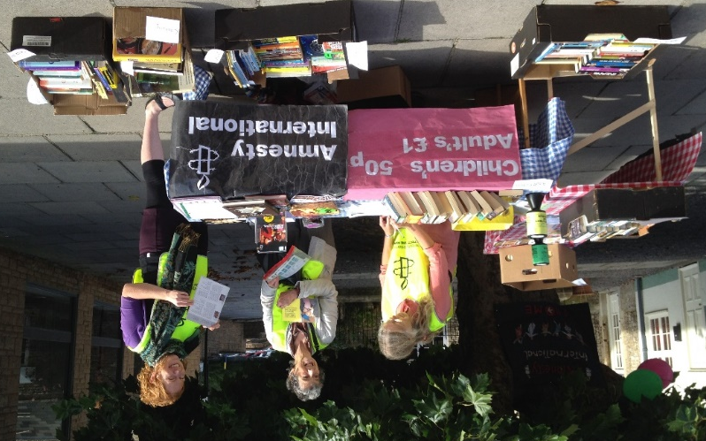
September – We joined Facebook!
We set up a Facebook group…
https://www.facebook.com/fromeamnesty/
So please like us, share us and subscribe to our events to hear about all upcoming group actions and events.
We also held a letter signing stall and book sale just outside M&S on Saturday 24th September.
November – Refugee play
We held an awareness raising stall at the play ‘You, Me and the Distance between us’ and sent 8 letters to Amber Rudd, the Home Secretary, urging her to take a lead in Europe and to welcome our fair share of refugees.
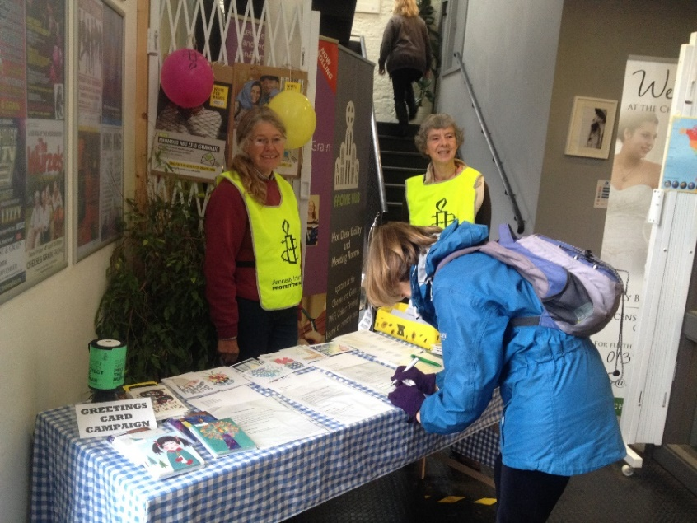
December – Write for Rights
We held a Write for Rights letter and card signing stall in the Foyer of the Cheese and Grain on Saturday 12th November and again on Saturday 10th December (Human Rights day). This year we focused our efforts on 6 individuals:
Nazanin Zaghari-Ratcliffe (a British-Iranian citizen), Mahmoud Abu Zeid (Egypt), Eren Kesken (Turkey), Ilham Tohti (China), Annie Alfred (Malawi) and Johan Teterissa (Indonesia). In total we sent 59 cards to these 6 people and 57 letters to the authorities. We also sold all packs of our Amnesty Christmas cards.
What a year! In total we have sent 337 letters! That’s nearly 1 letter for each day of the year! (and that’s not including the messages of solidarity written on cards, bunting and balloons!)
Thank you everyone for all your support. Hopefully this has whet your appetite for more human rights campaigning in 2017 and with that in mind….

Save the dates!

Saturday 21st January
The pop-up letter signing stall returns to the Archangel on Saturday 21st January 10:30-12. So feel free to pop by for a coffee and meet some fellow Frome Amnesty supporters and sign a letter or 2!
Saturday 28th January!
On Saturday 28th January come and enjoy a cuppa at our Frome Amnesty coffee morning.
Ann Burgess has kindly offered to host a coffee morning again at her house this January. It will be on Saturday 28th January 2017 10am-1pm. Her address is 64 Weymouth Road, Frome, BA11 1HJ. Please bring along yourself and a cake (if you’d like to contribute to the cake sale).

Your ideas for the newsletter…
If you have any feedback on this newsletter or would like anything included in the next issue then please feel free to contact me – Nadine Crook njwardman@yahoo.co.uk
Our group meets on the third Thursday of each month at the Bridge Café, Selwood Road, Frome, BA11 3BS at 8pm.
Our next meeting is: Thursday 19th January 2017.

