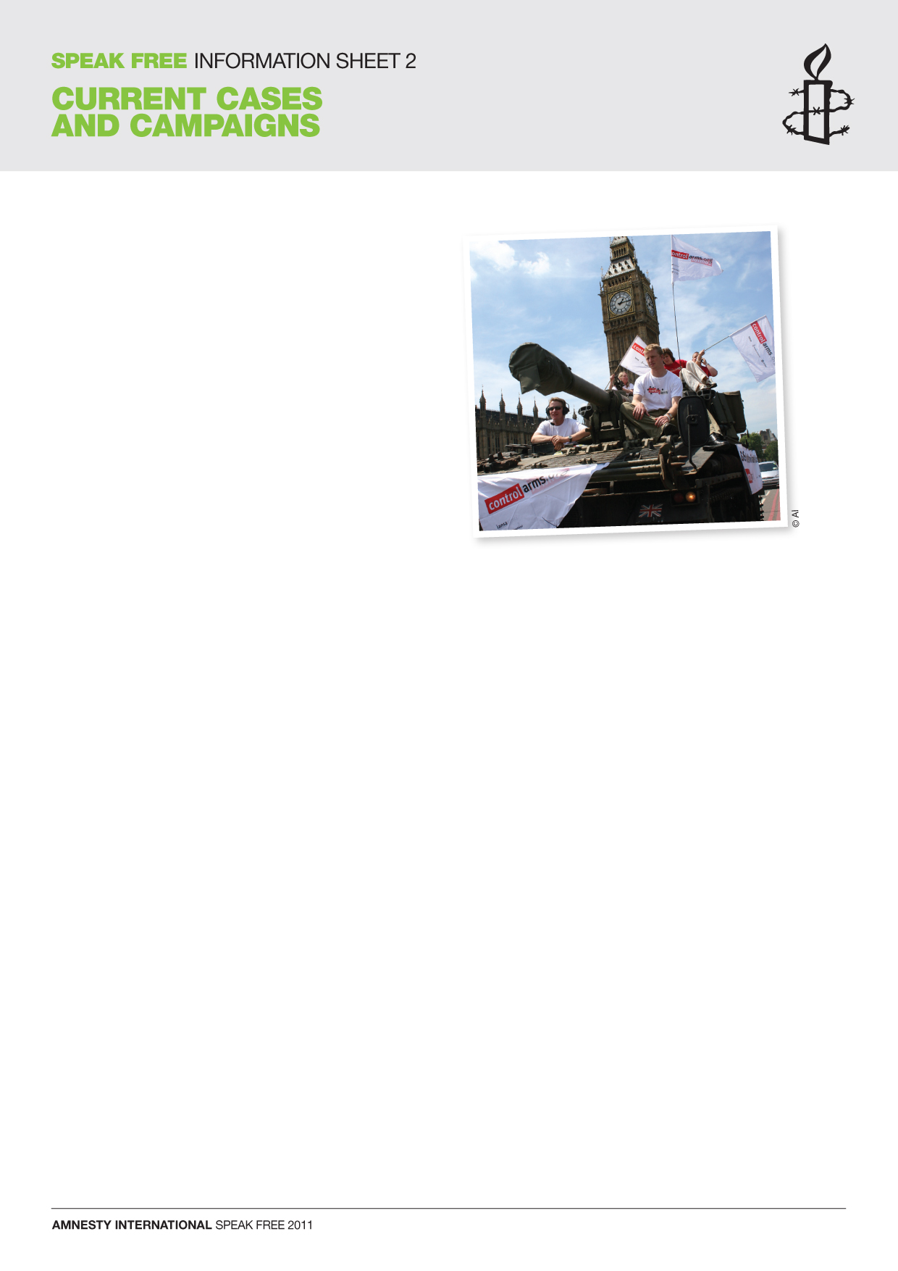
AMNESTY’S CAMPAIGN WORK – EXAMPLE 1

CONTROL ARMS CAMPAIGN
What / Who An international Arms Trade Treaty would help make people safer from armed violence by ensuring that both the supply and the use of weapons are strictly controlled by tough laws.

Where Worldwide

When Amnesty International has been involved in this campaign since 2003.
Why 740,000 people die every year as a result of armed violence. That’s more than one person a minute.

How DID AMNESTY CAMPAIGN More than 1 million people from all over the world took part in the Million Faces Petition calling for tighter arms controls. Many young people also wrote to the Foreign & Commonwealth Office and in June 2009 120 young Amnesty and Oxfam activists were invited to the FCO in London to meet officials and senior politicians. The aim of the meeting was to discuss the need for an Arms Trade Treaty. Young people have emailed US President Barack Obama, written to their MPs and to the Foreign Secretary, joined a FaceBook group, and taken part in publicity stunts like the one in the photo.

Outcome Before the Control Arms campaign started in October 2003, only three governments supported an Arms Trade Treaty: Costa Rica, Mali and Cambodia. In December 2008, 137 countries voted the Arms Trade Treaty through to the next formal stage of its development. 192 states are now involved in the treaty talks (2011-2012).

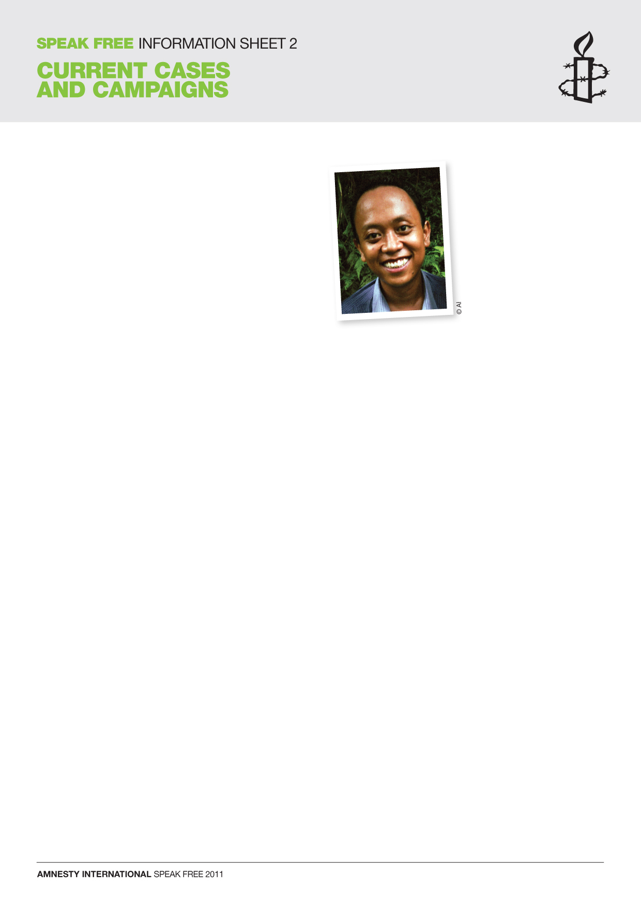
AMNESTY’S CAMPAIGN WORK – EXAMPLE 2

INDIVIDUAL AT RISK
IGNATIUS MAHENDRA
KUSUMA WARDHANA

What / Who A student leader called Mahendra, then aged 21, was sentenced to three years’ imprisonment after taking part in a peaceful protest.

Where Indonesia

When Mahendra was imprisoned in 2003

Why Mahendra was found guilty of ‘insulting the President or Vice President’ after participating in a peaceful demonstration against fuel price increases. Amnesty International considered Mahendra to be a prisoner of conscience.

How DID AMNESTY CAMPAIGN Young people from schools and universities, local group members and others across the UK sent greetings cards to Mahendra while he was in prison. People also wrote to the Indonesian government asking for his release.

Outcome Mahendra was finally released in August 2005 after being imprisoned for more than two and a half years. He told Amnesty of the poor food and conditions in prison, and said it was ‘a very lonely place’. The letters from Amnesty members were a great comfort: ‘We knew from the letters that many people were supporting us and that we were not forgotten.’

Mahendra has always been a courageous activist.He noticed that the guards treated him more carefully once the greetings cards arrived and he felt brave enough to start campaigning inside the prison for free access to clean water.

After Mahendra’s release, there was a landmark change in the Criminal Code in Indonesia. In December 2006, the Constitutional Court voted to change part of the law under which Mahendra had been imprisoned. ‘Insulting the President or Vice-President’ is no longer a crime.

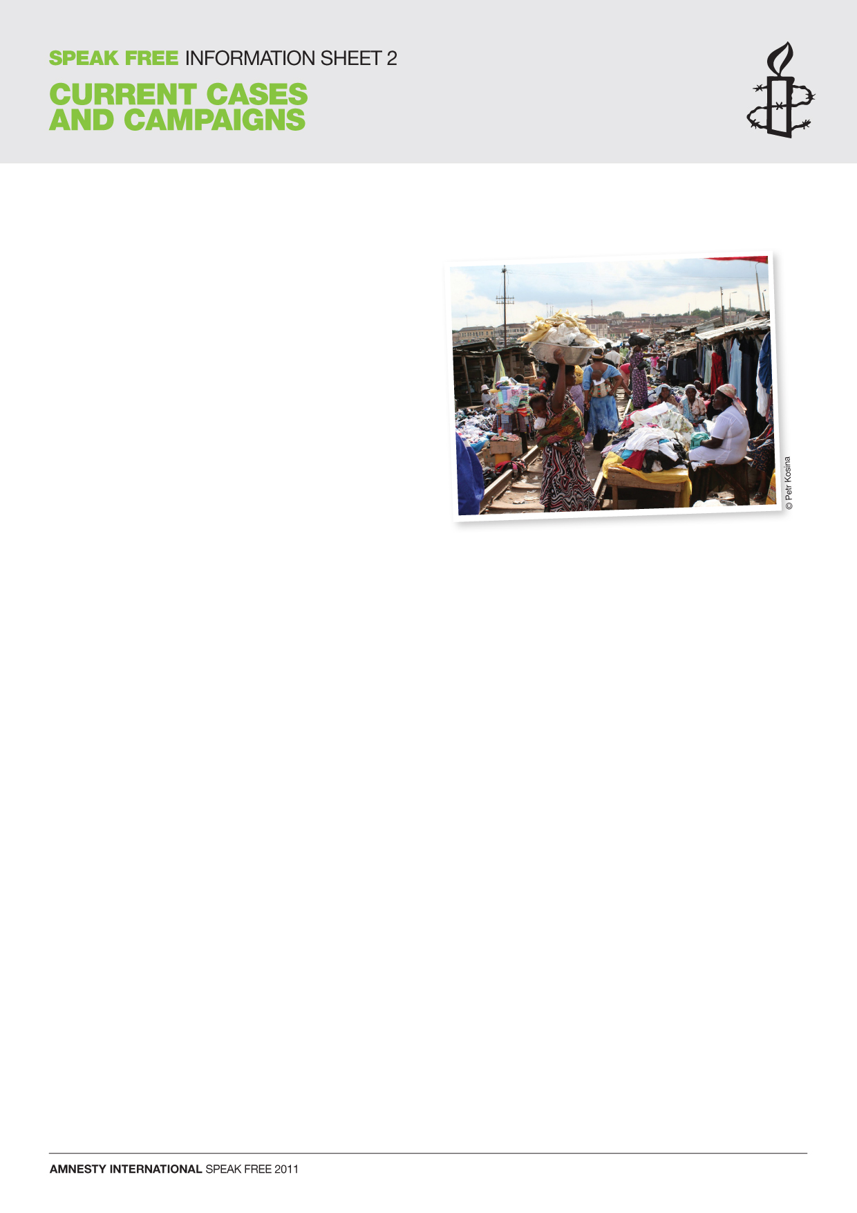
AMNESTY’S CAMPAIGN WORK – EXAMPLE 3

END FORCED EVICTIONS
What / Who Amnesty works to try to stop people being forcibly evicted from their homes. Thousands of people living and working next to railway lines in Accra, the capital of Ghana, face the threat of eviction from their homes.

Where Accra, the capital of Ghana, in West Africa
When January 2011

Why The Railway Dwellers, the men, women and children, who live and trade in kiosks and small structures along the railway lines, faced homelessness and extreme poverty if forcibly evicted from their homes. Forced eviction is a violation of human rights.

How DID AMNESTY CAMPAIGN Between December 2010 and January 2011, more than 63,000 people across the world signed an Amnesty petition. It was handed in to the authorities in Accra. It urged them to stop the forced evictions and to ensure that the human rights of the Railway Dwellers were respected and protected.

Outcome Thankfully, the eviction in Ghana did not take place as scheduled. However, the community is still under threat. Amnesty Ghana, along with many other local and international organisations, is working with the community and the authorities to try to resolve the situation. In addition, Amnesty International Ghana is seeking the involvement of the President of Ghana.

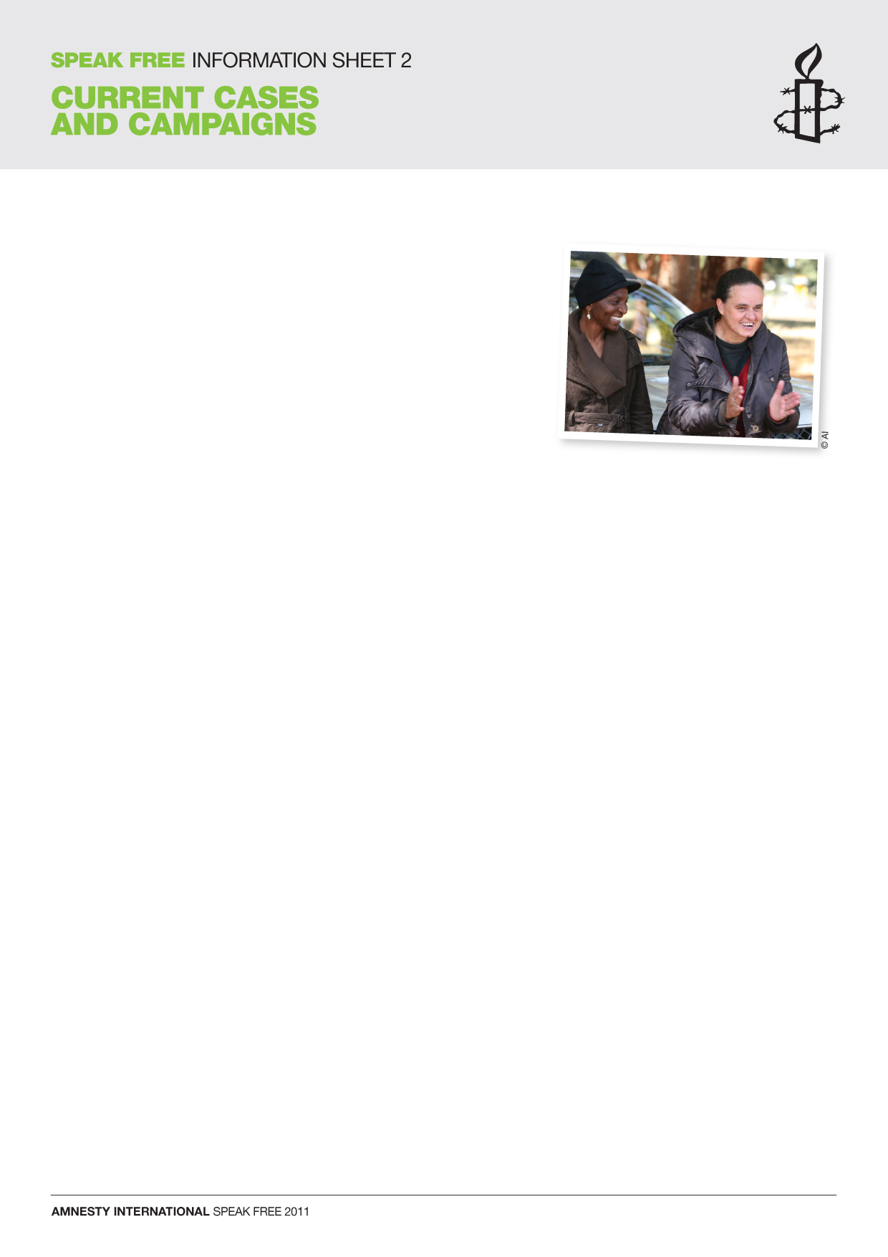
AMNESTY’S CAMPAIGN WORK – EXAMPLE 4

WOMEN OF ZIMBABWE ARISE
(WOZA)

What / Who WOZA was formed to provide women with a united voice, encourage them to stand up for their rights and freedoms, and to empower them to take leadership roles in the community. Members of WOZA have been arrested, harassed and severely beaten in police custody after holding peaceful protests. They have repeatedly been denied access to food, lawyers and medical care while in detention. Despite the human rights abuses they face, WOZA members continue to show great courage in their struggle to defend their rights.

Where Zimbabwe, in southern Africa

When Since WOZA’s formation in 2003.

Why WOZA members were arrested for exercising their right to peaceful protest.

How DID AMNESTY CAMPAIGN Young people all over the UK sent cards to WOZA as part of Amnesty’s Greetings Card Campaign. They also sent paper roses to WOZA for the women to hand out at their peaceful protests for Valentine’s Day and Mother’s Day. WOZA members use the rose as a symbol that ‘the power of love can conquer the love of power’. Young people also sent paper roses to the Zimbabwean High Commission in London and wrote to the Commissioner of Police in Harare, Zimbabwe.

Outcome Jenni Williams, one of WOZA’s national coordinators has said:

‘Amnesty is our big sister. When I’m in prison, if I know that someone, my big sister, is shouting for me, telling people about me, then I feel less distressed, less frightened, less alone.’

In 2009, US President Barack Obama presented the Robert F Kennedy Human Rights Award to Jenni Williams and Magodonga Mahlangu, at a ceremony at the White House.

