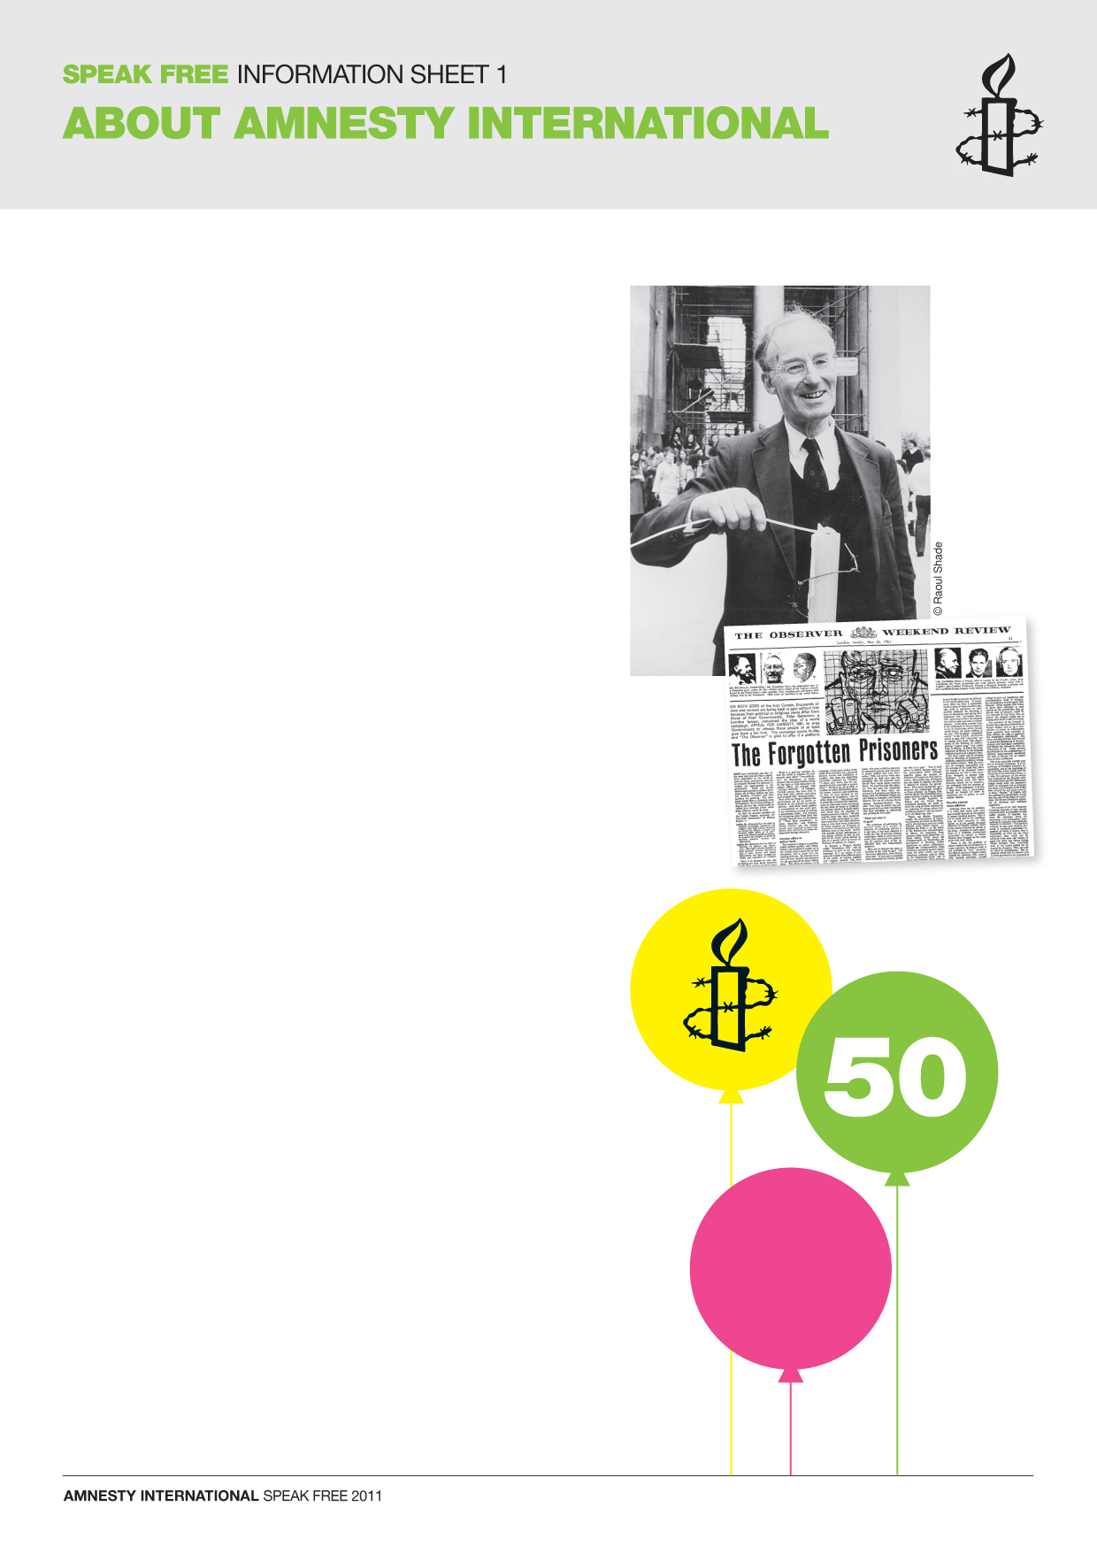
PART 1 – HOW AMNESTY INTERNATIONAL BEGAN

In 1960, Peter Benenson, a 40-year-old British lawyer, told a
story about two Portuguese students who had raised their
glasses to drink a toast to ‘Freedom!’ in a bar in Lisbon,
the capital of Portugal.

At that time, Portugal was under the dictatorship of General Salazar. Peter Benenson had read that the students had been arrested and sentenced to seven years’ imprisonment for their simple gesture.

On 28 May 1961 Peter Benenson’s article ‘The Forgotten Prisoners’ appeared in The Observer newspaper. It told the stories of people who were in prison simply because of their ideas.

This was the opening paragraph:

‘Open your newspaper any day of the week and you will find a
report from somewhere in the world of someone being imprisoned, tortured or executed because his opinions or religion are unacceptable to his government. There are several million such people in prison… and their numbers are growing. The newspaper reader feels a sickening sense of impotence. Yet if these feelings of disgust all over the world could be united into common action, something effective could be done.’

PART 2 – HAPPY BIRTHDAY AMNESTY!
Peter Benenson began to think about ways in which governments could be persuaded to release prisoners like the Portuguese students, who he called ‘prisoners of conscience’. His idea was to bombard governments with letters of protest about prisoners of conscience, and to call for their release.

The article in The Observer received a tremendous response: letters of support and money arrived, details of many more prisoners were sent in, and volunteers eager to work for the release of prisoners of conscience came forward in many countries. Within eight weeks the first international meeting had taken place. Amnesty International had begun. In its first year, Amnesty International offices were set up in seven countries.

Today, Amnesty International has over 3 million members in over
150 countries and territories in every region of the world. In the UK there are more than 224,000 paying members of Amnesty and there are offices in England, Northern Ireland, Scotland and Wales.

28 May 2011 marked the beginning of Amnesty International’s
50th year. Happy birthday Amnesty.

