HUMAN RIGHTS ACT PETITION - SCOTLAND
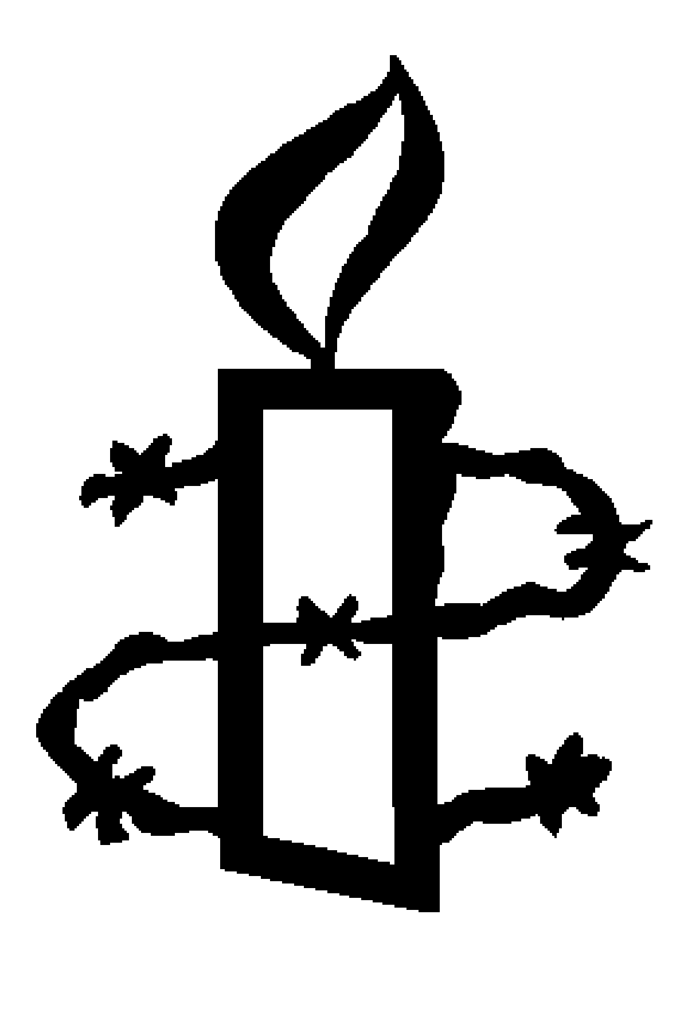

To: Michael Gove

We the undersigned oppose the repeal of the Human Rights Act in Scotland and throughout the United Kingdom. The Human Rights Act protects us from having our human rights taken away by the state and makes it easier for us to take a case in a court in Scotland. We will not stand for any compromise that will retain the Human Rights Act in some parts of the UK and not others as that will put many people, including many in Scotland, at risk.

PLEASE USE CAPITALS

Name | Address | Post Code | E-mail | Signature | Keep me  updated*
Thank you for taking action. We will pass the petition forms to the addressee of the action.
*By ticking this box you are agreeing for your details to be held by Amnesty International UK Section and Charitable Trust. We will contact you by post or email about our work and other ways that you can support us. You can unsubscribe or update your preferences at any time by calling our Supporter Care Team on 020 7033 1777 (Mon-Fri 9am-6pm) or emailing them at sct@amnesty.org.uk

