HUMAN RIGHTS ACT PETITION
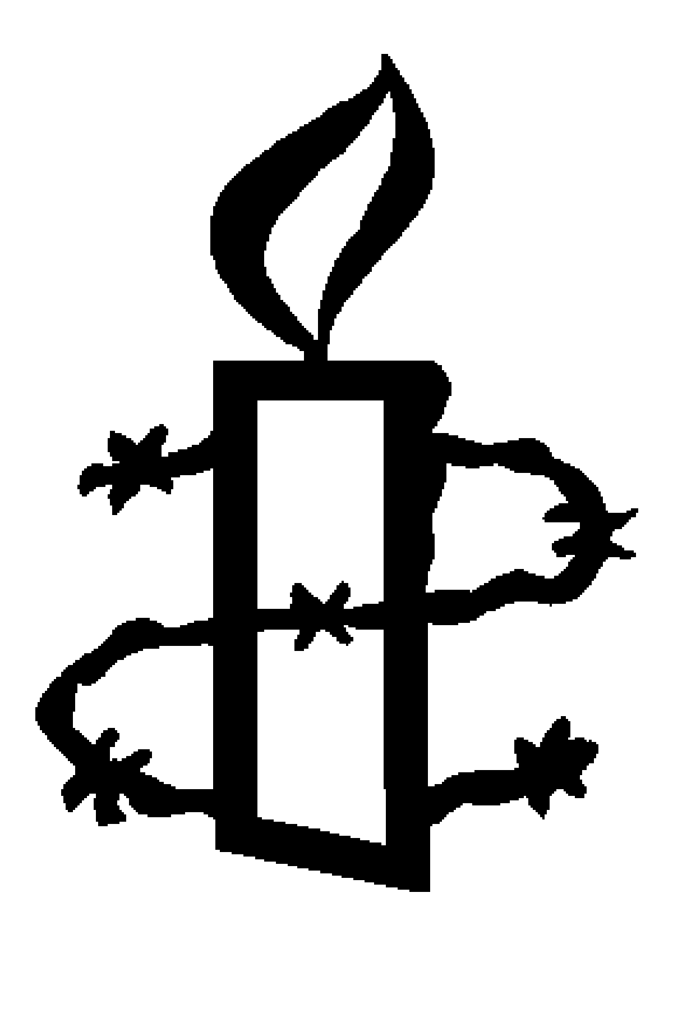

The Human Rights Act protects the fundamental rights we all have as human beings, and allows us to challenge authorities if they violate them. You might not have used it, but it's there if you need it. Our government wants to scrap the Act, and bring an end to universal human rights in the UK.

Don’t let universal freedoms turn into privileges for a chosen few. Call on Justice Secretary Michael Gove to save the Human Rights Act.

PLEASE USE CAPITALS

Name | Address | Post Code | E-mail | Signature | Keep me  updated*
Thank you for taking action. We will pass the petition forms to the addressee of the action.
*By ticking this box you are agreeing for your details to be held by Amnesty International UK Section and Charitable Trust. We will contact you by post or email about our work and other ways that you can support us. You can unsubscribe or update your preferences at any time by calling our Supporter Care Team on 020 7033 1777 (Mon-Fri 9am-6pm) or emailing them at sct@amnesty.org.uk

