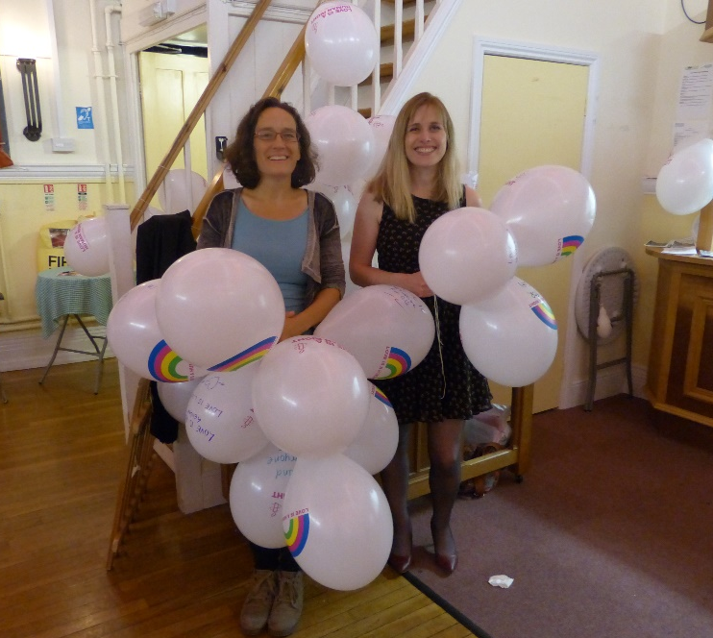  Amnesty International  Frome Group Newsletter  WE ARE ORDINARY PEOPLE FROM ACROSS THE WORLD STANDING UP FOR HUMANITY AND HUMAN RIGHTS  Website: www.amnesty.org.uk/groups/frome  Midsomer Norton Pride event SUCCESS!  Midsomer Norton held its first ever Pride festival on 17/18th June this year and Frome AI group was there for the opening of the festival…  Amnesty’s June Group action was to show solidarity with the LGBTI community in Tunisia and what better way than to write messages of solidarity on balloons and sign letters to the Tunisian authorities at the screening of the film ‘Pride’ in Midsomer Norton’s town hall.  We were overwhelmed by the show of support for our solidarity action. In total 20 people wrote messages on balloons and posed for their photo to be taken and 22 letters were signed, during the interval of the film.  I have emailed the photos to AIUK who will use the photos to create posters and postcards which will be shared with LGBTI organisations in Tunisia who will in turn share them with survivors of sexual and gender-based violence. If you would like to send a letter to the Tunisian Prime Minister then please contact me at njwardman@yahoo.co.uk for your copy of the letter. |  | July 2016  Issue 4  Issue 2  IN THIS ISSUE: *Pride event -our June group action * Pub letter signing * June Monthly meeting * Hidden gardens

Letter signing at the Archangel pub
We have now held 3 letter signing stalls at the Archangel pub; on Saturday 28th May, Saturday 4th June and Saturday 18th June. So far we have sent 65 letters from these sessions; 21 letters on 28th May, 16 letters on 4th June and 18 letters on 18th June.
At our most recent event (18th June) of the 18 letters that were sent:

- 5 letters were sent to the Rio 2016 Security commission reminding it of its responsibility for preventing unnecessary and excessive use of force by the police and military in security operations related to the Olympics.

- 7 letters were sent to the head of police in Indonesia regarding 3 prisoners of conscience : Ahmed Mushaddeq, Andry Cahya and Mahful Muis Tumanurang, the former leaders of the forcibly disbanded Gafatar religious group.
and
- 6 Urgent action letters were sent to Bahrain regarding 3 men sentenced to death and 7 men sentenced to life imprisonment for opposing the government, and who have also been tortured in detention before the trial.

If you have missed our ‘pop up letter signing shop’ then don’t worry it will be making a reappearance on 9th July and 23rd July at 10:30-12 at the Archangel pub, King Street, in Frome.
If you would like to send a letter to the Rio 2016 Security commission, to the head of police in Indonesia or to Bahrain then let me know which letter you would like by emailing me, Nadine, at njwardman@yahoo.co.uk
If you are interested in being more involved in letter signing events then please get in touch - there's lots to do from typing and printing the letters for the stall to running the stall. If it proves popular the plan is to have a rota of people who will take turns to run it so that it becomes a regular Saturday morning event.
Frome AI May meeting
The group met for our monthly meeting on Thursday 16th June at 8pm at the Bridge café.
We planned for forthcoming events e.g. the Hidden gardens event and the upcoming Archangel letter signing sessions. The pub letter signing sessions will be reviewed at July’s meeting and a decision will be made about whether we continue to run it. £300 has been sent to Amnesty International UK, as previously agreed. Judy gave out Human Rights Act pocket guides. Please contact her if you would like one.

Tea and cake…. and flowers
Support Amnesty and enjoy Frome Festival's Hidden Gardens
This year Frome Amnesty Group is providing refreshments at Orchard Street Allotments as part of Hidden Gardens on Saturday July 9th, from 11.00am - 5.00pm. If anyone would like to bring a cake or help serve refreshments on the day, please contact Judy on 07852 521302 or email judy.hosegood@btinternet.com
Or to enjoy the whole Hidden Garden event for a mere £5.00 you can see many hidden treasures of all sorts of gardens, large, small, manicured and wild.
Tickets available for the three day event from the Cheese and Grain or the Library.

Your ideas for the newsletter…
If you have any feedback on this newsletter or would like anything included in the next issue then please feel free to contact me – Nadine Crook
njwardman@yahoo.co.uk

Our group meets on the third Thursday of each month
at the Bridge Café, Selwood Road, Frome, BA11 3BS at 8pm.
Our next meeting is: Thursday 21st July 2016

