Friends of Mary
Hull's First 'Lady Doctor'
Mary Murdoch (1864-1916) Hull's much-loved first female GP from 1896 until her death, was a prominent national campaigner for gender equality, votes and
careers for women and better conditions for the poor.
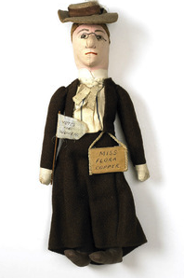
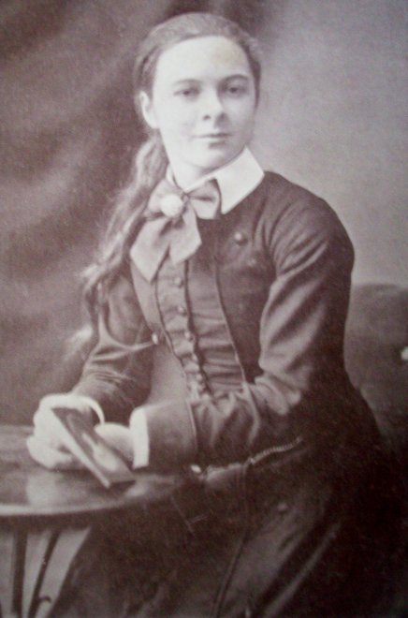

Photo of Mary as a schoolgirl Typical 'suffrage doll' in Mary's image

Born in Elgin, Scotland, educated in London and as one of the first graduates of the London School of Medicine for Women, Mary worked as a house-surgeon at the Victoria Hospital for Sick Children in Park Street, Hull (one of 'very few in Great Britain to welcome women on its staff') for two years from 1893, and returned in 1896 as a GP and an acknowledged expert in childhood diseases.
Her large surgery at 102 Beverley Road (now Grosvenor House) became, from 1904, the centre of Hull's suffrage movement, later renowned for its innovative and colourful campaigns (e.g. using card games and suffrage dolls in the image of prominent campaigners), challenging male candidates for Parliament to support votes for women.
Her insistence on career opportunities for women led her to prominence in the National Union of Women workers, where she served as national vice-president. She founded a School for Mothers, a creche for women workers and a training centre for young girls.
Mary's untimely death at the age of 51 from a chronic stomach complaint meant that she did not see votes for women become a reality two years later, but her tireless efforts won her many friends and admirers in the city. Thousands attended her funeral in March 1916.
Hull Amnesty Group seeks your support in making the life and work of this local
Human Rights Champion better known, especially among the young of the city.
How you can help revive the memory of one of Hull's unsung heroes.
Become a Friend of Mary
Remembering Mary Murdoch on the streets of Hull
Mary Murdoch was featured in Hull Amnesty Group's 2014 publication 'Not Just Wilberforce: Champions of Human Rights in Hull and East Yorkshire', eight essays by local authors on less well-known figures from the area, stretching over four centuries. We plan to highlight their contribution to Hull's history by creating giant puppets ('gigants') in period dress to perform during local events such as the annual Freedom Festival and summer street fairs, and draw attention to Hull's proud history as pioneering city for human rights in the UK.

Hull Amnesty Group is sponsoring the creation of a giant puppet representing Mary Murdoch in 2016, the centenary of her death. The head of the puppet will be constructed by a well-known local artist, with period clothes and supporting frame contributed by local community groups. Training sessions for young people in dancing with 'gigants' will enable the puppet (and, we hope, its successors) to be a feature of local parades, contributing to local community events and generating pride in our history.

For a contribution of £5 (£2 unwaged) you too can become a
Friend of Mary
and take part in this project as it unfolds.

We will send you email information of any events where the puppet will perform, and other events where Hull Amnesty Group has a presence. You will receive a card
confirming your membership as a Friend of Mary, entitling you to purchase 'Not Just Wilberforce' and other Hull Amnesty Group publications at a special discount price.

To become a Friend of Mary, please complete the slip below.
----------------------------------------------------------------------------------------------------------------
Name:________________________________________________________________

Address:______________________________________________________________

Telephone: ___________________________ Email:___________________________

Donation: £___________cheque/postal order, made payable to Hull Amnesty Group
Send to: Hull Amnesty Group, Friends of Mary, c/o 10 Strathmore Ave, Hull, HU6 7HJ
Contact Hull Amnesty Group:hullamnestygroup@gmail.com/www.amnesty.org.uk/Hull/07584079252

