Amnesty International  Frome Group Newsletter  WE ARE ORDINARY PEOPLE FROM ACROSS THE WORLD STANDING UP FOR HUMANITY AND HUMAN RIGHTS  Website: www.amnesty.org.uk/groups/frome  Facebook: www.facebook.com/fromeamnesty  Write for rights!  Join the global letter writing marathon…  We will be holding our next write for rights stall on Saturday 10th December 9am - 1pm in the foyer of the Cheese and Grain.  Thanks to everyone who supported the write for rights event on Saturday 12th November. We had a great response. We sent 35 cards and 34 letters.  Write for rights is the one time of the year when we send messages of support directly to prisoners of conscience to show them that they are not forgotten and that we are campaigning to secure their freedom. We also asked people to sign a corresponding letter to the relevant government which highlighted the person’s case.  This year we are focusing our efforts on 6 people from 4 different countries:  - Nazanin Zaghari-Ratcliffe (a British-Iranian citizen),  - Mahmoud Abu Zeid (also known as Shawkan) (Egypt),  - Eren Kesken (Turkey)  - Ilham Tohti (China)  - Annie Alfred (Malawi)  - Johan Teterissa (Indonesia) |  | December 2016  Issue 9  Issue 2  IN THIS ISSUE: *Write for rights *January coffee morning
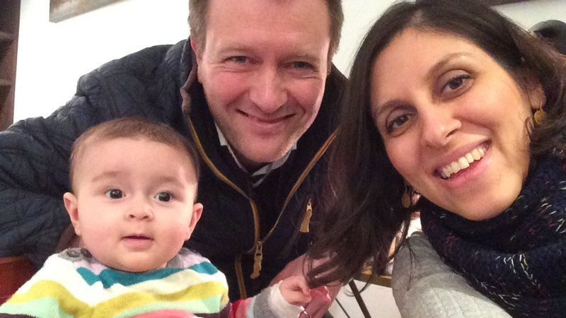

Nazanin Zaghari-Ratcliffe
Nazanin is employed by the Thomas Reuters Foundation (the news agency’s charitable arm). She was arrested on 3rd April this year at a check-in desk at Tehran airport after her spending a holiday visiting her parents.
Her 2 year old daughter Gabriella’s British passport was confiscated so she could not leave Iran. Gabriella has now been separated from both her parents now for over a quarter of her life. She is currently living with her grandparents.
Nazanin has been sentenced to 5 years in prison on spurious “national security related charges”.
She is one of a number of UK nationals with Iranian passports being held in Iranian prisons. She is part of a new wave of people from Western countries being arrested whilst visiting their families on accusations of national security. It appears that Nazanin is being held as a political bargaining chip. She is essentially being held hostage. She was told that she would be released if the UK reached an agreement with her jailors. Her husband Richard speaking on Radio 4 this week said that his family had been caught up in a disagreement between the two countries over an outstanding military debt that the UK refused to pay.

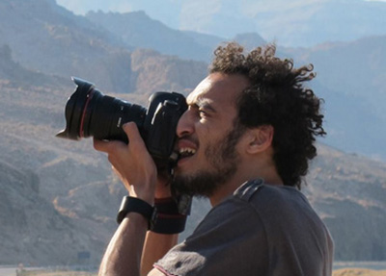
Mahmoud Abu Zeid (Shawkan)
Photojournalist Mahmoud Abu Zeid, known as Shawkan, was covering a sit-in on 14 August 2013 in Cairo when security forces, police and tanks swept in. As bullets and tear gas went flying, he photographed the mayhem around him.
When the police found out Shawkan was a journalist, they arrested him, tied his hands together with plastic cables that cut through his skin, and beat him. Up to a thousand people were killed on that day across Egypt, and Shawkan was among hundreds arrested. He has now been detained without charge for over three years, in contravention of Egyptian law. He has hepatitis C, but has been denied adequate medication. His health is deteriorating. Shawkan faces nine trumped-up charges, including ‘joining a criminal gang’ and ‘murder’. If convicted, he could face the death penalty.

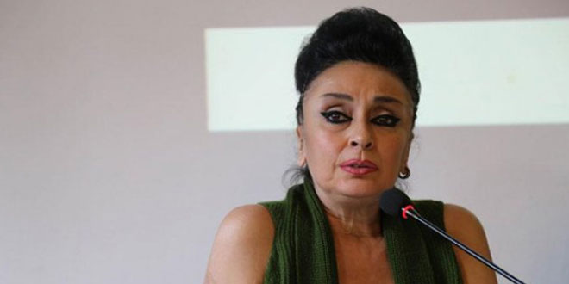
Eren Keskin
Eren is a human rights lawyer who has been subjected to death threats, physical attacks and sustained judicial harassment. She has been hauled before the courts more than a hundred times, and convicted on numerous occasions, largely because of her work defending Kurdish rights.
After July’s attempted coup, which Amnesty condemns, Eren was accused of offences linked to her work with Kurdish newspaper Özgür Gündem, including ‘membership of a terrorist organisation’. If convicted, she could receive a life sentence.
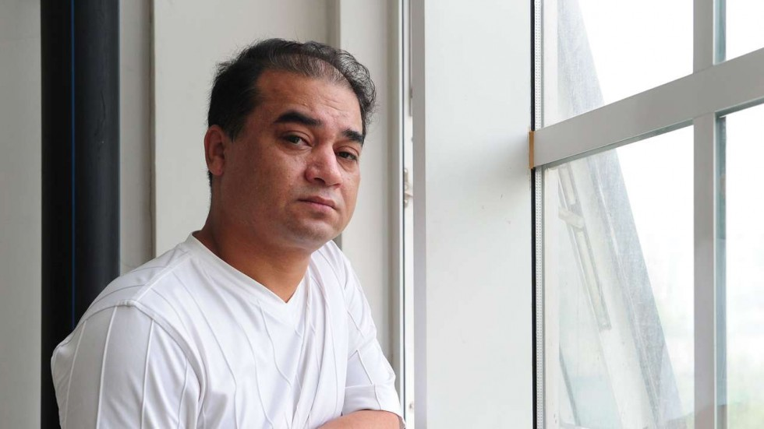
Ilham Tohti
Ilham is an academic and a prominent critic of the Chinese government’s policies in the Xinjiang Uighur Autonomous Region. Uighurs, members of an ethnic minority that practices Islam, face widespread discrimination in their employment, education and housing, curtailed religious freedom, and political marginalisation. Ilham has spoken out about his community’s plight for many years. His ‘Uighur Online’ website reported human rights violations, but has been repeatedly shut down. He has consistently opposed violence and worked peacefully to build bridges between communities. Nevertheless, he has been put under surveillance, and was interrogated after travelling to France in 2009 and giving media interviews critical of China’s policies on ethnic minorities. After being charged with ‘separatism’, an ‘offence’ often used against Uighurs who speak out, Ilham was sentenced to life imprisonment in 2014.
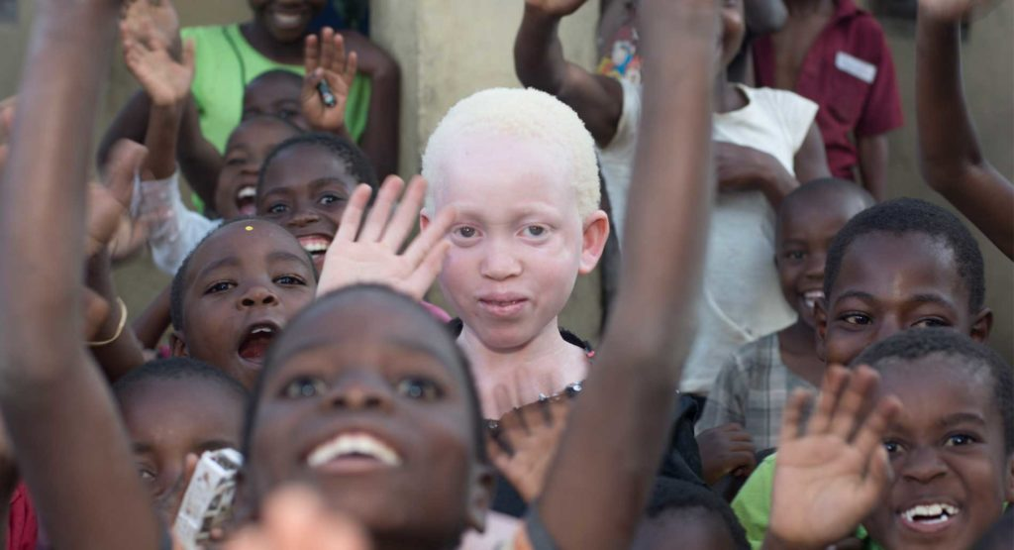
Annie Alfred
Annie is 11. Her life is in constant danger because she has a genetic condition: albinism. Some 7,000-10,000 Malawians live with albinism, which results in the absence of pigmentation in the eyes, skin and hair. They are in danger of being abducted, mutilated or killed because of erroneous beliefs and superstitions. Attacks against Malawians with albinism are rising: there have been six reported killings in 2016.
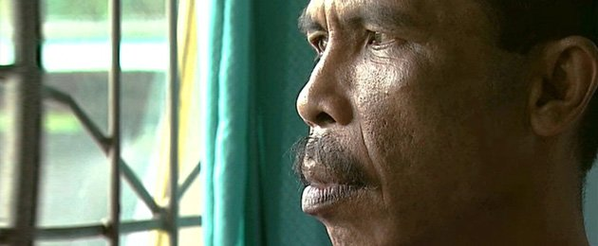
Johan Teterissa
Johan is a teacher. He is serving a 15-year jail sentence for raising a flag banned by the Indonesian government. In 2007 he led a group of people, mainly teachers and farmers, in a peaceful protest in front of the president. They performed a traditional war dance, before unfurling a ‘rainbow’ flag, a historical symbol of independence for the eastern province of Maluku.
Police officers removed Johan and the others, punching and beating them. After an unfair trial, the protestors were convicted of ‘rebellion’ and Johan was sentenced to life, later reduced to 15 years. He is in prison thousands of kilometres away from his family and friends.

So join us on Saturday 10th December (Human Rights Day!) to write a message on a greetings card to Nazanin, Shawkan, Eren, Ilham, Annie or Johan.
Or alternatively if you can’t make it then check out https://www.amnesty.org.uk/write-rights-2016 where you’ll find everything you could possibly need and more! There are suggestions for messages if you are stuck for inspiration, address labels and a link to download the Write for Rights brochure. It couldn’t be easier!
Or email Judy at judy.hosegood@btinternet.com for a letter to send to the relevant government.

And for any skeptics out there…. Write for rights really does work!...
Last year 3.7 million letters, messages, emails and tweets were sent to people who have suffered injustice, in solidarity with them, and to the authorities who could bring justice. In February 2016, Albert Woodfox was released from prison after an incredible 44 years of solitary confinement in the US state of Louisiana. During Write for Rights a couple of months earlier, more than 240,000 people sent him messages of support and called on Louisiana authorities to free him.
During November and December 2015, people around the world wrote more than 394,000 messages to a group of students in Burma imprisoned for peacefully protesting against an education law. The leader of one of the student unions was Phyoe Phyoe Aung. In April 2016, Burma announced that it was releasing all prisoners of conscience – including Phyoe Phyoe Aung and many of the students who had peacefully protested alongside her.

We are looking for volunteers to help us to run our next write for rights stall on Saturday 10th December between 11-12
if you are interested please contact :
Judy on judy.hosegood@btinternet.com or 01373 474375 or
Nadine on njwardman@yahoo.co.uk or 07985 097952, thank you!
.

Save the date! Saturday 28th January!
Beat your winter blues. Come and enjoy a cuppa and meet fellow Amnesty supporters!
Ann Burgess has kindly offered to host a coffee morning at her house on Saturday 28th January 2017 10am-1pm. Her address is 64 Weymouth Road, Frome, BA11 1HJ.

Your ideas for the newsletter…
If you have any feedback on this newsletter or would like anything included in the next issue then please feel free to contact me – Nadine Crook
njwardman@yahoo.co.uk
Our group meets on the third Thursday of each month
at the Bridge Café, Selwood Road, Frome, BA11 3BS at 8pm.
Our next meeting is: Thursday 15th December 2016.

