Theresa May, protect the children of Aleppo
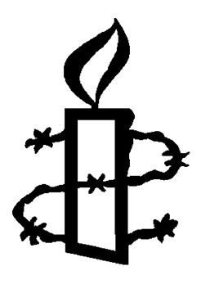

Save the children of Aleppo: if you tolerate this, what next?

Dear Prime Minister,

The slaughter in Aleppo is happening before our eyes. The children under the rubble, their screams, and their terror are played on our screens every day. Deliberate attacks on children and hospitals are ongoing. They cannot be dismissed as ‘collateral damage in a battle against terror'. It is a systematic attack on the laws of war.

Prime Minister – if you tolerate this, our children could be next. Every war crime we allow to go unpunished – by any party to this brutal conflict – makes the world more dangerous.

Resolutions at the UN Security Council are ignored. Diplomacy has so far failed. The UK urgently needs to deter the use of collective punishment against the civilians of Eastern Aleppo, beginning with sanctions targeting those ordering violations and a commitment to bring war criminals to justice.

We said never again. Now we must show we mean it.

Name | Address | postcode | Signature | Email
Thank you for taking action. We will pass this petition form that contains your personal information to the addressee of the action. The rules of the Data Protection Act 1998 apply; neither AIUK* or Amnesty Groups can be held responsible for what the data is subsequently used for.
*AIUK=Amnesty International UK Section and Amnesty International UK Section Charitable Trust

