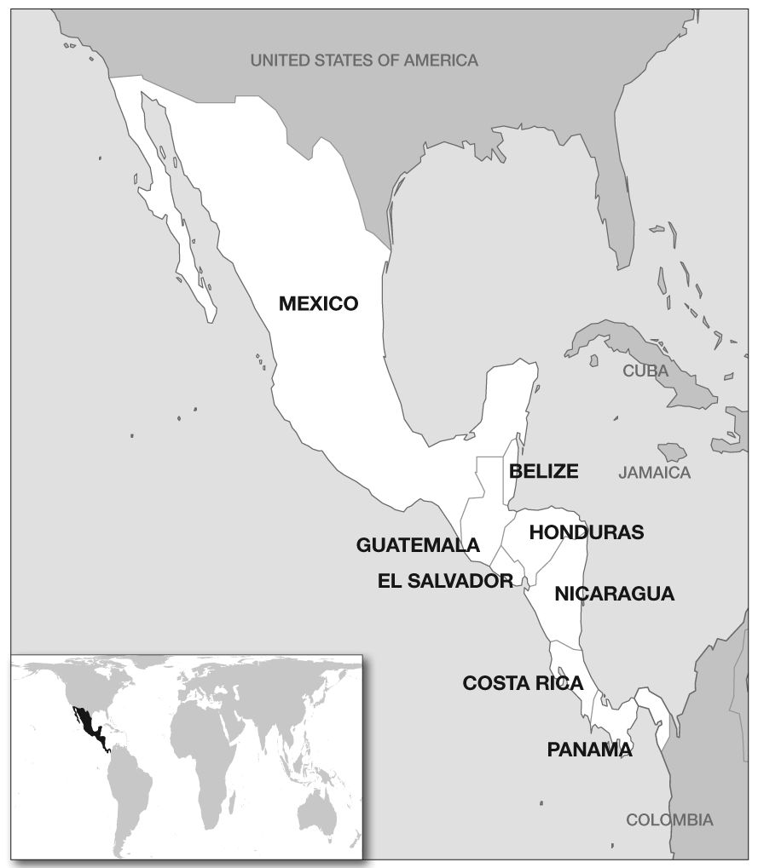
Central America Region

Newsletter

July 2013

Mexico

New report details Mexican government’s failure to tackle disappearances
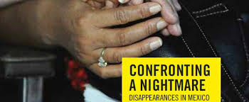
Amnesty has recently issued a comprehensive report on disappearances in Mexico. It includes details of criminal gangs and public officials who have been responsible for the abduction and disappearance of thousands of people in the last six years. The government has failed to fully investigate these disappearances – whether abductions committed by criminal gangs acting alone or enforced disappearances in which public officials have colluded or participated. This means the fate and whereabouts of the victims remains unknown and virtually no one has been prosecuted. This creates a climate of impunity and puts further people at risk of being disappeared.

The relatives of many of the victims have carried out their own investigations in the face of state inaction and at great personal risk, but after they handed over crucial leads to prosecutors, the cases remain stalled.

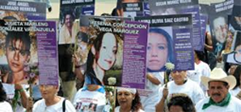
Under pressure from the victims’ relatives, the government has made a few commitments to grapple with the ongoing crisis. However, its measures are inadequate to deal with the shocking scale of the problem or to help victims and relatives.

Amnesty campaigner Rupert Knox and Daniel Zapico presented the report to officials at the Federal Attorney General's Office and the Ministry of the Interior. AI Mexico staff and volunteers organized a very well attended press conference, which included national and international media, NGOs, relatives of victims and the general public.

Here is a link to the 16-page report: http://www.amnesty.org/en/library/asset/AMR41/025/2013/en/d7198cc0-93d1-4021-a6b8-b098805ddeaf/amr410252013en.pdf

Family of disappeared Lieutenant presents its case to UK MPs
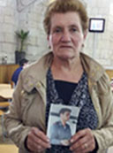Last week Sheila attended a meeting where representatives of the All-Party Parliamentary Group on Human Rights and the All-Party Group on Mexico heard testimony from the family of Miguel Orlando Muñoz Guzmán, a Lieutenant in the Mexican army. He disappeared on 8 May 1993, aged 25. He was last seen at his base in Ciudad Juarez. A career officer, his family said he was excited about taking up a position at a military training school. But the army claims he deserted and fled to the USA.

His family say he had been in dispute with senior officers regarding drug operations in the area and had felt he was in danger in the weeks before he disappeared. Officers falsified documents indicating that Lieutenant Guzmán intended to leave the army, forging his signature. As soon as the family started to investigate they began receiving death threats, warning them to stop accusing the army. The family claimed that no real investigation had been carried out and that any brief investigations had been made by military personnel. Maria Guzman with a photo of her son

In April 1999 the family filed a petition with the Inter-American Commission on Human Rights (IACHR), which published its report in 2006 and found that there was no proof that the Mexican state was involved in Lieutenant Guzmán’s disappearance. However, it did conclude that the Mexican state had not fulfilled its obligation to investigate and had denied Lieutenant Guzmán his right to a fair trial and to judicial protection. It then made a number of recommendations regarding thorough investigation and sanctions for those responsible.
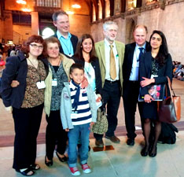
More than 20 years after he disappeared and seven years after the IACHR report was published, Mexico has still not complied with the recommendations. Instead the army has accused Lieutenant Guzman of desertion and criminal activity. The family has also endured threats and a kidnap attempt, the day before the IACHR hearing. The meeting was emotional, reinforcing the human story behind every enforced disappearance. Mrs Guzmán described her ordeal as “torture”. “I’ve spent 20 years searching”, she said, “but all I have to show for it is threats”. She wept as she showed her son’s photo. His sister Maria added: “I know it was over 20 years ago and there are so many other cases, but I can never give up.”
LtoR:Sheila Royce, AIUK Central America co-ordinator; Lieut Guzmán’s mother Maria,
Rupert Knox,, Amnesty’s Mexico researcher; Lieut Guzmán’s sister Maria;
Jeremy Corbyn MP. David Palmer and Sne Ganguly, Solicitors’ International Human
Rights Group. Front: Lieut Guzmán’s nephew Brandon
Jeremy Corbyn MP has sponsored an early day motion on this case in addition to a recent one on Amnesty’s report on enforced disappearance in Mexico. He also said the parliamentary group would write to President Nieto and the Mexican Human Rights Commission, copying in the IACHR, and brief the new British Ambassador.

Please write to your MPs and strongly urge them to sign these Early Day Motions:
http://www.parliament.uk/edm/2013-14/308, http://www.parliament.uk/edm/2013-14/203

Police and families work together to solve cases of disappearances
In Nuevo Leon prosecutors, detectives, human rights workers and families are undertaking the basic police work and poring over cases together. They have successfully solved 52 cases while overcoming the mistrust between civilians and authorities. http://www.nytimes.com/2013/06/23/world/americas/mexico-pursuing-vanished-victims-of-its-drug-wars.html?pagewanted=all&_r=2&

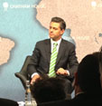
President says he’s satisfied with his government’s progress on human rights
President Ennrique Pena Nieto visited London in late June, and Amnesty researcher Mariano Machain asked him about his government’s progress on human rights issues, “We have seen major breakthroughs in human rights fulfilment,” the President said, “the number of reports of human rights violations have dropped compared to past figures, and we have created a special office in the federal government to address all the reports related to human rights, and I hope that this is enough to fulfill this commitment that my government has made.”

Bodies of three left-wing activists found in Guerrero
The activists from Unidad Popular (UP) were last seen on 30 May after a protest in support of local farmers. A local leader of the Party of the Democratic Revolution, Arturo Hernandez Cardona, was among the dead. The UP is a recently formed organisation which campaigns and lobbies for the social projects and resources for local Indigenous communities. The UP has also supported the movement of teachers in Guerrero state. At the end of this newsletter is a sample letter urging authorities to protect the other UP members and their families. http://www.bbc.co.uk/news/world-latin-america-22762485

Police charge 12 people with murders of women in Juarez
The suspects include alleged drug dealers, pimps and small-store owners. They allegedly belonged to a gang that forced young women into prostitution and drug dealing and then killed them. The 10 men and two women face charges of human trafficking and homicide. http://www.usatoday.com/story/news/world/2013/06/12/mexico-arrests-border-women/2417541/

Journalists curtail coverage
As we’ve noted before, Mexico is easily the most dangerous place in the Western Hemisphere for reporters. Dozens have been killed or disappeared and the success of the intimidation alarms advocates of both free speech and democracy. http://www.miamiherald.com/2013/05/16/3401001/in-mexico-fears-for-democracy.html#

More threats at migrants’ shelter
At the end of this newsletter is an action about new threats against the staff at the 72 migrants’ shelter in Tenosique.

Guatemala

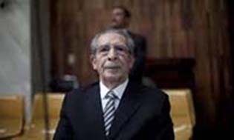
Ríos Montt trial annulled
On 10 May 2013, the Mayan Ixil communities, victims’ families, survivors of the conflict and the international human rights community celebrated as former president Efraín Ríos Montt was found guilty of genocide and crimes against humanity and sentenced to 80 years. For the first time a head of state has been tried in a domestic court for genocide. Ten days later, however, the Court annulled the guilty verdict and dismissed the case’s proceedings dating back to 19 April.

The Open Society Justice Initiative has called it a “legal stalemate”. What this means for the trial, its defendants, witnesses and the people of Guatemala is uncertain but this sudden, though not unpredictable, turnaround demonstrates the inefficiency of the justice system in Guatemala and suggests the country has a way to go in this process of transitional justice.

This article provides more details:
http://www.riosmontt-trial.org/2013/05/one-week-after-overturning-former-dictators-genocide-conviction-guatemalan-constitutional-court-hears-claim-that-rios-montt-should-benefit-from-1986-amnesty/
The following interview is also useful:
http://www.democracynow.org/2013/5/23/ros_montt_genocide_verdict_annulled_but

Human rights defender Rubén Herrera released

On 30 May 2013 Rubén Herrera was released from prison in Huehuetenango having been imprisoned since March 15 for his resistance to the Spanish-owned Cambalam hydro-electric dam. The Guatemala Human Rights Commission (GHRC) and the Network in Solidarity with the People in Guatemala (NISGUA) together collected over 2800 signatures and presented them to President Otto Peréz Molina and the Public Prosecutor’s Office.

Herrera was charged with crimes including terrorism and kidnapping but evidence against him was insufficient. While his release is a positive step forward, the criminalisation of defenders of environmental and social justice continues to be a worrying trend in Guatemala.
Handing over 2800 signatures to the MP

GHRC and NISGUA have both written updates on the case:
http://ghrcusa.wordpress.com/2013/05/23/2246/
http://nisgua.blogspot.co.uk/2013/05/ruben-herrera-released-from-prison.html

The US was aware of massacres and still supported government
While the US has publicly condemned the violations committed in Guatemala during the time of Ríos Montt in the early 1980s, both then and now, questions have been raised over the involvement of the US in the conflict.

Declassified military documents from the National Security Archive (NSA) show that not only were the US fully aware of the massacres of the Maya Ixil population and the disappearance and assassination of individuals such as Guatemalan rebel commander Efraín Bámaca Velásquez, but they were actually instrumental in the overthrow of the democratically elected Jacobo Arbenz government in 1954 and kept close ties with the military governments that followed.

Though the US publicly stopped financial aid to Guatemala while Reagan was in power, NSA documents make it clear that millions of US dollars continued to flow from the CIA to the Guatemalan government. The question of the US government’s accountability for crimes that occurred during the conflict has again been raised.

NSA Director Kate Doyle provides a detailed analysis of US involvement: http://www.gwu.edu/~nsarchiv/NSAEBB/NSAEBB373/

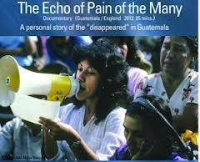
September screening reminder: The Echo of Pain of the Many
To commemorate the International Day of the Disappeared on 3 September, we will be showing the documentary The Echo of Pain of the Many. The screening will be held at the Human Rights Action Centre in London on Tuesday, 3 September at 7 pm, which will be followed by a Q&A session with the writer/director Lucia Cuevas.

If you are based in or around London, please put the date in your diaries and come to what promises to be a very thought-provoking evening. The event is free, but please register if you can by emailing Sheila.

Honduras

UN Special Rapporteur reports an increasing polarisation in society

The United Nations Special Rapporteur on the Situation of Human Rights Defenders (HRDs), has circulated a full report on the situation of human rights defenders in Honduras, following her visit to the country in February 2012. It concludes that the 2009 coup d’état aggravated institutional weaknesses, increased the vulnerability of human rights defenders and provoked a major polarisation in society.

Although the report recognises some positive initiatives taken by the government of Honduras (creation of the Ministry of Justice and Human Rights, Ministry for Development of Indigenous Peoples and Afrodescendants and the National Committee for the Prevention of Torture and other Cruel, Inhuman or Degrading Treatment), it concludes that the pervasive impunity and absence of effective investigations of human rights violations undermine the administration of justice and damage the public’s trust in the authorities. It also notes that the high levels of impunity are affecting the stability of society.

The report makes 13 recommendations to the government of Honduras. These include: raising awareness of the role and importance of the work of human rights defenders, creating an adequately resourced protection programme for human rights defenders and reforming the police force. Other recommendations are aimed at the judiciary, the Office of the Public Prosecutor, the National Commissioner for Human Rights, human rights defenders, the international community and “all stakeholders”.

Appeal letters to the Honduran authorities will in future include a call for them to implement the recommendations made in this report. You can access the 24-page report here: http://www.ohchr.org/Documents/HRBodies/HRCouncil/RegularSession/Session22/AHRC2247Add.1_English.pdf

Gangs announce truce
The two most notorious and violent street gangs in Honduras, Salvatrucha and 18 Street, have announced they will commit to zero crime and zero violence on the streets. In the world’s murder capital, hopes are high that this will be a significant step towards reducing the violence that plagues the country. A similar pact has been in place in neighbouring El Salvador for more than a year now, and its government claims that murders have dropped by around 52%.

Dina felt compelled to cover human rights abuses
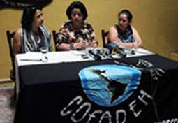
Journalist Dina Meza was just graduating from college when security forces abducted her brother, Victor. He was tortured with electric shocks and beaten. Dina mounted a campaign and he was eventually released. She joined revistazo.com in 2004, because “they were covering abuses committed by the security firms, against labour rights, the kind of stories the mainstream media didn’t want to cover,” She often speaks out about the security firm’s abuses. She and her children have been threatened because, she says, “Children, spouses, friends, are all seen as fair game by those seeking to silence journalists in her country.” http://www.independent.co.uk/voices/comment/voices-in-danger-in-honduras-they-come-after-your-family-too-8652478.html

TV journalist abducted
Three heavily armed men kidnapped Aníbal Barrow, a Honduran journalist, on 24 June in San Pedro Sula. Amnesty believes his life is in serious danger.

Aníbal Barrow works for Globo TV, where he presents a daily news programme. On the day of the abduction, he had interviewed three Libertad y Refundación (Libre) party candidates in the forthcoming November elections, talking about the fourth anniversary of the coup d’etat. The lack of ransom demands adds to fears that Barrow was attacked because of his journalistic activities. Appeal letters in English and Spanish are included at the end.

U.S. academic summarises human rights situation since coup
The coup which overthrew the democratically elected president Manuel Zelaya took place almost exactly four years ago, on 28 June 2009. Dana Frank, a professor at the University of California at Santa Cruz, has written extensively about human rights in Honduras. Here she provides a concise summary and details the tragedies that have occurred since that fateful day. http://thebaffler.com/past/vocabulary_lessons

Nicaragua

Amnesty wants government to investigate attack on youth activists
The IS recently called for Nicaraguan authorities to urgently investigate the attack against youth activists which started at 4 am Saturday 22 June. The students had been protesting for several days in solidarity with elderly demonstrators demanding access to a minimum state pension. Several hundred people attacked the young activists, who had slept at a protest camp alongside elderly protestors. The police failed to protect them.

Ten student activists were wounded, while others were threatened or robbed, and several were forced to strip down to their underwear by their assailants. There are reports that those involved in the attack were FSLN youth supporters.

Amnesty wants those responsible prosecuted and assurances that police agents fully abide by the UN Basic Principles on the Use of Force and Firearms by Law Enforcement Officials.

El Salvador

Country aims to protect its water by banning metal mining
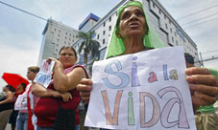
More than two-thirds of the population rely on the Lempa river basin for drinking water. In 2008, after strong public pressure to protect water from mining, Antonio Saca, El Salvador's president at the time, declared he would not issue any new mining permits. As a result, two mining companies are dragging El Salvador through a costly legal challenge at an international trade tribunal for attempting to protect limited water supplies by refusing permits for their operations. The Washington-based Institute for Policy Studies observed during a fact-finding mission to El Salvador that “the contrast between the communities exposes the myths of mega mining. Rather than generate wealth for the communities, decades of mining have left the people impoverished.” http://www.guardian.co.uk/global-development/poverty-matters/2013/jun/10/el-salvador-mining-ban-water-security

People in region satisfied with life
On an upbeat note, we’ve recently learned that three of our countries feature on the list of the top 10 happiest. People in Costa Rica, according to the World Database of Happiness, report the highest satisfaction with life. Mexico, quite surprisingly in our view, comes in at number 8 and number 10 is Panama.
Mexico Letter #1 in English

Jesús Murillo Karam
Attorney General of the Republic
Paseo de la reforma 211-213
Col. Cuauhtémoc, México D.F.
C.P. 06500, México
Email: ofproc@pgr.gob.mx

Dear Attorney General

I was shocked to learn that three activists were found dead on 3 June outside Iguala, Guerrero state. Arturo Hernández Cardona, Ángel Román Ramírez and Félix Rafael Bandera Román had taken part in a protest against the local government shortly before they disappeared. Their bodies showed signs of torture. Four others from the same organisation have gone into hiding.

Please do everything you can to protect the other members of Unidad Popular, UP and their families.

UP members have accused the local government of involvement in the abduction. There was a dispute between federal police and protesters shortly before the disappearances. I strongly urge you to launch a full investigation into these murders and the threats against UP activists, including allegations of local government collusion, and to prosecute the guilty parties.

Sincerely

May also be sent to:
Lic. Ángel Heladio Aguirre Rivero
Gobernador del Estado de Guerrero
Palacio de Gobierno Edificio Centro 2do. Piso
Col. Ciudad de los Servicios
C.P. 39074 Chilpancingo
Guerrero
México
secretariaparticulargb@guerrero.gob.mx
Sr. Gobernador

And please send a copy to:
HE Mr Eduardo Medina-Mora Icaza
Embassy of Mexico
16 St George Street, Hanover Square
London W1S 1FD
Embgbretana@sre.gob.mx
Mexico Letter #1 in Spanish

Jesús Murillo Karam
Procurador General de la República
Paseo de la reforma 211-213
Col. Cuauhtémoc, México D.F.
C.P. 06500
México
Email: ofproc@pgr.gob.mx

Sr Procurador General

Me quedé muy sorprendida al saber que se encontraron tres activistas muertos el 3 de junio fuera de Iguala, estado de Guerrero. Arturo Hernández Cardona, Ángel Román Ramírez y Félix Rafael Bandera Román habían participado en una protesta contra el gobierno local poco antes de que desaparecieran. Sus cuerpos presentaban señales de tortura. Otras cuatro personas de la misma organización han pasado a la clandestinidad.
Por favor, haga todo lo posible para proteger a los demás miembros de la Unidad Popular, UP y a sus familias.
Sus miembros han acusado al gobierno local de estar implicado en el secuestro. Hubo una disputa entre la policía federal y los manifestantes poco antes de la desaparición. Le insto encarecidamente a que inicie una investigación exhaustiva sobre estos asesinatos y las amenazas contra activistas de la UP, incluidas las denuncias de connivencia del gobierno local, y de enjuiciar a los culpables.

Cordialmente

Mexico Letter #2 in English

Sr Manuel Mondragón y Kalb
National Commissioner for Security
Av. Constituyentes #947
Col. Belén de las Flores
C.P. 01110
México D.F.
México
Email: ceac@cns.gob.mx

Dear Commissioner

I am deeply concerned to learn that new death threats have been made against workers at the 72 Migrants’ shelter in Tenosique, Tabasco state. I understand that the authorities have not provided the agreed-upon protection measures, and as a result staff are exposed to attacks.

Recently an unidentified man threatened migrants' rights activist Rubén Figueroa. Although the perpetrator was arrested along with three others, they were all released despite evidence implicating them.

Please safeguard Rubén Figueroa, Fray Tomás González, other shelter staff, and migrants at the La 72 migrants’ shelter. Some of the agreed-upon measures that would help to protect them would be effective streetlights, surveillance cameras, a panic button and new locks to secure access.

I also urge you to launch a full investigation into the threats against Fray Tomás, Rubén Figueroa and other shelter members and prosecute those responsible, including members of criminal gangs behind the threats and kidnapping of migrants.

Cordially

May also be sent to
Miguel Ángel Osorio Chong
Secretario de Gobernación
Bucareli 99, Col. Juárez
C.P. 6600, México D.F.
México
Email: secretario@segob.gob.mx

And please send a copy to:
HE Mr Eduardo Medina-Mora Icaza
Embassy of Mexico
16 St George Street, Hanover Square
London W1S 1FD
Embgbretana@sre.gob.mx

Spanish Letter #2 in Spanish

Sr Manuel Mondragón y Kalb
Comisionado Nacional de Seguridad
Av. Constituyentes #947
Col. Belén de las Flores
C.P. 01110
México D.F.
México
Sr. Comisionado
Me entero con mucha angustia que se han realizado nuevas amenazas de muerte contra trabajadores del refugio para migrantes “La 72” en Tenosique, Tabasco. Entiendo que las autoridades no han puesto plenamente en práctica las medidas de protección acordadas, y como resultado han dejado al personal expuesto a ataques.
Recientemente, un hombre no identificado amenazó a Rubén Figueroa, activista que defiende los derechos de las personas migrantes. A pesar de que el autor fue detenido junto con otras tres personas, fueron puestos en libertad a pesar de la existencia de pruebas que las implican.
Por favour le pido que brinde protección a Rubén Figueroa, Fray Tomás González y otros miembros y migrantes del refugio para migrantes “La 72”. Algunas de las medidas acordadas que ayuden a protegerlos habría la instalación de alumbrado eficaz en la calle, cámaras de vigilancia, un botón de pánico y nuevas cerraduras para proteger el acceso.
También le insto a poner en marcha una investigación exhaustiva sobre las amenazas contra Fray Tomás, Rubén Figueroa y otros miembros de refugio y llevar a la justicia a los responsables, incluidos los implicados en las bandas delictivas que presuntamente están tras las amenazas y secuestros de migrantes.
Cordialmente

Honduras Letter in English

Sr. Arturo Corrales
Ministro del Interior
Secretaría de Estado en el Despacho de Seguridad
Plantel Casamata, subida al Picacho,
Tegucigalpa,
Honduras

Dear Minister

Aníbal Barrow

I am writing to express my deep concern about the kidnapping of journalist Aníbal Barrow and urge you to take all necessary steps to ensure that he is found.

I also urge you to launch a full, impartial and independent investigation into the abduction of Aníbal Barrow, with the results made public and those responsible brought to justice.

Yours sincerely

Can also be sent to:
Sr. Juan Carlos Bonilla
Director de la Policia Nacional
Secretaría de Estado en el Despacho de Seguridad, Plantel Casamata, subida al Picacho,
Tegucigalpa, Honduras
Dear Director /Estimado Sr. Director

And please send a copy to
His Excellency Mr Ivan Romero-Martinez
Embassy of Honduras
115 Gloucester Place
London W1U 6JT.
Email: hondurasuk@lineone.net
Honduras Letter in Spanish

Sr. Arturo Corrales
Ministro del Interior
Secretaría de Estado en el Despacho de Seguridad
Plantel Casamata, subida al Picacho,
Tegucigalpa,
Honduras

Estimado Sr. Ministro

Aníbal Barrow

Le escribo para expresar mi profunda preocupación por el secuestro del periodista Aníbal Barrow y le insto a tomar todas las medidas necesarias para encontrarle.

Le insto también a llevar a cabo una investigación exhaustiva, imparcial e independiente sobre el secuestro de Aníbal Barrow, hacer públicos sus resultados y llevar a los responsables ante la justicia.

Atentamente

