ORGANISATION DETAILS
Organisation
Event Organiser |  | Telephone Number
Email Address
Postal Address
HRAC hiring rates operate on a sliding scale, based on charitable status and annual income. Please mark below to indicate your organisation’s status:
Status | Annual Income | Band
Charity | < £1 million | A | ☐
Charity | £1 million - £5 million | B | ☐
Charity | > £5 million | C | ☐
Non-profit organisations  Non-registered charities |  | C | ☐
Commercial organisation |  | D | ☐

EVENT DETAILS
Event Date |  | Event Title
Event Start Time |  | Event Finish Time
Organiser Arrival Time* |  | Organiser Leaving Time*
No. of Attendees |  | Event Ticket Price
Will you have any delegates with access issues?
Rooms Required | Auditorium |  | ☐ | Conference Room |  | ☐
 | Action Room 1 |  | ☐ | Atrium |  | ☐
 | Action Room 2 |  | ☐
*Please note that we charge based on hours in the building as follows:
- Half day: Up to 4 hours, earliest arrival time 08:30 unless otherwise discussed.
- Full Day: Up to 8.5 hours, earliest arrival time 08:30 unless otherwise discussed.
- Evening: Up to 4 hours, earliest arrival time 17:00 unless otherwise discussed.
AUDITORIUM: ROOM REQUIREMENTS
Ground floor: The Auditorium is a large space, ideal for conferences, film screenings, panel discussions, etc. Please note that the auditorium is not a music venue, so if your event will include live music please discuss this with the Event Manager before making a booking. Two small breakout rooms, the Action Rooms, and use of our catering space, the Atrium, are included in the hire price of the Auditorium, as is use of all installed AV (PC, projector, PA, lighting, WIFI).
Preferred Room Layout | Maximum Capacity | Notes
Cabaret Style | 100 | 10 tables of 9 chairs, 1 table of 10.  Incurs £50 additional charge for linen hire. | ☐
½ Space, Theatre Style Seating on Floor Level | 112 | Room will be partitioned to reduce to half the size, ideal for smaller events. | ☐
Full Space, Catwalk | 100 | Central catwalk on low staging. | ☐
Full Space, Theatre Style Seating on Floor Level | 230* | - | ☐
Full Space, Theatre Style Seating, Raked | 230* | Raked seating incurs £150 additional charge for set up. | ☐
Full Space, Empty | 400 | No furniture will be supplied unless discussed with HRAC Events Manager. | ☐
Other, please specify: |  |  | ☐
*In some circumstances, capacity can be increased to 250. Please discuss with HRAC Event Manager.
AV Requirements and Stage Layout
Number of microphones on stage (max 6 wired and/or 2 lapel mics, please indicate) |  | Use of Roving Mics (max 2) | ☐
If you require flipcharts, please indicate number |  | Use of Projector* | ☐
Please indicate below your ideal stage layout, including use of lectern, top table, number of chairs, etc.
Any additional AV or stage requirements:
* You will not be able to connect your laptop to the projector in the Auditorium. All content must be brought on USB or similar portable device for use with the installed PC in the Auditorium.
Technical Support
Zero: No Charge | The Duty Manager will show you how to operate the equipment and will be available to troubleshoot. | ☐
Weekday | The Duty Manager will be in the room during the event to operate all AV.
Half day | £150 for up to 4 hours (between 8am – 6pm) | ☐
Full day | £250 for between 4-8 hours (between 8am – 6pm) | ☐
Evening | £200 for up to 4 hours (between 5pm – 10pm) | ☐
Weekend | The Duty Manager will be in the room during the event to operate all AV.
Half day | £175 for up to 4 hours | ☐
Full day | £300 for between 4-8 hours | ☐
ACTION ROOMS: ROOM REQUIREMENTS
Ground floor: The two action rooms are adjacent to the Auditorium and come free with Auditorium bookings. They can be booked individually when there is no event in the Auditorium. Each room has the same specifications, as follows: PC, 46” LCD screen, flipchart, WIFI, air conditioning. Action Room 2 also has a small kitchenette with fridge and sink. Connection to PC is via VGA cable – if you are bringing a mac. Please bring a VGA adaptor.
Room | Layout | Maximum Capacity
☐Action Room 1  ☐Action Room 2 | Boardroom | 14 | ☐
 | Circle of chairs | 16 | ☐
 | Theatre style | 25 | ☐
 | Standing | 30 | ☐
 | Other, please specify: |  | ☐

CONFERENCE ROOM: ROOM REQUIREMENTS
Mezzanine floor: The Conference Room is a medium sized space, suitable for workshops, training, breakout groups, large meetings, etc. Contains as standard: PC, projector screen, projector, speakers, WIFI, air conditioning. Connection to PC is via VGA cable – if you are bringing a mac. Please bring a VGA adaptor.
Room | Layout | Maximum Capacity
☐Conference Room | Boardroom | 22 | ☐
 | Circle of chairs | 28 | ☐
 | Cabaret | 30 | ☐
 | Theatre style | 45 | ☐
 | Other, please specify: |  | ☐

ATRIUM: ROOM REQUIREMENTS
Lower Ground Floor: The Atrium is an airy space, ideal for lunches, drinks receptions, networking events, etc. The Atrium only comes free with the Auditorium when it is being used exclusively as a catering space. Please note that the Atrium is not a music venue, so if your event will include live music please discuss this with the Events Manager before making a booking. The Alcove in the Atrium can be used as another breakout room.
Room | Layout | Maximum Capacity
☐Atrium and Alcove | Catering only | 250 | ☐
☐Atrium for catering  ☐Alcove as breakout space | Boardroom | 20 | ☐
 | Circle of chairs | 30 | ☐
 | Cabaret | 30 | ☐
 | Theatre style | 50 | ☐
 | Other, please specify: |  | ☐

CATERING REQUIREMENTS
REFRESHMENTS  Provided by Amnesty International UK | COST |  | QTY PER SERVING | SCHEDULED TIME(S)
Freshly brewed coffee, and a selection of English and herbal teas | £1.40* | per person per serving
Freshly brewed coffee, a selection of teas and biscuits | £1.80* | per person per serving
Hot water only | £0.30* | per person per serving
Fruit juice | £0.90 | per person per serving
Mineral water (still or sparkling) | £0.80 | per 500ml plastic bottle
Tap water | FREE
DRINKS RECEPTION
Provided by Amnesty International UK
Red or white wine | £10.00 | per bottle
Beer | £3.00 | per bottle
A selection of crisps and nuts | £1.50 | per person per serving
Fruit platter | £1.25 | per person per serving
LUNCH OPTIONS
Provided by Limoncello Catering
Selection of sandwiches (1.5 rounds per person) with fresh fruit platter | £6.25 | per person per serving
Selection of sandwiches (1.5 rounds per person) with assorted cakes | £6.25 | per person per serving
Selection of sandwiches (1.5 rounds per person) with fresh fruit platter & assorted cakes | £7.95 | per person per serving
Selection of sandwiches (1 round per person) with 3 savoury canapés, fresh fruit platter & assorted cakes | £9.75 | per person per serving
*VAT does not apply.

For Auditorium bookings, lunch is served in the Atrium unless otherwise discussed with the HRAC Events team.

Our preferred caterer is Limoncello. Food is their passion and they source local and high quality ingredients. They are committed to using environmentally friendly and sustainable resources. They also cater for dietary requirements – just speak to a member of our team when booking an event. Please note that they have a minimum order of 8 for lunches. Limoncello can also provide hot buffet lunches and canapes – just ask for more details.

If you wish to use a different catering company, they must be registered with the Food Standards Agency, evidence of which must be sent to the HRAC Events Manager at least two weeks in advance. The catering company must have a Food Hygiene Rating of at least Generally Satisfactory (3) to comply with our policy.

ADDITIONAL INFORMATION
Additional Space Need
If you are likely to have delegates needing a quiet space for prayer, please indicate probable numbers
Please indicate if you are likely to need access to a space for nursing mothers

If you have any additional notes, queries or concerns, please add them here:

OFFICE USE ONLY

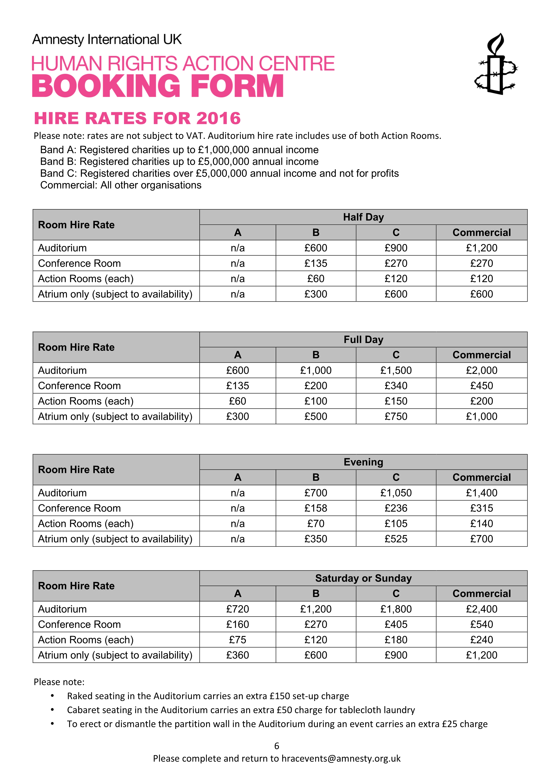
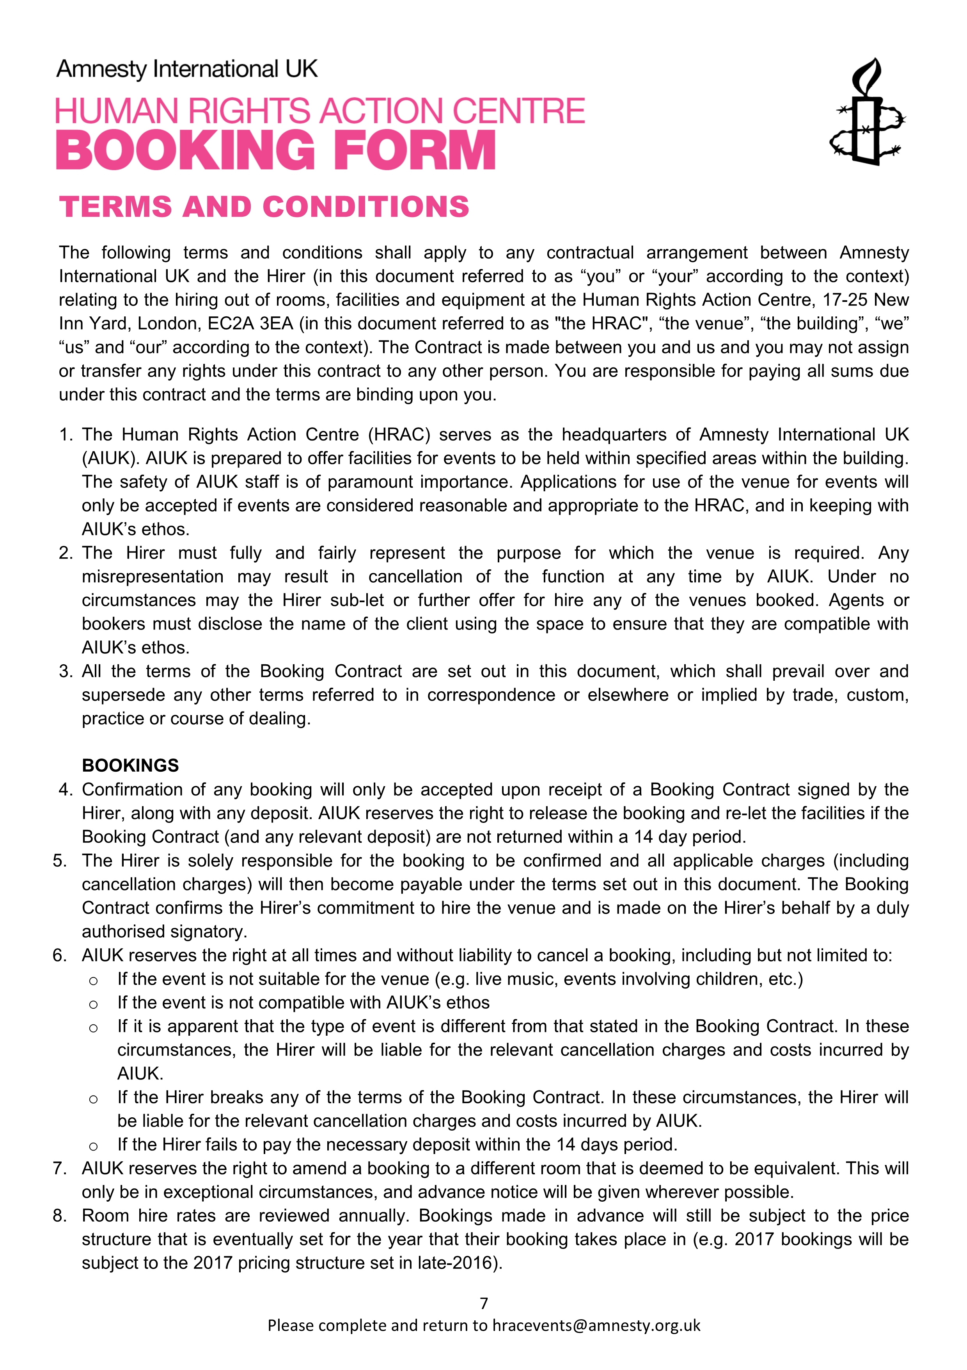

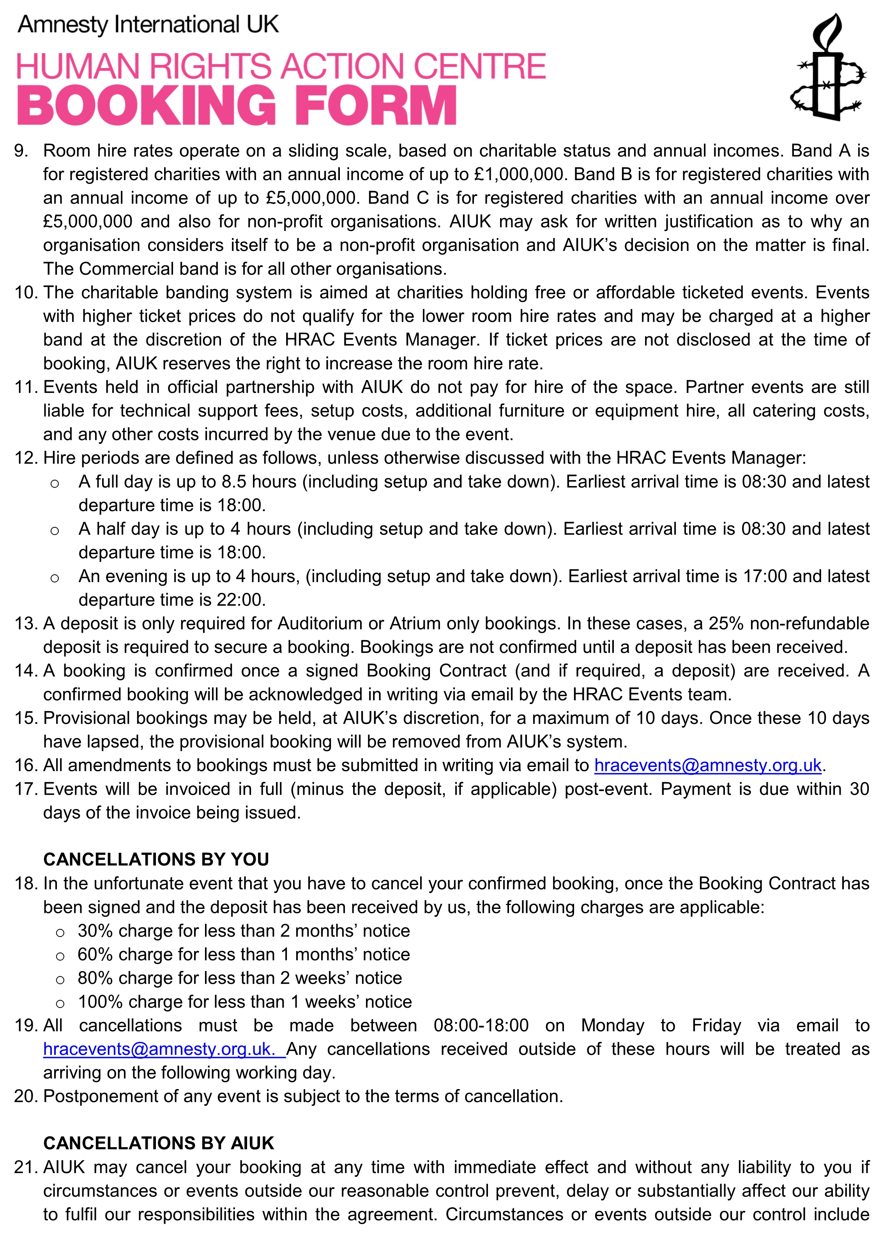
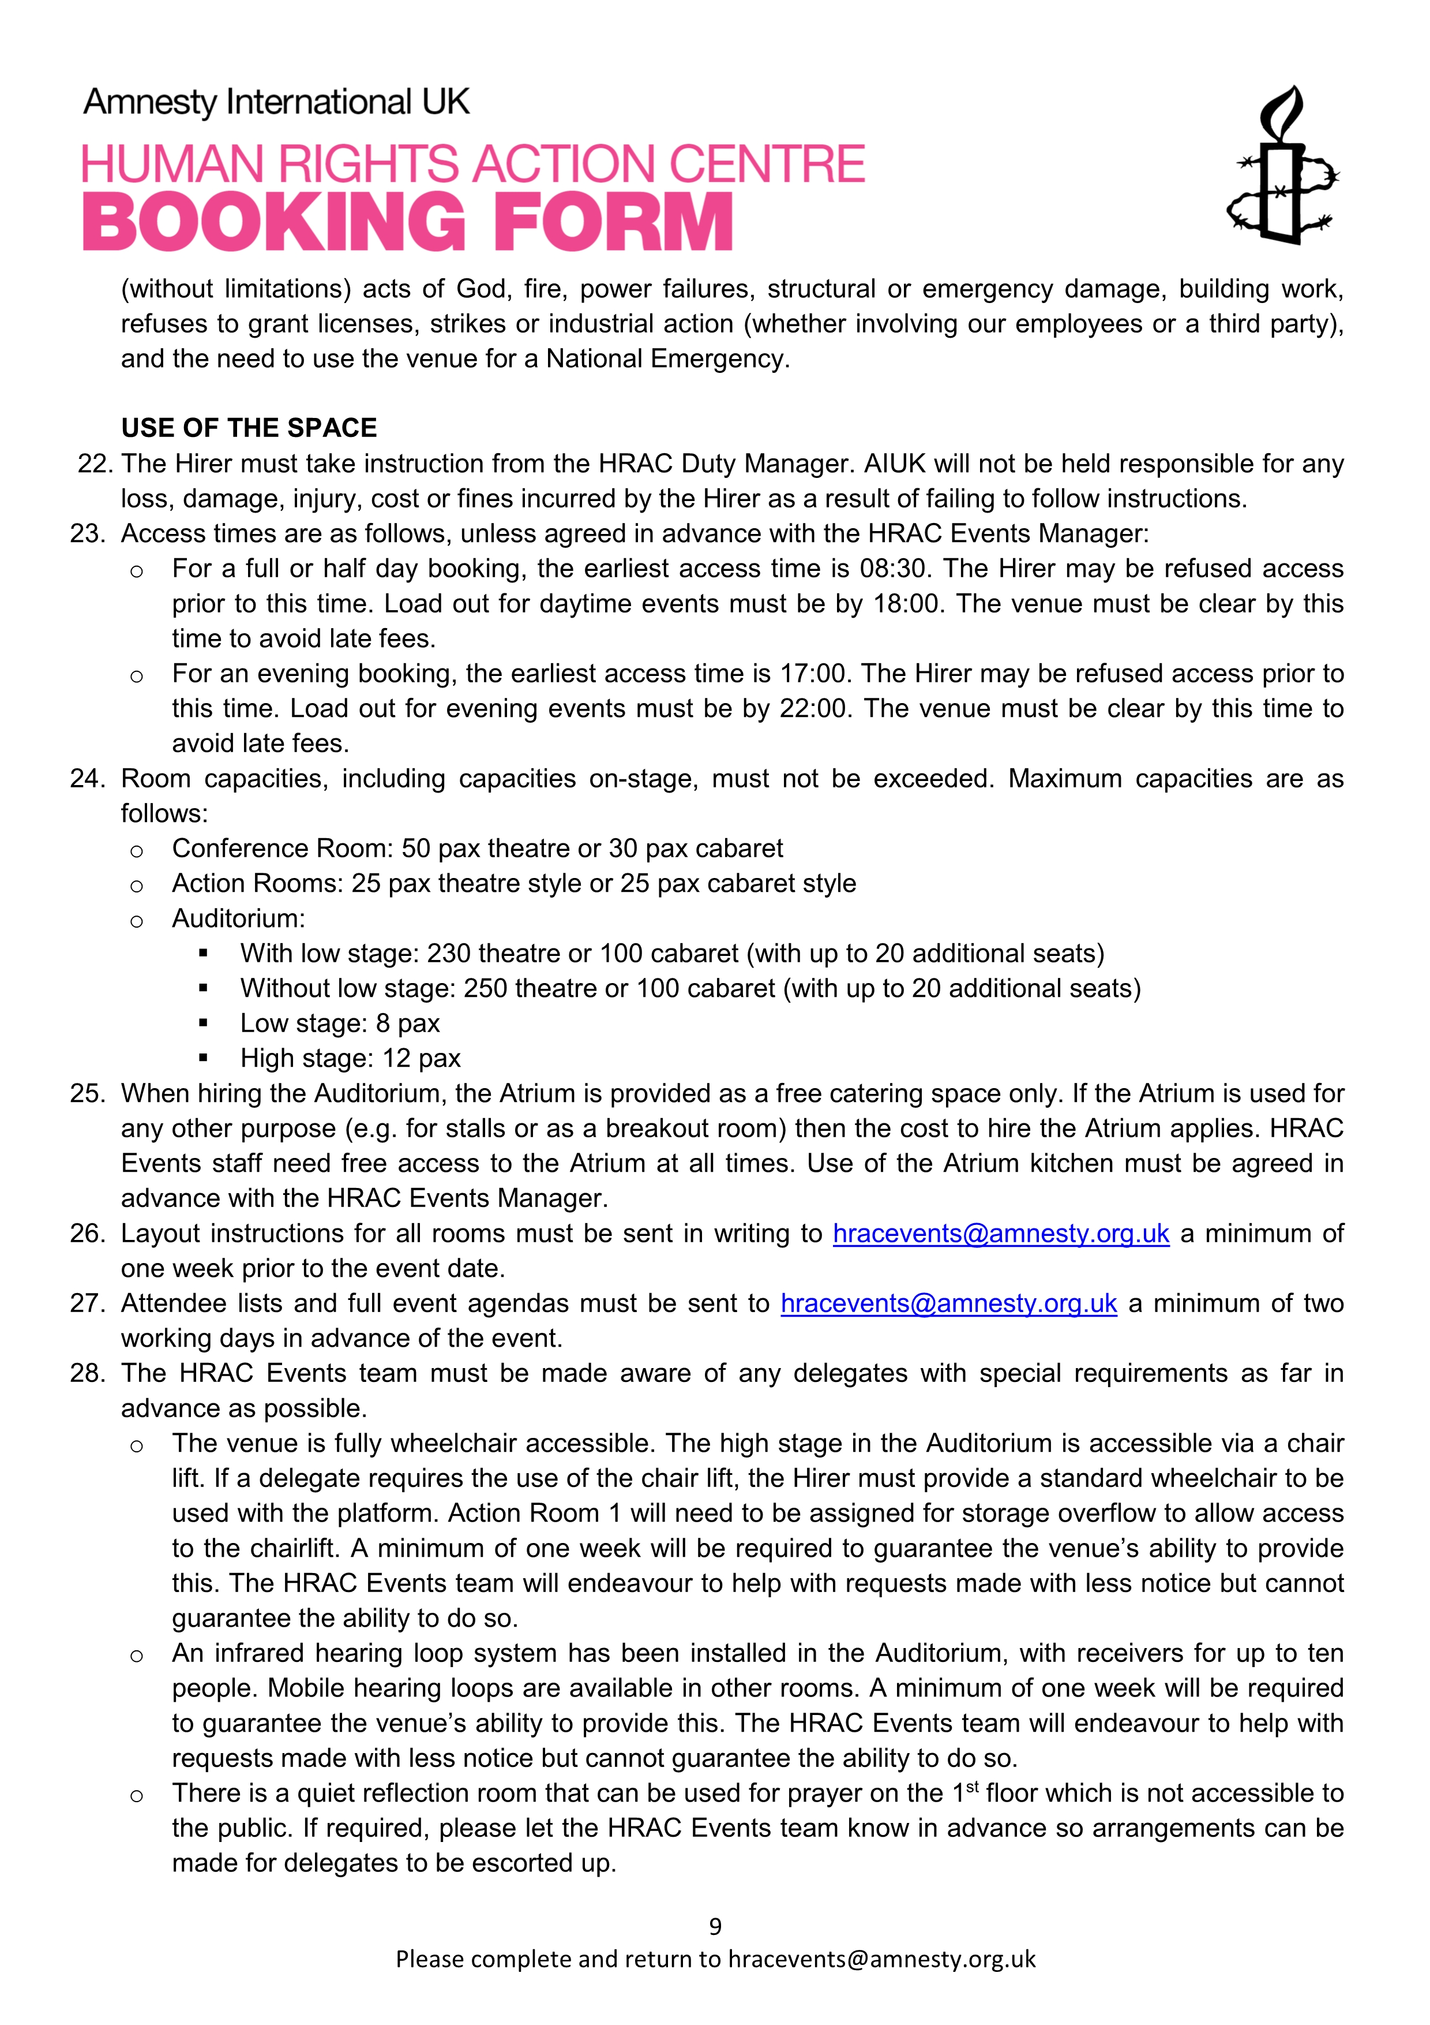
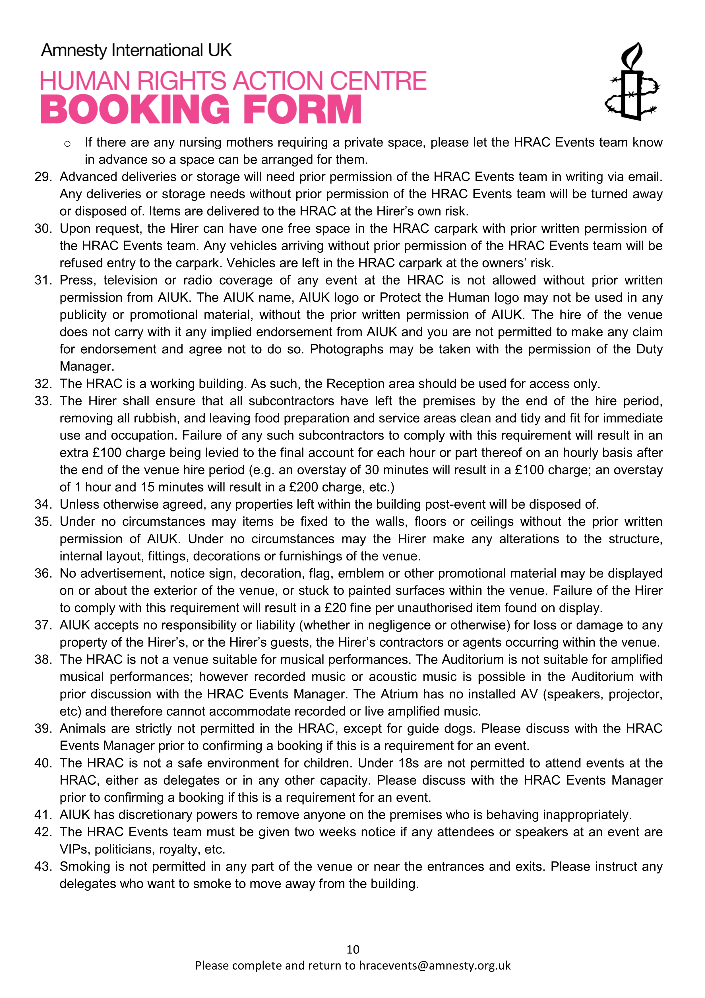
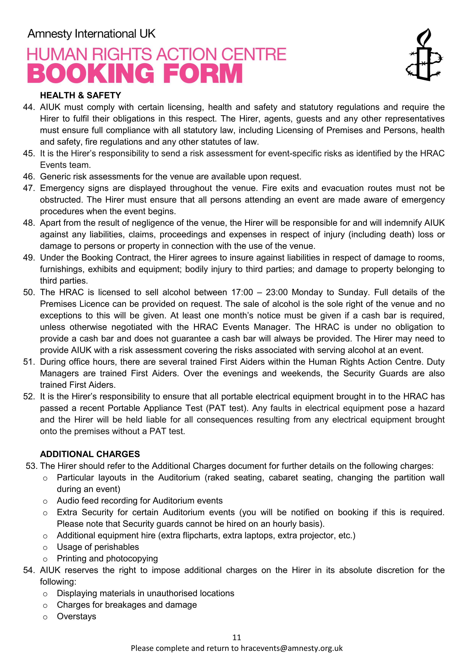
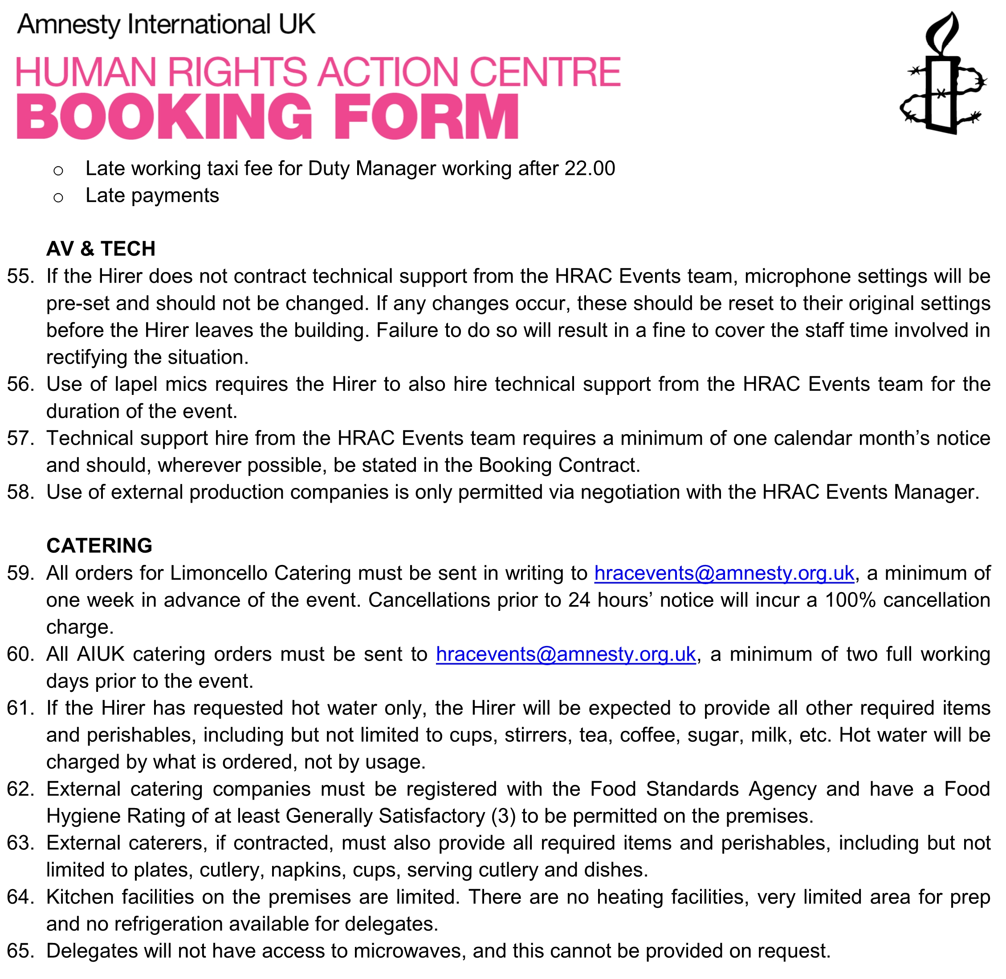

I, the undersigned, acknowledge that I have read the Terms and Conditions and agree to be bound by them to the exclusion of all other terms and conditions.
Signature
Full Name
Job Title
Date

