DIGITAL CAMPAIGNING
LIVE BLOGGING
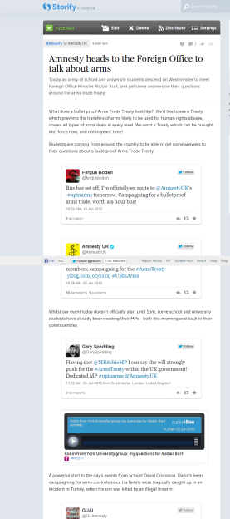
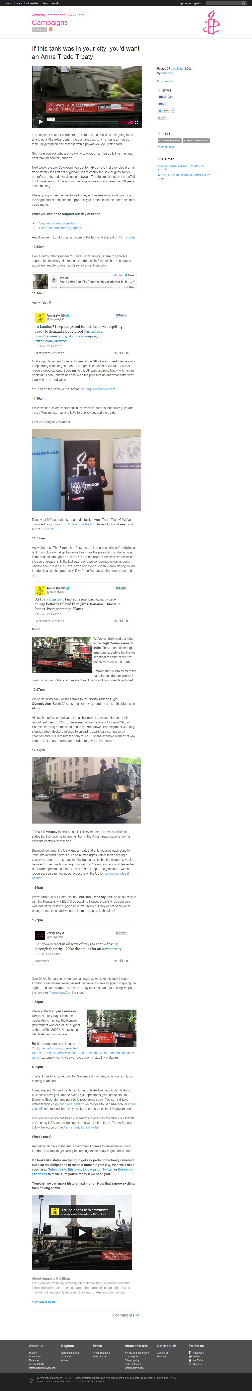
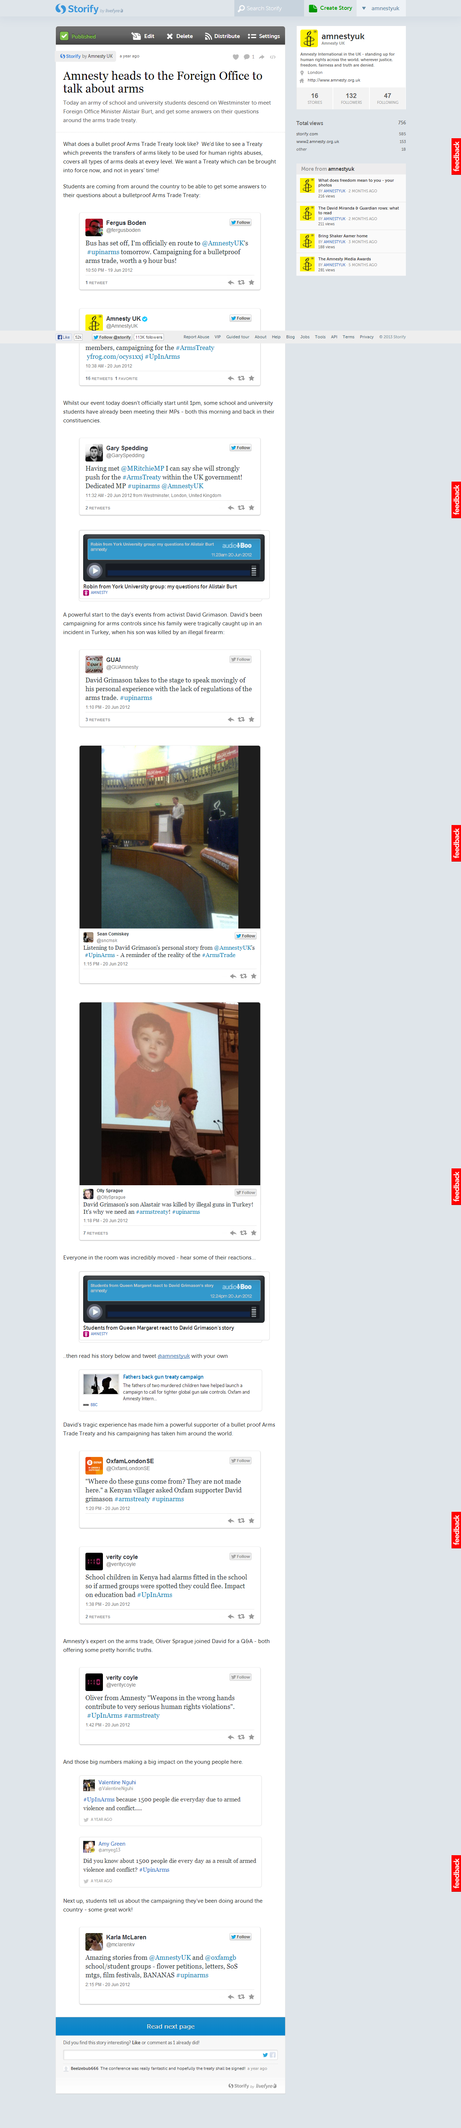
Get the key items in the title – for this, ‘Arms Trade Treaty’ and ‘tank’
Have a basic plan before you start – what ‘moments’ will you blog about. This might change – but start with a plan.
Make sure you repeat your key message several times!
Show you’re updating it – times in the headers can help
Remember the key things for a blog:
- Keep it informal
- Remember your readers aren’t experts – don’t use jargon or acronyms
- Make it stand out – embed tweets, use images
Top tip – consider trying Storify for live blogging – it allows you to pull in tweets, images, videos and more very easily.

