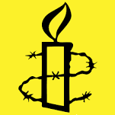 THE AMNESTY SHOW

Saturday 15 November
7.30 – 10.30 pm (doors open 7 pm)

Willand Church Hall
Rectory Close, Willand, EX15 2RH

An evening of MUSIC, POETRY and FUN
with a café atmosphere

Special Star Guests to include
top jazz/swing duo Charlie Hearnshaw and Maxine Green
and Irish poet Frances Corkey Thompson
PLUS a wealth of LOCAL TALENT (including Low Key)

Tickets £8, to include Cheese Ploughmans
Licensed bar available
(tickets from Bluebell Restaurant, Willand
or phone 01884 839282)

In aid of Amnesty International
[Mid Devon Branch http://www.amnesty.org.uk/groups/mid-devon]

