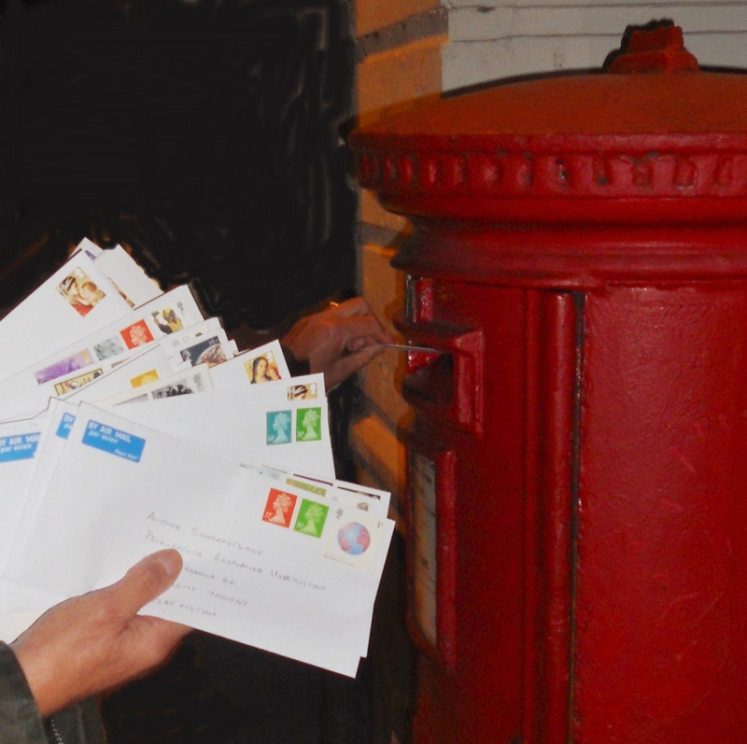

Join us on
Tea, Biscuits &
Letter Writing
for Amnesty International

Tuesday 18 November,
2.30-4.00 p.m.
Quaker Meeting House,
Bancks Street, Minehead (opposite the Library)

Come any time between 2.30 and 3.45.
Pens, paper and stamps supplied!

You’ll be given background information about those unjustly imprisoned or otherwise denied justice, and experienced letter-writers happy to give advice. Our cards and letters provide hope and support, and can transform lives.

Plenty of help to hand – as well as the homemade biscuits!

Organised by Amnesty International Minehead

Contact 01643 70477

