Bognor Regis and Chichester Branch of Amnesty International

Human rights and Afghanistan
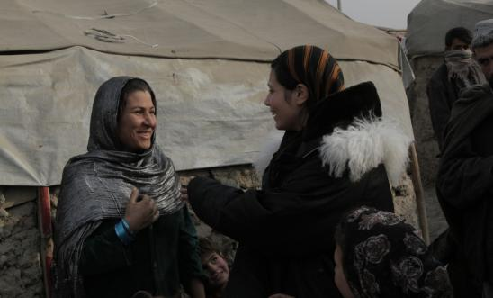
Janey Moffat (Toaster Productions), spent 2 weeks in Afghanistan.
Her presentation will be focusing on Afghan Mothers, the difficulties they face and the inspiring steps they are taking to overcome them. Much of the time will be taken up with actual video of interviews from the mothers themselves.
Janey worked with the organisation Voices for Creative Non-Violence (vcnv.org)
Since 2009, Voices has led five delegations to Afghanistan and two to Pakistan to listen and learn from non-violent grassroots movements and to raise awareness about the negative impacts of U.S. militarism in the region.
Friends' Meeting House, Priory Road, Chichester PO19 1NX
Wednesday 8 October 2014 19:30 - 21:00

