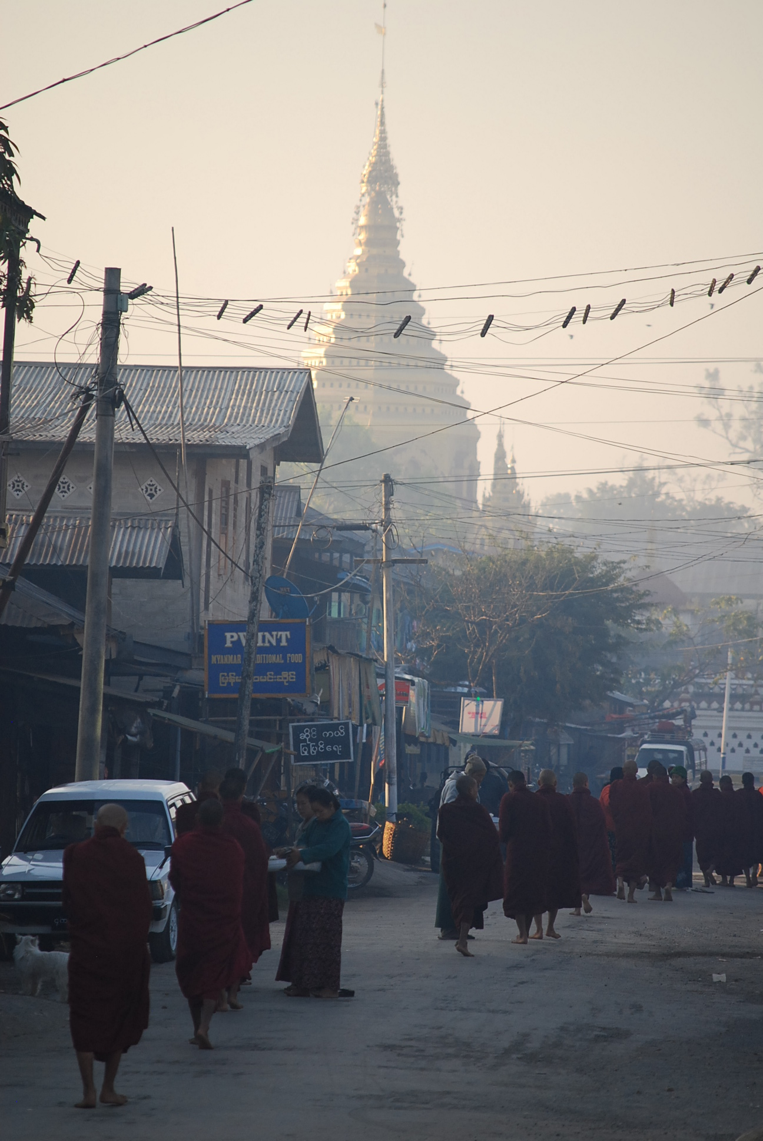
A Visit to Myanmar (Burma)

Following the 2010 national elections, the first civilian government for many years was established ; Aung San Suu Kyi was released from house arrest and in April 2012 she was elected to the Burmese Parliament.
The new government began to implement:
- The start of a series of political and economic reform including the release of political prisoners
- A small relaxation of media censorship
- Improved labour law
- The establishment of a National Human Rights Commission
In 1995 the National League for Democracy (NLD) called for a tourism boycott. In 2010 the boycott was called off but the NLD urged visitors to avoid package groups and cruises. NLD leader U Win Tin said “We want people to come to Burma not to help the junta ,but to help the people by understanding the situation: political, economic, moral – everything”.
Our trip was with a company that organised small group trips and our itinerary was planned so that we did not use any services owned by or affiliated with the government and we interacted with Burmese people wherever possible.
In May 2012 Amnesty International made an official visit to Myanmar and identified the following:
- Human Rights abuses continue – mainly in the ethnic minority areas
- Restrictions on freedom of religion and belief continue
- 100’s of political prisoners remain behind bars
Some of the conclusions of their report were:
- The government should initiate a review process of political prisoners including those in the ethnic minority areas who are not even recorded as being prisoners.
- The National Human Rights Commission capacity was insufficient and needed to be boosted.
- The International Commission of the Red Cross should be granted access to the prison system.
- Rehab and reintegration programmes for former political prisoners were required as a matter of urgency.
- Labour dispute settlement laws needed constructive change.

Our Experience
We visited Myanmar in February 2013 for a 15 day trip.
Our tour guide was Burmese and was clear that the current government was “good” unlike the previous military junta. When we were walking in the hills she was more able to discuss the aspects that still needed to change. She facilitated our talking to people in the villages and in the towns, agricultural workers, craftworkers, mothers, grandmothers and children.
We talked to a farmer living in the hills who described how his land had been taken from him and other local farmers by the military government. They got together locally and with support from the NLD claimed their land back successfully and he now has 14 cattle and his land rights reinstalled.
We talked to a 13 year old girl who was selling lacquer ware and postcards to tourists. She had lost both parents and was caring for her younger sister. She was fluent in English and had been attending school but had stopped going to school in order to raise money to enable her younger sister to attend school.
The owner of our hotel in the hill station of Kalaw had been a general in the military but he had been dismissed because of his allegiance to the NLD.
Our tour guide explained about the Health provision for Burma’s 60 million population. There are 4 types of hospital:
Government – used by 25% of the population – soldiers have free access
Private – used by 10% - high cost
Traditional –used by 25% including Hill tribes
Well wisher – run by monks with free access but paying for medication. These are in great demand and have long queues. They are supported from outside the country and by educated monks. The USA donate funding for specialists and the building of hospitals. If a person needs costly medication or an operation which they are unable to pay for, they put their name in the local press and donors meet the costs.
Teak forests are abundant particularly in the Northern states. Before 2010 if you had a teak tree growing in your garden or on your land and you cut it down, you would be sentenced to 3 years imprisonment as all teak was the property of the military government. Now independent, private companies are applying for rights to manage teak production. The lucrative trade is with China, Thailand and Singapore. Deforestation is a real concern.
We did not observe as much evidence of a military presence as we had expected. We did not go into the North /North Eastern areas where there is continuing conflict between the military and some of the ethnic groups. AI reported that in Northern Shan and Kachin states there is ongoing fighting and there are abuses on both sides. Rohingyas in northern Rakhine state are not recognised as citizens and suffer discrimination.
The AI report was clear that no one has yet been held accountable for human rights abuses in 1991,1988 and 2003 and has called for a UN commission of enquiry.
Aung San Suu Kyi is revered everywhere and referred to as “The Lady”. It did feel that there was a great burden of responsibility lying on her shoulders, both nationally and internationally.
In spite of the strides forward there is some way to go but we did encounter many people who want to live in a peaceful, democratic society and we did see evidence of communities working together to improve their lives.
Cathy Harris , Solihull AI , February 2013
