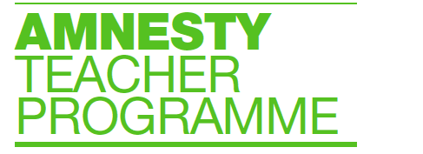

Teacher Advisory Group Objectives 2018-2019:

1. Support the development of effective resources
a. Pilot and evaluate resources in the classroom
b. Measure impact of resources on students
c. Suggest resources and priority areas
d. Give feedback on which resources to promote

2. Advise on engaging at a whole school level
a. Share understanding of systems and governance
b. Suggest means of engaging governing bodies
c. Suggest means of engaging school leaders
d. Give feedback on strategic plans in this area

3. Facilitate increased awareness of AIUK’s human rights education work
a. Make introductions and suggest possible contacts
b. Suggest key search terms
c. Share relevant online resource banks and forums
d. Promote through own networks

