DEATH PENALTY
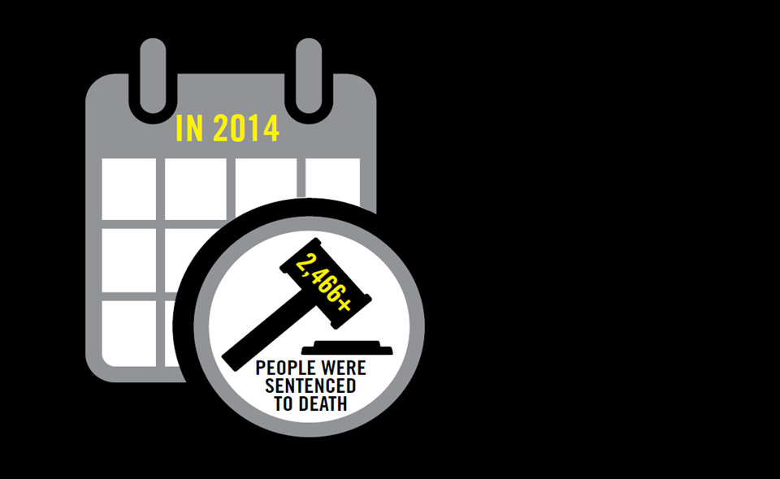
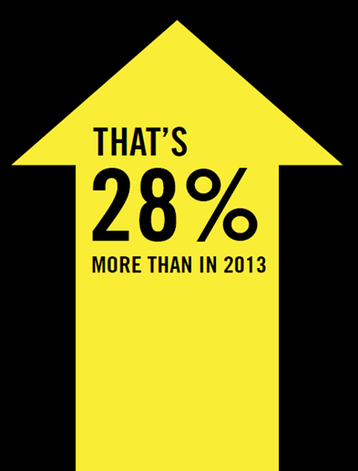
ACTIVITY – For or Against

LEARNING OBJECTIVES
This activity gives participants an opportunity to think about and discuss arguments both for and against the death penalty.
Participants will:
- Be able to make up their own minds about the principles, practicalities and implications of executions carried out by the state.
- Gain information and arguments for challenging the death penalty in conversation with others or in campaigning.

PREPARATION
- You will need space so that participants can form small groups of 2 or 4 and then move around the room or form two parallel lines facing each other.
- You will need post-its for each group and a large wall space or flip chart sheets, with two sections, one marked “For” and the other “Against”.
- Photocopy the supporting list of arguments. (below)
- Photocopies of information about 3 or 4 individuals at risk from Amnesty International web-sites. So far as possible these should be for cases in different countries and should illustrate different aspects of the death penalty e.g. unfair trials, probable innocence, torture or cruel treatment, forced confessions, juveniles, mental incapacity. There are some examples linked in the “Links to Further Information” document, but feel free to use others.

RUNNING THE ACTIVITY
Part One 10 mins
- Form the participants as far as possible into groups of even numbers. If possible position half the groups on one side of the room and the rest on the other, with space between them so that they are not distracted by those thinking of opposite arguments.
- Ask one set of groups to think of arguments in favour of the death penalty and the other of arguments against (this may require them to suspend their own opinions).
- Ask them to write a brief heading for each argument on a post-it e.g. “deterrent”, “cost”.
- Ask them to put their post-its on the wall or flip chart sheets in the appropriate section.

Part Two 10 mins
- Ask them to come up and look at the post-its, especially those for the side they have not discussed if numbers and space allow it.
- Then summarise and give out the handout on arguments for and against, drawing in any extra points raised by the groups. Pair any arguments where appropriate:
e.g. For: it costs more to keep people in prison for life
Against: if appeals are allowed, as in the US, it costs more to have someone on death row and then execute them than to keep them in prison for life.
Part Three 15 to 20 mins
- Mix up the groups so that each has half who argued one way and half the other.
- Give each group an information sheet about one of Amnesty’s individuals at risk. Each person in the group should read one and highlight the key points to the others.
- Then ask the individuals in the group to reverse roles, arguing the opposite way to the way they argued before, using the case studies as examples where appropriate.
Note: depending on the participants this could be a friendly discussion or a mock argument. If participants need to or are keen to gain practice in challenging arguments, you could form them in two lines with one side for and one against for short two minute paired encounters, moving them on to different pairings every 2 minutes.
This can build confidence for encounters e.g. in street actions.

Arguments FOR and AGAINST

ARGUMENTS USED FOR THE DEATH PENALTY
- A Life for a life: those who have taken away life – through murder, terrorism or the drug trade – should pay for their crimes with their own lives.
- The death penalty deters people from committing capital offences (those that might incur the death penalty).
- Someone who has been executed cannot be a threat to society again.
- Victims and their families need justice and retribution.
- The state shouldn’t have to pay for the long term (perhaps for life) imprisonment of people who have taken others’ lives.
- It is more humane to put someone to death than to keep them locked up for years.

ARGUMENTS USED AGAINST THE DEATH PENALTY
- Killing is wrong, including killing by the state. If the state carries out executions itself it weakens this moral stance. The third article of the Universal Declaration of Human Rights says “Everyone has the right to life…”
- Multiple studies, including some conducted by the UN, show that the death penalty does not deter crime more effectively than other forms of punishment. This includes comparative studies of states in the USA with the death penalty and without, and the effects when the death penalty is adopted or abolished.
- Courts can make mistakes and innocent people are sometimes executed.
- Some victims’ families and friends are strongly opposed to the death penalty and campaign against it. Many who have wanted a murderer to be killed when they have taken the life of a loved one find that in fact they are not helped by the execution.
- Studies have shown that legal proceedings for the death penalty can cost significantly more than for equivalent non-capital cases, often making it more expensive than keeping someone in prison for life.
- If someone is executed they also lose the chance to reform their lives and make a positive contribution to the world.
- Life on death row waiting for execution is cruel, inhuman and degrading punishment as is the execution itself, however it is carried out.
- The death penalty is discriminatory and is often used disproportionately against people from poor backgrounds, minority racial groups or those with mental health problems.

