NEXT GROUP MEETING

The next group meeting will be held on 15th JANUARY at 7pm. Venue – Stockton Heath Methodist Church, Heath St WA4 6LP

PALESTINE ACTION - Counter-terrorism
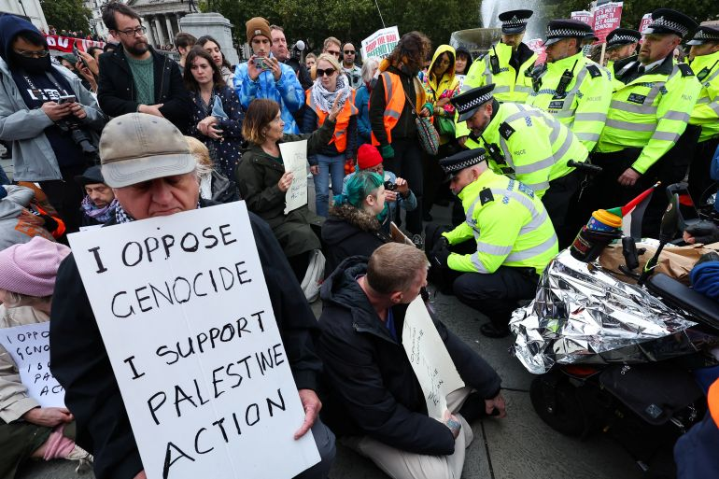
The UK’s two largest human rights organisations, Liberty and Amnesty UK criticised the UK’s definition of terrorism as being “extremely broad”, and said it “extends beyond international definitions”. Proscribing a group whose actions fall under the “outer reaches” of the UK definition is not proportionate, the groups said. Broad counter terror powers and a lack of clarity on where the line is drawn on criminal liability have discouraged people from engaging in protest due to the risk of incurring sentences of up to 14 years in prison.
Liberty and Amnesty UK said the decision to proscribe any protest group as a terrorist group also impinges on the rights to freedom of expression and freedom of association.
There have been more than 700 arrests of protesters related to the proscription of Palestine Action so far, with more than 100 people charged. The vast majority of arrests have been due to holding signs or placards deemed as supportive of Palestine Action under the Terrorism Act.

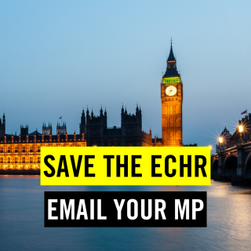

Our rights are under attack. Politicians want to tear up the European Convention on Human Rights – the safety net that protects every one of us. Tell your MP to defend the ECHR and keep our rights safe.
For 75 years, the European Convention on Human Rights (ECHR) has protected people in the UK, from families seeking justice after Hillsborough, to domestic violence survivors, military personnel and workers holding the government to account.
Right now, these vital protections are under threat. Some politicians want to pull the UK out of the ECHR altogether, or water it down so much that it no longer protects those who need it most.
Leaving the ECHR would be unprecedented. It would put the UK alongside Russia and Belarus, countries expelled or isolated for their human rights abuses. It would also jeopardise the Good Friday Agreement, the cornerstone of peace in Northern Ireland.
Human rights are universal - they belong to all of us, not just those who are popular with politicians or the media. Protecting the rights of migrants, survivors of abuse, and those facing injustice protects the rights of everyone.

Edward Snowden: 'Privacy is for the powerless'
Today, the government is granting itself the power to police every citizen’s private life.
Every man, woman, child, boy, girl. It doesn’t matter who you are, how innocent or not innocent you are, they are watching everything you’re doing. They’re intercepting it, analysing it and storing it for increasing periods of time.
The fact that we’ve got agencies like the GCHQ looking through webcams into people’s bedrooms, into the four walls of their homes, is terrifying.
The NSA is collecting billions of phone location records a day, so they know where you got on the bus, where you went to work, where you slept and what other cell phones slept with you. We have to ask: 'Do we want to live in a society where we live totally naked in front of government, and they are totally opaque to us?'
Some people say: 'If you’ve done nothing wrong, you’ve got nothing to hide from government spying'. But it’s not about having nothing to hide, it’s about being you. It’s about being friends with who you want to be friends with, without worrying about what it looks like on paper or inside some private record in some dark government vault. It’s about realizing there’s a reason we close the bathroom door. There’s a reason we don’t want the police to have a video camera so they can watch us sitting in the bubble bath.
You could be the most innocent person in the world, but if somebody who is programmed to see patterns of criminality looks at your data, they’re not going to find you – they’re going to find a criminal. Having been an analyst sitting at the desks and targeting people using surveillance, I know that the information that’s in data banks can lead people very easily to the wrong conclusion – particularly when the people who are looking at this data are looking for terrorists and criminals.
We could have the most responsible government in the world today but tomorrow there could be a change.
And in times of conflict, when we face serious foreign adversaries and the threat of terrorism, it’s even more important that we protect our values. Because it is in times of panic that we lose rights. We don’t want our politicians to think: “I’m concerned that people will say I didn’t do enough, so instead I did too much.”
Suddenly we have an algorithmic enforcement, investigation and prediction of criminal activity. What we’ll find is that, when we realize that the person to our left or right got arrested for some incredibly minor infraction of law, we are going to rigidly avoid anything that could be considered controversial. There will be no free speech.
Privacy is for the powerless. Transparency is for the powerful. You don’t need to say why you want to be left alone by the state. It is the natural state of being that we are allowed in a free society to be free. If they want to restrict and monitor our activities it really changes the nature of human society

COMPULSORY DIGITAL ID CARDS
Javier Ruiz Diaz, Amnesty International UK’s Technology and Human Rights Lead, said:
“The case for ID cards has not been made. It is not clear how these will solve any issues around migration beyond generalities that the lack of ID cards makes the UK more attractive.
“Introducing digital ID cards to control migration creates new risks of discrimination, and will likely increase existing issues identified by Amnesty UK, including racialised policing. We must oppose the introduction of a digital ID scheme because it fails on its own terms and poses grave dangers to privacy, democracy, and social cohesion. Defending our freedoms demands vigilance against any measure that would turn Britain into a “checkpoint society”, with the potential down the line for something even worse.

