AMNESTY INTERNATIONAL KENT NETWORK NEWSLETTER: DECEMBER 2025
HIGHLIGHTS
We are taking a bit of a break during this festive season, which we hope you will also enjoy however you decide to spend it. This newsletter will therefore be shorter than usual. This month you can:
- respond by 12 February to the UK Government’s consultation on its immigration and asylum proposals
- write to your MP opposing these proposals
- continue to promote this year’s Write for Rights Campaign
- still call on the Prime Minister to mend the UK’s social security system
- catch up with Amnesty statements on some key current issues
- tell us who you would like as speakers at our 2026 meetings
IMMIGRATION AND ASYLUM
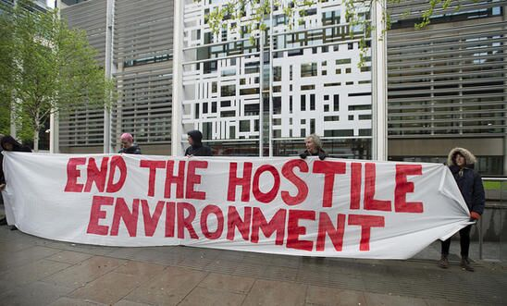
The UK Government has announced proposals to make the immigration and asylum systems very much harsher for people except those regarded as highly skilled and/or relatively wealthy. Amnesty UK is strongly opposed to these proposals which will harm many people, families, and wider society. It has asked us to help raise awareness and register strong objection to them. It is important that as many of us as possible do so and that Government and MPs clearly hear that what is being done is neither right nor supported. To help you do this, there is material here – including Guidance on how to respond to the Government’s consultation on some of these proposals and template letters to MPs about them. Please take action.
WRITE FOR RIGHTS 2025
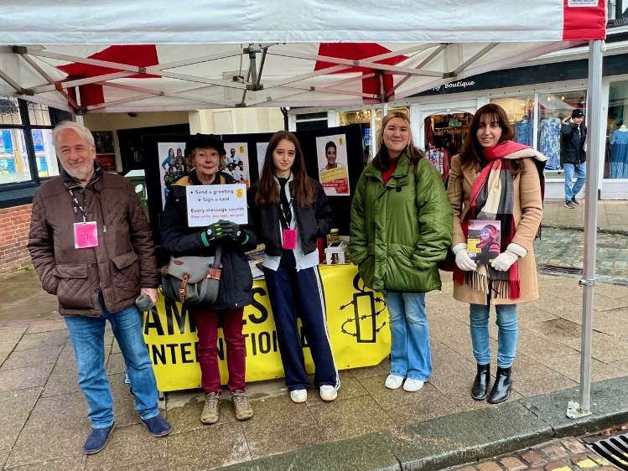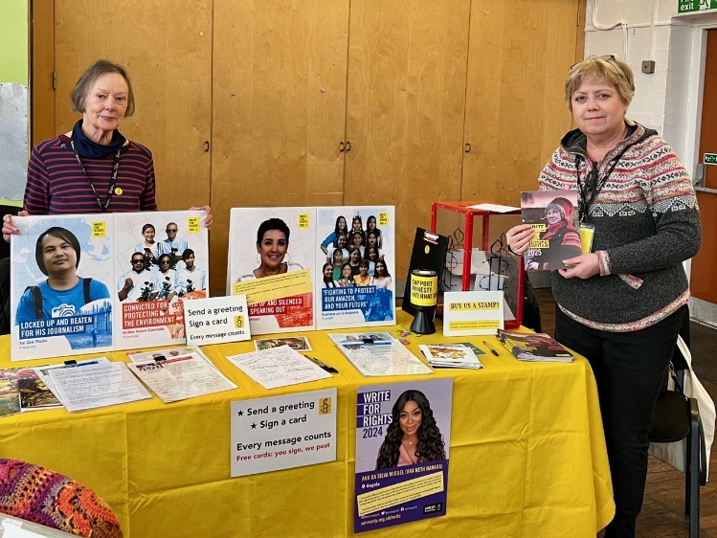
The Maidstone, Medway and Swale Group were at the street market in Faversham on 29 November and at the Sunlight Centre in Gillingham on 6 December to promote Amnesty’s Write for Rights Campaign. 53 greetings cards were signed for despatch and signatures were collected for appeals to the relevant authorities.
The campaign is continuing throughout this month. The Case booklet has been updated as the case of Makhabat Tazhibek Kyzy has been withdrawn following a risk assessment in light of the changing and uncertain political situation in Kyrgyzstan. Advice on organising an event can be found here.
HUMAN RIGHTS DAY
Amnesty UK held its annual Human Rights Day Reception in Parliament on 3 December. The focus of the event was to celebrate human rights successes that we have achieved over the years, working alongside Parliamentarians, and to emphasise the importance of civil society, rightsholders and Parliamentarians working together. There were stalls focussing on Amnesty’s priority campaigns so that Parliamentarians could see the breadth of our work and consider what areas they might want to support. The event was held jointly with the Parliamentary Human Rights Group (PHRG) and took place Wednesday 3 December. 23 parliamentarians attended and speakers included Fabian Hamilton MP (Chair of the PHRG), Baroness Kennedy, Monica Harding MP (Lib Dem International Development spokesperson), as well as Kerry Moscogiuri (AIUK Interim CEO).
SOCIAL SECURITY IN THE UK
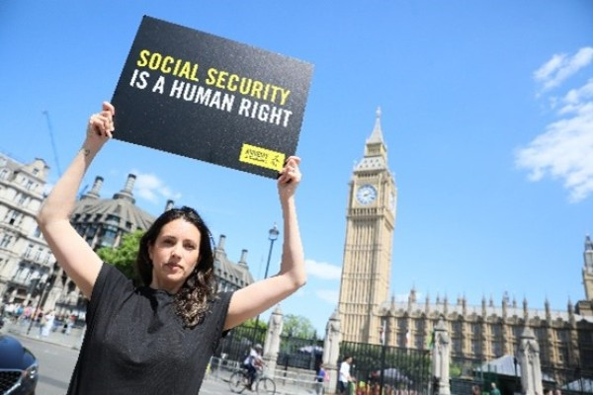
In the UK budget, announced on 26 November, the Government committed to scrapping the two-child benefit limit, which will take an estimated 450,000 children out of poverty. This is very welcome and long overdue. Amnesty has called on the government to go further, make poverty eradication its key priority and recognise that a decent standard of living is a human right, not a gift to be given or taken away. You can still sign the petition calling on the Prime Minister to make sure the social security system works for everyone.
PROTECT THE PROTEST
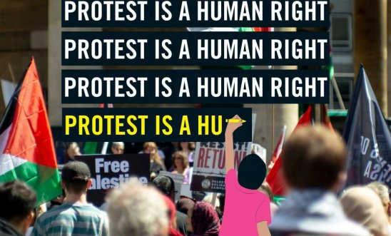
Responding to reports that five Palestine Action activists who are on hunger strike have been hospitalised, Amnesty UK have called on prosecutors to drop the allegations of a ‘terrorism connection’ in these cases and end any excessively lengthy pre-trial detention. Amnesty has consistently opposed the use of anti-terrorism powers in these cases, stating that the use of terrorism laws to circumvent due process and impose harsher punishments on direct action protesters is a threat to expression and assembly rights for everyone.
ISRAEL / PALESTINE
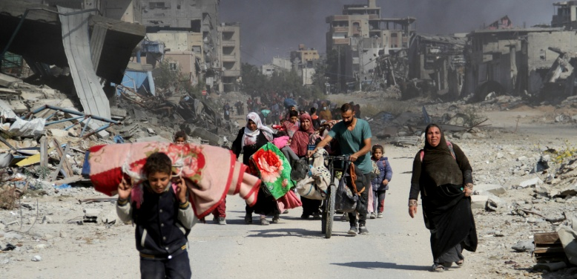
Amnesty has published a new legal analysis of the genocide in Gaza with testimonies from local residents, medical staff and humanitarian workers highlighting the dire conditions for Palestinians there. This showed that, despite a reduction in the scale of attacks in Gaza recently and some limited improvements, there has been no meaningful change in the conditions Israel is inflicting on Palestinians in Gaza and no evidence to indicate that Israel’s intent has changed. In Amnesty’s view, the Israeli authorities are still committing genocide against Palestinians in the occupied Gaza Strip by continuing to inflict conditions of life calculated to bring about their physical destruction, without signalling any change in their intent.
HOMELESSNESS

Commenting on the UK Government's homelessness strategy, Amnesty has welcomed the government’s acknowledgement of the scale of England’s homelessness crisis but said that it does not match the urgency required to address it. It has identified several policies that actively undermine the fight against homelessness, including social security levels that are too low to meet basic needs, housing benefits frozen below real rents, sanctions that can remove 100% of a person’s income for missing a single appointment, and discriminatory housing eligibility rules.
EUROPEAN CONVENTION ON HUMAN RIGHTS
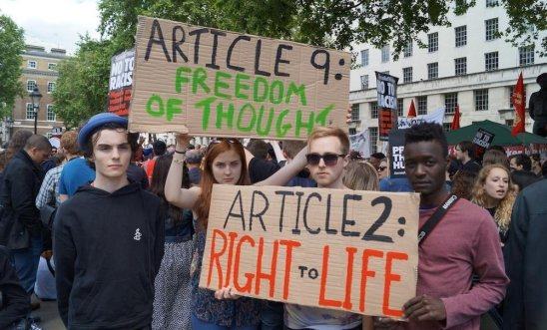
Amnesty UK has pointed out the irony of the UK government, on Human Rights Day, calling for the weakening of protections under the European Convention on Human Rights (ECHR). It has urged the UK government and all participating states to reaffirm, not rewrite, what human rights stand for, arguing that weakening these protections would betray decades of human rights leadership, endanger lives and cast a long-lasting moral shadow over the UK’s commitment to justice and dignity.

2026 SPEAKER MEETINGS
Our first speaker meeting in 2026 will be on Tuesday 20 January at 19:30hrs when we shall be joined by Refugees at Home. Email mark.clixby@amnesty.org.uk for a link.
Thank you to those who have offered suggestions for our speaker meetings in 2026. We would like to hear from more of you about this. Please send any suggestions to mark.clixby@amnesty.org.uk.
With very best wishes for the festive season and for the coming year
Graham

