AMNESTY INTERNATIONAL KENT NETWORK NEWSLETTER: OCTOBER 2025
HIGHLIGHTS
Welcome to our October newsletter. This month you can
- learn about how to use personal divestment as a tool for change at next Tuesday’s speaker meeting
- call on politicians, the media and others to end racist rhetoric and not allow their platforms to be used to put people in danger
- call on your MP to stand up for the UK’s membership of the European Convention on Human Rights
- call for the dropping of all charges against people protesting peacefully against the banning of Palestine Action
- ask for a meeting with your local MP to discuss one or more human rights issues
- join our new team seeking to strengthen our work with local schools
- demand that the US authorities stop the wrongful removal of students’ visas and residency status and respect their human rights
- participate in this year’s Write for Rights Campaign
- support Amnesty by buying gifts, cards and other things from the Amnesty shop’s new catalogue
- participate in events held by our friends at local United Nations Association branches and the Medway Inter-Faith Network

NEXT SPEAKER MEETING: 21 OCTOBER
Join us on Tuesday 21 October at 7:30pm when Stephanie Lord will talk about personal divestment, particularly as a tool for change in Palestine. Personal divestment is a way of influencing change by moving your savings, investments or pension funds away from businesses that do not live up to your ethical expectations. Stephanie is a member of Amnesty UK’s United Nations Network and member of the mid-Warwickshire Group. Email mark.clixby@amnesty.org.uk for a link.
ISRAEL / PALESTINE
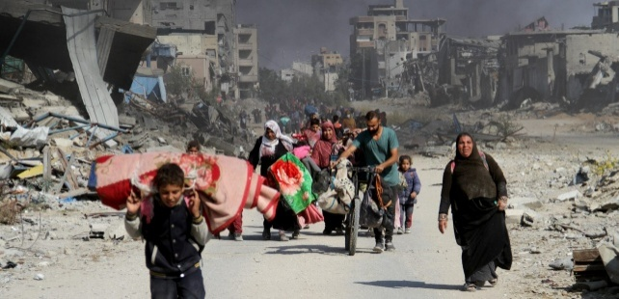
Israel and Hamas have agreed to the first phase of a ceasefire deal which, according to reports, includes the immediate opening of five crossings to allow humanitarian aid into the Gaza Strip, the rapid release of all living Israeli and other nationals held hostage in Gaza in exchange for Palestinian prisoners, and the partial withdrawal of the Israeli military from the occupied Gaza Strip. Amnesty has called for the ceasefire to be a pathway to ending Israel's unlawful occupation, apartheid and genocide. For any lasting ceasefire agreement to succeed, it must be firmly rooted in respect for human rights and international law.
REFUGEES
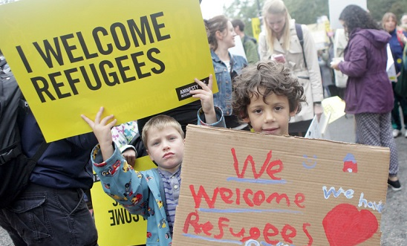
At our September speaker meeting, Colin Parker spoke to us about the work of Refugee Action in supporting refugees and seeking asylum. At this link, you can sign their latest petition calling on all politicians, the media, public bodies and public figures to end racist rhetoric and not to allow their platforms to be used to put racially minoritised people in danger.
EUROPEAN CONVENTION ON HUMAN RIGHTS

The Conservative Party leader, Kemi Badenoch, has announced that a future Conservative Government would take the UK out of the European Convention on Human Rights (ECHR). For 75 years, the ECHR has protected people in the UK, from families seeking justice after Hillsborough, to domestic violence survivors, to soldiers and workers, by holding the government to account. Amnesty has warned that leaving the ECHR would leave people vulnerable to the political whims of those who seek to undermine and deny them their rights. Please call on your MP to stand up for the UK’s membership of the ECHR and protect our rights for generations to come. You can use this link.
PROTECT THE PROTEST
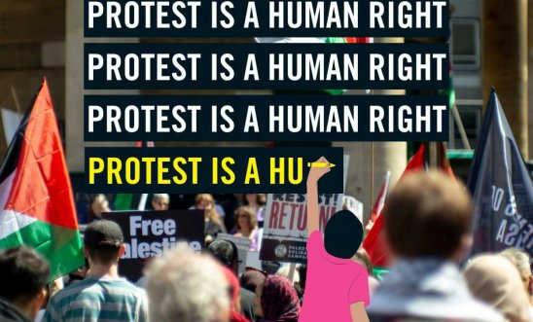
The number of arrests under terrorism law of people protesting peacefully against the banning of Palestine Action has risen to over 2100. Please sign Amnesty’s petition calling for all charges to be dropped.
The Home Secretary has announced new powers for the police to tackle repeat protests. In response, Amnesty has pointed out that the measure is an attempt to introduce powers that the last Government tried to push through under regulations that the courts found to be unlawful.
LINKS WITH MPs
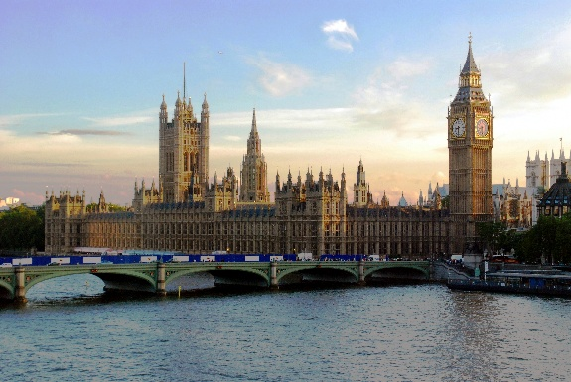
Now is a good time to approach your local MP to raise human rights issues with them. Our members have several in person meetings lined up for the next month or two, but we would like more. If you have already had a meeting with your MP, please consider timing for a follow-up. If you manage to secure a meeting, whether in person or online, we can support you, both by providing briefing and by taking part in the meeting. There are numerous current issues on which we would like our MPs to focus and we would be pleased to provide suggestions, bearing in mind the interests of your MP and the issues on which they are likely to engage constructively. Please email me if you would like to take this up.
WORKING WITH SCHOOLS
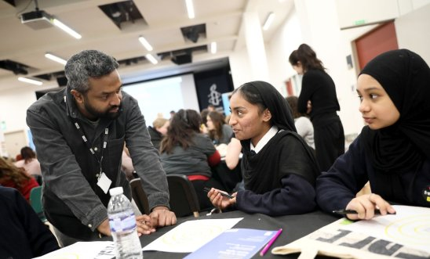
We have had a good response from Network members to our invitation to get involved in our efforts to build stronger links with local schools. Thank you to those who have replied. We shall be in touch shortly about next steps.
PRESIDENT TRUMP’S VISIT TO THE UK
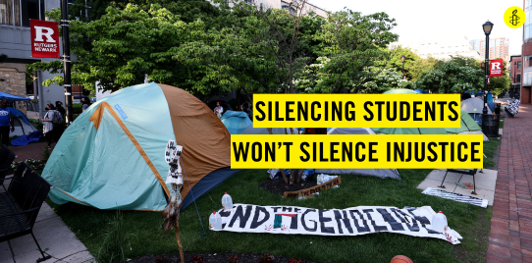

Thanks to all who joined the Amnesty bloc at the march and rally organised by the Stop Trump Coalition. While the red carpet was being rolled out for President Trump, thousands took to the street to say: ‘Expect Resistance’. The US, under Trump’s policies, has shown the world how quickly progress can be reversed. This is a warning to the world: our hard-won rights can be lost overnight. The UK should be actively opposing this extreme rollback, but instead we are seeing some of the same rights being restricted here. Please email the US Secretary of Homeland Security to demand US authorities stop the wrongful removal of students’ visas and residency status and respect their human rights.
ALAA ABDEL FATTAH
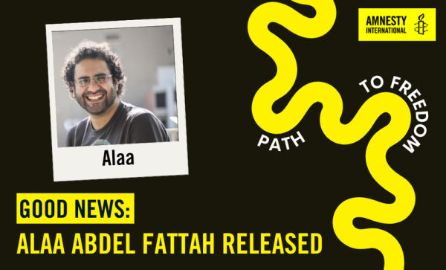
Good news. Alaa Abdel Fattah has been released after six years of unjust imprisonment. Alaa featured in several of our newsletters when we urged you to join the campaign for his release. Thank you to all those who took action to demand his release.
WRITE FOR RIGHTS 2025
We are gearing up for this year’s Write for Rights Campaign. This is Amnesty’s flagship campaign and an opportunity to encourage others to take action in solidarity and for human rights impact together with thousands of people around the world, as well as taking action yourselves. If you are planning a local event to promote the campaign and would like to order resources, please email me and we shall order them for you. More information will follow in our next newsletter.
AMNESTY SHOP CHRISTMAS RANGE

The new Amnesty Shop Christmas Range is now available. You can order here.
OUR FRIENDS’ EVENTS
On 24 October at 10am, Medway United Nations Association (MUNA) will honour United Nations Day by raising the United Nations Flag at Medway Council, followed by a coffee morning at Rochester Cathedral and an Evensong Service. For more information, email medwayuna@gmail.com and please let them know if you plan to attend the coffee morning.
The Tunbridge Wells branch of the United Nations Association (UNA) is organising a choral evening celebrating the 80th anniversary of the United Nations on Saturday, 25 October at 7pm at the Church of King Charles the Martyr, Tunbridge Wells. There will be some light refreshments available in the King Charles the Martyr Hall after the concert. Book here.
From 9-16 November, Medway Interfaith Action will present their 2025 Interfaith Week Programme, with events in various Medway faith centres and other venues. For the full programme, email thesoulweaver@rocketmail.com

Tuesday 21 October at 7:30pm: Kent Network speaker meeting on personal divestment with Stephanie Lord. Email mark.clixby@amnesty.org.uk.
Friday 24 October from 10:00am: Medway United Nations Association United Nations Day events. Email medway@gmail.com.
Saturday 25 October at 7:00pm: Tunbridge Wells United Nations Association branch choral evening at King Charles The Martyr Church, Tunbridge Wells. Book here.
Monday 3 November at 7:30pm to 9:00pm: Maidstone, Medway and Swale Group meeting at Maidstone Community Support Group, 39-48 Marsham Street, Maidstone, ME14 1HH, and online. Email mmands.amnestygroup@gmail.com.
Wednesday 5 November at 1:00pm to 3:00pm: Monthly Guantanamo vigil outside Houses of Parliament. Email mark.clixby@amnesty.org.uk.
9-16 November: Medway Interfaith Action Interfaith Week. Email thesoulweaver@rocketmail.com.
15 November: Gravesend Inter-Faith Walk. Details to follow. Email gpminter@amnesty.org.uk.
All the best
Graham

