AMNESTY INTERNATIONAL KENT NETWORK NEWSLETTER: NOVEMBER 2025
HIGHLIGHTS
Welcome to our November newsletter with a longer than usual list of options to get involved this month. This month you can:
- learn about the work of Kent Stand Up to Racism at our speaker meeting this Tuesday
- tell us who you would like as speakers at our 2026 meetings
- participate in this year’s Write for Rights Campaign
- call on your MP to stand up for the UK’s membership of the European Convention on Human Rights
- order and display Amnesty posters calling for the arrest of Benjamin Netanyahu
- learn about using personal divestment as a powerful force for change
- become better able to talk confidently about refugees with our friends, families and wider communities
- support Safe Passage’s campaign for the government to restore refugee family reunion
- call on the Prime Minister to mend the UK’s social security system
- call on the government to extend and mandate Relationships and Sex Education to sixth form and college students
- attend one of the launches of our Student Action Network’s Defend Dissent Campaign on 25 and 27 November
- support our efforts to strengthen links with our local MPs
- join our new Working with Schools Team
- volunteer to join our new Social Media Team
- buy your Christmas cards and presents from the Amnesty shop
- join the online training session on 25 November on when and how to take direct action
- support the elimination of violence against women at Human Rights Solidarity’s Stand Up at Trafalgar Square on 22 November
- march with Soroptimist International in Canterbury on 29 November to raise awareness of domestic violence against women and girls

NEXT SPEAKER MEETING: STAND UP TO RACISM: 18 NOVEMBER
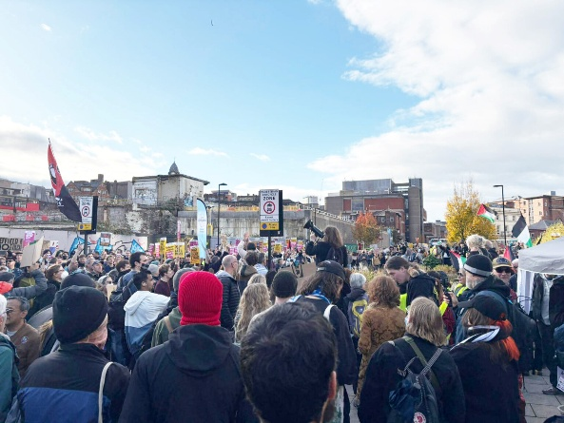
Join us on Tuesday 18 November at 7:30pm when Steve Wilkins of Kent Stand Up to Racism will talk about the work of that organisation. Stand Up to Racism (SUTR) is part of an international network of anti-racist organisations which aim to coordinate efforts to oppose the rise of the far right and racism internationally. Email arianna.pisetti@amnesty.org.uk for a link.
We are working on Speaker Meetings for 2026. If you have any suggestions, please email mark.clixby@amnesty.org.uk.
SOUTH EAST REGIONAL GATHERING: 18 OCTOBER
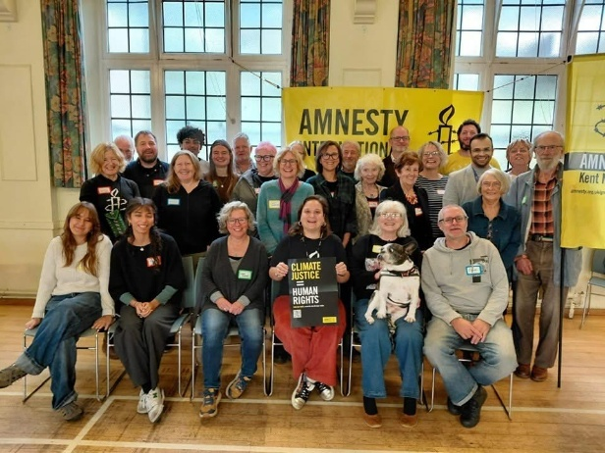
Amnesty members from Kent, Sussex and Surrey gathered in Tunbridge Wells on 18 October for an inspiring programme of talks, discussions and workshops. Our discussions covered issues such as the rise of extremist movements and hate narrative and how to build community power to counteract a hostile environment; how to localise national human rights issues for our campaigning; connecting and building relationships with local organisations; and how to lobby our MPs. It enabled us to build stronger links with Amnesty activists across the region as well as to attract individual Amnesty members from the local area who are interested in joining us in our campaigning. This was the first such gathering for over 10 years and it is planned to hold further gatherings annually.
WRITE FOR RIGHTS 2025
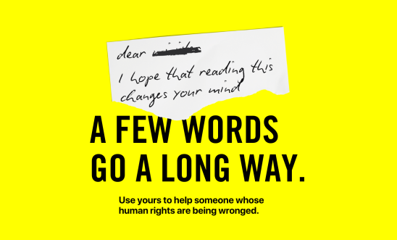
This year’s Write for Rights Campaign is well under way. Thousands of Amnesty members and supporters around the world are writing messages of support to people who have suffered injustice and appealing to the authorities who can bring them justice. You can download the campaign booklet here. You can also hold an event to get others to take action with you. For example, the Maidstone, Medway and Swale Group will hold a stall at the street market in Faversham on 29 November. But you can also do something less public or on a smaller scale, by inviting friends around to take action with you or promoting the campaign at your local faith centre or school or college. Here are tips for organising a successful event. If you are organising something, please let us know.
Email annabelle_clayton@hotmail.co.uk for details of the Faversham event.
EUROPEAN CONVENTION ON HUMAN RIGHTS

If you haven’t done so already, we urge you to call on your MP to stand up for the UK’s membership of the European Convention on Human Rights (ECHR). The ECHR plays a crucial role in protecting human rights in the UK. Despite this (or maybe because of it), the UK’s membership is facing growing opposition from politicians and media commentators. The Government have suggested they may weaken its protections, while both Reform and the Conservatives have declared that the UK should leave. You can take action by clicking here, but it will be much more effective if you write your own message. You can use the guidance here.
ISRAEL / PALESTINE


Amnesty International continues to call for a lasting and permanent ceasefire by all parties in the occupied Gaza Strip and Israel, as well as an end to all arms transfers. However, there can be no peace without justice and no justice without accountability. Last year the International Criminal Court issued an arrest warrant for Benjamin Netanyahu, Israel’s Prime Minister, who has presided over a genocide in Gaza. Amnesty has produced the above poster and encouraged us to display it in public spaces around our communities. You can order your posters here.
Personal Divestment
At our last speaker meeting, Stephanie Lord encouraged us all to think about personal divestment, particularly in relation to Palestine and human rights. She explained how personal divestment can be a powerful force for change and how it can be a channel for activism in support for Palestinian human rights and against illegal occupation, apartheid and genocide. You can find out more about how to undertake it at this link and watch a YouTube video on the subject here.
REFUGEES

The Refugee Council have produced a very useful guide with ten practical tips to help us talk confidently about refugees with friends, family and our communities.
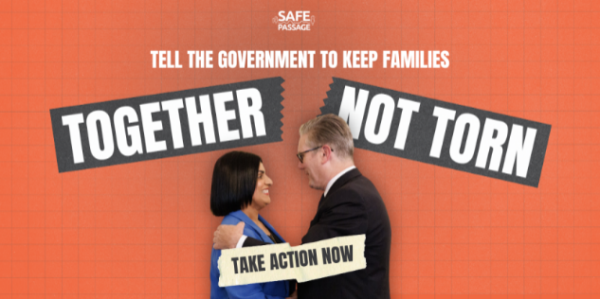
Safe Passage have produced an explainer about the UK Government’s decision in September to suspend Refugee Family Reunion. You can support their campaign to restore it here.
SOCIAL SECURITY IN THE UK
Years of successive government decisions have left us with a social security system that is hard to access, does not provide enough to live on and punishes people for things outside their control. Political choices have led to support being chipped away while prices soar and public services collapse. Amnesty is calling for a better system that works for us all. Its new petition calls on the Prime Minister to:
- Make sure that those affected are able to help shape the solution
- Set up a Social Security Commission with the power to ensure the system works for us and our communities
- Make tax and spending choices that advance our everyday rights
You can sign it here.
AMNESTY FEMINISTS: RELATIONSHIPS AND SEX EDUCATION
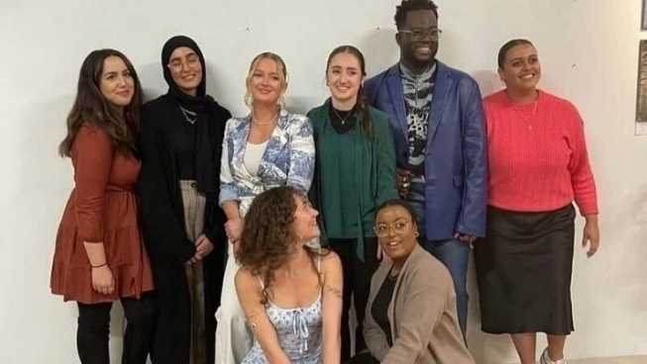
Amnesty Feminists are promoting a petition calling on the government to extend and mandate RSE (Relationships and Sex Education) to KS5 students (sixth form and college students aged 16-18) as one step in a wider societal approach to preventing violence against women and girls. You can sign it here.
STUDENT ACTION NETWORK: DEFEND DISSENT
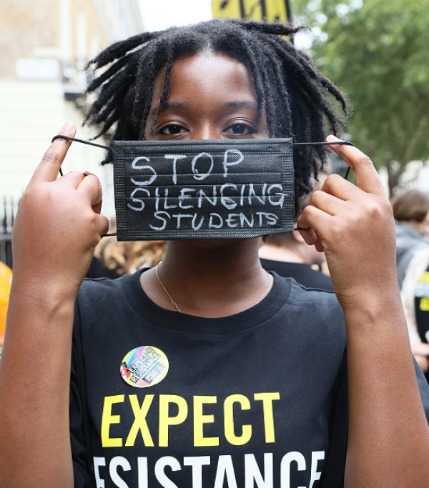
The Student Action Network are launching a Defend Dissent Campaign to push back against the crackdown on dissent in universities, defend free expression and stand up for the right to protest. You are invited to join the campaign launch events and connect with student organisers, hear their experiences, and explore how we can act together to resist repression and build solidarity between generations of activists.
London launch
6.30pm, Tuesday 25 November
Sheikh Zayed Theatre, London School of Economics 54 Lincoln's Inn Fields, London, WC2A 3LJ
Book your ticket here
Promo pack including mails, blurbs, flyers, social media to help spread the word here: Defend Dissent - London
Online launch
6.30pm, Thursday 27 November
On Zoom – details after you register.
Book your ticket here
Promo pack including mails, blurbs, flyers, social media to help spread the word here: Defend Dissent - Online
PROTECT THE PROTEST
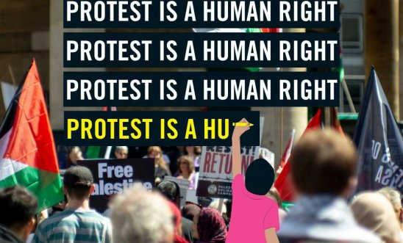
The UK government has failed in its attempt to block a judicial review of its decision to ban Palestine Action under terrorism laws. Amnesty has welcomed the news, saying that there are serious human rights concerns around the proscription decision and the consequences it has had on the rights to free speech and assembly.
LINKS WITH MPs
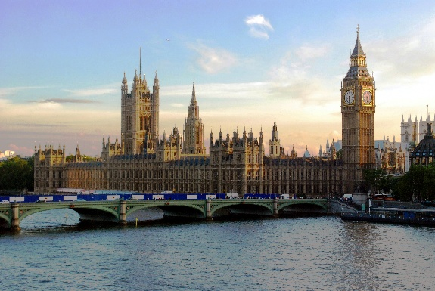
We shall be writing to you shortly to seek your help in strengthening links with your local MP. Please offer to help with this if you can. We want to develop a strategic approach to our contacts with each MP, seeking to identify those issues where they are likely to have most interest and the greatest influence in promoting Amnesty’s human rights goals.
WORKING WITH SCHOOLS
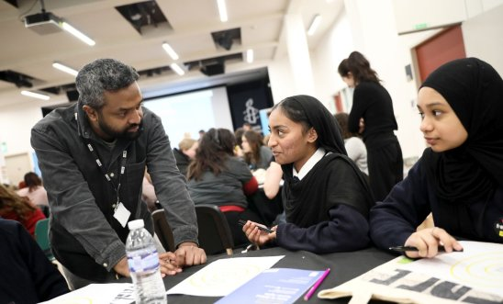
We are launching a new team to coordinate our efforts to build stronger links with local schools. We are looking for volunteers who can help to generate requests from schools and/or who can visit schools to speak to or meet students who are interesting in supporting human rights and Amnesty. If you would like to join the team, please email me.
SOCIAL MEDIA
We are also seeking volunteers to help build our presence on social media, especially Instagram. If you would like to be part of this team, please email zara.kumbas@yahoo.com.
AMNESTY SHOP CHRISTMAS RANGE

The Amnesty Shop Christmas Range is available here.
TRAINING: DIRECT ACTION
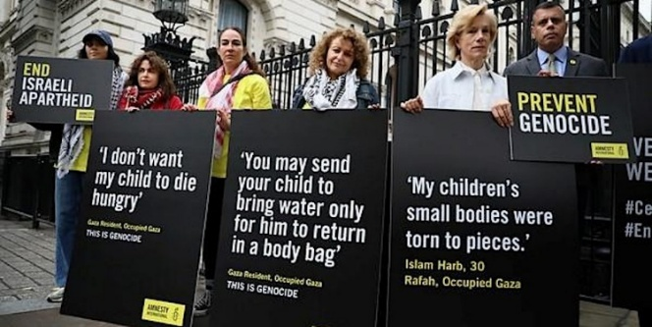
Amnesty is holding an online training session to enable activists to gain an understanding of some of the direct action tactics which can be used, when it is strategic to escalate to direct action and knowledge of risk analysis, safeguarding and the practical things you need to consider before undertaking direct action. This will be on Tuesday 25 November from 6:00pm to 7:30pm. Register here.
OUR FRIENDS’ EVENTS
Human Rights Solidarity invites you to Stand Up at Trafalgar Square on 22 November at noon to mark the International Day for the Elimination of Violence Against Women. They will be coming together in silence to deliver a powerful message - that what you wear never justifies sexual abuse. Women from all walks of life will stand side by side dressed freely to confront the falsehood that clothing causes violence. Contact Ceyda Kemanci at 07495 673630 for information or to confirm your participation. Bring your courage. Wear what you want.
Soroptimist International Canterbury invites you to march with them on Saturday 29 November. They will march in silence to symbolise the silenced and unheard voices of those suffering abuse and to help raise awareness of the shocking rates of domestic abuse and violence against women and girls that persists in the UK today. The Lord Mayor of Canterbury and the Rt Revd Bishop of Dover & Bishop in Canterbury, Bishop Rose. Meet at The Buttermarket in Canterbury at 10:45am to hear a keynote speech from a survivor. The march will process via Burgate, High Street Orange Street and Sun Street and return to The Buttermarket. Posters will be provided or bring your own. Wear something orange if you can.

Tuesday 18 November at 7:30pm: Kent Network speaker meeting with Steve Wilkins, Kent Stand Up To Racism. Email arianna.pisetti@amnesty.org.uk for a link.
Saturday 22 November at noon. Human Rights Solidarity Stand Up at Trafalgar Square to mark the International Day for the Elimination of Violence Against Women. Contact Ceyda Kemanci at 07495 673630.
Tuesday 25 November at 6:30pm: London launch of Student Action Network’s Defend Dissent Campaign at Sheikh Zayed Theatre, London School of Economics, 54 Lincoln's Inn Fields, London, WC2A 3LJ. Book your ticket here.
Tuesday 25 November from 6:00pm to 7:30pm. Online training session on Direct Action. Register here.
Thursday 27 November at 6:30pm: Online launch of Student Action Network’s Defend Dissent Campaign. On Zoom – details after you register. Book your ticket here
Saturday 29 November: Write for Rights stall at Faversham market. Email annabelle_clayton@hotmail.co.uk.
Saturday 29 November at 10:45am starting at The Buttermarket, Canterbury: Soroptimist International Canterbury march to raise awareness of domestic violence against women and girls.
Monday 1 December at 7:30pm to 9:00pm: Maidstone, Medway and Swale Group meeting at Maidstone Community Support Centre, 39-48 Marsham Street, Maidstone, ME14 1HH, and online. Email mmands.amnestygroup@gmail.com.
Wednesday 3 December at 1:00pm to 3:00pm: Monthly Guantanamo vigil outside Houses of Parliament. Email mark.clixby@amnesty.org.uk.
All the best
Graham

