NEXT GROUP MEETING

The next group meeting will be held on Thursday 20th November at 7pm. Venue – Stockton Heath Methodist Church, Heath St WA4 6LP

FINANCIAL UPDATE

We have £164.74 – in our bank account.

FUNDRAISNG
Gill and her daughter are having a fund-raising stall at a children’s market in Northwich in November.
WRITE 4 RIGHTS
Card-signing, 6th December, 2.00 – 4.00 pm Stockton Heath Methodist Church.
Cards with preprinted messages will be provided for signing, Afternoon tea will be provided (tea, coffee and cake)
We have chosen three cases to highlight:
Sai Zaw Thaike (Myanmar) -a photojournalist imprisoned and tortured for exposing the truth about the aftermath of Cyclone Mocha.
Sonia Dahmani (Tunisia) a lawyer unjustly detained for peacefully expressing her views and criticising the government.
Makhabat Tazhibek-kyzy (Kyrgyzstan) imprisoned for 6 years for exposing high-level corruption.
CULCHETH CHRISTMAS TREE FESTIVAL
12-14 DECEMBER.
We have booked in to contribute an Amnesty tree and will set up on Thursday 11th December. Evelyn will prepare 20 cards with different messages of support included for people to sign.

We chose Makhabat Tazhibek-kyzy’s case to highlight. Gill will provide the profile and Evelyn will put pictures of all the cases on baubles to hang on the tree. The theme of the festival is ‘Following the star’. Gill will take the tree down on 9th January.
Jane will hold a card-writing session at Padgate Methodist church on a Sunday in December.
OSMAN KAVALA

We sent solidarity messages to Osman Kavala in prison in Turkey.
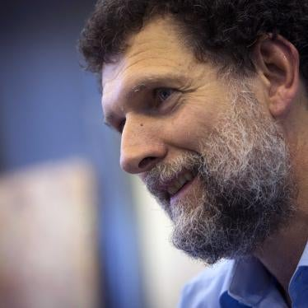
Osman Kavala, the respected Turkish human rights defender, has been behind bars in Istanbul’s Silivri high security jail for almost eight years. He is serving a life sentence without the chance of parole, having been convicted following a preposterous trial. He was convicted on baseless allegations of organizing and financing the Istanbul Gezi Park protests in 2013 in an attempt to overthrow the government in Turkey. The May-June 2013 Gezi Park demonstrations and sit-ins took place in Istanbul’s Taksim Square as a protest against a government-planned urban development project and resulted in hundreds of thousands of people around Turkey exercising their right to peaceful protests.
The Turkish government has ignored two rulings by the European Court of Human Rights ordering Kavala’s immediate release.
Despite his circumstances he is in reasonable health and treated with respect by his prison guards his sights still set on upholding rights, both in prison and outside.

COTE D’IVOIRE
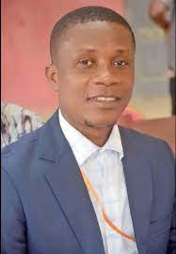

Unionist’s conviction and sentencing upheld:

Ghislain Duggary Assy

On 16 July, the Abidjan Court of Appeal upheld the conviction and two-year prison sentence of unionist Ghislain Duggary Assy.
In April 2025 he was convicted of ‘obstructing the operation of the public service’. A coalition of teachers’ unions called a strike which he joined. No committal order was issued, so Ghislain Duggary Assy remains free however Amnesty International still urges the authorities to quash Ghislain Duggary Assy’s conviction and end his prosecution.

WITHDRAWALS FROM THE INTERNATIONAL CRIMINAL COURT

Burkina Faso, Mali and Niger

In September 2025 three states in the region – Burkina Faso, Mali and Niger – announced their withdrawal from the International Criminal Court (ICC), a serious step backwards in the fight against impunity for serious crimes such as war crimes, crimes against humanity or genocide. These states have accused the ICC of being an instrument of neo-colonial repression only targeting poor countries.
Burkina Faso, Mali, and Niger called the ICC an "instrument of neocolonial repression in the hands of imperialism," suggesting the court is a tool of foreign domination rather than impartial justice.
Selective justice: They accuse the ICC of applying justice selectively, arguing that it unfairly targets African nations while ignoring crimes committed by more powerful countries.
Incapacity and bias: The nations claimed the court has proven itself "incapable of handling and prosecuting proven war crimes" and that it has an anti-African bias, noting that a vast majority of the ICC's cases have involved African countries.

RWANDA

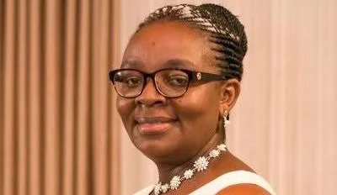

Opposition politician Victoire Ingabire is president of the Development and Liberty for All (DALFA-Umurinzi) political party. She was arrested at her home in Kigali on 19 June. The Rwanda Investigations Bureau has linked her arrest to alleged subversion for communicating with nine others who were arrested in October and December 2021 and are facing charges of attempting to overthrow the government.

Ingabire is accused of, among other charges, “establishing or joining a criminal Organization, conspiring to commit crimes against the government, and inciting unrest or disorder among the population.” She has denied these charges, but if convicted, she could face up to life in prison. She has been denied bail. Victoire Ingabire was previously arrested after she returned to Rwanda from exile in the Netherlands in January 2010 to participate in the presidential elections. She was barred from election and arrested on charges including ‘genocide ideology’ and ‘divisionism’ and later sentenced to 15 years imprisonment. In 2017 the African Court on Human and Peoples’ Rights ruled that Rwanda had violated her rights to freedom of expression and a fair trial.

She received a presidential pardon in 2018.

Victoire Ingabire’s arrest and imprisonment is a part of the persistent politcal persecution in Rwanda, which has seen criminalization of freedom of expression and association, as well as peaceful politcal dissent.

