AMNESTY KENT NETWORK NEWSLETTER: SEPTEMBER 2025
Dear Kent Network members and supporters
HIGHLIGHTS
Welcome to our August newsletter. This month, you can
- Hear about the work of Refugee Action and how we can support it at our speaker meeting on 16 September
- Join us on the Stop Trump march and subsequent networking event in London on 17 September
- Join us at the Medway Human Rights Network’s 10th Anniversary event on 27 September
- Call on the UK’s Chief Prosecutors not to prosecute peaceful protesters
- Ask your MP to support the call to ban imports of goods produced in the illegal Israeli settlements in the occupied Palestinian Territory
- Ask your MP to press for greater UK government support for the rights of women and girls in Afghanistan
- Attend the world premiere in London on 18 September of Lviv Diary: Screening of In Solidarity: A Hong Kong Filmmaker’s Eye on the Ukraine War
- Register to attend Amnesty’s South-East Regional Gathering in Tunbridge Wells on 18 October
- Join forthcoming Amnesty training sessions on Digital Campaigning and Planning an Event
NEXT SPEAKER MEETING: REFUGEE ACTION

Join us at our next speaker meeting on 16 September at 7:30pm when Colin Parker of Refugee Action will tell us about their work around asylum housing with an insight into their upcoming report on how to make sure a reliance on hotels never happens again. Email mark.clixby@amnesty.org.uk for a link.
STOP TRUMP
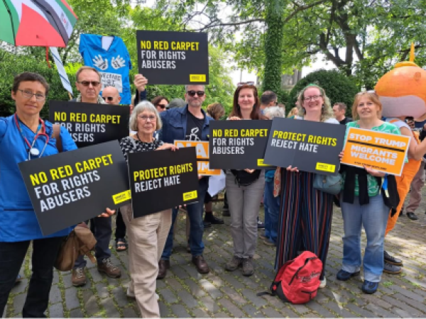
Amnesty will have a bloc at the Stop Trump march and rally in London on 17 September starting at 2pm. Trump is coming to the UK for an official state visit on 17-19 September. This is an important moment to come together to resist his anti-rights agenda and to show UK political leaders that we reject the rise of hate around the world. The march will be followed by a rally starting at 5pm. There will be organisations from across movements calling on Trump to stop the rollback on rights. Those joining the Amnesty bloc will receive campaigns materials such as placards, stickers and t-shirts (first come first serve!). In the evening, Amnesty will host a relaxed evening of networking and Human Rights action planning at The Abbey Centre, 34 Great Smith Street, SW1P 3BU (just an 8-minute walk from the march end-point) from 6:30pm to 8:30pm. A light dinner will be provided. No need to book for the evening.
The Stop Trump Coalition is organising the route and Amnesty’s allocated assembly point is Bloc C at the junction of Portland Place and New Cavendish Street. Register here to join the Amnesty bloc. If you would like to link up with other Kent Amnesty activists taking part, email mark.clixby@amnesty.org.uk or arianna.pisetti@amnesty.org.uk.
REFUGEES
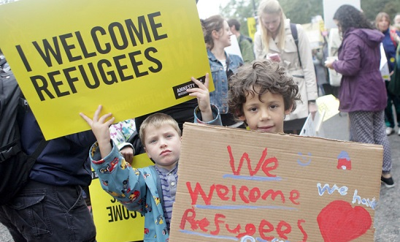
Responding to the Government’s latest immigration statistics, Amnesty UK has said that “Thousands of refugees are being refused asylum under flawed criteria that were introduced but not applied by the previous government….This is a shocking abandonment of people fleeing war, torture and persecution and simply pushes backlogs and costs elsewhere – including into the appeals system. The Government continues to demonstrate that it has no better understanding than its predecessor of its responsibilities and the consequences of trying to avoid them. As a result, we see the same outcomes of harm to refugees, wasted public money, dysfunction at the Home Office, and more fuel to those spreading hate and division.”
Sadly, today’s Maidstone Community MELA in Mote Park has been cancelled due to the forecast of heavy rain and strong winds. Our next opportunity to spread our message to welcome refugees will now be on 27 September at the Medway Human Rights Network’s 10th anniversary event at the Sunlight Centre in Gillingham. At our stall, organised by the Maidstone, Medway and Swale Group, we plan to display and hand out materials aimed at countering the lies being spread by those falsely blaming refugees and migrants for violence against women and girls. Stand Up to Racism have produced an excellent factsheet about this and we encourage you to use it. Email me if you would like to join us at the event.
PROTECT THE PROTEST
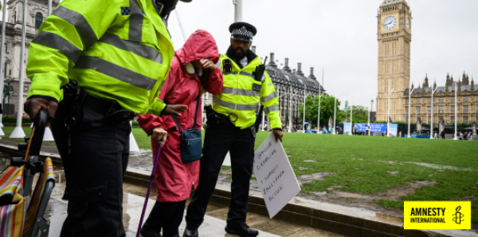
Responding to news that police made another 857 arrests under the Terrorism Act at the Defend Our Juries peaceful protest on 6 September, Amnesty UK called the act “a shocking demonstration of how the UK's overly broad terrorism laws are being used to suppress free speech”. Amnesty’s observers witnessed episodes of police aggression, including supporters of the protest being shoved away and batons being pulled out on people. The arrest of peaceful protestors is a violation of the UK’s international obligations to protect the rights of freedom of expression and peaceful assembly. This cannot go unchallenged. Amnesty is urging the Chief Prosecutors of England & Wales, Scotland and Northern Ireland not to prosecute peaceful protestors. Please support the call here.
ISRAEL AND PALESTINE
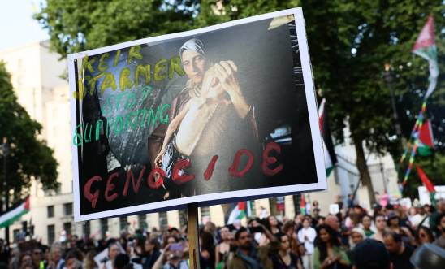
Israeli President Isaac Herzog visited the UK last week. Ahead of the visit, Amnesty UK’s Chief Executive said: “Prime Minister Starmer must not provide diplomatic cover for a state committing genocide. The UK has clear obligations under the Genocide Convention to prevent and punish genocide and a moral duty to humanity: stop all arms exports to Israel, fully support the ICC and resist efforts to undermine it, enforce ICJ rulings, ban settlement goods, adopt targeted sanctions against those Israeli officials most implicated in international crimes, and demand an end to Israel’s system of apartheid and illegal occupation. This visit is a test of leadership and principle: polite handshakes and warm words will demonstrate neither. The UK will be judged on whether it took strong action against genocide or helped to whitewash it.”
On 10 September, Amnesty UK held a solemn vigil to honour the more than 240 Palestinian journalists and media workers killed by Israel in Gaza since October 2023 - the deadliest period for journalists ever recorded. The gathering marked one month since an Israeli airstrike killed six Al Jazeera journalists in a single attack. The Israel-Gaza crisis has been the most dangerous conflict for journalists since the Committee to Protect Journalists (CPJ) started keeping records in 1992. Al Jazeera’s Gaza Bureau Chief, Wael Al-Dahdouh, attended the vigil and delivered a powerful address on the systematic targeting of journalists during the genocide. Wael’s wife, seven-year-old daughter, and 15-year-old son were killed in an Israeli airstrike on the Nuseirat refugee camp on 28 October 2023, in addition to eight of his other relatives.
Amnesty’s message remains the same – the UK must sanction Israeli officials implicated in international crimes; end all arms exports and military assistance; and end all trade that contributes to the genocide, illegal occupation and system of apartheid against Palestinians. Every second that our Government refuses to act is another second of abject failure by the international community to defend human rights and prevent further crimes against humanity and genocide.
Thank you to those who have already written to their MP calling on them to support the campaign to ban the import to the UK of goods produced in the illegal Israeli settlements in the occupied territories. So far, over 50 MPs have been lobbied by Amnesty groups and activists and 71 MPs have now signed Early Day Motion 1266. If you haven’t already done so, we urge you to write to your MP. With Israel recently announcing worrying new plans for the expansion of illegal settlements in the West Bank, it is crucial that the UK Government is held accountable for its complicity in incentivising this through trade and business. If you need further guidance about what to write, please email mark.clixby@amnesty.org.uk.
WOMEN AND GIRLS IN AFGHANISTAN

At the Medway Human Rights Network’s 10th anniversary event on 27 September, we also plan to collect signatures for letters to the three local MPs. These letters will ask them to call on the UK government to take stronger action to support international efforts to secure rights for women and girls in Afghanistan. Since the Taliban regained power in Afghanistan in 2021, they have introduced increasingly devastating restrictions on the rights of women and girls, virtually erasing them from public and social life. Women and girls have been banned from attending secondary school, from working and earning a living, and from leaving their home without a chaperone. Any protests against the oppressive regime have been met with immediate violence. Despite this, women in and outside Afghanistan continue to speak out.
I have already written to my MP on the subject and received a supportive response. If you are willing to do the same, please email me and I’ll share my communication with you. You are welcome to use it as a template.
HONG KONG AND UKRAINE
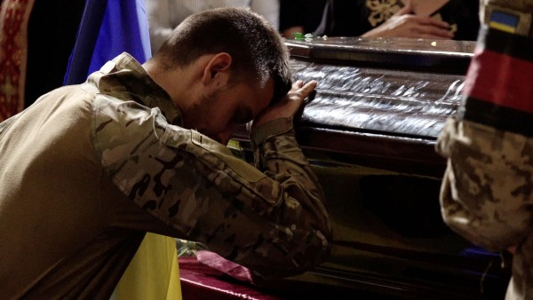
Amnesty UK is partnering with the Hong Kong Film Festival UK to explore human rights, censorship and resistance across Hong Kong and other regions through film. As part of the London programme, Amnesty is supporting the world premiere of Lviv Diary: Screening of In Solidarity: A Hong Kong Filmmaker’s Eye on the Ukraine War, Tammy Cheung’s latest Ukraine war documentary followed by a director’s talk. The film dives into the realities lived by Lviv and its people and is a sobering insight into the tears and trauma of war, shining a necessary spotlight on the people holding onto Ukraine’s fight for freedom and against authoritarian expansion. The screening will be at the Garden Cinema, Parker Street, Covent Garden, London, on 18 September at 8:20 pm. Book tickets here.
PRIDE
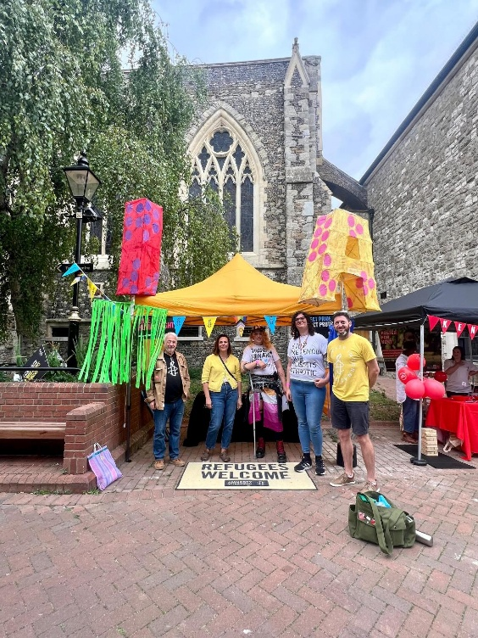
We were at our third and final Pride event on 23 August, this time in Dover, further raising our profile in the town and collecting lots of new sign-ups to our Network.
AMNESTY SOUTH-EAST REGIONAL GATHERING: 18 OCTOBER
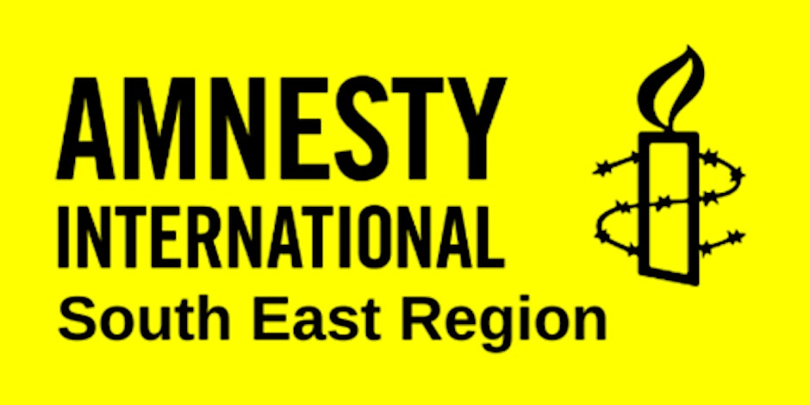
You can now register for Amnesty’s first south-east regional gathering for over 10 years. This is a fantastic opportunity to meet Amnesty and other activists from across the region, which includes Surrey and Sussex as well as Kent. The event will take place on 18 October from 10:00am to 4:30pm in Tunbridge Wells at the King Charles Church Hall, which has a capacity for 60 people. The main topic will be building relationships with other like-minded organisations to counter the hostile environment and the growing threat from organisations that seek to destroy our human rights and protections. Attendance is limited to Amnesty members, members of Local Amnesty Groups and Networks and representatives of local organisations with whom we work, so please do not share the link more widely than that without asking first. Register here.
TRAINING OPPORTUNITY: DIGITAL CAMPAIGNING
On Tuesday 23 September from 6:00pm to 7:30pm, you are invited to join a training session aimed at providing a better understanding of digital mobilisation, exploring different tactics for mobilising supporters online and applying those tactics to achieve campaign objectives. Register here.
TRAINING OPPORTUNITY: PLANNING AN EVENT
On Tuesday 7 October from 6:00 to 7:30pm, you are invited to join a training session on how to plan an event. The session will explore how to organise an event, from coming up with the idea, to event delivery and beyond. Register here.
NEW OFFICE FOR AMNESTY UK
Amnesty UK has moved offices. Its new address is Amnesty International United Kingdom Section, 2nd Floor, Peter Benenson House, 1 Easton Street, London WC1X 0DW.
OTHER EVENTS
Our friends at the Tunbridge Wells and Wealden branch of the United Nations Association (UNA TWW) are presenting a Choral Concert on 25 October at King Charles the Martyr Church, Tunbridge Wells, in commemoration of the 80th Anniversary of the United Nations. UNA TWW are supporting Hall4All, a charitable fund to refurbish the King Charles the Martyr Hall roof. Get tickets here.


Tuesday 16 September from 7:30pm to 8:30pm. Kent Network online speaker meeting: Colin Parker, Refugee Action. Email mark.clixby@amnesty.org.uk for a link.
Wednesday 17 September from 2:00pm. Stop Trump march and rally, followed by Amnesty networking event from 6:30pm to 8:30pm at the Abbey Centre, 34 Great Smith Street, SW1P 3BU. Register here to join the Amnesty bloc.
Tuesday 23 September from 6:00pm to 7:30pm: Digital Campaigning training. Register here.
Saturday 27 September at 2pm to 5pm. Medway Human Rights Network 10th Anniversary Celebration, with Amnesty stall, at the Sunlight Centre, 105 Richmond Road, Gillingham, ME7 1LX. Programme attached. Email graham.minter@amnesty.org.uk to volunteer.
Wednesday 1 October at 1:00pm to 3:00pm. Monthly Guantanamo vigil outside Houses of Parliament. Email mark.clixby@amnesty.org.uk for details.
Monday 6 October at 7:30pm to 9:00pm. Maidstone, Medway and Swale Group meeting at Maidstone Community Support Centre, 39-48 Marsham Street, Maidstone, ME14 1HH, and online. Email mmands.amnestygroup@gmail.com for details or for a link.
Tuesday 7 October from 6:00pm to 7:30pm. Training on Planning an Event. Register here.
Saturday 18 October from 10:00am to 4:30pm. South East Regional Gathering at King Charles Church Hall, 3 Warwick Park, Tunbridge Wells TN2 5TA. For further details, email arianna.pisetti@amnesty.org.uk.
All the best
Graham

