CUBA NEWS 1/11/25
The influential Cuban dissident leader and prisoner of conscience, José Daniel Ferrer, for whom Amnesty has been campaigning for many years, has been released but exiled from Cuba to Miami.
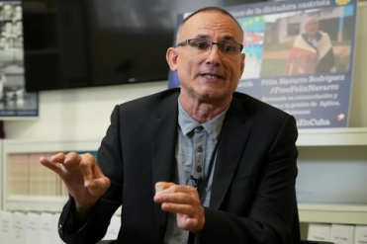
Cuban dissident Jose Daniel Ferrer speaks of his experience leaving Cuba during an interview Wednesday, Oct. 22, 2025, in Miami. (AP Photo/Marta Lavandier)
(ASSOCIATED PRESS)

Ferrer says that the island's fractured and weakened opposition movements need to shift strategies and oppose the government from outside the Caribbean nation.
The comments from Ferrer, in an interview with The Associated Press, come after he spent years in prison in Cuba where he believed he could fuel a larger fight against the government. “Being a prisoner turned me into a symbol of resistance,” he told the AP in Miami.
Now, although he would prefer to be in Cuba, he said he believes he and other exiles must build a strategy outside of the island.

Ferrer said he was forced to leave his country because of the continuing government crackdown on critics triggered by mass anti-government protests that broke out in 2021. It has fuelled an exodus of civil society representatives, activists and journalists, weakening groups who oppose the government. Ferrer arrived in Miami earlier this month on a flight from Cuba with family and U.S. officials.

https://www.yahoo.com/news/articles/influential-cuban-dissident-says-fight-205443866.html?fr=sycsrp_catchall&guccounter=1&guce_referrer=aHR0cHM6Ly91ay5zZWFyY2gueWFob28uY29tL3NlYXJjaD9mcj1tY2FmZWUmdHlwZT1FMjEwR0IxNDk0RzAmcD1qb3NlK2ZlcnJlcg&guce_referrer_sig=AQAAAIMPpN0Vcw6Edgt1KbNRXm_F9ILhfJcgbIwQM15xsMXpmQm7cmlk5xhhY3m5zCxhRN_W-ZJlo5pzBqWrQ6ha8Zgf6GbbcshOQnvmOfaD9sFLFYiRjJRhhYEbNrPJUZ5rVBD4bKzXRGEulQYWVrPoCiha4JTBbG8XeNUfr-lEjYDQ
HURRICANE MELISSA After causing catastrophic devastation in Jamaica, hurricane Melissa was downgraded from Category 5 to Category 3 by the time it reached Cuba. More than 735,000 were evacuated from the country's east, and no fatalities had been reported as of Thursday, when people began returning to their homes.
Officials from the affected eastern provinces reported losses of roofs, power lines, fibre-optic telecommunications cables, cut roads, isolated communities and losses of banana, cassava and coffee plantations.

In the more rural areas outside the city of Santiago de Cuba, water remained in vulnerable homes on Wednesday night as residents returned from their shelters to save beds, mattresses, chairs, tables and fans they had elevated ahead of the storm.
Many communities were still without electricity, internet and telephone service on Thursday due to downed transformers and power lines.

