North West Amnesty Meet-up

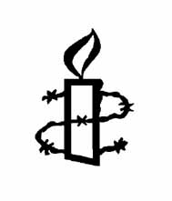
Saturday 8th November
11am – 15.30pm
(doors open 10.30am)
Brewery Arts Centre
122a Highgate, Kendal, LA9 4HE

Let’s meet up to chat about human rights and how we can make a difference

Provisional Programme

11 am Campaigning on human rights worldwide
Interactive session lead by Anne Walker, NW Activism Rep
- Priority campaigns
- Activist lead campaigns
- Campaigning for individuals at risk

12.30 Lunch + craft

13.30 Campaigning on human rights in the UK
Interactive session lead by Elena Auer, NW Activism Rep

15.00 Group Action

15.30 Farewell

Booking

Via WeGotTickets: https://wegottickets.com/event/679365

The event is free; drinks and a basic sandwich lunch will be provided. Feel free to bring some food to share, but there is no obligation to do so.

Any queries: anne.walker@amnesty.org.uk

