**NEXT GROUP MEETING**

The next group meeting will be held on **Wednesday 22nd October** at 7pm. Venue – Stockton Heath Methodist Church, Heath St WA4 6LP

Upcoming dates

**Sat 4th Oct – KNOW THEIR NAMES -** Town Centre vigil & reading of names of children killed or starved to death in GAZA

**Sat 11th Oct** Vigil for GAZA – St Heath Methodist Church - between 10am & 12 noon

**Friday 17th Oct -** 100th vigil for GAZA in Manchester from 5pm

**Sat 6th Dec** - Write for Rights Warrington Group - between 2 & 4 pm

**Thurs 11th Dec** – Christmas Tree Festival@ Culcheth

**Gill and Evelyn are participating in KNOW THEIR NAMES on Saturday morning.**

**NO PREVENT DUTY IN OUR CLASSROOMS**

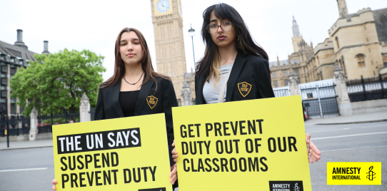

The UK government's "Prevent" duty is not keeping children safe. It is keeping them under surveillance. Tell your MP it doesn’t belong in classrooms.

As a parent, you deserve to know your child is safe at school - not being surveyed. As a student, you deserve not be treated like a suspect.

As a teacher, you deserve to teach with trust - not fear.

Right now, hundreds of children as young as 9 are being swept into the UK government’s flawed “Prevent” duty, with lasting and harmful consequences.

Under this policy, teachers are asked to report students to counter-terror police for signs of “radicalisation”, often relying on vague or subjective judgements.

The result?

* Disproportionate harm to Muslim and neurodiverse children
* Erosion of trust between students and teachers
* Unnecessary trauma for families

What you need to know:

* **11–15-year-olds** are the most reported group under the "Prevent" duty
* Hundreds of children**under 10** are being referred every year
* **93%** of referrals lead nowhere — but the damage is already done.

Email your MP today and demand an end to Prevent in schools.

**SUDAN - DAFUR**

The UN secretary-general called for an immediate ceasefire after a deadly drone attack on Friday killed more than 70 worshippers in el-Fasher, urging the warring parties to engage in dialogue and provide humanitarian corridors. The civil war is in its 3rd year.

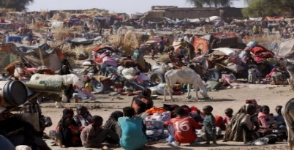People displaced following attacks on Zamzam displacement camp shelter.

**ALAA ABDEL FATTAH PARDONED**

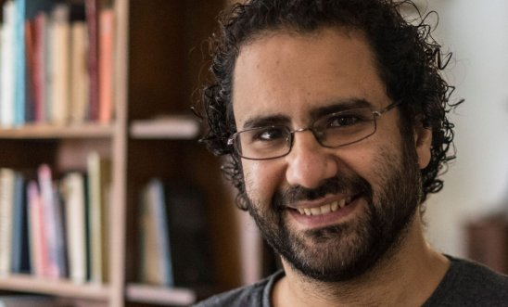

© KHALED DESOUKI/AFP via Getty Images

Responding to the news that President Abdel Fattah al-Sisi has issued a pardon for Egyptian-British activist Alaa Abdel Fattah, Kerry Moscogiuri, Director of Campaigns at Amnesty International, said:

“We are thrilled and relieved to hear reports that Alaa Abdel Fattah has finally been pardoned after eleven years of wrongful imprisonment, but we won't be able to celebrate until he is safely back in the UK with his family.

“Alaa should never have endured this nightmare in the first place. Alaa and his family – particularly his mother Laila, who has repeatedly put her life at risk by going on hunger strike - have endured unimaginable pain by his groundless imprisonment.

“Amnesty calls on the Prime Minister to urgently push for Alaa’s complete freedom and safe travel to the UK. This an opportunity to begin a new chapter in which the UK government works more strategically and consistently on behalf of UK nationals arbitrarily held overseas.”

EMAIL YOUR MP ABOUT UK’s actions to ensure that UK nationals detained abroad are given full support and not left languishing in foreign jails.

**EXECUTIONS IN IRAN**

Within less than nine months, the number of people executed by the Iranian authorities so far this year has already surpassed last year’s grim total of 972 executions.

**IRAN**

Since the 2022 Woman Life Freedom uprising, the Iranian authorities increased their use of the death penalty as a tool of state repression and to crush dissent, and amid an ongoing spike in executions for drug-related offences. In 2025 the authorities have also intensified their use of the death penalty under the guise of national security in the aftermath of the escalation of hostilities between Israel and Iran in June 2025 following Israeli military strikes against Iran.

“The ongoing escalation of executions in Iran has reached horrific proportions as the Iranian authorities continue to systematically weaponize the death penalty as a tool of repression and to quash dissent.

**MEXICO**

On July 22, the home of **Dora Roblero**, Director of the Fray Bartolomé de Las Casas Human Rights Centre Chiapas, was raided by unknown people. We urge the Ministry of the Interior and the Federal Protection Mechanism for Human Rights Defenders and Journalists to:

* guarantee the safety of Dora Roblero and members of CDH Frayba,
* to ensure investigation of the events of July 22, as well any other attacks

This is not an isolated attack. CDH Frayba has reported more than 51 incidents, including harassment, intimidation, and surveillance against members of the human rights organisation over the past 11 months. CDH Frayba continues to denounce that the Mexican authorities have not yet granted them effective protection measures nor investigated the attacks. The Inter-American Commission on Human Rights (IACHR), calls on the Mexican State to address the situation of risk in which they find themselves.

ATTACKS STILL CONTINUE.

**Email the embassy – mexuk@sre.gob.mx to express concern about recent attacks against Dora Roblero**.