Bawm Prisoners IAR Case

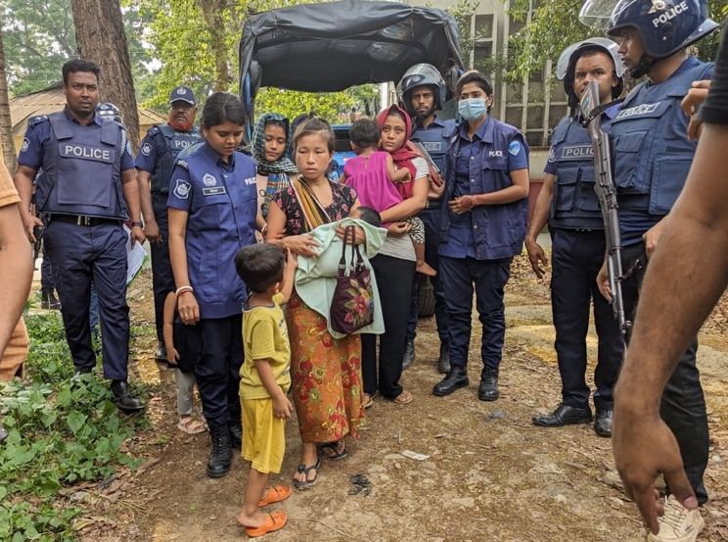
Since April 2024, 126 Indigenous Bawm people, including 30 women and children, have been arbitrarily arrested as part of an ongoing military operation in the Chittagong Hill Tracts in southeastern Bangladesh. They have been in prison for more than a year on trumped-up charges. Of those who weren’t arrested, many have now fled to jungle areas near the villages or out of the country. The entire Bawm nation is being blamed for the actions of an armed group. Amnesty International has been calling for the immediate release of all civilians who have been arbitrarily arrested and an end to the crackdown against the Bawm community.

A delegation of Indigenous leaders from across Bangladesh met with the Interim government in September 2024, and urged the release of innocent Bawm women, children, and others, but to no effect.

On 15 May 2025, one of the Bawm prisoners died in jail due to lack of treatment, according to the CHT Commission. Two further prisoners have died since.

The Bawm Prisoner IAR Case needs your support. Their situation is worsening. For further information please contact jerry.allen@amensty.org.uk

