**AMNESTY KENT NETWORK NEWSLETTER: AUGUST 2025**

**HIGHLIGHTS**

Welcome to our August newsletter. This month, you can

* **Save the date** for our **South East Regional Gathering** in **Tunbridge Wells** on **18 October**
* **Save the date** for our next online **speaker meeting** with Colin Parker of **Refugee Action** on **16 September**
* **Volunteer** to support us at **Dover Pride** on **23 August**
* **Join us** at the **Stop Trump march and rally** in **London** on **17 September**
* **Support West Kent** **Palestine Solidarity Campaign**’s campaign for KCC’s Pension Fund to **divest from companies supporting atrocities against Palestinians**
* **Volunteer** to help on our stall at the **Medway Human Rights Network’s 10th Anniversary Celebration** in **Gillingham** on **27 September**
* **Tell your local MP** that **social security is a human right** and **learn more** at Amnesty’s **online briefing** on **9 September**
* **Learn how to get involved** with the **Rise With Afghan Women Campaign** at an online **briefing** on **20 August**
* **Read** Amnesty’s recent statements and reports on **refugees**
* **Read** the new Amnesty resource on ‘**5 ways to keep resisting racism**’
* **Read** about Amnesty’s campaign for **justice in the Niger Delta**
* **Learn** about **working with schools** and help us to **build links with local schools**.
* **Read the guidance** on **staying safe at protests** and **knowing your rights**

**SOUTH EAST REGIONAL GATHERING: SAVE THE DATE**

**On 18 October**, we are helping to organise Amnesty’s first **South East Regional Gathering** for over 10 years. **The event will take place at a venue in Tunbridge Wells and will bring together Amnesty activists from across Surrey, Sussex and Kent**. The main topic will be building relationships with other like-minded organisations to **counter the hostile environment and the growing threat from organisations that seek to destroy our human rights and protections**. We have invited representatives from other organisations as well as experts from Amnesty UK. We shall also discuss how we can be more effective in reaching out to schools. **If you would like to be kept informed directly of developments, please email** [**arianna.pisetti@amnesty.org.uk**](mailto:arianna.pisetti@amnesty.org.uk)**.**

**NEXT SPEAKER MEETING: SAVE THE DATE**

There is no speaker meeting this month. The next will be on **16 September** when we shall be joined by **Colin Parker** of **Refugee Action**.

**PRIDES**

We participated with a stall at **Folkestone Pride** on 26 July. The event was well attended and the stall was very busy all afternoon with many people thanking us and Amnesty for all the work that is being done. We collected 67 signatories for a petition on Pride criminalisation in Russia and 48 signatories for a letter to the local MP, Tony Vaughan, calling for the UK to ban goods produced in the illegal Israeli settlements in the West Bank.

We also participated in the **Margate Pride** march on 9 August and gave out materials to onlookers en route. We had a great day and it was another step towards raising our profile in Thanet.

We are now seeking volunteers for **Dover Pride** on **23 August,** where we shall have a stall and participate in the march. **If you can help, please email** [**martin3769@hotmail.com**](mailto:martin3769@hotmail.com).

**STOP TRUMP**

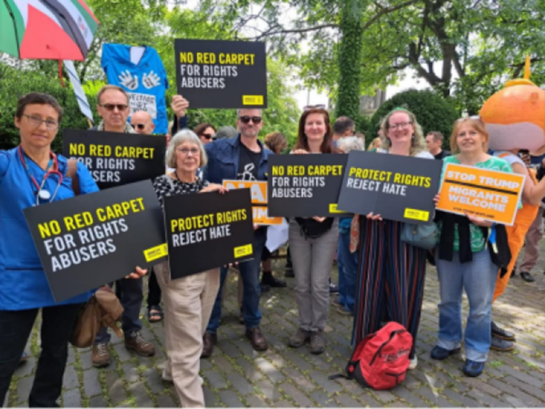

Amnesty will be participating as a bloc in the **Stop Trump march and rally** in London organised by the [Stop Trump Coalition](https://email.amnestyuk.org.uk/c/12GfB3V5T9RQXLUl4jaCd02TLxuO) on **17 September from 2pm**. President Trump will be in the UK for an official state visit on 17-19 September, where he is expected to be visiting London and Windsor. This is an important opportunity for us to make clear our rejection of Trump’s anti-rights agenda and our resistance to his authoritarian practices. The march will be followed by a rally starting from 5pm. Materials will be available to order and will be available on the day. Further details, including location, will follow soon.

**ISRAEL AND PALESTINE**

Our Network is supporting **West Kent** **Palestine Solidarity Campaign’s** campaign forKent County Council to **divest from companies enabling Israel’s atrocities against Palestinians**. Over £300 million of Kent County Council's pension fund is invested in companies complicit in Israel’s war crimes. We encourage you to support the campaign by calling on your local councillors to support motions calling for disinvestment and pressure Kent County Council and the Kent Pension Fund Committee to act. [Please take action here](https://palestinecampaign.eaction.org.uk/kentpensionfund).

The UK government has announced that it will recognise the State of Palestine in September unless Israel takes certain steps over Gaza. **Amnesty has described this as “totally insufficient”**. It has reiterated [**what the UK must do immediately**](https://www.amnesty.org.uk/press-releases/uk-must-take-robust-action-end-israels-genocide-occupation-and-apartheid-every) to help secure a sustainable ceasefire as a step towards ending the genocide: sanctioning Israeli officials implicated in international crimes; halting all arms exports and military assistance to Israel; ending all trade and cooperation that contributes to the genocide, illegal occupation and system of apartheid against Palestinians; and supporting and funding investigations in the UK and abroad.

Amnesty has also described the **mass arrests of Palestine Action protesters** under UK terrorism law as “[deeply concerning](https://www.amnesty.org.uk/press-releases/uk-arrests-palestine-action-protesters-deeply-concerning)”, stating that peaceful protest is a fundamental right and that people are understandably outraged by the genocide in Gaza and **are entitled under human rights law to express their horror**.

**MEDWAY HUMAN RIGHTS NETWORK**

The **Medway Human Rights Network** will hold a **10th Anniversary celebration** at theSunlight Centre in **Gillingham** on **27 September** and we plan to have a stall there. Our stall will be organised by the Maidstone, Medway and Swale Group who would welcome any offers of support from other Kent Network members. **If you would like to help, please email me**.

**SOCIAL SECURITY IN THE UK**

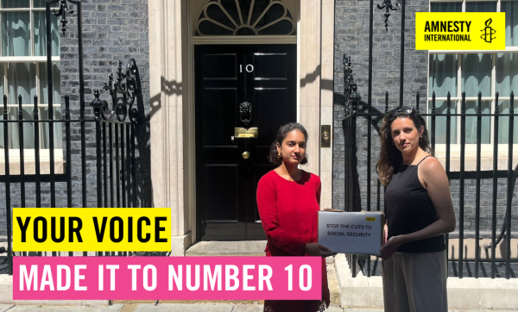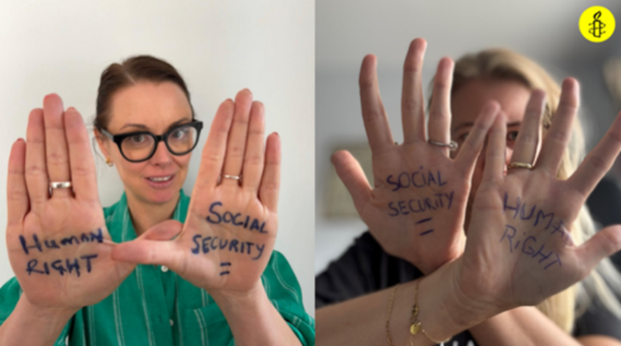

Last month, Amnesty handed in a petition to No 10 Downing Street calling on the government to stop cutting social security. We want to send a clear message to our local MPs that **social security is a human right** and that **poverty is a political choice**. If you plan to seek a meeting with your local MP in the coming months, **please consider including this in your agenda**. We can provide briefing and other support.

To mark **International Eradication of Poverty Day on 17 October**, Amnesty is encouraging its activists to email them a photograph of themselves with one of two messages: Social Security is a Human Right or Poverty is a Political Choice. If you would prefer not to show your face in the picture, that is fine. Amnesty will use the photos to raise awareness around 17 October, including on a banner that they will be taking to Parliament to make the message loud and clear. **Email your photo with message to** [**weekofaction@amnesty.org.uk**](mailto:weekofaction@amnesty.org.uk). You can find [more information about this action here](https://email.amnestyuk.org.uk/c/12GfAzwVzO8S7MitMzTCyxkobSc4).

If you would like to know more about this and related issues, you can **join Amnesty’s briefing on “every day rights” on 9 September from 6pm to 7:30pm**. At the briefing you will **learn more about Amnesty's campaign on Social Security** as part of its work on Economic, Social and Cultural Rights. [Register here](https://email.amnestyuk.org.uk/c/12GfLBiFBbXWZDxjIvyZJXtQDmuL).

**AMNESTY FEMINIST NETWORK: AFGHAN WOMEN**



Advocating for **Afghan women’s rights** is a top priority for the Amnesty Feminist Network. Since the Taliban regained power in Afghanistan in 2021, they have introduced increasingly devastating restrictions on the rights of women and girls, virtually erasing them from public and social life. Women and girls have been banned from attending secondary school, from working and earning a living, and from leaving their home without a chaperone. Any protests against the oppressive regime have been met with immediate violence. Despite this, women in and outside Afghanistan continue to speak out.

Amnesty Feminists have recently launched their **2025 Rise with Afghan Women campaign pack.** It includes MP letter templates, petition links, ideas for community events, further reading and much more. **You can access the pack here.**

On 20 August at 6pm, you can hear more about the campaign and how you can get involved. [**Click here to register**](https://email.amnestyuk.org.uk/c/12GfIazvpJT57GgiIoE2aIshBHnz).

**REFUGEES**

Amnesty has **described the UK government’s deal with France as “**[**another cruel, costly failure dressed up as policy**](https://www.amnesty.org.uk/press-releases/uk-france-another-cruel-costly-failure-dressed-policy-amnesty-warns-new-migrant)**”** and one that sacrifices human lives for political convenience, ignoring the root causes of migration and risking pushing smugglers towards more dangerous and hidden routes. It accused the government of unjustly punishing people simply for exercising their right to seek asylum in the UK through the only route left open to them. It argued that resources should be used to **process asylum claims fairly and efficiently** rather than using them as political pawns in a wider deterrence strategy

**ANTI-RACISM**

[**Amnesty has published the results of its analysis of X(formerly Twitter)’s open-source code**](https://www.amnesty.org.uk/press-releases/uk-x-created-staggering-amplification-hate-during-2024-riots), revealing that the platform’s content ranking algorithms **prioritise the type of content that can spread misinformation and hate**, with deeply inadequate safeguards to prevent human rights abuses. It found that X had **played a central role in the spread of false narratives and content which incited violence against Muslim and migrant communities** in the wake of the Southport murders.

Amnesty have recently published [**this resource**](https://email.amnestyuk.org.uk/c/12GTbLW2U1c4LqdZsAbLJRIIvmNS) in collaboration with [**Maslaha**](https://email.amnestyuk.org.uk/c/12GTc1883H3zbq1V6rPgz64Yicsf) and [**Praxis**](https://email.amnestyuk.org.uk/c/12GTcgkddmV3BpPQKjsLokre526C), on **‘5 ways to keep resisting racism’**, with more opportunities to take action.

**NIGER DELTA**

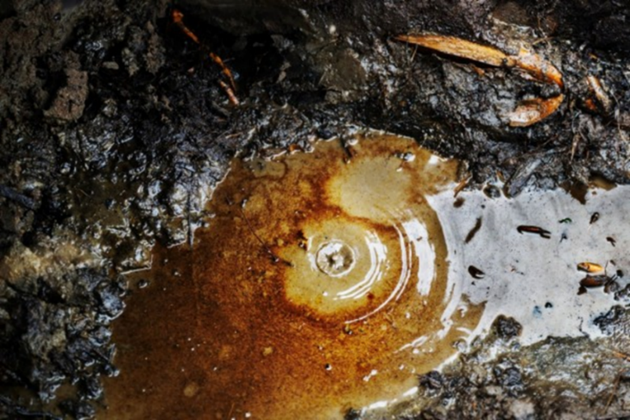

In the coming months, Amnesty will continue to campaign for a **clean-up of the Niger Delta** and **justice for its inhabitants**, who have suffered from hundreds of oil spills from Shell infrastructure during the decades that the company was operating there. **You can** [**read more about the campaign here**](https://email.amnestyuk.org.uk/c/12GfBNvlmbskdLk7ZU56GH7F82rV). The Bodo community took Shell to court in May and a judgement is expected later this year. Next month, there will be a campaign pack available and an online meeting for activists to discuss options for action.

**WORKING WITH SCHOOLS**

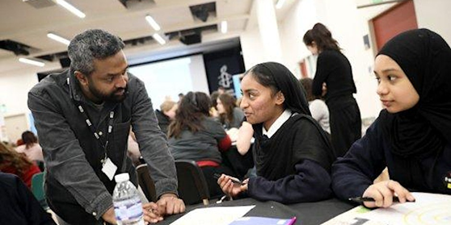

A reminder that Amnesty will hold an **online training session on working with schools** on **Tuesday 26 August** from 6:00pm to 7:30pm. The session will include advice about how to plan work with schools, including awareness about safeguarding and inclusive practice, as well as discussion about some key human rights case studies, covering issues such as refugee rights and LGBTQ+ rights. [**Register here**](https://email.amnestyuk.org.uk/c/12GfL6UvhQeY9DVsqMi05uLl3Hc1).

This is an area where Amnesty needs to do better – and that includes our own Kent Network. **If you are interested in helping us to build more links with local schools, please email me.**

**STAYING SAFE AT PROTESTS**

Here are some **tips on staying safe at protests** and **some information on your rights. We recommend that you look at these before attending a protest.**

* [**Practical Protest Tips (Liberty)**](https://email.amnestyuk.org.uk/c/12GTaiLxXY18fropBomMMtzbMmTE)
* [**Practical Tips for Disabled Protesters (Liberty)**](https://email.amnestyuk.org.uk/c/12GTaxXD7DSCFrclfg0hBHVrzcy1)
* [**Staying Safer During Anti-Fascist Organising (Netpol)**](https://email.amnestyuk.org.uk/c/12GTb2lNqZBBvqOcwZhhgaDX8RQL)
* [**Know Your Rights (Green and Black Cross)**](https://email.amnestyuk.org.uk/c/12GTbhxSAFt5VqC8aQUM5p0cVHv8)
* [**Bustcard - (Green and Black Cross)**](https://email.amnestyuk.org.uk/c/12GTbwJXKlkAlqq3OIygUDmsIx9v)



**Wednesday 20 August at 6pm to 7:30pm. Meet the Amnesty Feminist Network. “Rise with Afghan Women”.** [**Register here**](https://email.amnestyuk.org.uk/c/12GfIazvpJT57GgiIoE2aIshBHnz)**.**

**Saturday 23 August. Dover Pride. Email** [**martin3769@hotmail.com**](mailto:martin3769@hotmail.com) **for details.**

**Tuesday 26 August at 6:00pm to 7:30pm. Online training session on working with schools.** [**Register here**](https://www.eventbrite.co.uk/e/a-guide-to-working-with-schools-tickets-1319806088539?aff=oddtdtcreator)**.**

**Monday 1 September at 7:30pm to 9:00pm.  Maidstone, Medway and Swale Group meeting at Maidstone Community Support Centre, 39-48 Marsham Street, Maidstone, ME14 1HH, and online.  Email**[**mmands.amnestygroup@gmail.com**](mailto:mmands.amnestygroup@gmail.com)**for details or for a link.**

**Wednesday 3 September at 1:00pm to 3:00pm. Monthly Guantanamo vigil outside Houses of Parliament. Email** [**mark.clixby@amnesty.org.uk**](mailto:mark.clixby@amnesty.org.uk) **for details.**

**Tuesday 9 September at 6:00pm to 7:30pm. A briefing on everyday rights.** [**Register here**](https://email.amnestyuk.org.uk/c/12GfLBiFBbXWZDxjIvyZJXtQDmuL)**.**

**Sunday 14 September at 11:00am to 5:00pm. Maidstone MELA with Amnesty stall. Email** [**mmands.amnestygroup@gmail.com**](mailto:mmands.amnestygroup@gmail.com) **to volunteer.**

**Tuesday 16 September at 7:30pm to 8:30pm.  Kent Network online speaker meeting: Colin Parker, Refugee Action. Email**[**mark.clixby@amnesty.org.uk**](mailto:mark.clixby@amnesty.org.uk)**for a link.**

**Wednesday 17 September from 2:00pm. Stop Trump march and rally. Details to follow.**

**Saturday 27 September at 2pm to 5pm. Medway Human Rights Network 60th Anniversary Celebration, with Amnesty stall, at the Sunlight Centre, 105 Richmond Road, Gillingham, ME7 1LX. Email** [**graham.minter@amnesty.org.uk**](mailto:graham.minter@amnesty.org.uk) **to volunteer.**

**Saturday 18 October. South East Regional Gathering in Tunbridge Wells. Details to follow.**

All the best

Graham